# Product Design Input Form (ARC 6525)

1. Introduction

Test Tooling Solutions (TTS) has a process workflow for tracking customer’s request for product design, starting from product specs input from customer until the product design drawing is completed and approved by the customer. Currently, TTS uses Excel file for capturing the product design specs. Communication flows through email and Skype messages. Project 6525 will convert the workflow into a more seamless process by capturing the information electronically. In addition to that, files can be attached to each product design request and communication message is available in this project.

1. Prerequisites

* This project uses Document Control Link: 2190. Hence, link security permission is required for users who need permissions to this document control link.
* Courier & Communication Options needs to be configured correctly for sending email within GSS
* Configure the Subject & Body of the email template used in this project. The email template is Apps\Global\Plugins\Gab\Gas\GAB_6525_EMAIL_DRAWING_TEMPLATE.txt

1. Installations

This project can be installed from ARC. The project number is 6525.

There are several new menu items:

* Estimating / Routing & Quote Management > File > Product Design Input Form (6525)

Use: GAB_6525_PDIF_NEW.g2p

* Estimating / Routing & Quote Management > Transactions > PDIF Workflow (6525)

Use: GAB_6525_PDIF_WORKFLOW.g2p

* Estimating / Routing & Quote Management > View > PDIF Dashboard (6525)

Use: GAB_6525_PDIF_DASHBOARD.g2p

* Estimating / Routing & Quote Management > Administration > PDIF Maintenance (6525)

Use: GAB_6525_PDIF_SETUP.g2p

There are also several Hooks activated:

* Hook: 10923 – Quote Post Save Hook 🡪 GAB_6525_PDIF_Quote.g2u
* Hook: 17301 – Post Move Quote to Sales Order Hook 🡪 GAB_6525_PDIF_SO.g2u
* Hook: 16800 – Work Order Entry Post OK Hook 🡪 GAB_6525_PDIF_WO.g2u

1. Configurations

Once the installation is completed, please do the following steps:

* Run Estimating / Routing & Quote Management > Administration > PDIF Maintenance (6525)
* Configure the starting number of the PDIF

* Configure the role of each user whether the user is Sales, PE (Program Executive), or Designer

* Set the link security permission through User Security Maintenance to Document Control Link: 2190 for the users defined as Sales, PE, and Designer

1. Usage Procedures

* Sales opens Estimating / Routing & Quote Management > File > Product Design Input Form (6525) to enter the customer’s request for product design

There are three types of forms: Standard, PCB, and Probe Pin.

Choose the form type and click New button.

The upper section is the PDIF Header information which is the same for all forms. The lower section is the PDIF Detail information specific to each form type.

Once all the information is entered, click Save button to save the form. A PDIF No will be assigned to the saved PDIF.

Click on the Attach Document button to attach documents to the PDIF.

Click Clear button to clear the form for creating new PDIF or to open an existing PDIF.

To open an existing PDIF, enter the PDIF No directly or click the Browse icon to search for the PDIF No.

Use the right navigation pane to select the information to see regarding the PDIF:

* PDIF Main
* PDIF Header History
* PDIF Detail History
* Status of the PDIF

* Once the PDIF information is completed, Sales opens Estimating / Routing & Quote Management > Transactions > PDIF Workflow (6525)

PDIF Workflow screen appears with the view and actions specific to Sales. This screen shows those PDIFs with specific status for Sales to take action against.

Refer to the following matrix table for statuses available to Sales, PE, and Designer.

|  |  |  |  |
| --- | --- | --- | --- |
| **Status** | **Sales** | **PE** | **Designer** |
| Open | 1 |  |  |
| Waiting Review |  |  | 2 |
| Quote Package Ready |  | 3 |  |
| Quote Created |  | 4 |  |
| Customer PO Received |  |  | 5 |
| Drawing |  |  | 6 |
| Drawing Ready | 7 |  |  |
| Waiting Approval | 8 |  |  |
| Close | FINAL | | |

PDIF Workflow screen allows user to enter Notes for the PDIF and to view the notes.

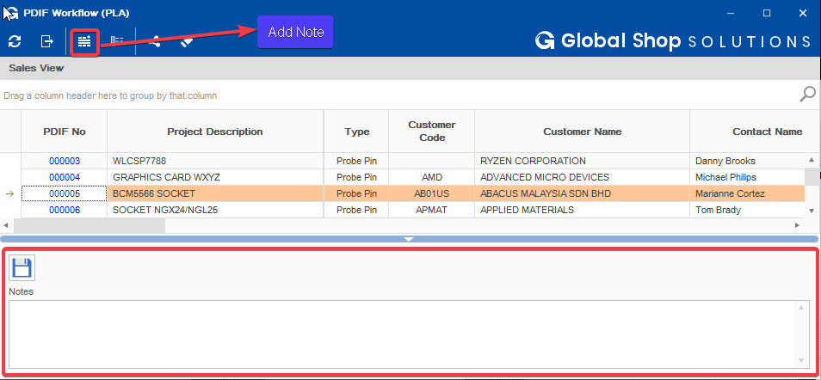

Sales can do the following actions:

* Submit the PDIF to Designer so that Designer can review the information
* Close the PDIF
* Return the PDIF back to Designer if the drawing is not complete
* Send Drawing to customer
* Approve Drawing
* Reject Drawing

* Once the PDIF information is submitted to Designer, Designer opens Estimating / Routing & Quote Management > Transactions > PDIF Workflow (6525)

PDIF Workflow screen appears with the view and actions specific to Designer. This screen shows those PDIFs with specific status for Designer to take action against.

Designer clicks on the PDIF No to launch the PDIF screen. Designer looks at the information provided by Sales and reviews the documents attached for the PDIF.

Designer can add Note to the PDIF and return the PDIF back to Sales if the PDIF information is insufficient.

Once the Designer reviews the PDIF information, Designer clicks the Create Quote Package button on the PDIF screen to launch the Quote Package screen and creates the Quote Package. Then, Designer submits the Quote Package to PE (Program Executive).

* Once the Quote Package is submitted to PE, PE opens Estimating / Routing & Quote Management > Transactions > PDIF Workflow (6525)

PDIF Workflow screen appears with the view and actions specific to PE. This screen shows those PDIFs with specific status for PE to take actions against.

PE clicks on the PDIF No to launch the PDIF screen. PE looks at the information provided by Sales, reviews the documents attached for the PDIF, and reviews the Quote Package from Designer.

PE returns the PDIF back to Designer if there is insufficient information in the Quote Package. Otherwise, PE can create Quote for the PDIF.

Create Quote button launches the Quick Quote screen where user create the quote. The Quote Number is written to the PDIF for reference.

PE sends the Quote to customer. When customer issues a PO, PE creates Sales Order by winning the Quote to a Sales Order. Sales Order Number is written to the PDIF.

PE can also link existing Sales Order to the PDIF instead or winning the Quote and creating New Sales Order.

* Once Sales Order is created for the PDIF, it appears in PDIF Workflow screen - Designer View.

Designer starts the Drawing by clicking the Start Drawing button to create the Work Order for capturing the hours applied to the drawing process. Choose Single Level Work Order Type. Enter the necessary information on the Work Order Entry screen. Click Save. Add the necessary Labor sequence in the Work Order Sequences screen. Then schedule the Work Order. The Work Order Number is written to the PDIF.

After the drawing is completed, Designer attach the drawing files to the PDIF by clicking the Submit Drawing button. Attach the drawing files using Document Control Link. The dates related to the drawing process is written to the PDIF. Est Drawing Complete Date is from the Due Date of the Work Order for Drawing. The Drawing Complete Date is the submission date of the drawing from Designer to Sales.

* The PDIF appears back in PDIF Workflow screen – Sales View.

Sales reviews the drawing from Designer. Then, Sales sends the drawing to customer for approval by clicking Send Drawing button. The Drawing Sent Date is written to the PDIF.

Sales approves or rejects the PDIF Drawing based on customer’s response. Rejecting the PDIF Drawing will change the status of the PDIF back to Drawing and the PDIF is moved back to Designer. Designer revises the drawing based on rejection reason entered by Sales during the rejection process. After that Designer submits the drawing again to Sales. Then Sales sends the drawing to customer again for approval.

Once customer approves the drawing, Sales clicks Approve Drawing button to complete the PDIF workflow. PDIF is closed and the related information is written to the PDIF.

Sales clicks Close PDIF button to close the PDIF if there is cancellation by customer or for any other reason where the PDIF workflow is no longer required.

* User can use Estimating / Routing & Quote Management > View > PDIF Dashboard (6525) to view the list of PDIF in the system

