ARC 6658 – Upload WO Operations

This program will upload job operations from csv or xls file, if there is a operation that is already in that job, a notification pops up and lets user know. They can select either go to next operations or abort the process. If it is new operation, the program will append a line to the job. The program also backward schedules the job after appending all lines.

Once everything is done, a gridview shows all duplicated parts for user to review. They can export it to Excel for modification if needed.

1. Select a WO from the browser or enter it in the text field

1. Select a file (.xls or .csv) to upload

1. Hit Process. If there is a operation that is already in that job, a notification pops up and lets user know. They can select either go to next operations or abort the process.

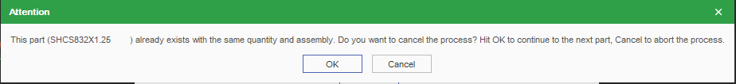

1. Once everything is done, a gridview shows all duplicated parts for user to review. They can export it to Excel for modification if needed.

1. Job operations before and after running this program

