\*\*PROJECT NO LONGER LAUNCHES FROM THE GUI. CODE WAS LEFT IN INCASE THAT NEEDS TO BE ADDED BACK IN\*\*\*

This program allows employees to apply time to jobs through a custom time sheet instead of by clocking into them. The time sheet can be launched either from the script 2 button on the GUI or from On Line System > File > Employee Timesheet (6667).

If your windows username is tied to your Global Shop User in System Support > File > User Security Maintenance, you will not be prompted to sign in. Otherwise you will need to sign in with your Global Shop username and password.

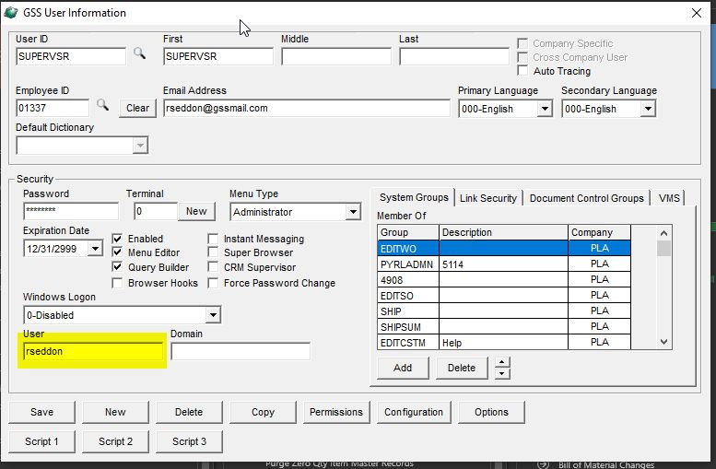System Support > File > User Security Maintenance

For each user that will be launching the time sheet from the GUI, the windows username will need to be set up here. This will be the username they use to log into their computer, it should be visible on the lock screen but can also be found in Settings > Accounts in windows.

If it is not set up, the user will be prompted to sign in with their Global Shop credentials.

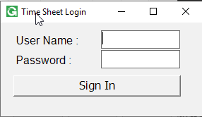

After Signing in from the GUI for from On Line System > File > Employee Timesheet (6667).

The Grid will load with Records that have been previously added to the Current week with the ability to change the week and click the Refresh button to reload Data in the Grid.

To add New Records. Select A Sales Order.

Department is Defaulted to the Employees Department

Select a Work Center

Click Add

Additional Feature

Add Records clicking add from template.

Click the Template button to maintain the template. Sales Order, Work Order, Dept and WC can be added as a Template

Clicking the Add From Template Button this will add all Template Records that have been set up by the User. The two highlight records are my two Template Records that was created.

For Entering Time into the Grid the time is entered in decimal Time. i.e. For an 8 hours and 15 Minutes the user will enter 8.25. There is logic that checks to make sure the entered time is in 15 min intervals. So, the only allowed decimal time is .00, .25, .50, .75. If the is not correct the time is reverted to the original time that was in that column. Additionally, there will be a prompt to let the user know the time entered must be in increments of .25.

When done updating the current records in the time click the Ready for Approval button (at the bottom left of the Screen) to lock those records and marks them as ready for an Admin to post



After Records have been flagged as Ready the User can no longer update or apply time to that record. The user does have the ability to continue adding Unique Sales Order, Work Order, Dept, WC records to the Grid to add time for the week.

For Records that been marked as ready the row will turn green for as a quick indicator.

Admin Users:

Setting up an Admin User.

Create Group PYRLADMN in System Support > File > Group Security Maintenance.

You can also add in Users from here as well.

If group doesn’t currently exist type in PYRLADMN in the Group ID and Enter in any Description you feel. If group already exists it can be browsed to load.

To add users make sure the group members tab is selected and click the add button to select users to add to the group.

System Support > File > User Security Maintenance and put the User into the PYRLADMN security group. On the System Groups Tab Click the Add button and Select the PYRLADMN group to add the user to that group.

When an Admin User launches the Employee Time Dashboard they will receive a prompt to launch as an Admin or as a User.



If launching as a user follow above instructions to add time.

If launching as an Admin

The Grid will load there data that is ready for Approval.

Admin Users can load the Grid by changing the highlighted Text boxes and clicking the Refresh button at the bottom right of the screen. For Example the Admin can Change the Employee and Load the Grid. Or the User can remove the Employee and Supervisor fields and load using just the Sales Order Number. Same can be done if only wanting to all records tied to a Dept or WC etc.

From this Screen the Admin User as the ability to change the time for the records. There is still a check to make suer the time entered in in increments for .25. The Admin User also has the ability to add Unique Time records for an Employee by filling out the Sales Order, Dept, and WC fields.

For Locking and Unlocking Records.

The Admin User can click Unlock and this will mark all records in the grid and Not Ready and save that data. So, the User can make changes and resubmit.

Or the Admin User can click in the Ready Column for each individual record to check/uncheck each record. Doing this the Admin user will need to select Save to submit these changes.

Once all changes have been made by the Admin to records in he Grid. The Admin user and Submit these Time Records to GSS.

\*Note to determine what Job,Suffix,Seq to apply the time to in GSS the program looks for the WC that is tied to the Labor Steps for the Job if No Labor Seq is found with the assigned Work Center then the time gets applied to the Miscellaneous Labor Seq on the Job.

After Posting Data to GSS the submitted rows will be marked as submitted and not additional changes can be made to these records.

Any changes from here for the time applied from the Job will need to be handled with. Core GSS.

The Export Button is available to both Standard and Admin Users. This Export Button will Export the data loaded in the Grid to either a Excel File if the User has Excel installed and to a CSV if the user doesn’t have Excel Installed.

