**ARC ID: 6705 – Custom Material Backflush by Bin**

Robert Cole, May 2022

For: Wisconsin Metal Fab

Contact(s): Dean Hetchler [dhetchler@wisconsinmetalfab.com](mailto:dhetchler@wisconsinmetalfab.com)

**Business Case:**

Wisconsin Metal Fab needs to be able to direct their shop floor employees to issue material from a bin when updating jobs from the SFDC. Standard backflushing only allows for parts to be issued from a default bin or on a FIFO basis, so they needed the ability to select which Lot/Bin/Serial/Heat the material was being issued from.

**Project Components:**

This project is composed of a custom screen that fires from the GUI when the Job Process Update hook is fired. It accounts for both single job and multiple job scenarios.

**Project Step-by-step:**

The user will update their work in the SFDC and a screen will pop up showing all raw materials to be issued to jobs and the user will enter how much material they are issuing:

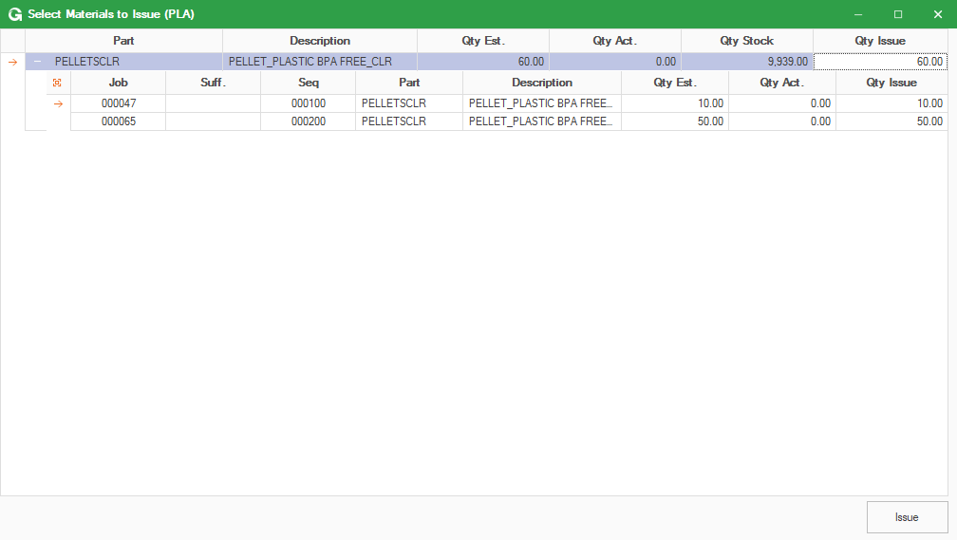

Once the user clicks on Issue it will populate the screen with all available Lot/Bin/Heat/Serial in the system:

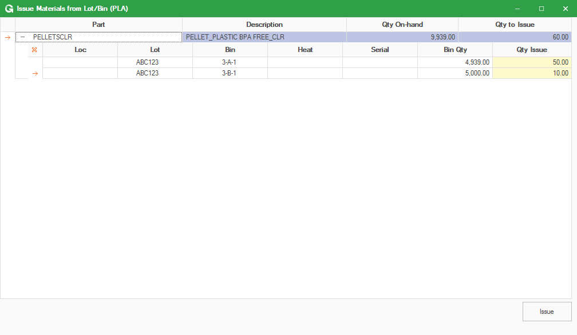

The user can then select what quantity they want from the Lot/Bin/Heat/Serial(s) and it will issue it in relation to the quantity in the Lot/Bin/Heat/Serial and the quantity required on the job(s).