

Dynamics 365 Higher Education Accelerator

Installation Guide

Contents

Installing the Higher Education Accelerator Solutions 2

Step 1: Acquire Prerequisite Files 2

Step 2: Perform the following main solution installs 2

Option 1: Use Package Deployer to Install Solutions 2

Option 2: Import Solutions Manually 3

Step 3: Import Sample Data for Main Solutions 5

Step 4: Installing Higher Education Portal 5

1. Perquisites 5

2. Create a Blank Portal 6

3. Update System Setting to allow js and css files needed for Portal Config 6

4. Import Higher Education Portal Solution 7

5. Import Portal Config Data with Configuration Migration Tool 7

6. Update Portal Binding 8

7. Set up Portal user login for Anton Chew 8

References 9

Manually Importing Solutions 9

Acquiring Configuration Migration tool 9

Importing Data using Configuration Migration Tool 9

# Installing the Higher Education Accelerator Solutions

## Step 1: Acquire Prerequisite Files

* To import the Main Solutions, acquire the following managed solution files:
  + Education Accelerator Anchor (EducationAnchor_managed.zip)
  + Education Accelerator Common (EducationAcceleratorCommon_managed.zip)
  + Dynamics 365 Higher Education Accelerator (Dynamics365HigherEducationAccelerator_managed.zip)
  + Dynamics 365 Higher Education Accelerator Canvas Model Apps (Dynamics365HigherEducationAcceleratorCanvasModel_managed.zip)
  + Dynamics 365 Higher Ed Portal (Dynamics365HigherEdPortal_managed.zip)
  + Package Deployer file (PackageDeployer.zip)
* To import the Sample Data, acquire the following data files:
  + Higher Education Default Data (HIED-DefaultData.zip)
  + Higher Education Portal Data (HIED-PortalData.zip)

## Step 2: Perform the following main solution installs

Please use either one of the options below. If you are familiar with Package Deployer tool, option 1 is easier and installs all the main solutions together.

### Option 1: Use Package Deployer to Install Solutions

#### Download Package Deployer Tool

To import using the Package Deployer, you’ll need to download Package Deployer Tool

For Download Instructions follow these steps –

* + - * Navigate [here](https://docs.microsoft.com/en-us/powerapps/developer/common-data-service/download-tools-nuget) to acquire the Package Deployer tool
      * Click the NuGet package link for the Package Deployer tool
      * Follow directions to download the Package Deployer tool via Package Manager

#### Install Higher Education Accelerator using Package Deployer

* + Use the below command script to import the solutions using package deployer:

./PackageDeployer.exe /Settings:"EducationAnchor=true|EducationAcceleratorCommon=true| EducationAcceleratorK12=false|EducationAcceleratorK12CanvasApps=false|Dynamics365HigherEducationAccelerator=true|Dynamics365HigherEducationAcceleratorCanvasModel=true|SkipSampleData=false"

* + Expected Result: Import should be successful and have green checkmarks for every step and install following solutions and sample data.
    - Education Accelerator Anchor (EducationAnchor_managed.zip)
    - Education Accelerator Common (EducationAcceleratorCommon_managed.zip)
    - Dynamics 365 Higher Education Accelerator (Dynamics365HigherEducationAccelerator_managed.zip)
    - Dynamics 365 Higher Education Accelerator Canvas Model Apps (Dynamics365HigherEducationAcceleratorCanvasModel_managed.zip)
    - Higher Education Default Data (DefaultData.zip)

### Option 2: Import Solutions Manually

**Solutions must be installed in the following order:**

*To import, follow steps in the reference section for “Manually Import Solutions” section below.

#### 1. Education Accelerator Anchor (EducationAnchor_managed.zip)

* Time to complete – 30 seconds to 2 minutes
* Post installation message

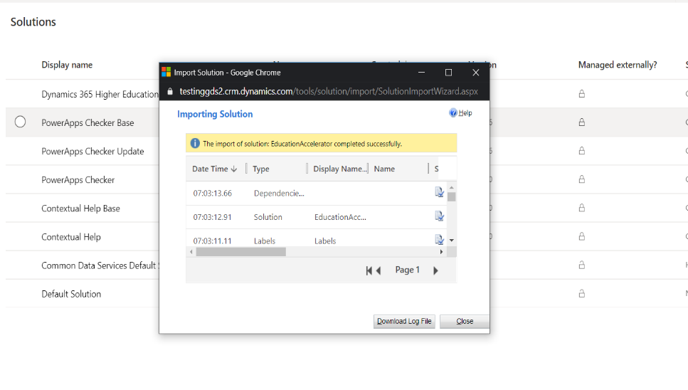

#### Education Accelerator Common (EducationAcceleratorCommon_managed.zip)

* Time to complete – 2 to 6 minutes
* Post installation message

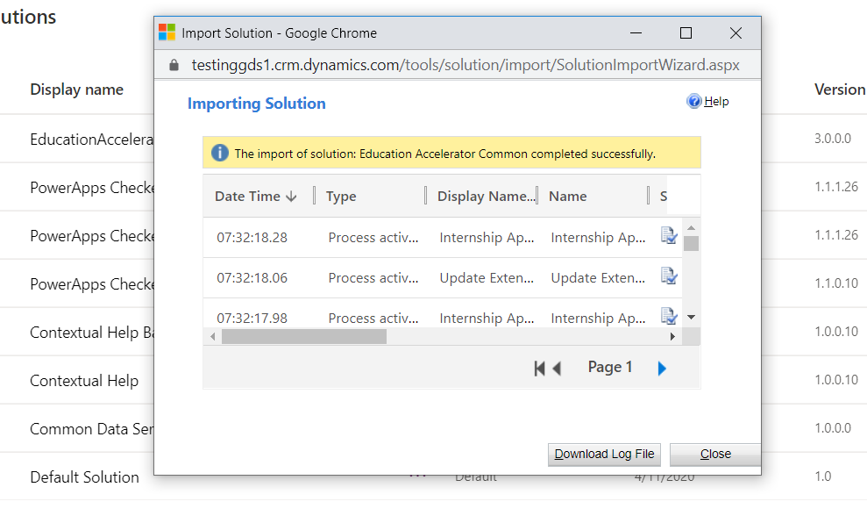

#### Dynamics 365 Higher Education Accelerator (Dynamics365HigherEducationAccelerator_managed.zip)

* Time to complete – 2 to 5 minutes
* Post installation message

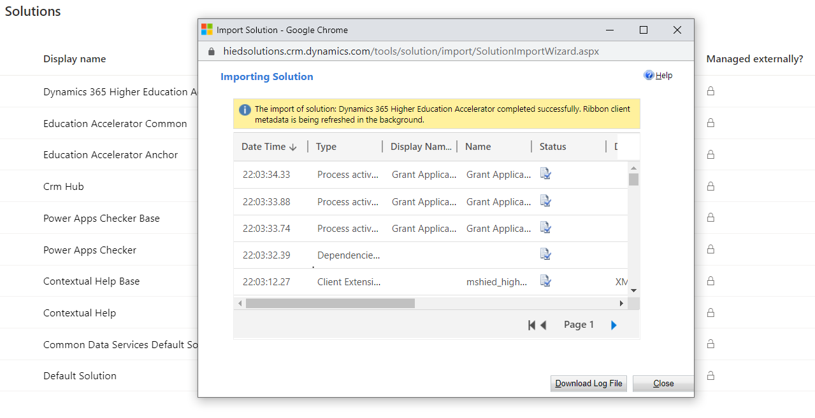

#### Dynamics 365 Higher Education Accelerator Canvas Model Apps (Dynamics365HigherEducationAcceleratorCanvasModel_managed.zip)

* Time to complete – 2 to 5 minutes
* Post installation message

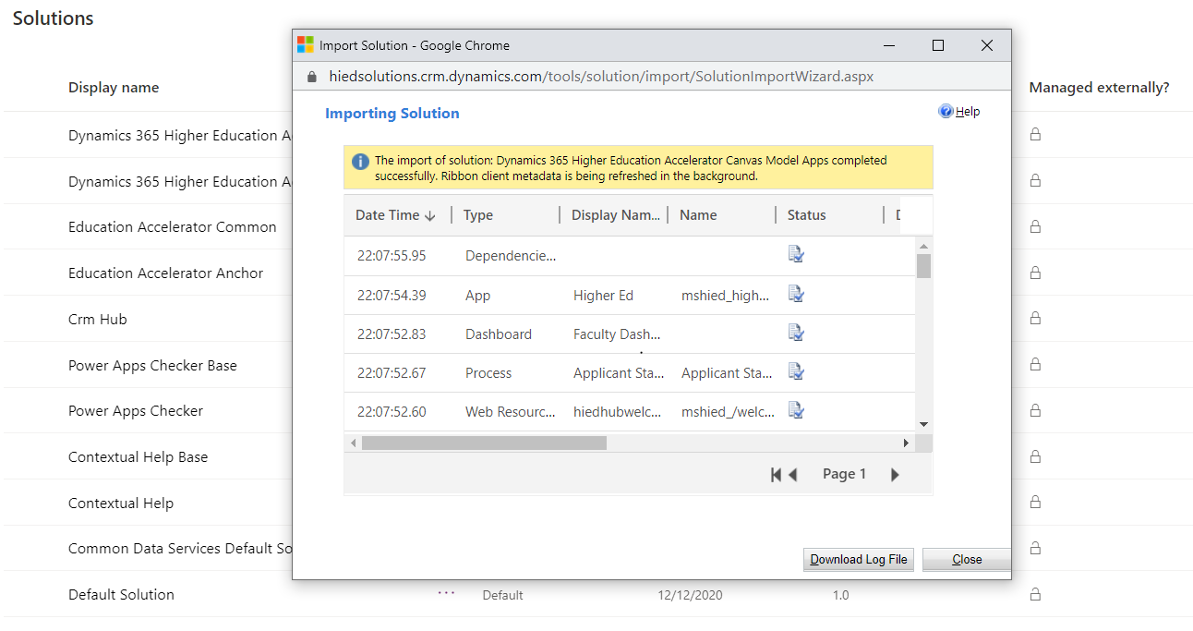

## Step 3: Import Sample Data for Main Solutions

Acquire Configuration Migration Tool using the steps as described in section – “Acquiring Configuration Migration Tool”

To import, follow steps in the reference section on “Import Data using Configuration Migration Tool” below.

* Higher Education Default Data (HIED-DefaultData.zip)
  + Time to complete – 8 to 25 minutes
  + Post Installation Message

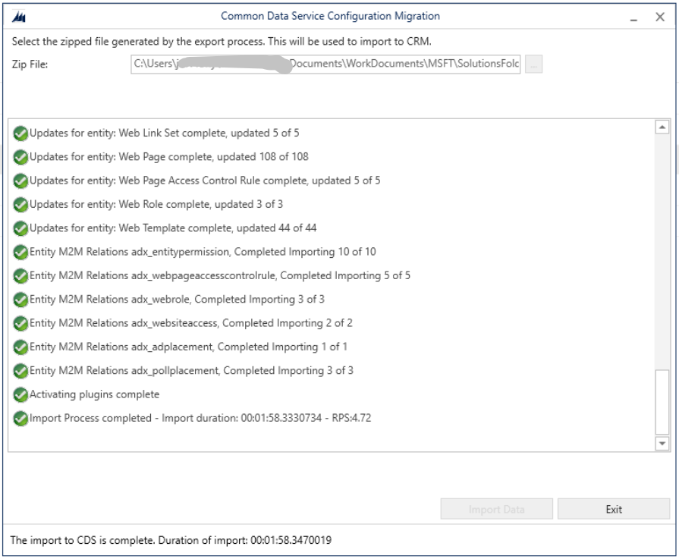

## Step 4: Installing Higher Education Portal

### Perquisites

Following solutions should be installed from Step 2 before proceeding to this step.

* + Education Accelerator Anchor (EducationAnchor_managed.zip)
  + Education Accelerator Common (EducationAcceleratorCommon_managed.zip)
  + Dynamics 365 Higher Education Accelerator (Dynamics365HigherEducationAccelerator_managed.zip)

### Create a Blank Portal

Create a new Blank Portal with the **Portal from blank template** by following [these](https://docs.microsoft.com/en-us/powerapps/maker/portals/create-portal) directions

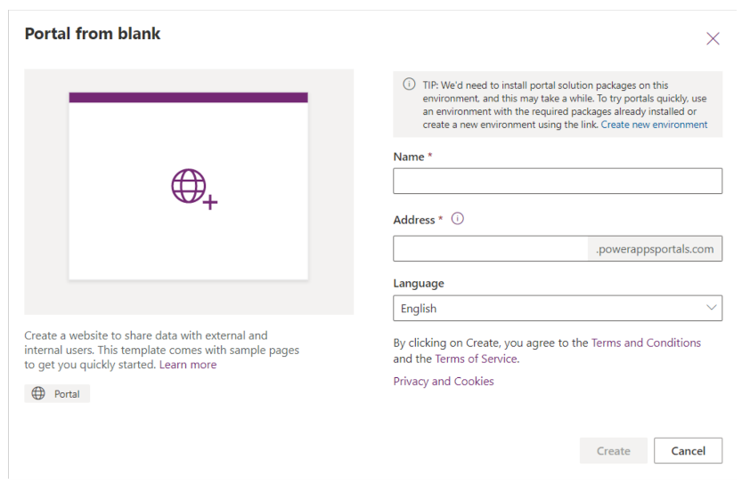

* Time to complete – 12 – 25 minutes
* Post installation message

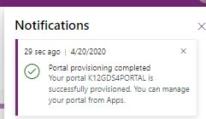

**Note**: Do not proceed to install the Dynamics 365 Higher Ed Portal (Dynamics365HigherEdPortal_managed.zip) solution (Step 4: Import Higher Education Portal Solution) until the Blank Portal is fully provisioned.

### Update System Setting to allow js and css files needed for Portal Config

Once the Custom Portal is provisioned, the user will need to remove the .js and .css file types in the System Settings

* + 1. Click on the Settings icon (sprocket) in the upper-righthand corner and click on Advanced Settings
    2. Within Settings, click on Administration within the System area group
    3. Click on System Settings
    4. Within the General tab, proceed to **Set blocked file extension for attachments** section and remove the .js and .css file extension

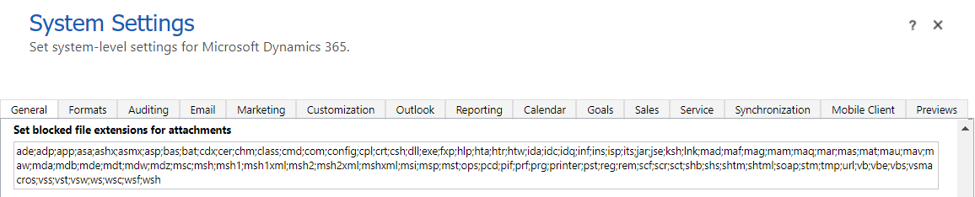

### Import Higher Education Portal Solution

**Dynamics 365 Higher Ed Portal (Dynamics365HigherEdPortal_managed.zip)**

* Time to complete – 1 to 3 minutes
* Post installation message

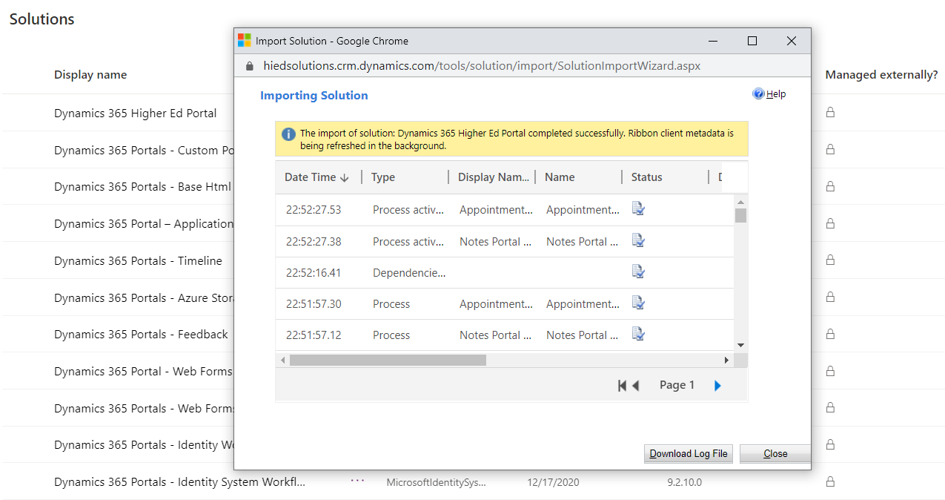

### Import Portal Config Data with Configuration Migration Tool

To import below config page, follow steps in the reference section “Importing Data using Configuration Migration Tool”.

* Higher Education Portal Data (HIED-PortalData.zip)
  + Time to complete – 1 – 3 minutes
  + Post Installation Message

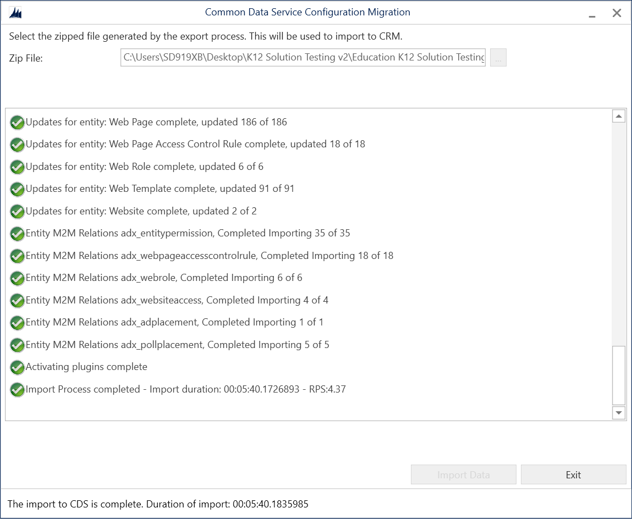

### Update Portal Binding

1. Click on Apps, locate the newly created Portal and click the ellipses to select **Settings**
2. Within the Portal Settings, under the Advanced Settings, click on **Administration** link (will open in a window/tab).
3. Within the Portal Details, find ‘**Update Portal Binding**’
4. Change ‘Select Website Record’ to “**Higher Ed Portal (Custom)**”
5. Click ‘Update’
   1. After this change, it may take up to 5 minutes for website binding data to sync.
   2. Please wait a few minutes before attempting to open the portal URL

### Set up Portal user login for Anton Chew

1. Navigate to the Portal Management model driven app
2. Select Contacts in the sitemap
3. Navigate to Anton Chew’s contact form
4. Click Create Invitation in the top horizontal bar

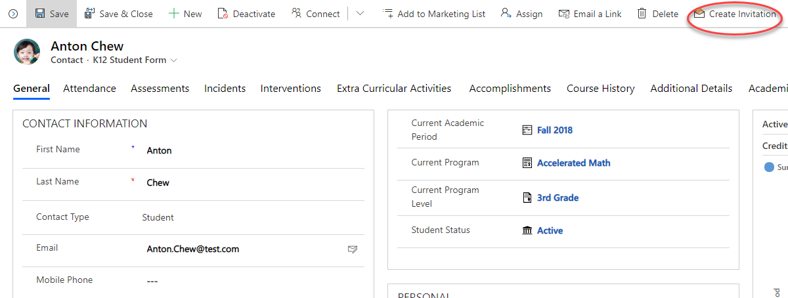

1. On the invitation form click Save
2. Navigate to the Advanced tab on the Invitation form
3. Copy the invitation code to your clipboard
4. Navigate to the Parent Student Portal
5. Click Sign In
6. Click Redeem Invitation
7. Paste the invitation code and click register
8. Complete registration by entering a username and password and saving
9. Confirm user details in the portal
10. Navigate to the coursework page of the portal to view Anton Chew’s Education records

# References

## Manually Importing Solutions

To manually import a main solution:

1. Navigate to <https://make.powerapps.com/home> > Select your Environment > Click Solutions in left-hand Navigation
2. Click Import button in ribbon
3. Click Choose File button and select managed solution zip file

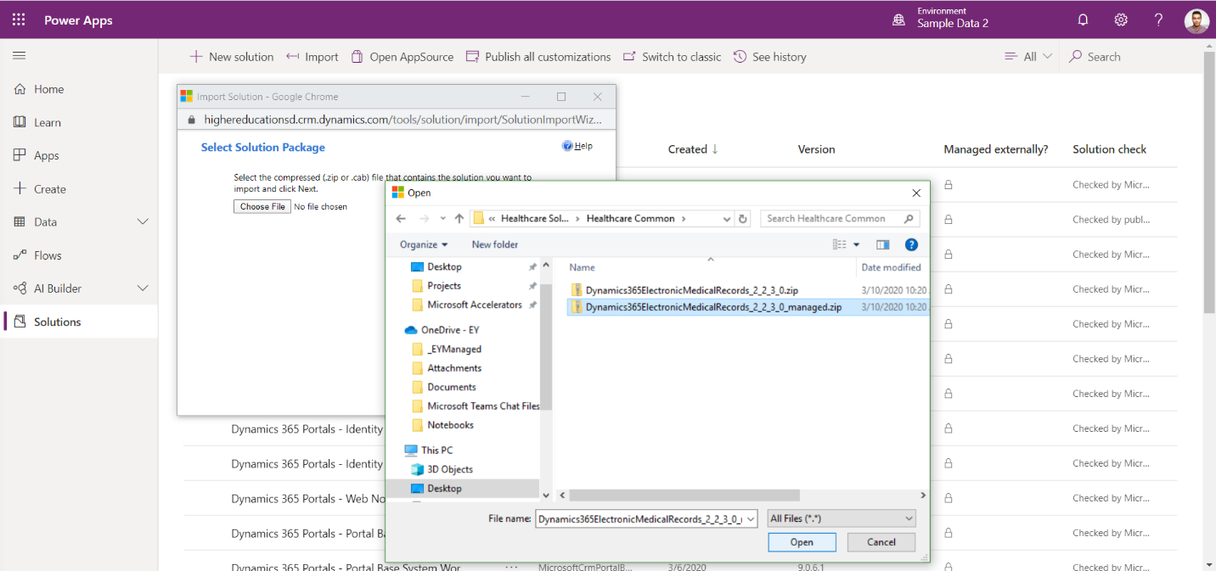

1. Click Open button
2. Click Next through all steps and then Import

**\*Note:** Some imports may take up to an hour to install

## Acquiring Configuration Migration tool

1. Navigate [here](https://docs.microsoft.com/en-us/powerapps/developer/common-data-service/download-tools-nuget) to acquire the Configuration Migration tool
2. Click the NuGet package link for the Configuration Migration Tool
3. Follow directions to download the Configuration Migration tool via Package Manager

## Importing Data using Configuration Migration Tool

To Import an additional solution using the Configuration Migration Tool:

1. Open Configuration migration tool
   1. Select “Import Data”
   2. Connect to the org to import the data to the environment of your choice
   3. Select the appropriate data zip file
   4. Perform the import