

Dynamics 365 Nonprofit Accelerator

v3.0 Release Notes

**Published**: December 2020

**Accelerator Release Version**: v3.0

**Document Purpose**

This document details the enhancements and scope delivered as part of Microsoft Tech for Social Impact’s December 2020 (v3.0) release of the Microsoft Dynamics 365 Nonprofit Accelerator (“Accelerator”).

**Capabilities Included in this December 2020 release:**

1. **Volunteer Management** data schema extensions
2. **Assessment Management** data schema extensions, sample application, and related sample data
3. **Frontline Humanitarian Logistics** data schema extensions and related sample data
4. **Frontline Humanitarian Logistics Mapping Guide** for Nonprofits
5. **Architectural enhancements** to scale and simplify the solution foundation and dependent platform capabilities included in the Nonprofit Accelerator

**Value to Nonprofits Delivered in v3.0**

We measure our success at Tech for Social Impact by the specific value we deliver to the nonprofit sector. Key value drivers for this December 2020 release include:

| **Value** | **Description** |
| --- | --- |
| **Volunteer Management** | * Additional **volunteer management** extensions will aid partners in building affordable solutions for nonprofits at a time when recruiting and retaining critical volunteers is essential. Organizations can track and recruit for a broad range of engagement opportunities, while volunteers themselves can align their time, talents, and qualifications with available volunteer opportunities. The new volunteer data extensions remove any dependency on Dynamics Project Service Automation (PSA). Now partners can build directly on PowerApps to lower the total cost of ownership to support volunteer engagement. |
| **Assessment Management** | * Our Assessment Management CDM extensions, sample app and sample data provide partners with a foundation to enable frontline workers to accurately, consistently, rapidly and efficiently record detailed observations and answer the “who,” “where,” “what,” “how,” and “when” questions critical to delivering nimble services. * These investments allow disaster organizations to evaluate damage and assess on-the-ground needs to enable easier coordinated field response. The assessment management extensions support nonprofit program and beneficiary management and can be leveraged in tandem with the program management and case management data schema already included in the Common Data Model for Nonprofits. |
| **Frontline Humanitarian Logistics** | * Convened by NetHope, the **Frontline Humanitarian Logistics** (FHL) initiative produced a data standard designed to reduce the time and cost involved in implementing IT solutions within humanitarian supply chains and encourage interoperability of data, service delivery, and systems across the sector. * NetHope convened a cross-sector group of 24 collaborating academic, public, and private sector organizations which resulted in the development of a [Frontline Humanitarian Logistics Data Standard](https://solutionscenter.nethope.org/resources/initiatives/frontline-humanitarian-logistics). * The Frontline Humanitarian Logistics data schema in this release aligns item requests, types, and groups to the [FHL Data Standard](https://solutionscenter.nethope.org/resources/initiatives/frontline-humanitarian-logistics) as well as to existing program delivery, donation, and constituent schema in the Common Data Model for Nonprofits to provide donors with exact information about what items are in demand, where the supplies they helped fund with their donations were delivered, and the subsequent impact made to beneficiaries. The ability to report back on donor impact is critical at this time of increased demand for transparency. |
| **Frontline Humanitarian Logistics Mapping Guide** | * The **Frontline Humanitarian Logistics Mapping Guide** provides guidance to nonprofits and partners on how to put the NetHope convened and nonprofit sector-developed [Frontline Humanitarian Logistics Data Standard](https://solutionscenter.nethope.org/resources/initiatives/frontline-humanitarian-logistics) into practice. * In conjunction with key partners, Microsoft has mapped the FHL Data Standard to the Common Data Model for Nonprofits as part of this release to support organizations who align to these valuable industry standards. |
| **Architecture Enhancements** | * We continue to look for ways to scale our CDM for Nonprofits and Nonprofit Accelerator architecture for rapid adoption. * In the v3.0 release, we reduced the data schema packages and removed all Dynamics dependencies. Therefore, nonprofits will only need a Power Platform SKU to utilize the entire Nonprofit Accelerator. The new architecture gives nonprofits and partners the power to rapidly launch Power Platform applications. * We also stopped releasing the Nonprofit Accelerator CE and Nonprofit Sales packages. They are still available on GitHub in previous releases, but we will not continue to maintain or support these packages. * In addition, the IATI package was rebuilt to remove any Dynamics Sales dependencies allowing nonprofits to use IATI with Power Platform. |

**Additional Benefits:**

1. Additional Program Delivery Investments
   * Provide nonprofits across the globe with Volunteer Management, Assessment Management, and Frontline Humanitarian Logistics building blocks to modernize and automate program delivery and operations workstreams during a time when nonprofits are under increased pressure to deliver programs with greater efficiency.
     + One sample app (Assessment Management) and supporting sample data
     + New Volunteer management data schema with no PSA dependency
2. Nonprofit efficiency gains:
   * Help nonprofits evolve from homegrown legacy systems and spreadsheets used to manage critical areas of finance, operations, and program delivery
   * Automate workloads and tasks that were highly manual and duplicative in the past
3. Resource savings and data interoperability:
   * Save nonprofits money on overall data management costs by helping them to the leverage the Common Data Model for Nonprofits, thus ensuring that data in disparate systems is relatable and share in common a standard definition set.
   * Drive more trustworthy and accurate reporting, business intelligence, and data discovery by leveraging the CDM for Nonprofits to enforce standard data definitions across systems.
4. Platform acceleration to benefit partners:
   * Accelerate development and sustainability of partner solutions aligned to the Common Data Model for Nonprofits and Nonprofit Accelerator in the areas of nonprofit assessment management, frontline humanitarian logistics, and further expanded volunteer management.
   * Increase access of Common Data Model for Nonprofits and Nonprofit Accelerator to global nonprofits of all sizes.
   * Streamline, simplify, and scale the existing Nonprofit Accelerator building blocks, ensuring that partners have all the tools needed to publish finished product to AppSource.

**Table of Contents**

1. **Common Data Model Enhancements**
   1. **Volunteer Management Sample App, Portal & Sample Data**
   2. **Assessment Management Sample App & Sample Data**
   3. **Frontline Humanitarian Logistics Data Schema**
2. **Frontline Humanitarian Logistics Mapping Guide**
3. **Nonprofit Accelerator Architecture Enhancements**
4. **Release Assets**
5. **Mapping Guide**

# Nomenclature Update

Please note that the follow names have been updated and changed ([More Information](https://docs.microsoft.com/en-us/powerapps/maker/common-data-service/data-platform-intro#terminology-updates)):

|  |  |
| --- | --- |
| **Legacy term** | **Current term** |
| Entity, entities | Table, tables |
| Field, fields, Attribute, attributes | Column, columns |
| Record, records | Row, rows |
| Option set, multi select option sets  Picklist, picklists | Choice, choices |
| Two Options | Yes/No |

1. Common Data Model Enhancements

This release includes important extensions to the Common Data Model for Nonprofits in the areas of volunteer management, assessment management and frontline humanitarian logistics. New fields and tables are detailed below, along with functional requirements, use cases, and “How to” guidance on how leverage and extend the CDM for Nonprofits data schema.

1. Volunteer Management Sample Data

A priority goal of the Microsoft Dynamics 365 Nonprofit Accelerator is to aid nonprofit program staff in creating and managing a lifecycle of volunteer opportunities, tracking volunteers through every stage of their engagement and creating volunteer schedules. These extensions come at a critical time when nonprofits are relying heavily on volunteers to help serve the greater need among their beneficiaries. The Nonprofit Accelerator v3.0 release enables this through the addition of nine new volunteer-oriented tables and related fields.

Personas Served:

* **Volunteer Manager/Leader**: these individuals are the primary liaison between the nonprofit organization and the volunteers who serve with their organization. They set up volunteer opportunities, communicate frequently with volunteers and must be able to manage multiple schedules and volunteer opportunities.
* **Volunteer**: these individuals voluntarily offer their time, experience or knowledge for a service or undertaking and need an easy way to manage profile information, sign up for available opportunities, and provide preferences to organizations they would like to serve with.

Use Cases covered in this release:

We extended the Common Data Model for Nonprofits data schema to generally handle the following use cases common to most nonprofits managing volunteers:

| **#** | **As a…<type of user>** | **I want to…<some goal>** | **…so that <some reason>** |
| --- | --- | --- | --- |
| 1 | Volunteer | Create and maintain my profile based on my preferences, skills, location, schedule, etc. | A nonprofit can engage me based on the details I define |
| 2 | Volunteer | Apply for open volunteer positions based on my preferences, skills, location, schedule, etc. | I can self-select volunteer opportunities that match my interest(s) |
| 3 | Volunteer Manager | Create and manage a lifecycle for volunteer opportunities | My organization can manage volunteers and volunteer opportunities |
| 4 | Volunteer Manager | Search for volunteers based on specific criteria for volunteer opportunities | My organization can correctly match volunteers with volunteer opportunities |
| 5 | Volunteer Manager | Filter specific volunteers in and/or out of searches based on specific volunteer and/or volunteer opportunity criteria | My organization can correctly match volunteers with volunteer opportunities |
| 6 | Volunteer Manager | Provide and track completion of training for volunteers | Volunteers have the required skills to fulfill volunteer opportunity requirements |
| 7 | Supervisor | Easily assign case access privileges for my case managers | I can ensure case data is appropriately safeguarded |

Key Concepts and Tables Leveraged for Volunteer Management

The following are the dependent CDM for Nonprofits tables leveraged by the volunteer management sample application:

| # | Category | Requirement |
| --- | --- | --- |
| 1 | Work Item | An entity that tracks a logical unit of work or process of work. |
| 2 | Work Item Action | This entity contains the action that are taken to complete a work item. This can include information gathering, providing services, or any other action. |
| 3 | Delivery Framework | Delivery Framework represents a management unit of work defined by the organization or entity doing the work. In IATI, the Delivery Framework is an “Activity.” |
| 4 | Salutation | A Salutation represents the way a constituent wishes to be addressed, depending on the source, purpose and content of a of communication. Salutations may or may not be auto-created by workflow. |
| 5 | Preference | Preference represents an abundance of constituent or organization information that doesn't live cleanly on an account or contact record, or that can be associated with both an Account and a Contact. |
| 6 | Employment History | Employment History represents historical and/or current information about where a contact works, volunteers or serves in some capacity at an organization. |
| 7 | Education | Education references biographical information about the educational institutions a contact attended or is attending. |
| 8 | Engagement Opportunity | Defines one or more opportunities to engage in an Activity. |
| 9 | Engagement Opportunity Participation Qualification | Defines optional and/or required qualifications or characteristics for participation in an engagement. |
| 10 | Engagement Opportunity Schedule | Defines the schedule(s) for an Engagement Opportunity. |
| 11 | Participation | Defines a Contact's prospective, current, or past involvement in an Activity. |
| 12 | Participation Type | Defines the category of Participation. |
| 13 | Availability | Defines a Contact's time preference and/or work time. |
| 14 | Qualification | Defines a Contact's quality or accomplishment that make them suitable for a particular role, job, or activity. |
| 15 | Qualification Type | Defines the category of qualification. |

How to Model Volunteer Management

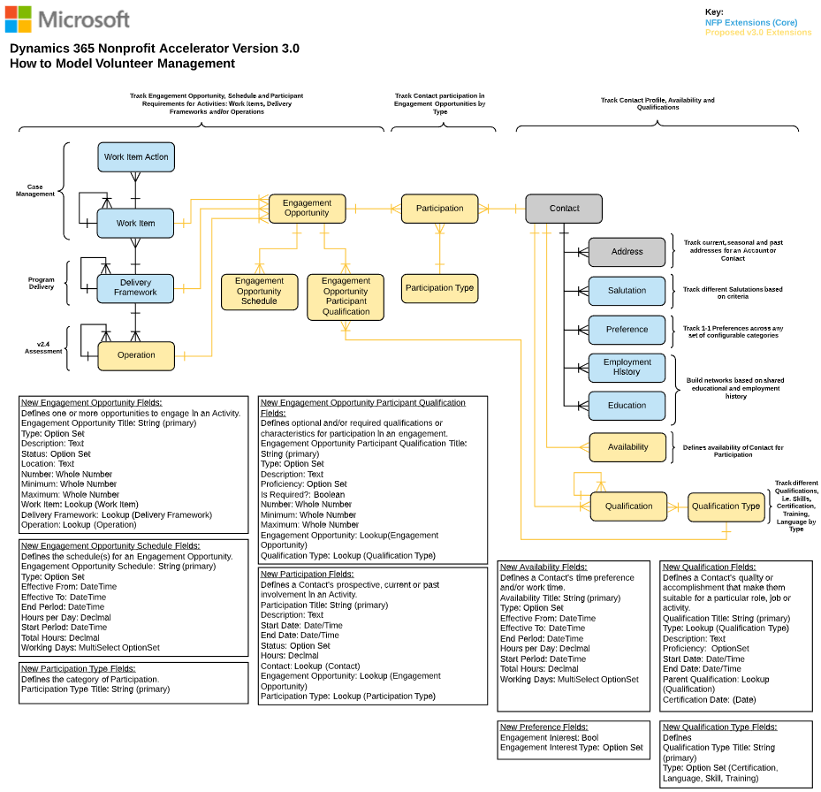

New Common Data Model for Nonprofits Volunteer Management Fields

The following are fields related to each of the new Volunteer Management tables added in this release

1. **Engagement Opportunity** (msnfp_engagementopportunity)

|  |  |  |  |
| --- | --- | --- | --- |
| **Schema Name** | **Display Name** | **Type** | **Description** |
| msnfp_deliveryFrameworkId | Delivery Framework | Lookup | The related Delivery Framework unique identifier. |
| msnfp_deliveryFrameworkIdName | N/A | String | N/A |
| msnfp_description | Description | Memo | The description of the Engagement Opportunity. |
| msnfp_engagementopportunityId | Engagement Opportunity | Uniqueidentifier | Unique identifier for entity instances |
| msnfp_engagementOpportunityStatus | Engagement Opportunity Status | Picklist | The status of the Engagement Opportunity. |
| msnfp_engagementopportunitystatusName | N/A | Virtual | N/A |
| msnfp_engagementOpportunityTitle | Engagement Opportunity Title | String | The name of the custom entity. |
| msnfp_location | Location | String | The location of the Engagement Opportunity. |
| msnfp_maximum | Maximum | Integer | The maximum number of participants the Engagement Opportunity can support. |
| msnfp_minimum | Minimum | Integer | The minimum number of participants needed for Engagement Opportunity. |
| msnfp_number | Number | Integer | The number of participants needed for the Engagement Opportunity. |
| msnfp_operationId | Operation | Lookup | The related operation unique identifier. |
| msnfp_operationIdName | N/A | String | N/A |
| msnfp_type | Type | Picklist |  |
| msnfp_typeName | N/A | Virtual | N/A |
| msnfp_workItemId | Work Item | Lookup | The related Work Item unique identifier. |
| msnfp_workItemIdName | N/A | String | N/A |

1. **ENGAGEMENT OPPORTUNITY Participation QUalifications** (msnfp_engagementopporutnitypart)

|  |  |  |  |
| --- | --- | --- | --- |
| **Schema Name** | **Display Name** | **Type** | **Description** |
| msnfp_description | Description | Memo | The description for the Engagement Opportunity Participant Qualification. |
| msnfp_engagementOpportunityId | Engagement Opportunity | Lookup | The unique identifier for the related Engagement Opportunity. |
| msnfp_engagementOpportunityIdName | N/A | String | N/A |
| msnfp_engagementopportunityparticipantqualId | Engagement Opportunity Participant Qualification | Uniqueidentifier | Unique identifier for entity instances |
| msnfp_engagementOpportunityParticipantQuaTitle | Engagement Opportunity Participant Qualification | String | The name of the custom entity. |
| msnfp_isRequired | Is Required | Boolean | Indicates if the qualification is required for participation. |
| msnfp_isrequiredName | N/A | Virtual | N/A |
| msnfp_maximum | Maximum | Integer | The maximum number of participants needed with the participant qualification. |
| msnfp_minimum | Minimum | Integer | The minimum number of participants needed with the participant qualification. |
| msnfp_number | Number | Integer | Number number of participants needed with the participant qualification. |
| msnfp_proficiency | Proficiency | Picklist | The proficiency for the qualification. |
| msnfp_proficiencyName | N/A | Virtual | N/A |
| msnfp_qualificationTypeId | Qualification Type | Lookup | The unique identifier for the related Qualification Type. |
| msnfp_qualificationTypeIdName | N/A | String | N/A |
| msnfp_type | Type | Picklist | The type of Engagement Opportunity Participant Qualification. |
| msnfp_typeName | N/A | Virtual | N/A |

1. **ENGAGEMENT OPPORTUNITY SCHEDULE** (msnfp_engagementopportunitysche)

|  |  |  |  |
| --- | --- | --- | --- |
| **Schema Name** | **Display Name** | **Type** | **Description** |
| msnfp_effectiveFrom | Effective From | DateTime | The date and time that the schedule is effective from. |
| msnfp_effectiveTo | Effective To | DateTime | The date and time that the schedule is effective to. |
| msnfp_endPeriod | End Period | DateTime | The end date and time of the schedule |
| msnfp_engagementOpportunity | Engagement Opportunity | Lookup | The related Engagement Opportunity unique identifier. |
| msnfp_engagementOpportunityName | N/A | String | N/A |
| msnfp_engagementOpportunitySchedule | Engagement Opportunity Schedule Title | String | The name of the custom entity. |
| msnfp_engagementopportunityscheduleId | Engagement Opportunity Schedule | Uniqueidentifier | Unique identifier for entity instances |
| msnfp_hoursPerDay | Hours per Day | Decimal | The hours per day for the Engagement Opportunity. |
| msnfp_startPeriod | Start Period | DateTime | The start date and time of the schedule. |
| msnfp_totalHours | Total Hours | Decimal | The total hours for the schedule. |
| msnfp_type | Type | Picklist | The type of Engagement Opportunity Schedule. |
| msnfp_typeName | N/A | Virtual | N/A |
| msnfp_workingDays | Working Days | MultiSelect OptionSet | The number of days for the schedule. |
| msnfp_workingdaysName | N/A | Virtual | N/A |

1. **PARTICIPATION** (msnfp_participation)

|  |  |  |  |
| --- | --- | --- | --- |
| **Schema Name** | **Display Name** | **Type** | **Description** |
| msnfp_contactId | Contact | Lookup | The unique identifier of the related Contact. |
| msnfp_contactIdName | N/A | String | N/A |
| msnfp_contactIdYomiName | N/A | String | N/A |
| msnfp_description | Description | Memo | The description of the Participation. |
| msnfp_endDate | End Date | DateTime | The date and time that the Participation ends. |
| msnfp_engagementOpportunityId | Engagement Opportunity | Lookup | The unique identifier for the related Engagement Opportunity. |
| msnfp_engagementOpportunityIdName | N/A | String | N/A |
| msnfp_hours | Hours | Decimal | Hours of participation. |
| msnfp_participationId | Participation | Uniqueidentifier | Unique identifier for entity instances |
| msnfp_participationTitle | Participation Title | String | The name of the custom entity. |
| msnfp_participationTypeId | Participation Type | Lookup | The type of Participation. |
| msnfp_participationTypeIdName | N/A | String | N/A |
| msnfp_startDate | Start Date | DateTime | The time and date the Participation starts. |
| msnfp_status | Participation Status | Picklist | The status of the Participation. |
| msnfp_statusName | N/A | Virtual | N/A |

1. **PARTICIPATION TYPE** (msnfp_participationtype)

|  |  |  |  |
| --- | --- | --- | --- |
| **Schema Name** | **Display Name** | **Type** | **Description** |
| msnfp_participationtypeId | Participation Type | Uniqueidentifier | Unique identifier for entity instances |
| msnfp_participationTypeTitle | Participation Type Title | String | The name of the custom entity. |

1. **AVAILABILITY** (msnfp_availability)

|  |  |  |  |
| --- | --- | --- | --- |
| **Schema Name** | **Display Name** | **Type** | **Description** |
| msnfp_availabilityId | Availability | Uniqueidentifier | Unique identifier for entity instances |
| msnfp_availabilityTitle | Availability Title | String | The name of the custom entity. |
| msnfp_contactId | Contact | Lookup | The unique identifier for the related Contact. |
| msnfp_contactIdName | N/A | String | N/A |
| msnfp_contactIdYomiName | N/A | String | N/A |
| msnfp_effectiveFrom | Effective From | DateTime | The date the Availability starts. |
| msnfp_effectiveTo | Effective To | DateTime | The date the Availability ends. |
| msnfp_endPeriod | End Period | DateTime | The date the Availability period ends. |
| msnfp_hoursPerDay | Hours per Day | Decimal | Hours of availability per day. |
| msnfp_startPeriod | Start Period | DateTime | The start period of the Availability. |
| msnfp_totalHours | Total Hours | Decimal | Total number of hours of availability. |
| msnfp_type | Type | Picklist | The type of availability. |
| msnfp_typeName | N/A | Virtual | N/A |
| msnfp_workingDays | Working Days | MultiSelect OptionSet | Number of days available for participating. |
| msnfp_workingdaysName | N/A | Virtual | N/A |

1. **QUALIFICATION** (msnfp_qualification)

|  |  |  |  |
| --- | --- | --- | --- |
| **Schema Name** | **Display Name** | **Type** | **Description** |
| msnfp_CertificationDate | Certification Date | DateTime | The date for the certification. |
| msnfp_contactId | Contact | Lookup | The unique identifier for the related Contact. |
| msnfp_contactIdName | N/A | String | N/A |
| msnfp_contactIdYomiName | N/A | String | N/A |
| msnfp_description | Description | Memo | The description of the Qualification. |
| msnfp_endDate | End Date | DateTime | The end date of the qualification. |
| msnfp_parentQualificationId | Parent Qualification | Lookup | The unique identifier of the parent qualification. |
| msnfp_parentQualificationIdName | N/A | String | N/A |
| msnfp_proficiency | Proficiency | Picklist | The proficiency of the Contact's Qualification. |
| msnfp_proficiencyName | N/A | Virtual | N/A |
| msnfp_qualificationId | Qualification | Uniqueidentifier | Unique identifier for entity instances |
| msnfp_qualificationTitle | Qualification Title | String | The name of the custom entity. |
| msnfp_startDate | Start Date | DateTime | The start date of the Qualification. |
| msnfp_typeId | Type | Lookup | The unique identifier for the related Qualification Type. |
| msnfp_typeIdName | N/A | String | N/A |

1. **QUALIFICATION TYPE** (msnfp_qualificationtype)

|  |  |  |  |
| --- | --- | --- | --- |
| **Schema Name** | **Display Name** | **Type** | **Description** |
| msnfp_qualificationtypeId | Qualification Type | Uniqueidentifier | Unique identifier for entity instances |
| msnfp_qualificationTypeTitle | Qualification Type Title | String | The name of the custom entity. |
| msnfp_type | Type | Picklist | The type of Qualification Type. |
| msnfp_typeName | N/A | Virtual | N/A |

1. Assessment Management Sample Application & Sample Data

The Nonprofit Accelerator v3.0 release enables this by extending the Common Data Model for Nonprofits to enable frontline workers to accurately, consistently, rapidly and efficiently record detailed observations during an assessment. This extension can be used by nonprofits doing assessments after a natural disaster, by case managers doing assessments of beneficiaries and program managers assessing the impact of their programs. It is anchored by ten new tables and related fields.

Assessment Management use cases enabled through our Common Data Model for Nonprofits and Nonprofit Accelerator enhancements include:

Personas Served:

* **Assessor:** nonprofit frontline worker or volunteer who is responsible for describing damage, impact, or beneficiary needs on the frontline of a disaster, health and human services initiative, or nonprofit mission that often requires cross-organization collaboration.

Use Cases covered in this release:

| **#** | **As a…<type of user>** | **I want to…<some goal>** | **…so that <some reason>** |
| --- | --- | --- | --- |
| 1 | Assessor | Accurately, consistently, rapidly and efficiently record detailed observations during an assessment | I can describe damage and share it with others to enable decision support and reduce redundancy |
| 2 | Assessor | Compile, view and analyze multiple assessments | Response(s) can be prioritized |
| 3 | Assessor | Share assessments with others | Response(s) can be prioritized |
| 4 | Assessor | Record and share information about the “Who” in an assessment, including the responding organization and/or individual recording the assessment | An accurate record of an assessment is recorded and others can trace the assessment to an organization and/or individual |
| 5 | Assessor | Record and share information about the “Where” in an assessment including a point, area and/or polygon | An accurate record of an assessment is recorded and others can trace the assessment to the correct location |
| 6 | Assessor | Record and share information about the “When” in an assessment including a point in time and/or a span of time (including dates and times) | An accurate record of an assessment is recorded and others can trace the assessment to the correct time, as well as enable performance of temporal analysis |
| 7 | Assessor | Record and share information about the “What” in an assessment including the operations being conducted and/or an identified and met/unmet need | An accurate record of an assessment is recorded and others can validate the result and/or others can prioritize responses based on unmet needs |
| 8 | Reviewer | Have access to data and information in a consistent format | I can accurately assess damage and prioritize responses |

Key Concepts and Tables Leveraged for Assessment Management

The following are the dependent CDM for Nonprofits tables leveraged by the assessment management sample application:

| # | Category | Requirement |
| --- | --- | --- |
| 1 | Delivery Framework | Delivery Framework represents a management unit of work defined by the organization or entity doing the work. In IATI, the Delivery Framework is an “Activity.” |
| 2 | Report | Reports represent information submitted by an awardee to the awarding entity (i.e., a Foundation) or information submitted by an authorized awarding entity individual/entity about an awardee. |
| 3 | Operation | Records the operation(s) being conducted by the organization(s) and/or person(s) conducting the Assessment of Observation(s). |
| 4 | Assessment | Records one or more Observations by type related to an Operation. |
| 5 | Observation | Records one or more Variables at a point in time and geographic location. Multiple Observations may be grouped into an Assessment. |
| 6 | Observed Variable | Connects an Observation to one or more Variables. |
| 7 | Variable | Defines a generally understood representation of a variable as defined by the Variable itself and/or (Recommended) one or more of the following references: Codelist, Range, Unit of Measure and/or Spec |
| 8 | Standard | Defines a recognized standard for defining a Specification or Specifications. |
| 9 | Specification | Defines the source of a Codelist for a Variable. |
| 10 | Codelist | Defines values of a Variable set by a Specification. |
| 11 | Range | Determines the minimum, maximum and target values of a Variable. |
| 12 | Unit of Measure | Defines the unit(s) of measure of a Variable. |

How to Model Assessment Management

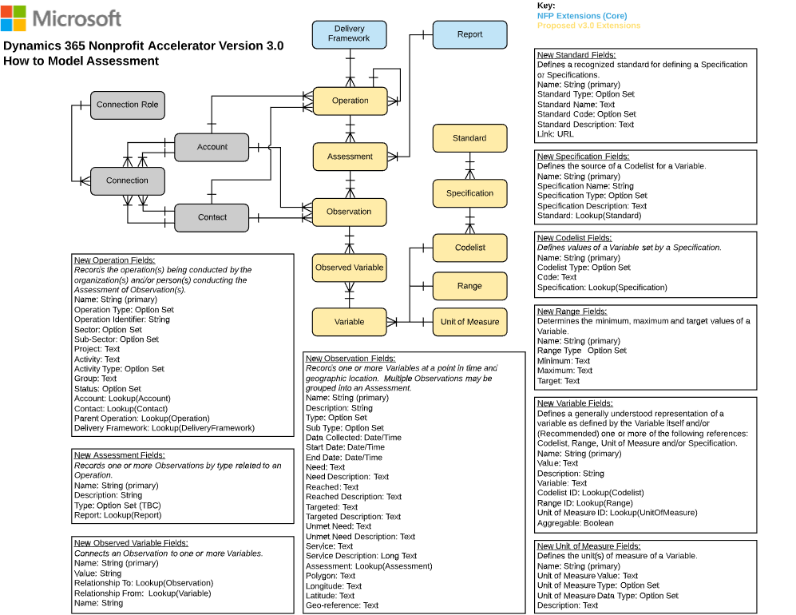

New Common Data Model for Assessment Management Fields

The following are fields related to each of the new Assessment Management tables added in this release

1. **OPERATION** (msnfp_operation):

|  |  |  |  |
| --- | --- | --- | --- |
| **Schema Name** | **Display Name** | **Type** | **Description** |
| msnfp_accountId | Account | Lookup |  |
| msnfp_accountIdName | N/A | String | N/A |
| msnfp_accountIdYomiName | N/A | String | N/A |
| msnfp_activity | Activity | String | Activity/Task of operating organization within Project. |
| msnfp_activityType | Activity Type | Picklist |  |
| msnfp_activitytypeName | N/A | Virtual | N/A |
| msnfp_contactId | Contact | Lookup |  |
| msnfp_contactIdName | N/A | String | N/A |
| msnfp_contactIdYomiName | N/A | String | N/A |
| msnfp_deliveryFrameworkId | Delivery Framework | Lookup |  |
| msnfp_deliveryFrameworkIdName | N/A | String | N/A |
| msnfp_group | Group | String |  |
| msnfp_name | Name | String | The name of the custom entity. |
| msnfp_operationId | Operation | Uniqueidentifier | Unique identifier for entity instances |
| msnfp_operationIdentifier | Operation Identifier | String | This field store an auxiliary identifier. |
| msnfp_operationStatus | Operation Status | Picklist | Status of Program/Project/Activity/Task. |
| msnfp_operationstatusName | N/A | Virtual | N/A |
| msnfp_operationType | Operation Type | Picklist | They type of Operation being conducted, completed or planned to be conducted. |
| msnfp_operationtypeName | N/A | Virtual | N/A |
| msnfp_parentOperationId | Parent Operation | Lookup |  |
| msnfp_parentOperationIdName | N/A | String | N/A |
| msnfp_project | Project | String | Program/Project name from operating organization. |
| msnfp_sectorType | Sector | Picklist | Sector. |
| msnfp_sectortypeName | N/A | Virtual | N/A |
| msnfp_subSectorType | Sub-Sector | Picklist | Sub-Sector. |
| msnfp_subsectortypeName | N/A | Virtual | N/A |
| msnfp_typeDescription | Type Description | Memo | Text description of the type of event requiring operation(s). |

1. **Assessment** (msnfp_assessment)

|  |  |  |  |
| --- | --- | --- | --- |
| **Schema Name** | **Display Name** | **Type** | **Description** |
| msnfp_assessmentId | Assessment | Uniqueidentifier | Unique identifier for entity instances |
| msnfp_description | Description | Memo | Description of the of Assessment. |
| msnfp_name | Name | String | The name of the custom entity. |
| msnfp_operationId | Operation | Lookup | Unique identifier for entity instances |
| msnfp_operationIdName | N/A | String | N/A |
| msnfp_reportId | Report | Lookup | Unique identifier for related report instances |
| msnfp_reportIdName | N/A | String | N/A |
| msnfp_type | Type | Picklist | Type of Assessment. |
| msnfp_typeDescription | Type Description | Memo | Description of the type of Observation. |
| msnfp_typeName | N/A | Virtual | N/A |

1. **OBSERVATION** (msnfp_observation)

|  |  |  |  |
| --- | --- | --- | --- |
| **Schema Name** | **Display Name** | **Type** | **Description** |
| msnfp_accountId | Account | Lookup | The unique identifier for the related account. |
| msnfp_accountIdName | N/A | String | N/A |
| msnfp_accountIdYomiName | N/A | String | N/A |
| msnfp_assessmentId | Assessment | Lookup | Unique identifier for related assessment. |
| msnfp_assessmentIdName | N/A | String | N/A |
| msnfp_classificationDescription | Classification Description | Memo |  |
| msnfp_classificationType | Classification | Picklist | The classification of the the observation. |
| msnfp_classificationtypeName | N/A | Virtual | N/A |
| msnfp_contactid | Contact | Lookup | The unique identifier for the related contact. |
| msnfp_contactidName | N/A | String | N/A |
| msnfp_contactidYomiName | N/A | String | N/A |
| msnfp_dataCollected | Data Collected | DateTime | Date the data was collected. |
| msnfp_description | Description | Memo | This contains a description. |
| msnfp_endDate | End Date | DateTime | The end date. |
| msnfp_geoReference | Geo-Reference | String | Stores the Geo-Reference for the operation. |
| msnfp_latitude | Latitude | String |  |
| msnfp_longitude | Longitude | String |  |
| msnfp_name | Name | String | The name of the custom entity. |
| msnfp_need | Need | String | Need observed. |
| msnfp_needDescription | Need Description | Memo | Description of the need observed. |
| msnfp_observationId | Observation | Uniqueidentifier | Unique identifier for entity instances |
| msnfp_polygon | Polygon | String |  |
| msnfp_reached | Reached | String | Need fulfilled by the organization. |
| msnfp_reachedDescription | Reached Description | Memo | Description of the need fulfilled by the organization. |
| msnfp_service | Service | String | the service for the operation. |
| msnfp_serviceDescription | Service Description | Memo | The description of the service. |
| msnfp_startDate | Start Date | DateTime | The start date. |
| msnfp_subType | Sub-Type | Picklist | Sub type of Observation. |
| msnfp_subtypeName | N/A | Virtual | N/A |
| msnfp_targeted | Targeted | String | Need targeted by the organization. |
| msnfp_targetedDescription | Targeted Description | Memo | Description of the need targeted but not fulfilled by the organization. |
| msnfp_type | Type | Picklist | Type of Observation. This value determines logic of relationships to Variable. Examples may include: Need, Reached, Target, Unmet Need. |
| msnfp_typeName | N/A | Virtual | N/A |
| msnfp_unmetNeed | Unmet Need | String | Need not fulfilled or targeted by the organization. |
| msnfp_unmetNeedDescription | Unmet Need Description | Memo | Description of the need not fulfilled or targeted by the organization. |

1. **Observed Variable** (msnfp_observedvariable)

|  |  |  |  |
| --- | --- | --- | --- |
| **Schema Name** | **Display Name** | **Type** | **Description** |
| msnfp_name | Name | String | The name of the custom entity. |
| msnfp_observedvariableId | Observed Variable | Uniqueidentifier | Unique identifier for entity instances |
| msnfp_relatedToObservationId | Related To Observation | Lookup | Unique identifier for the Observation related to the Variable. |
| msnfp_relatedToObservationIdName | N/A | String | N/A |
| msnfp_relatedToVariableId | Related To Variable | Lookup | Unique identifier for the Variable related to the Observation. |
| msnfp_relatedToVariableIdName | N/A | String | N/A |
| msnfp_value | Value | String | Describes the value of the observed Variable. |

1. **VARIABLE** (msnfp_variable)

|  |  |  |  |
| --- | --- | --- | --- |
| **Schema Name** | **Display Name** | **Type** | **Description** |
| msnfp_aggregable | Aggregable | Boolean | Indicates if the Value is aggregable. |
| msnfp_aggregableName | N/A | Virtual | N/A |
| msnfp_codelistId | Codelist | Lookup |  |
| msnfp_codelistIdName | N/A | String | N/A |
| msnfp_description | Description | Memo |  |
| msnfp_name | Name | String | The name of the custom entity. |
| msnfp_rangeId | Range | Lookup |  |
| msnfp_rangeIdName | N/A | String | N/A |
| msnfp_unitOfMeasureId | Unit of Measure | Lookup |  |
| msnfp_unitOfMeasureIdName | N/A | String | N/A |
| msnfp_variable | Variable | String |  |
| msnfp_variableId | Variable | Uniqueidentifier | Unique identifier for entity instances |

1. **Standard** (msnfp_standard)

|  |  |  |  |
| --- | --- | --- | --- |
| **Schema Name** | **Display Name** | **Type** | **Description** |
| msnfp_link | Link | String | URL of the Standard. |
| msnfp_name | Name | String | The name of the custom entity. |
| msnfp_standardCode | Standard Code | Picklist | Code (identifier) of the Standard. |
| msnfp_standardcodeName | N/A | Virtual | N/A |
| msnfp_standardDescription | Description | Memo | Description of the Standard. |
| msnfp_standardId | Standard | Uniqueidentifier | Unique identifier for entity instances |
| msnfp_standardType | Standard Type | Picklist | Type of Standard the is being defined for. |
| msnfp_standardtypeName | N/A | Virtual | N/A |

1. **Specification** (msnfp_specification)

|  |  |  |  |
| --- | --- | --- | --- |
| **Schema Name** | **Display Name** | **Type** | **Description** |
| msnfp_specificationDescription | Specification Description | Memo | Description of the Specification. |
| msnfp_specificationId | Specification | Uniqueidentifier | Unique identifier for entity instances |
| msnfp_specificationName | Name | String | The name of the Specification. |
| msnfp_specificationType | Specification Type | Picklist | Type of Specification. |
| msnfp_specificationtypeName | N/A | Virtual | N/A |
| msnfp_standardId | Standard | Lookup | Unique identifier for related Standard instance. |
| msnfp_standardIdName | N/A | String | N/A |

1. **Codelist** (msnfp_codelist)

|  |  |  |  |
| --- | --- | --- | --- |
| **Schema Name** | **Display Name** | **Type** | **Description** |
| msnfp_code | Code | String |  |
| msnfp_codelistId | Codelist | Uniqueidentifier | Unique identifier for entity instances |
| msnfp_codelistType | Codelist Type | Picklist | Type of codelist the vocabulary is being defined for. |
| msnfp_codelisttypeName | N/A | Virtual | N/A |
| msnfp_name | Name | String | The name of the custom entity. |
| msnfp_specificationId | Specification | Lookup | The related specification. |
| msnfp_specificationIdName | N/A | String | N/A |

1. **RAnge** (msnfp_range)

|  |  |  |  |
| --- | --- | --- | --- |
| **Schema Name** | **Display Name** | **Type** | **Description** |
| msnfp_name | Name | String | The name of the custom entity. |
| msnfp_rangeId | Range | Uniqueidentifier | Unique identifier for entity instances |
| msnfp_rangeMaximum | Maximum | String | Maximum value of the Range. |
| msnfp_rangeMinimum | Minimum | String | Minimum value of the Range. |
| msnfp_rangeTarget | Target | String | Target value of the Range. |
| msnfp_rangeType | Range Type | Picklist | Type of Range. |
| msnfp_rangetypeName | N/A | Virtual | N/A |

1. **Unit of Measure** (msnfp_unitofmeasure)

|  |  |  |  |
| --- | --- | --- | --- |
| **Schema Name** | **Display Name** | **Type** | **Description** |
| msnfp_name | Name | String | The name of the custom entity. |
| msnfp_unitOfMeasureDataType | Unit of Measure Data Type | Picklist | Data Type of Unit of Measure. |
| msnfp_unitofmeasuredatatypeName | N/A | Virtual | N/A |
| msnfp_unitOfMeasureDescription | Description | Memo | Description of the Unit of Measure. |
| msnfp_unitofmeasureId | Unit of Measure | Uniqueidentifier | Unique identifier for entity instances |
| msnfp_unitOfMeasureType | Unit of Measure Type | Picklist | Type of Unit of Measure. |
| msnfp_unitofmeasuretypeName | N/A | Virtual | N/A |
| msnfp_unitOfMeasureValue | Unit of Measure Value | String | Value of the Unit of Measure |

1. Frontline Humanitarian Logistics Data Schema

Led by Oxfam, Goal, and NetHope, the **Frontline Humanitarian Logistics** (FHL) initiative was created to reduce the time and cost involved in implementing IT solutions within humanitarian supply chains and encourage interoperability of data, service delivery, and systems across the sector.

NetHope led a cross-sector group of 24 collaborating organizations including leading technology vendors, academics, and nonprofit organization subject matter experts which resulted in the development of a [Frontline Humanitarian Logistics Data Standard](https://solutionscenter.nethope.org/resources/initiatives/frontline-humanitarian-logistics) With this release, we are aligning item requests, types, and groups to that standard to further ease collaboration between nonprofits responding to the same crisis to ensure faster delivery of needed services.

The Frontline Humanitarian Logistics Common Data Model for Nonprofits data extensions focus on data schema that can provide donors with exact information about what items are in demand, where the supplies they helped fund with their donations were delivered, and the subsequent impact made to beneficiaries. The ability for nonprofit organizations to report back on donor impact is critical at this time of increased demand for transparency.

The Nonprofit Accelerator v3.0 release enables this through the addition of five new frontline humanitarian logistics-oriented tables and related fields.

Personas Served:

* **Humanitarian Logistician**: these individuals work (often under challenging conditions) to determine and deliver on the following question: Who needs what, where, why and when? They often work with multiple nonprofit organizations, government agencies, and corporations in a coordinating role to perform tasks under tight timelines where lives can be saved or lost based on their performance and collaboration.
* **Donor Services**: these individuals work with individual, institutional, corporate and government partners to source goods and services that are either stored until required in a humanitarian logistics event or on demand. They use tools and technology to track and report on the status of the goods and services themselves, as well as related information including but not limited to donor requirements and compliance.

Use Cases covered in this release:

We extended the Common Data Model for Nonprofits data schema to generally handle the following use cases common to most nonprofits managing frontline humanitarian logistics:

| **#** | **As a…<type of user>** | **I want to…<some goal>** | **…so that <some reason>** |
| --- | --- | --- | --- |
| 1 | Humanitarian Logistician | Create and maintain requests for goods and/or services based on Assessments and Programs | I can source goods and/or services to meet humanitarian needs |
| 2 | Humanitarian Logistician | Associate requests for goods and/or services to Assessments and Programs | I can connect requests to operations and/or delivery initiatives for fulfillment |
| 3 | Humanitarian Logistician | Create and manage types of items | I can accurately describe and/or source goods and/or services as requested |
| 4 | Humanitarian Logistician | Create and manage groups of items | I can efficiently manage goods and/or services in logical groups or based on bundling |
| 5 | Donor Services | Accept items from donors | I can track the goods and/or services offered by donors |
| 6 | Donor Services | Report to donors on how their donations are utilized | I can ensure our operations are transparent to donors and that a donor’s wishes are respected |
| 7 | Donor Services | Easily assign case access privileges for my case managers | I can ensure case data is appropriately safeguarded |

Key Concepts and Tables Leveraged for Frontline Humanitarian Logistics

The following are the dependent CDM for Nonprofits tables leveraged by the frontline humanitarian logistics data schema

| # | Category | Requirement |
| --- | --- | --- |
| 1 | Operation | Records one or more Variables at a point in time and geographic location. Multiple Observations may be grouped into an Assessment. |
| 2 | Assessment | Records one or more Observations by type related to an Operation. |
| 3 | Address | Address and shipping information. Used to store additional addresses for an account or contact. |
| 4 | Designation Plan | A line item attached to a Pledge, Payment Schedule, or Campaign indicating how associated payments should be designated. |
| 5 | Award | An Award represents the total amount of funding that has been agreed to be awarded to an individual or institution. |
| 6 | Payment Asset | Payment Asset represents the asset or assets associated with specific types of payments including, but not limited to, in-kind gifts, stocks and securities.. |
| 7 | Item Request | Defines a request for an item or items of varying types and quantities for a location and date. |
| 8 | Item Request Line | Defines a request for a quantity of a single type of item as defined in Item Type. |
| 9 | Item Type | Defines a type of item or a type of item group. |
| 10 | Item | Defines an individual article or unit that may be part of a group of articles or units required for a program activity or donated by a donor. |
| 11 | Item Group | Defines a group of items that are logically handled together as a unit such as a kit. |

How to Model Frontline Humanitarian Logistics

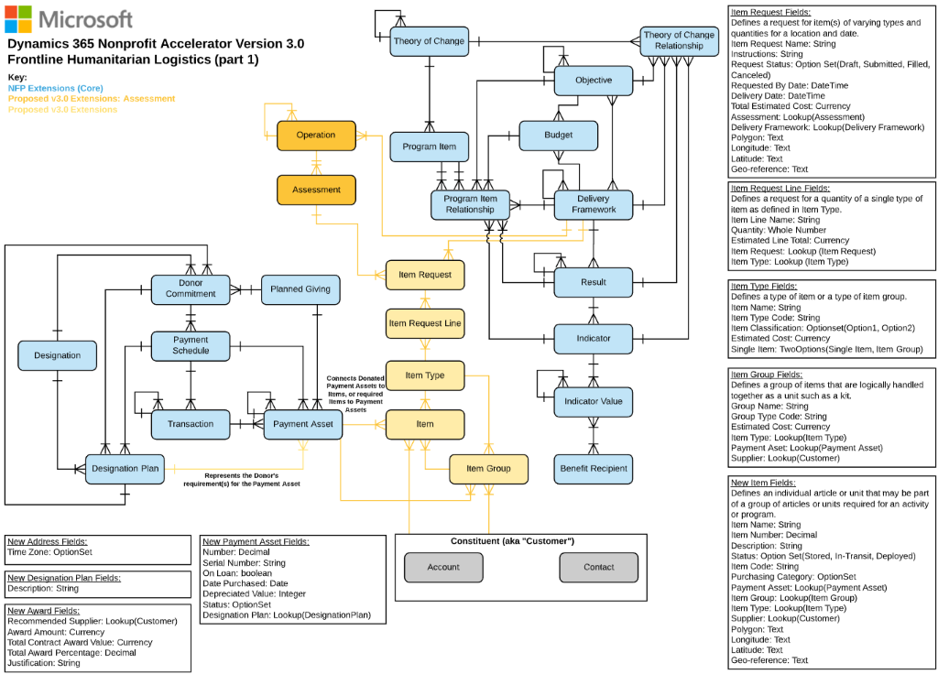

New Common Data Model for Frontline Humanitarian Logistics Fields

The following are fields related to each of the new Frontline Humanitarian Logistics tables added in this release

1. **ITEM** (msnfp_item)

|  |  |  |  |
| --- | --- | --- | --- |
| **Schema Name** | **Display Name** | **Type** | **Description** |
| msnfp_description | Description | Memo | The description of the item. |
| msnfp_georeference | Geo-reference | String | The Geo-reference of the item. |
| msnfp_itemCode | Item Code | String | The code for the item. |
| msnfp_itemGroupId | Item Group | Lookup | The unique identifier for the related Item Group. |
| msnfp_itemGroupIdName | N/A | String | N/A |
| msnfp_itemId | Item | Uniqueidentifier | Unique identifier for entity instances |
| msnfp_itemName | Item Name | String | The name of the custom entity. |
| msnfp_itemNumber | Item Number | Decimal | The number used to identify the item. |
| msnfp_itemStatus | Item Status | Picklist | The status of the item. |
| msnfp_itemstatusName | N/A | Virtual | N/A |
| msnfp_itemTypeId | Item Type | Lookup | The unique identifier for the related item type. |
| msnfp_itemTypeIdName | N/A | String | N/A |
| msnfp_latitude | Latitude | String | The latitude of the item. |
| msnfp_longitude | Longitude | String | The longitude of the item. |
| msnfp_paymentAsssetId | Payment Assset | Lookup | The unique identifier for the related Payment Asset. |
| msnfp_paymentAsssetIdName | N/A | String | N/A |
| msnfp_polygon | Polygon | String | The geolocational polygon of the item. |
| msnfp_purchasingCategoryType | Purchasing Category | Picklist | The type of purchasing category. |
| msnfp_purchasingcategorytypeName | N/A | Virtual | N/A |
| msnfp_supplierId | Supplier | Customer | The unique identifier for the related supplier. |
| msnfp_supplierIdName | N/A | String | N/A |
| msnfp_supplierIdType | N/A | EntityName | N/A |
| msnfp_supplierIdYomiName | N/A | String | N/A |

1. **Item Group** (msnfp_itemgroup)

|  |  |  |  |
| --- | --- | --- | --- |
| **Schema Name** | **Display Name** | **Type** | **Description** |
| msnfp_estimatedCost | Estimated Cost | Money | The estimated cost of the item group. |
| msnfp_estimatedcost_Base | Estimated Cost (Base) | Money | Value of the Estimated Cost in base currency. |
| msnfp_groupName | Group Name | String | The name of the custom entity. |
| msnfp_groupTypeCode | Group Type Code | String | The code used to identify a group of items. |
| msnfp_itemgroupId | Item Group | Uniqueidentifier | Unique identifier for entity instances |
| msnfp_itemTypeId | Item Type | Lookup | The unique identifier for the related item type. |
| msnfp_itemTypeIdName | N/A | String | N/A |
| msnfp_paymentAssetId | Payment Asset | Lookup | The unique identifier for the related payment asset. |
| msnfp_paymentAssetIdName | N/A | String | N/A |
| msnfp_supplierId | Supplier | Customer | The unique identifier for the related contact or account. |
| msnfp_supplierIdName | N/A | String | N/A |
| msnfp_supplierIdType | N/A | EntityName | N/A |
| msnfp_supplierIdYomiName | N/A | String | N/A |

1. **Item Request** (msnfp_itemrequest)

|  |  |  |  |
| --- | --- | --- | --- |
| **Schema Name** | **Display Name** | **Type** | **Description** |
| msnfp_assessmentId | Assessment | Lookup | The unique identifier for the related assessment. |
| msnfp_assessmentIdName | N/A | String | N/A |
| msnfp_deliveryDate | Delivery Date | DateTime | The date for delivery of the item request. |
| msnfp_deliveryFrameworkId | Delivery Framework | Lookup | The unique identifier for the related delivery framework. |
| msnfp_deliveryFrameworkIdName | N/A | String | N/A |
| msnfp_georeference | Geo-reference | String | The geo reference for the item request. |
| msnfp_instructions | Instructions | Memo | Provide instructions for the request. |
| msnfp_itemrequestId | Item Request | Uniqueidentifier | Unique identifier for entity instances |
| msnfp_itemRequestName | Item Request Name | String | The name of the custom entity. |
| msnfp_latitude | Latitude | String | The latitude for the item request. |
| msnfp_longitude | Longitude | String | The longitude for the item request. |
| msnfp_polygon | Polygon | String | The geolocational polygon for the item request. |
| msnfp_requestByDate | Request By Date | DateTime | The desired date for the item request to be filled by. |
| msnfp_requestStatus | Request Status | Picklist | The status of the item request. |
| msnfp_requeststatusName | N/A | Virtual | N/A |
| msnfp_totalEstimatedCost | Total Estimated Cost | Money | The estimated cost of the entire item request. |
| msnfp_totalestimatedcost_Base | Total Estimated Cost (Base) | Money | Value of the Total Estimated Cost in base currency. |

1. **Item request Line** (msnfp_itemrequestline)

|  |  |  |  |
| --- | --- | --- | --- |
| **Schema Name** | **Display Name** | **Type** | **Description** |
| msnfp_estimatedLineTotal | Estimated Line Total | Money | The estimated cost of the item request line. |
| msnfp_estimatedlinetotal_Base | Estimated Line Total (Base) | Money | Value of the Estimated Line Total in base currency. |
| msnfp_itemLineName | Item Line Name | String | The name of the custom entity. |
| msnfp_itemRequestId | Item Request | Lookup | The unique identifier for the related Item Request. |
| msnfp_itemRequestIdName | N/A | String | N/A |
| msnfp_itemrequestlineId | Item Request Line | Uniqueidentifier | Unique identifier for entity instances |
| msnfp_itemTypeId | Item Type | Lookup | The unique identifier for the related Item Type. |
| msnfp_itemTypeIdName | N/A | String | N/A |
| msnfp_quantity | Quantity | Integer | The number of item types being requested. |

1. **Item Type** (msnfp_itemtype)

|  |  |  |  |
| --- | --- | --- | --- |
| **Schema Name** | **Display Name** | **Type** | **Description** |
| msnfp_estimatedCost | Estimated Cost | Money | The estimated cost of the item type. |
| msnfp_estimatedcost_Base | Estimated Cost (Base) | Money | Value of the Estimated Cost in base currency. |
| msnfp_itemClassification | Item Classification | Picklist | The classification or category of the item type. |
| msnfp_itemclassificationName | N/A | Virtual | N/A |
| msnfp_itemName | Item Name | String | The name of the custom entity. |
| msnfp_itemTypeCode | Item Type Code | String | The code used to identify the item type. |
| msnfp_itemtypeId | Item Type | Uniqueidentifier | Unique identifier for entity instances |
| msnfp_singleItem | Single Item | Boolean | Denotes whether item type is a single item or item group. |
| msnfp_singleitemName | N/A | Virtual | N/A |

1. **Address** (msnfp_address)

|  |  |  |  |
| --- | --- | --- | --- |
| **Schema Name** | **Display Name** | **Type** | **Description** |
| msnfp_description | Description | Memo | The description of the designation plan. |

1. **Award** (msnfp_award)

|  |  |  |  |
| --- | --- | --- | --- |
| **Schema Name** | **Display Name** | **Type** | **Description** |
| msnfp_awardAmount | Award Amount | Money | The award amount. |
| msnfp_justification | Justification | Memo | the justification for the award. |
| msnfp_recommendedSupplierId | Recommended Supplier | Customer | The unique identifier for the recommended supplier for the award. |
| msnfp_recommendedSupplierIdName | N/A | String | N/A |
| msnfp_recommendedSupplierIdType | N/A | EntityName | N/A |
| msnfp_recommendedSupplierIdYomiName | N/A | String | N/A |
| msnfp_totalAwardPercentage | Total Award Percentage | Decimal | The total award percentage for the award. |
| msnfp_totalContractAwardValue | Total Contract Award Value | Money | The total award value for the contract. |
| msnfp_totalcontractawardvalue_Base | Total Contract Award Value (Base) | Money | Value of the Total Contract Award Value in base currency. |

1. **Payment Asset** (msnfp_paymentasset)

|  |  |  |  |
| --- | --- | --- | --- |
| **Schema Name** | **Display Name** | **Type** | **Description** |
| msnfp_datePurchased | Date Purchased | DateTime | The date purchased for the payment asset. |
| msnfp_depreciatedValue | Depreciated Value | Integer | The depreciated value for the payment asset. |
| msnfp_designationPlanId | Designation Plan | Lookup | The designation plan for the payment asset. |
| msnfp_designationPlanIdName | N/A | String | N/A |
| msnfp_number | Number | Decimal | The number for the payment asset. |
| msnfp_onLoan | On Loan | Boolean | Determines whether the payment asset is on loan. |
| msnfp_onloanName | N/A | Virtual | N/A |
| msnfp_serialNumber | Serial Number | String | The serial number for the payment asset. |
| msnfp_status | Status | Picklist | The status for the payment asset. |
| msnfp_statusName | N/A | Virtual | N/A |

1. Frontline Humanitarian Logistics Mapping Guide

Led by Oxfam, Goal, and NetHope, the Frontline Humanitarian Logistics (FHL) initiative was created to reduce the time and cost involved in implementing IT solutions within humanitarian supply chains and encourage interoperability of systems across the sector.The [FHL Data Standard](https://solutionscenter.nethope.org/resources/initiatives/frontline-humanitarian-logistics) project brought together experience from nonprofits, some of the world’s biggest technology companies with expertise in supply chain management, technology consultants and academics with a focus on humanitarian logistics,” and resulted in the publishing of the inaugural version (v1.0.2 - September 2020) of the [Frontline Humanitarian Logistics Data Standard](https://solutionscenter.nethope.org/resources/initiatives/frontline-humanitarian-logistics).

The **Frontline Humanitarian Logistics Mapping Guide** provides guidance to nonprofits and partners on how to put the NetHope and nonprofit sector-developed [Frontline Humanitarian Logistics Data Standard](https://solutionscenter.nethope.org/resources/initiatives/frontline-humanitarian-logistics) into practice. In conjunction with key partners, Microsoft has mapped the FHL Data Standard to the Common Data Model for Nonprofits as part of this release to support organizations who align to these valuable industry standards.

1. Nonprofit Accelerator Architectural Enhancements

*Scale for growth and deliver simplicity*

As the Common Data Model for Nonprofits and Nonprofit Accelerator evolve, we continue to scale these resources for maximum value and use by nonprofits of all sizes and mission types. In the v3.0 release, we reduced the data schema packages and removed all Dynamics dependencies. The new architecture gives developers the power to rapidly launch Power Platform applications, end-to-end Dynamics solutions, and cross-cloud solutions that leverage Azure and Modern Work technologies.

As a part of this streamlined architecture, we have rebuilt IATI without a Dynamics dependency. We are unable to support updates from the previous Dynamics dependent, IATI package to the new v3.0 IATI package. There is no change in functionality between the two packages. Please use the most recent IATI v3.0 package when looking to build on this data schema.

We also stopped releasing the Nonprofit Accelerator CE and Nonprofit Sales packages. They are still available on GitHub in previous releases, but we will not continue to maintain or support these packages.

Our goals in scaling and streamlining the CDM for Nonprofits and Nonprofit Accelerator architecture include:

1. Providing partners and nonprofit developers with as much flexibility as possible to extend and build from the architecture, whether in the form of lightweight Power Platform applications, end-to-end Dynamics solutions, and/or cross-cloud solutions that leverage Azure and Modern Work technologies.
2. Serve small, medium, large, and enterprise nonprofits with schema and solutions purpose-built to fuel their fundraising, program, operations, finance, IT, and analyst staff forward.
3. Reduce the overall footprint of the Accelerator architecture to aid with seamless upgrades, forward and backward compatibility and extensibility.
4. Serve as a standard across all Microsoft Industry Accelerators for continue to add value to our Nonprofit Accelerator at a rapid pace.

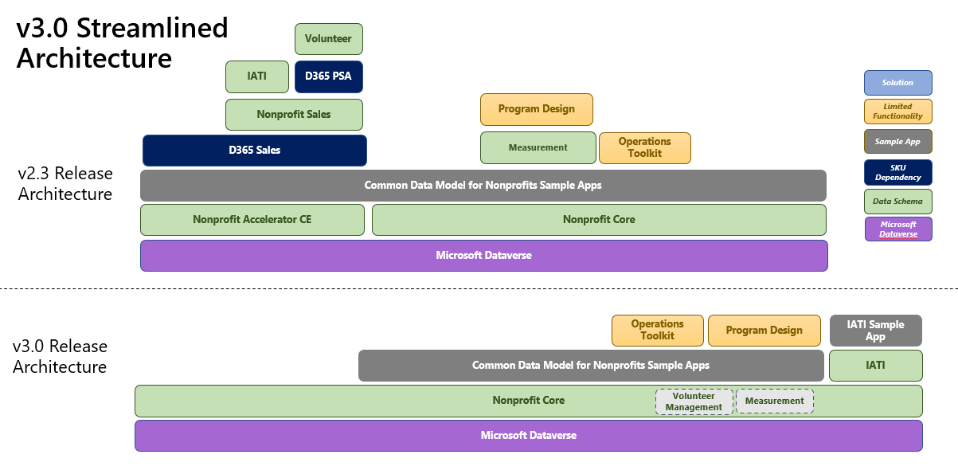

Release Assets (Documentation, Administrative Guides, Sample Data, and Solutions)

This release includes the following assets to aid partners and nonprofits as they adopt and extend these capabilities. All release documentation is available on GitHub here:  
<https://github.com/microsoft/Industry-Accelerator-Nonprofit/releases>

| **Name** | **Asset Type** | **Description** |
| --- | --- | --- |
| NonprofitAnchor_managed.zip | Solution | Base Solution Layer - Managed |
| NonprofitCore_3_0_3_0_managed.zip | Solution | Core Solution Layer - Managed |
| NonprofitIATI_3_0_3_0_managed.zip | Solution | IATI Solution Layer - Managed |
| CommonDataModelNonprofitSampleApps_2_3_3_0_managed.zip | Solution | This extension contains the sample applications that compliment and showcase Nonprofit Core functionality. |
| CommonDataModelNonprofitSampleAppsBase_2_3_3_0_managed.zip | Solution | A supporting layer to assist with moving Sample Apps during the upgrade process. |
| NonprofitIATISampleApps_3_0_3_0_managed.zip | Solution | This extension contains the sample applications that compliment and showcase Nonprofit IATI functionality. |
| ProgramDesign-v3_0_3_0.zip | Solution | Program Design app |
| NonprofitAccelerator_CDS_ProgramDesign_Flow_msnfp_CreateSummaryDocument_Template.docx | Solution | Template to set up documents in Program Design app |
| NonprofitOperationsToolkit_1_1_3_5_managed.zip | Solution | Nonprofit Operations Toolkit Layer - Managed |
| NonprofitOperationsToolkitFlows_1_1_3_5_managed.zip | Solution | Nonprofit Operations Toolkit Flows – Managed imported after NonprofitOperationsToolkit_1_1_3_5_managed.zip |
| NFP.Accelerator.3.0.-.Package.Deployer.Solution.zip | Solution | This zip file contains the components that can be used by administrators to install the Nonprofit Accelerator in conjunction with the Microsoft Package Deployer tool. |
| NFP.Accelerator.3.0.-.IATI.Codelist.Sync.zip | Solution |  |
| NFP.Accelerator.3.0.-.Measurement.SDG.Icons.zip | Solution | Icons used in the CDS to highlight the SDG goals, indicators, and targets |
| NonprofitAccelerator_NonprofitCore_DataPackage_3_0_3_0.zip | Sample Data | Sample data package supporting the Core solution layer |
| NonprofitAccelerator_Nonprofit_IATI_DataPackage_3_0_3_0.zip | Sample Data | Sample data package supporting the IATI solution layer |
| NonprofitOperationsToolkit_DataPackage_1_1_3_5.zip | Sample Data | Sample data package supporting the Nonprofit Operations Toolkit solution layer |
| NFP.Accelerator.3.0.-CDM.to.Frontline.Humanitarian.Logistics.Mapping.Guide.docx | Reference | Frontline Humanitarian Logistics Mapping Guide |
| NFP.Accelerator.3.0.-.Core.Metadata.Reference.xlsx | Reference | Core layer entity and attribute reference documentation |
| NFP.Accelerator.3.0.-.IATI.Metadata.Reference.xls | Reference | IATI layer entity and attribute reference documentation |
| NFP.Accelerator.3.0.-.Release.Notes.docx | Reference | Release Notes with details about added tables and fields |
| NFP.Accelerator.3.0.-.Admin.Guide.docx | Reference | Solution requirements and detailed description of Nonprofit Accelerator power app solutions |
| NFP.Accelerator.3.0.-.Demo.Guide.docx | Reference | Walkthrough of the Nonprofit Accelerator Scenarios |
| NFP.Accelerator.3.0.-.Deployment.Guide.docx | Reference | Overview of deployment process |
| NFP.Accelerator.3.0.-.Nonprofit.ERD.and.How-to.Guide.docx | Reference | Nonprofit ERD and How-to Maps |
| NonprofitsOperationsToolkit_AdminGuide_1_1_3_5.docx | Reference | Nonprofit Operations Toolkit Admin Guide with scenario walk throughs |
| NonprofitOperationsToolkit_DemoGuide_1_1_3_5.pptx | Reference | Nonprofit Operations Toolkit Demo Guide |
| NFP Accelerator 3.0 – ERDs.zip | Reference | PDFs of the CDM ERDs |