CoAP-Protokoll Test Purposes

Inhaltsverzeichnis

1. Einführung 2

2. Das CoAP-Protokoll 2

2.1 Rollen 2

2.1.1 Server 2

2.1.2 Client 2

2.1.3 Proxy 2

3. Test Suite Structure 3

3.1 Server as SUT 3

3.1.1 Test configurations 3

3.2 Client as SUT 3

4. Test Purposes for CoAP Server 3

4.1 Mandatory Message Data Fields 3

4.1.1 Regular and illegal/corrupted data 3

4.1.1.1 TP_CoAP_Server_001 3

4.1.1.2 TP_CoAP_Server_GET_001 4

4.1.1.3 TP_CoAP_Server_GET_002 4

4.1.1.4 TP_CoAP_Server_GET_003 4

4.1.1.5 TP_CoAP_Server_GET_004 (TODO) 5

4.1.1.6 TP_CoAP_Server_GET_005 5

4.1.1.7 TP_CoAP_Server_POST_001 5

4.1.1.8 TP_CoAP_Server_POST_002 6

4.1.1.9 TP_CoAP_Server_POST_003 6

4.1.1.10 TP_CoAP_Server_POST_004 (TODO) 7

4.1.1.11 TP_CoAP_Server_POST_005 7

4.1.1.12 TP_CoAP_Server_PUT_001 8

4.1.1.13 TP_CoAP_Server_PUT_002 8

4.1.1.14 TP_CoAP_Server_DELETE_001 9

4.1.1.15 TP_CoAP_Server_DELETE_002 9

# Einführung

Das vorliegende Dokument …

# Das CoAP-Protokoll

Im vorliegenden Dokument wird das CoAP-Protokoll in der Version [[RFC 7252]](https://tools.ietf.org/html/rfc7252) verwendet. Die Terminologie wird daher aus der genannten Version verwendet, um die Konsistenz zu wahren.

## Rollen

Im CoAP-Protokoll teilnehmende Entitäten werden als Endpunkte bezeichnet, die auf einem Knoten „leben“. Dabei agieren Endpunkte als Sender (Quelle) und Empfänger (Ziel). In Abbildung 1 sind schematisch die Rollen in einer CoAP-Architektur dargestellt.

### Server

Ein CoAP-Server ist allgemein ein Endpunkt, der Ziel einer Anfrage und der Ursprung einer Antwort ist. Zumeist ist ein CoAP-Server mit Dingen verbunden oder einer eingeschränkten Umgebung (eine Menge von Dingen).

### Client

Ein CoAP-Client ist allgemein ein Endpunkt, der Ursprung einer Anfrage und das Ziel einer Antwort ist.

### Proxy

Ein Proxy hält die Rolle eines Servers und eines Clients inne. Er dient als Mittelsmann; beispielsweise zwischen verschiedenen Netzwerk, in denen unterschiedliche Protokolle für die Kommunikation eingesetzt werden.

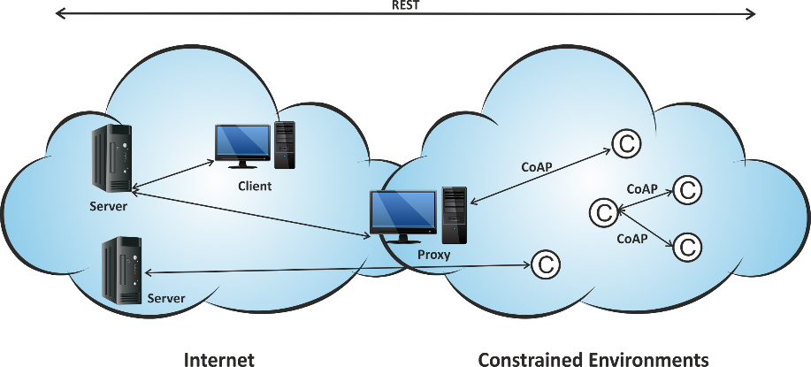

Abbildung 1: Schematische CoAP-Architektur mit den Rollen Proxy, Server und Client.

# Test Suite Structure

## Server as SUT

1. All mandatory message data fields
   1. Support all defined method codes and understand regular and illegal or corrupted data along with them
2. Protocol features
   1. General
      1. Block transfer
      2. Piggybacked responses
      3. Message Types (ACK, CON, NON-con, ReSeT)
   2. Options
      1. Max-Age
      2. Token option
      3. Several URI-path options
      4. Several URI-query options
   3. Lossy context
   4. Discovery service
   5. Error handling

## Test configurations

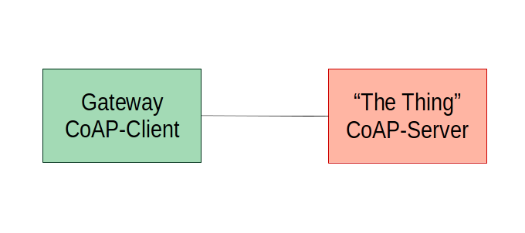

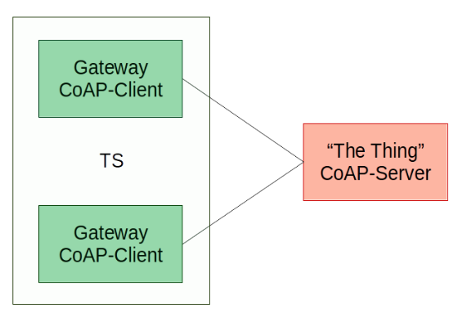

## Client as SUT

### Test configuration

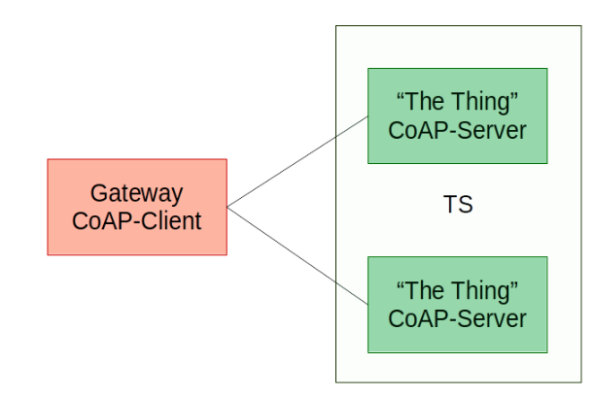

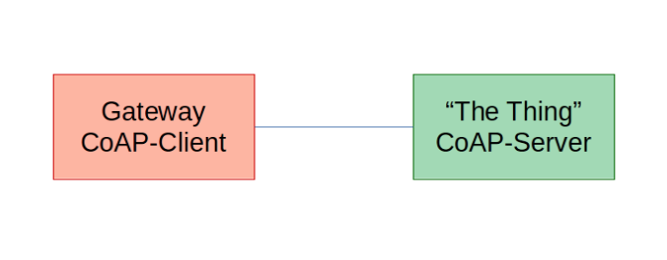

# Test Purposes for CoAP Server

## Mandatory Message Data Fields

### Regular and illegal/corrupted data

### TP_CoAP_Server_001

|  |  |
| --- | --- |
| **TP-ID** | TP_CoAP_Server_001 |
| **Selection** | PIC_Server |
| **Summary** | The IUT is responding on a RESET message. |
| **Reference** | [RFC7252#section4.2](https://tools.ietf.org/html/rfc7252#section-4.2) |
| **Initial condition** | none |
| **Test purpose** | |
| Ensure that the IUT  **on receipt** of an **EMPTY** message  containing msg_type := 0 (CONfirmable)  containing code := 0.00  **sends** a **RESPONSE** message  containing msg_type := 3 (ReSeT) | |
| **Comments** | |

### TP_CoAP_Server_GET_001

|  |  |
| --- | --- |
| **TP-ID** | TP_CoAP_Server_GET_001 |
| **Selection** | PIC_Server |
| **Summary** | The IUT is responding with code 2.05 on a GET request. |
| **Reference** | [RFC7252#section-5.8.1](https://tools.ietf.org/html/rfc7252#section-5.8.1) |
| **Initial condition** | The IUT must provide a resource named Simple_Resource. |
| **Test purpose** | |
| Ensure that the IUT  **on receipt** of a **GET** message on the resource **Simple_Resource**  containing msg_type := 0 (CONfirmable)  and code := 0.01  and option uri_path := “Simple_Resource”  **sends** a **RESPONSE** message  containing msg_type := 2 (ACKnowledgement)  and code := 2.05 | |
| **Comments** | |

### TP_CoAP_Server_GET_002

|  |  |
| --- | --- |
| **TP-ID** | TP_CoAP_Server_GET_002 |
| **Selection** | PIC_Server |
| **Summary** | The IUT is responding with code 2.05 on a GET request. |
| **Reference** | [RFC7252#section-5.8.1](https://tools.ietf.org/html/rfc7252#section-5.8.1) |
| **Initial condition** | The IUT must provide a resource Simple_Resource/New_Resource. |
| **Test purpose** | |
| Ensure that the IUT  **on receipt** of a **GET** message on the resource **Simple_Resource**  containing msg_type := 0 (CONfirmable)  and code := 0.01  and option uri_path := “Simple_Resource”  and option uri_path := “New_Resource”  **sends** a **RESPONSE** message  containing msg_type := 2 (ACKnowledgement)  and code := 2.05 | |
| **Comments** | |

### TP_CoAP_Server_GET_003

|  |  |
| --- | --- |
| **TP-ID** | TP_CoAP_Server_GET_003 |
| **Selection** | PIC_Server |
| **Summary** | The IUT is responding with code 4.05 on a GET request. |
| **Reference** | [RFC7252#section-5.8.1](https://tools.ietf.org/html/rfc7252#section-5.8.1) |
| **Initial condition** | The IUT must provide a resource Simple_Resource and must not implement the GET operation. |
| **Test purpose** | |
| Ensure that the IUT  **on receipt** of a **GET** message on the resource **Simple_Resource**  containing msg_type := 0 (CONfirmable)  and code := 0.01  and option uri_path := “Simple_Resource”  **sends** a **RESPONSE** message  containing msg_type := 2 (ACKnowledgement)  and code := 4.05 | |
| **Comments** | |

### TP_CoAP_Server_GET_004 (TODO)

|  |  |
| --- | --- |
| **TP-ID** | TP_CoAP_Server_GET_004 |
| **Selection** | PIC_Server |
| **Summary** | The IUT is responding with code 2.03 on a GET request. |
| **Reference** | [RFC7252#section-5.8.1](https://tools.ietf.org/html/rfc7252#section-5.8.1) |
| **Initial condition** | The IUT must provide a resource Simple_Resource |
| **Test purpose** | |
| TODO | |
| **Comments** | |
| Ich habe noch nicht herausgefunden, wann der ResponseCode auf eine GET-Anfrage nicht 2.05 (Content) sondern 2.03 (Valid) benutzt wird. | |

### TP_CoAP_Server_GET_005

|  |  |
| --- | --- |
| **TP-ID** | TP_CoAP_Server_GET_005 |
| **Selection** | PIC_Server |
| **Summary** | The IUT is responding with code 4.04 on a GET request. |
| **Reference** | [RFC7252#section-5.8.1](https://tools.ietf.org/html/rfc7252#section-5.8.1) |
| **Initial condition** | The IUT must not provide a resource named Simple_Resource. |
| **Test purpose** | |
| Ensure that the IUT  **on receipt** of a **GET** message on the not existing resource **Simple_Resource**  containing msg_type := 0 (CONfirmable)  and code := 0.01  and option uri_path := “Simple_Resource”  **sends** a **RESPONSE** message  containing msg_type := 2 (ACKnowledgement)  and code := 4.04 | |
| **Comments** | |

### TP_CoAP_Server_POST_001

|  |  |
| --- | --- |
| **TP-ID** | TP_CoAP_Server_POST_001 |
| **Selection** | PIC_Server |
| **Summary** | The IUT is responding with code 2.01 on a POST request. |
| **Reference** | [RFC7252#section-5.8.2](https://tools.ietf.org/html/rfc7252#section-5.8.2) |
| **Initial condition** | The IUT must provide a resource Storage_Resource. |
| **Test purpose** | |
| Ensure that the IUT  **on receipt** of a **POST** message on the resource **Storage_Resource**  containing msg_type := 0 (CONfirmable)  and code := 0.02  and option uri_path := “Storage_Resource”  and payload := 116 145 167 061 057 116 145 167 062  **sends** a **RESPONSE** message  containing msg_type := 2 (ACKnowledgement)  and code := 2.01  and Location-Path := New1  and Location-Path := New2 | |
| **Comments** | |
| Add two new resources named New1 and New2. | |

### TP_CoAP_Server_POST_002

|  |  |
| --- | --- |
| **TP-ID** | TP_CoAP_Server_POST_002 |
| **Selection** | PIC_Server |
| **Summary** | The IUT is responding with code 2.04 on a POST request. |
| **Reference** | [RFC7252#section-5.8.2](https://tools.ietf.org/html/rfc7252#section-5.8.2) |
| **Initial condition** | The IUT must provide a resource Storage_Resource/New1/New2. |
| **Test purpose** | |
| Ensure that the IUT  **on receipt** of a **POST** message on the resource **Storage_Resource/New1/New2**  containing msg_type := 0 (CONfirmable)  and code := 0.02  and option uri_path := “Storage_Resource”  and option uri_path := “New1”  and option uri_path := “New2”  and payload := 116 145 167 061 057 116 145 167 062  **sends** a **RESPONSE** message  containing msg_type := 2 (ACKnowledgement)  and code := 2.04  and Location-Path := New1  and Location-Path := New2 | |
| **Comments** | |
| Try to add two new resources named New1 and New2 which already exist. | |

### TP_CoAP_Server_POST_003

|  |  |
| --- | --- |
| **TP-ID** | TP_CoAP_Server_POST_003 |
| **Selection** | PIC_Server |
| **Summary** | The IUT is responding with code 2.04 on a POST request. |
| **Reference** | [RFC7252#section-5.8.2](https://tools.ietf.org/html/rfc7252#section-5.8.2) |
| **Initial condition** | The IUT must provide a resource Storage_Resource/New1/New2. |
| **Test purpose** | |
| Ensure that the IUT  **on receipt** of a **POST** message on the resource **Storage_Resource/New1/New2**  containing msg_type := 0 (CONfirmable)  and code := 0.02  and option uri_path := “Storage_Resource”  and option uri_path := “New1”  and option uri_path := “New1a”  and payload := 116 145 167 061 057 116 145 167 061 141  **sends** a **RESPONSE** message  containing msg_type := 2 (ACKnowledgement)  and code := 2.04  and Location-Path := New1  and Location-Path := New1a | |
| **Comments** | |
| Change resource Storage_Resource/New1/New2 to Storage_Resource/New1/New1a. | |

### TP_CoAP_Server_POST_004 (TODO)

|  |  |
| --- | --- |
| **TP-ID** | TP_CoAP_Server_POST_004 |
| **Selection** | PIC_Server |
| **Summary** | The IUT is responding with code 2.02 on a POST request. |
| **Reference** | [RFC7252#section-5.8.2](https://tools.ietf.org/html/rfc7252#section-5.8.2) |
| **Initial condition** | The IUT must provide a resource Storage_Resource/New1/New2. |
| **Test purpose** | |
| TODO | |
| **Comments** | |
| Ich habe noch nicht herausgefunden, wie man eine Resource mit der POST-Operation löschen kann. | |

### TP_CoAP_Server_POST_005

|  |  |
| --- | --- |
| **TP-ID** | TP_CoAP_Server_POST_005 |
| **Selection** | PIC_Server |
| **Summary** | The IUT is responding with code 4.05 on a POST request. |
| **Reference** | [RFC7252#section-5.8.2](https://tools.ietf.org/html/rfc7252#section-5.8.2) |
| **Initial condition** | The IUT must provide a resource Simple_Resource and must not implement the POST operation. |
| **Test purpose** | |
| Ensure that the IUT  **on receipt** of a **POST** message on the resource **Simple_Resource**  containing msg_type := 0 (CONfirmable)  and code := 0.02  and option uri_path := “Simple_Resource”  **sends** a **RESPONSE** message  containing msg_type := 2 (ACKnowledgement)  and code := 4.05 | |
| **Comments** | |

### TP_CoAP_Server_PUT_001

|  |  |
| --- | --- |
| **TP-ID** | TP_CoAP_Server_PUT_001 |
| **Selection** | PIC_Server |
| **Summary** | The IUT is responding with code 2.01 on a PUT request. |
| **Reference** | [RFC7252#section-5.8.3](https://tools.ietf.org/html/rfc7252#section-5.8.3) |
| **Initial condition** | The IUT must provide a resource Storage_Resource. |
| **Test purpose** | |
| Ensure that the IUT  **on receipt** of a **PUT** message on the resource **Storage_Resource**  containing msg_type := 0 (CONfirmable)  and code := 0.03  and option uri_path := “Storage_Resource”  and payload := 116 145 167 061 057  **sends** a **RESPONSE** message  containing msg_type := 2 (ACKnowledgement)  and code := 2.01  and Location-Path := New1 | |
| **Comments** | |
| Add a new resources named New1. | |

### TP_CoAP_Server_PUT_002

|  |  |
| --- | --- |
| **TP-ID** | TP_CoAP_Server_PUT_002 |
| **Selection** | PIC_Server |
| **Summary** | The IUT is responding with code 2.04 on a PUT request. |
| **Reference** | [RFC7252#section-5.8.3](https://tools.ietf.org/html/rfc7252#section-5.8.3) |
| **Initial condition** | The IUT must provide a resource Storage_Resource/New1 |
| **Test purpose** | |
| Ensure that the IUT  **on receipt** of a **PUT** message on the resource **Storage_Resource**  containing msg_type := 0 (CONfirmable)  and code := 0.03  and option uri_path := “Storage_Resource”  and option uri_path := “New1”  **sends** a **RESPONSE** message  containing msg_type := 2 (ACKnowledgement)  and code := 2.04  and Location-Path := New1 | |
| **Comments** | |
| Try to add resource New1 although it already exists. | |

### TP_CoAP_Server_DELETE_001

|  |  |
| --- | --- |
| **TP-ID** | TP_CoAP_Server_DELETE_001 |
| **Selection** | PIC_Server |
| **Summary** | The IUT is responding with code 2.02 on a DELETE request. |
| **Reference** | [RFC7252#section-5.8.4](https://tools.ietf.org/html/rfc7252#section-5.8.4) |
| **Initial condition** | The IUT must provide a resource Storage_Resource. |
| **Test purpose** | |
| Ensure that the IUT  **on receipt** of a **DELETE** message on the resource **Storage_Resource**  containing msg_type := 0 (CONfirmable)  and code := 0.04  and option uri_path := “Storage_Resource”  **sends** a **RESPONSE** message  containing msg_type := 2 (ACKnowledgement)  and code := 2.02 | |
| **Comments** | |
| Delete resource Resource “Storage_Resource” | |

### TP_CoAP_Server_DELETE_002

|  |  |
| --- | --- |
| **TP-ID** | TP_CoAP_Server_DELETE_002 |
| **Selection** | PIC_Server |
| **Summary** | The IUT is responding with code 2.02 on a DELETE request. |
| **Reference** | [RFC7252#section-5.8.4](https://tools.ietf.org/html/rfc7252#section-5.8.4) |
| **Initial condition** | The IUT must not provide a resource Storage_Resource. |
| **Test purpose** | |
| Ensure that the IUT  **on receipt** of a **DELETE** message on the resource **Storage_Resource**  containing msg_type := 0 (CONfirmable)  and code := 0.04  and option uri_path := “Storage_Resource”  **sends** a **RESPONSE** message  containing msg_type := 2 (ACKnowledgement)  and code := 2.02 | |
| **Comments** | |
| Get Response code 2.02 although the requested resource does not exist. | |