Test Purposes of the CoAP protocol

Table of contents

1. Introduction 2

2. The CoAP protocol 2

2.1 Endpoint 2

2.1.1 Server 2

2.1.2 Client 2

2.1.3 Proxy 2

3. Test Suite Structure 4

3.1 Server as SUT 4

3.1.1 Test configurations 4

3.2 Client as SUT 5

3.2.1 Test configuration 5

4. Test Purposes for CoAP Server 5

4.1 Mandatory Message Data Fields 5

4.1.1 Regular and illegal/corrupted data 5

4.1.1.1 TP_CoAP_Server_001 5

4.1.1.2 TP_CoAP_Server_GET_001 5

4.1.1.3 TP_CoAP_Server_GET_002 6

4.1.1.4 TP_CoAP_Server_GET_003 6

4.1.1.5 TP_CoAP_Server_GET_004 (TODO) 7

4.1.1.6 TP_CoAP_Server_GET_005 7

4.1.1.7 TP_CoAP_Server_POST_001 7

4.1.1.8 TP_CoAP_Server_POST_002 8

4.1.1.9 TP_CoAP_Server_POST_003 8

4.1.1.10 TP_CoAP_Server_POST_004 (TODO) 9

4.1.1.11 TP_CoAP_Server_POST_005 9

4.1.1.12 TP_CoAP_Server_PUT_001 9

4.1.1.13 TP_CoAP_Server_PUT_002 10

4.1.1.14 TP_CoAP_Server_DELETE_001 10

4.1.1.15 TP_CoAP_Server_DELETE_002 11

4.2 Protocol features 11

4.2.1 General 11

4.2.1.1.1 Block transfer 11

4.2.1.1.2 Piggybacked response 11

4.2.1.1.3 Separate response 11

4.2.1.1.4 Message types 11

4.2.1.1.4.1 TP_CoAP_Server_NON_001 11

# Introduction

# The CoAP protocol

This document uses version [[RFC 7252]](https://tools.ietf.org/html/rfc7252) of the CoAP protocol, thus we are using its terminology.

## Endpoint

The participating entities within the CoAP protocol are named endpoints that lives on a node. They can act either as sender (source) oder receiver (target). Figure 1 illustrates the roles in an exemplary CoAP architecture.

### Server

In general, a CoAP server is a destination endpoint and the originating endpoint of a response. Mostly, a CoAP server is connected to “things” or with a constrained environment (a set of “things”).

### Client

A CoAP client is an originating endpoint of a request and the destination of a response.

### Proxy

A proxy holds the role of a server and a client. It is an intermediary and connects two different networks where different protocols for communication are used.

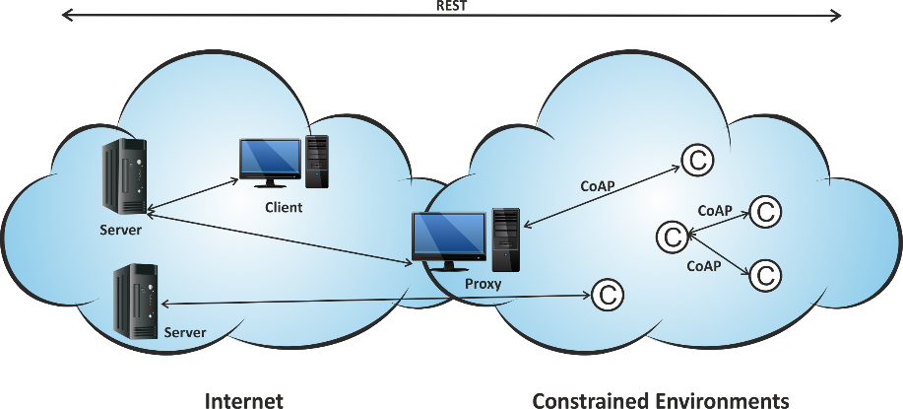

Figure 1: CoAP architecture with server, client and proxy endpoints.

# Test Suite Structure

## Server as SUT

1. All mandatory message data fields
   1. Support all defined method codes and understand regular and illegal or corrupted data along with them
2. Protocol features
   1. General
      1. Block transfer
      2. Piggybacked responses
      3. Separate responses
      4. Message Types (ACK, CON, NON-con, ReSeT)
   2. Options
      1. Max-Age
      2. Token option
      3. Several URI-path options
      4. Several URI-query options
   3. Lossy context
   4. Discovery service
   5. Error handling

## Test configurations

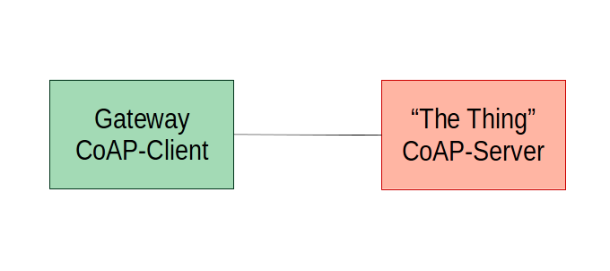

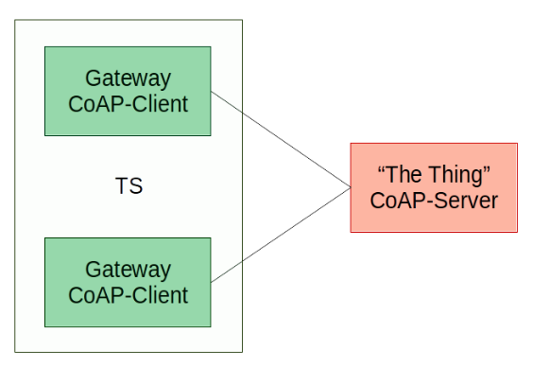

## Client as SUT

### Test configuration

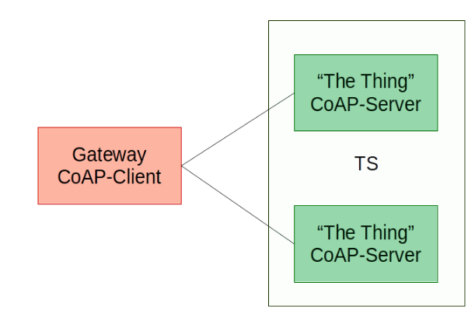

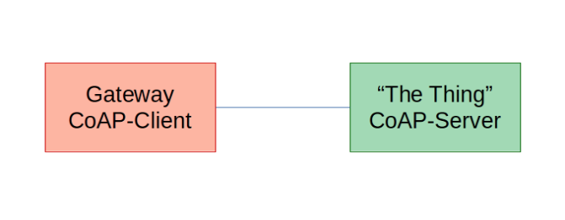

# Test Purposes for CoAP Server

## Mandatory Message Data Fields

### Regular and illegal/corrupted data

### TP_CoAP_Server_001

|  |  |
| --- | --- |
| **TP-ID** | TP_CoAP_Server_001 |
| **Selection** | PIC_Server |
| **Summary** | The IUT is responding on a RESET message. |
| **Reference** | [RFC7252#section4.2](https://tools.ietf.org/html/rfc7252#section-4.2) |
| **Initial condition** | none |
| **Test purpose** | |
| Ensure that the IUT  **on receipt** of an **EMPTY** message  containing msg_type := 0 (CONfirmable)  containing code := 0.00  **sends** a **RESPONSE** message  containing msg_type := 3 (ReSeT) | |
| **Comments** | |

### TP_CoAP_Server_GET_001

|  |  |
| --- | --- |
| **TP-ID** | TP_CoAP_Server_GET_001 |
| **Selection** | PIC_Server |
| **Summary** | The IUT is responding with code 2.05 on a GET request. |
| **Reference** | [RFC7252#section-5.8.1](https://tools.ietf.org/html/rfc7252#section-5.8.1) |
| **Initial condition** | The IUT must provide a resource named Simple_Resource. |
| **Test purpose** | |
| Ensure that the IUT  **on receipt** of a **GET** message on the resource **Simple_Resource**  containing msg_type := 0 (CONfirmable)  and code := 0.01  and option uri_path := “Simple_Resource”  **sends** a **RESPONSE** message  containing msg_type := 2 (ACKnowledgement)  and code := 2.05 | |
| **Comments** | |

### TP_CoAP_Server_GET_002

|  |  |
| --- | --- |
| **TP-ID** | TP_CoAP_Server_GET_002 |
| **Selection** | PIC_Server |
| **Summary** | The IUT is responding with code 2.05 on a GET request. |
| **Reference** | [RFC7252#section-5.8.1](https://tools.ietf.org/html/rfc7252#section-5.8.1) |
| **Initial condition** | The IUT must provide a resource Simple_Resource/New_Resource. |
| **Test purpose** | |
| Ensure that the IUT  **on receipt** of a **GET** message on the resource **Simple_Resource**  containing msg_type := 0 (CONfirmable)  and code := 0.01  and option uri_path := “Simple_Resource”  and option uri_path := “New_Resource”  **sends** a **RESPONSE** message  containing msg_type := 2 (ACKnowledgement)  and code := 2.05 | |
| **Comments** | |

### TP_CoAP_Server_GET_003

|  |  |
| --- | --- |
| **TP-ID** | TP_CoAP_Server_GET_003 |
| **Selection** | PIC_Server |
| **Summary** | The IUT is responding with code 4.05 on a GET request. |
| **Reference** | [RFC7252#section-5.8.1](https://tools.ietf.org/html/rfc7252#section-5.8.1) |
| **Initial condition** | The IUT must provide a resource Simple_Resource and must not implement the GET operation. |
| **Test purpose** | |
| Ensure that the IUT  **on receipt** of a **GET** message on the resource **Simple_Resource**  containing msg_type := 0 (CONfirmable)  and code := 0.01  and option uri_path := “Simple_Resource”  **sends** a **RESPONSE** message  containing msg_type := 2 (ACKnowledgement)  and code := 4.05 | |
| **Comments** | |

### TP_CoAP_Server_GET_004 (TODO)

|  |  |
| --- | --- |
| **TP-ID** | TP_CoAP_Server_GET_004 |
| **Selection** | PIC_Server |
| **Summary** | The IUT is responding with code 2.03 on a GET request. |
| **Reference** | [RFC7252#section-5.8.1](https://tools.ietf.org/html/rfc7252#section-5.8.1) |
| **Initial condition** | The IUT must provide a resource Simple_Resource |
| **Test purpose** | |
| TODO | |
| **Comments** | |
| Ich habe noch nicht herausgefunden, wann der ResponseCode auf eine GET-Anfrage nicht 2.05 (Content) sondern 2.03 (Valid) benutzt wird. | |

### TP_CoAP_Server_GET_005

|  |  |
| --- | --- |
| **TP-ID** | TP_CoAP_Server_GET_005 |
| **Selection** | PIC_Server |
| **Summary** | The IUT is responding with code 4.04 on a GET request. |
| **Reference** | [RFC7252#section-5.8.1](https://tools.ietf.org/html/rfc7252#section-5.8.1) |
| **Initial condition** | The IUT must not provide a resource named Simple_Resource. |
| **Test purpose** | |
| Ensure that the IUT  **on receipt** of a **GET** message on the not existing resource **Simple_Resource**  containing msg_type := 0 (CONfirmable)  and code := 0.01  and option uri_path := “Simple_Resource”  **sends** a **RESPONSE** message  containing msg_type := 2 (ACKnowledgement)  and code := 4.04 | |
| **Comments** | |

### TP_CoAP_Server_POST_001

|  |  |
| --- | --- |
| **TP-ID** | TP_CoAP_Server_POST_001 |
| **Selection** | PIC_Server |
| **Summary** | The IUT is responding with code 2.01 on a POST request. |
| **Reference** | [RFC7252#section-5.8.2](https://tools.ietf.org/html/rfc7252#section-5.8.2) |
| **Initial condition** | The IUT must provide a resource Storage_Resource. |
| **Test purpose** | |
| Ensure that the IUT  **on receipt** of a **POST** message on the resource **Storage_Resource**  containing msg_type := 0 (CONfirmable)  and code := 0.02  and option uri_path := “Storage_Resource”  and payload := 116 145 167 061 057 116 145 167 062  **sends** a **RESPONSE** message  containing msg_type := 2 (ACKnowledgement)  and code := 2.01  and Location-Path := New1  and Location-Path := New2 | |
| **Comments** | |
| Add two new resources named New1 and New2. | |

### TP_CoAP_Server_POST_002

|  |  |
| --- | --- |
| **TP-ID** | TP_CoAP_Server_POST_002 |
| **Selection** | PIC_Server |
| **Summary** | The IUT is responding with code 2.04 on a POST request. |
| **Reference** | [RFC7252#section-5.8.2](https://tools.ietf.org/html/rfc7252#section-5.8.2) |
| **Initial condition** | The IUT must provide a resource Storage_Resource/New1/New2. |
| **Test purpose** | |
| Ensure that the IUT  **on receipt** of a **POST** message on the resource **Storage_Resource/New1/New2**  containing msg_type := 0 (CONfirmable)  and code := 0.02  and option uri_path := “Storage_Resource”  and option uri_path := “New1”  and option uri_path := “New2”  and payload := 116 145 167 061 057 116 145 167 062  **sends** a **RESPONSE** message  containing msg_type := 2 (ACKnowledgement)  and code := 2.04  and Location-Path := New1  and Location-Path := New2 | |
| **Comments** | |
| Try to add two new resources named New1 and New2 which already exist. | |

### TP_CoAP_Server_POST_003

|  |  |
| --- | --- |
| **TP-ID** | TP_CoAP_Server_POST_003 |
| **Selection** | PIC_Server |
| **Summary** | The IUT is responding with code 2.04 on a POST request. |
| **Reference** | [RFC7252#section-5.8.2](https://tools.ietf.org/html/rfc7252#section-5.8.2) |
| **Initial condition** | The IUT must provide a resource Storage_Resource/New1/New2. |
| **Test purpose** | |
| Ensure that the IUT  **on receipt** of a **POST** message on the resource **Storage_Resource/New1/New2**  containing msg_type := 0 (CONfirmable)  and code := 0.02  and option uri_path := “Storage_Resource”  and option uri_path := “New1”  and option uri_path := “New1a”  and payload := 116 145 167 061 057 116 145 167 061 141  **sends** a **RESPONSE** message  containing msg_type := 2 (ACKnowledgement)  and code := 2.04  and Location-Path := New1  and Location-Path := New1a | |
| **Comments** | |
| Change resource Storage_Resource/New1/New2 to Storage_Resource/New1/New1a. | |

### TP_CoAP_Server_POST_004 (TODO)

|  |  |
| --- | --- |
| **TP-ID** | TP_CoAP_Server_POST_004 |
| **Selection** | PIC_Server |
| **Summary** | The IUT is responding with code 2.02 on a POST request. |
| **Reference** | [RFC7252#section-5.8.2](https://tools.ietf.org/html/rfc7252#section-5.8.2) |
| **Initial condition** | The IUT must provide a resource Storage_Resource/New1/New2. |
| **Test purpose** | |
| TODO | |
| **Comments** | |
| Ich habe noch nicht herausgefunden, wie man eine Resource mit der POST-Operation löschen kann. | |

### TP_CoAP_Server_POST_005

|  |  |
| --- | --- |
| **TP-ID** | TP_CoAP_Server_POST_005 |
| **Selection** | PIC_Server |
| **Summary** | The IUT is responding with code 4.05 on a POST request. |
| **Reference** | [RFC7252#section-5.8.2](https://tools.ietf.org/html/rfc7252#section-5.8.2) |
| **Initial condition** | The IUT must provide a resource Simple_Resource and must not implement the POST operation. |
| **Test purpose** | |
| Ensure that the IUT  **on receipt** of a **POST** message on the resource **Simple_Resource**  containing msg_type := 0 (CONfirmable)  and code := 0.02  and option uri_path := “Simple_Resource”  **sends** a **RESPONSE** message  containing msg_type := 2 (ACKnowledgement)  and code := 4.05 | |
| **Comments** | |

### TP_CoAP_Server_PUT_001

|  |  |
| --- | --- |
| **TP-ID** | TP_CoAP_Server_PUT_001 |
| **Selection** | PIC_Server |
| **Summary** | The IUT is responding with code 2.01 on a PUT request. |
| **Reference** | [RFC7252#section-5.8.3](https://tools.ietf.org/html/rfc7252#section-5.8.3) |
| **Initial condition** | The IUT must provide a resource Storage_Resource. |
| **Test purpose** | |
| Ensure that the IUT  **on receipt** of a **PUT** message on the resource **Storage_Resource**  containing msg_type := 0 (CONfirmable)  and code := 0.03  and option uri_path := “Storage_Resource”  and payload := 116 145 167 061 057  **sends** a **RESPONSE** message  containing msg_type := 2 (ACKnowledgement)  and code := 2.01  and Location-Path := New1 | |
| **Comments** | |
| Add a new resources named New1. | |

### TP_CoAP_Server_PUT_002

|  |  |
| --- | --- |
| **TP-ID** | TP_CoAP_Server_PUT_002 |
| **Selection** | PIC_Server |
| **Summary** | The IUT is responding with code 2.04 on a PUT request. |
| **Reference** | [RFC7252#section-5.8.3](https://tools.ietf.org/html/rfc7252#section-5.8.3) |
| **Initial condition** | The IUT must provide a resource Storage_Resource/New1 |
| **Test purpose** | |
| Ensure that the IUT  **on receipt** of a **PUT** message on the resource **Storage_Resource**  containing msg_type := 0 (CONfirmable)  and code := 0.03  and option uri_path := “Storage_Resource”  and option uri_path := “New1”  **sends** a **RESPONSE** message  containing msg_type := 2 (ACKnowledgement)  and code := 2.04  and Location-Path := New1 | |
| **Comments** | |
| Try to add resource New1 although it already exists. | |

### TP_CoAP_Server_DELETE_001

|  |  |
| --- | --- |
| **TP-ID** | TP_CoAP_Server_DELETE_001 |
| **Selection** | PIC_Server |
| **Summary** | The IUT is responding with code 2.02 on a DELETE request. |
| **Reference** | [RFC7252#section-5.8.4](https://tools.ietf.org/html/rfc7252#section-5.8.4) |
| **Initial condition** | The IUT must provide a resource Storage_Resource. |
| **Test purpose** | |
| Ensure that the IUT  **on receipt** of a **DELETE** message on the resource **Storage_Resource**  containing msg_type := 0 (CONfirmable)  and code := 0.04  and option uri_path := “Storage_Resource”  **sends** a **RESPONSE** message  containing msg_type := 2 (ACKnowledgement)  and code := 2.02 | |
| **Comments** | |
| Delete resource Resource “Storage_Resource” | |

### TP_CoAP_Server_DELETE_002

|  |  |
| --- | --- |
| **TP-ID** | TP_CoAP_Server_DELETE_002 |
| **Selection** | PIC_Server |
| **Summary** | The IUT is responding with code 2.02 on a DELETE request. |
| **Reference** | [RFC7252#section-5.8.4](https://tools.ietf.org/html/rfc7252#section-5.8.4) |
| **Initial condition** | The IUT must not provide a resource Storage_Resource. |
| **Test purpose** | |
| Ensure that the IUT  **on receipt** of a **DELETE** message on the resource **Storage_Resource**  containing msg_type := 0 (CONfirmable)  and code := 0.04  and option uri_path := “Storage_Resource”  **sends** a **RESPONSE** message  containing msg_type := 2 (ACKnowledgement)  and code := 2.02 | |
| **Comments** | |
| Get Response code 2.02 although the requested resource does not exist. | |

## Protocol features

## General

## Block transfer

## Piggybacked response

## Separate response

## Message types

### TP_CoAP_Server_NON_001

|  |  |
| --- | --- |
| **TP-ID** | TP_CoAP_Server_NON_001 |
| **Selection** | PIC_Server |
| **Summary** | The IUT is responding on a NON-confirmable message. |
| **Reference** | [RFC7252#section4.2](https://tools.ietf.org/html/rfc7252#section-4.2) |
| **Initial condition** | The IUT must provide a resource named Simple_Resource that handles GET. |
| **Test purpose** | |
| Ensure that the IUT  **on receipt** of a **GET** message  containing msg_type := 1 (NON-confirmable)  and code := 0.01  **sends** a **RESPONSE** message  containing msg_type := 1 (NON-confirmable)  and code := 2.05 | |
| **Comments** | |