Open Source Independent Review and Interpretation System

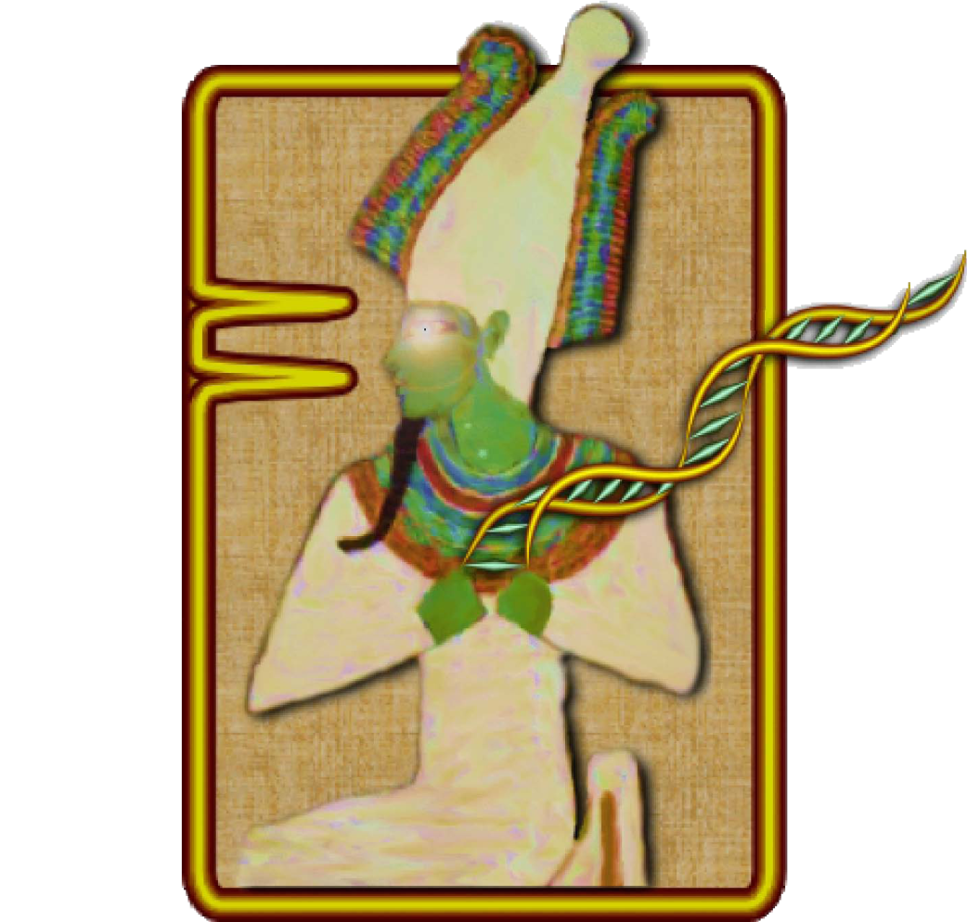

**Version 1.3**

**User’s Guide**

helix.png

National Center for Biotechnology Information

National Library of Medicine

National Institutes of Health

U.S. Department of Health & Human Services

logos.png

Table of Contents

Background 3

Getting Started 4

Obtaining and Installing Osiris 4

A Quick Tutorial 4

Configuration 8

File Names 9

Thresholds 10

Allele Exceptions 12

Analysis 14

OSIRIS Report Files 16

Toolbar and Menu 17

Osiris Plot Files 20

Toolbar 22

Resizing Plots 24

Viewport and Zooming 25

# Background

OSIRIS (Open Source, Independent Review and Interpretation System) is a public domain quality assurance software package that facilitates the assessment of multiplex short tandem repeat (STR) DNA profiles based on laboratory-specific protocols. OSIRIS evaluates the raw electrophoresis data contained in an .fsa file using an independently derived mathematically-based sizing algorithm. OSIRIS currently supports ABI capillary analytical platforms and numerous commercially available CODIS-compliant marker kits.

OSIRIS searches for peaks by iteratively fitting expected parametric data signatures to the observed data, usually achieving matches with correlations in excess of 0.999. Parametric peak locations are determined with sub-second accuracy and transformed to base pair coordinates. Traditional sizing methods for DNA fragments usually rely on either the local or global Southern methods to interpolate the internal lane standard (ILS) into base pair estimates. OSIRIS departs from this approach, using instead the correspondence between a sample’s ILS and an associated allelic ladder to map the time scale of the ladder into that of the sample. This integration of the ladder with the sample permits a straightforward and accurate comparison of sample peaks with ladder locus peaks. Typically, OSIRIS-analyzed sample peaks align within 0.1 base pair of the position within a locus. Thus, in addition to providing reliable and accurate peak analysis, OSIRIS offers two new peak quality measures – fit level and sizing residual.

Based on a laboratory’s own protocols, these two measures can enhance quality metrics currently available to assess STR DNA profiles. OSIRIS can be customized to accommodate laboratory-specific signatures including settings sensitive to typical background noise and can include any customized naming conventions or additional internal laboratory controls. When used in complement with other analysis methods, OSIRIS can provide a second independent assessment of data and may alleviate the need for human review of passing profiles.

OSIRIS was initiated in response to recommendations of a multidisciplinary advisory group (the Kinship and DNA Analysis Panel, KADAP) empanelled by the U.S. Department of Justice. KADAP was assembled to assist the New York City Office of the Medical Examiner (OCME) and New York State Police (NYSPD) DNA laboratories in the difficult and unprecedented legal and humanitarian challenges the World Trade Center victim identifications raised by developing guidelines and recommendations for management of the identification process, focusing on ways to enhance the number and quality of identifications that could be made.1 Developed in collaboration with state, local and federal forensic laboratories and NIST, the National Center for Biotechnology Information (NCBI) created OSIRIS using C++ and object oriented design to facilitate the development of add-on applications by those using the program. NCBI performs internal quality assurance on its programs and will maintain OSIRIS at <http://www.ncbi.nlm.nih.gov/projects/SNP/osiris> as part of its extensive public domain toolkit for exploring and managing genetic data.

# Getting Started

## Obtaining and Installing Osiris

OSIRIS for Microsoft Windows XP, Windows Vista and Apple Macintosh OSX 10.5 can be downloaded at <http://www.ncbi.nlm.nih.gov/projects/SNP/osiris>. When using the version for Microsoft Windows, if there is already a previous version of OSIRIS that this download will replace, the old version **must first be uninstalled** before the newer version is installed.

To uninstall an older version for Windows, go to the ‘Start’ menu and select Programs -> Osiris -> Uninstall OSIRIS. Alternatively, you can go to the Control Panel and select Add or Remove Programs, then scroll down to highlight Osiris and select the “Remove” button. You can now install the new version of OSIRIS from <http://www.ncbi.nlm.nih.gov/projects/SNP/osiris>

When using Microsoft Windows, once OSIRIS has been downloaded, open the file from Windows Explorer and follow the installation instructions. The only installation option is selecting the location for the installation. If a previous version of OSIRIS was removed prior to installation, the new version should be installed in the same location as the older version in order to use the prior settings that are saved from your previous install.

## A Quick Tutorial

This is a quick overview on using OSIRIS. The files shown in the examples illustrated in this guide are included with your OSIRIS download. All of these example .fsa files were created by the Human Identity Team at the National Institute of Standards and Technology (NIST) and are available through their STRBase website (<http://www.cstl.nist.gov/div831/strbase/>). It is recommended that you use the Quick Tutorial along with the provided NIST files to help familiarize yourself with OSIRIS. Details of OSIRIS’ features will be described in the later chapters.

Below is an illustration of the opening window. Note the menu bar availability above the logo. The logo disappears after a moment.

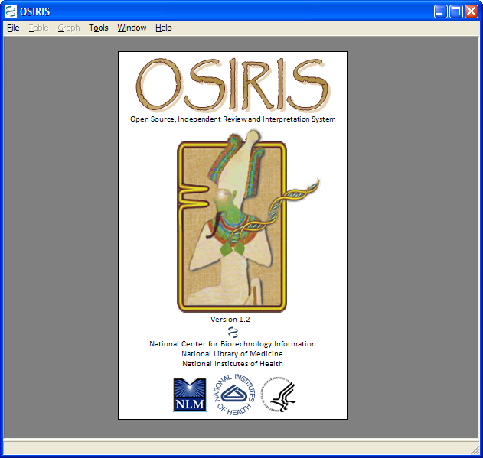

After the OSIRIS logo disappears, select “New Analysis…” from the “File” pull down menu as shown below. A dialog box labeled “Analyze Data” will appear.

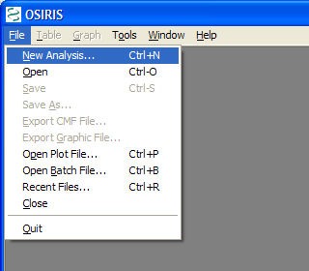

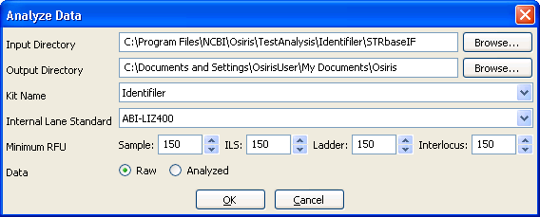

When this dialog box appears, the user can enter the specific information and click “OK” to begin the analysis. Note that different minimum RFU values are available for the different sample types. The drop-down menus detail the kits and standards that OSIRIS currently recognizes. Requests for other marker sets or controls can be sent to [forensics@ncbi.nlm.nih.gov](mailto:forensics@ncbi.nlm.nih.gov).

In the illustrated example, we are using data files for IdentifilerTM created by NIST and provided with the OSIRIS software. The NIST test files are located in a subdirectory named “TestAnalysis” which is in the directory where OSIRIS was installed.

When the analysis begins, a new window appears (see below) which shows each subdirectory that will be analyzed along with its current analysis status. If only one subdirectory is to be analyzed a new window opens upon completion with a table containing the results of the analysis.

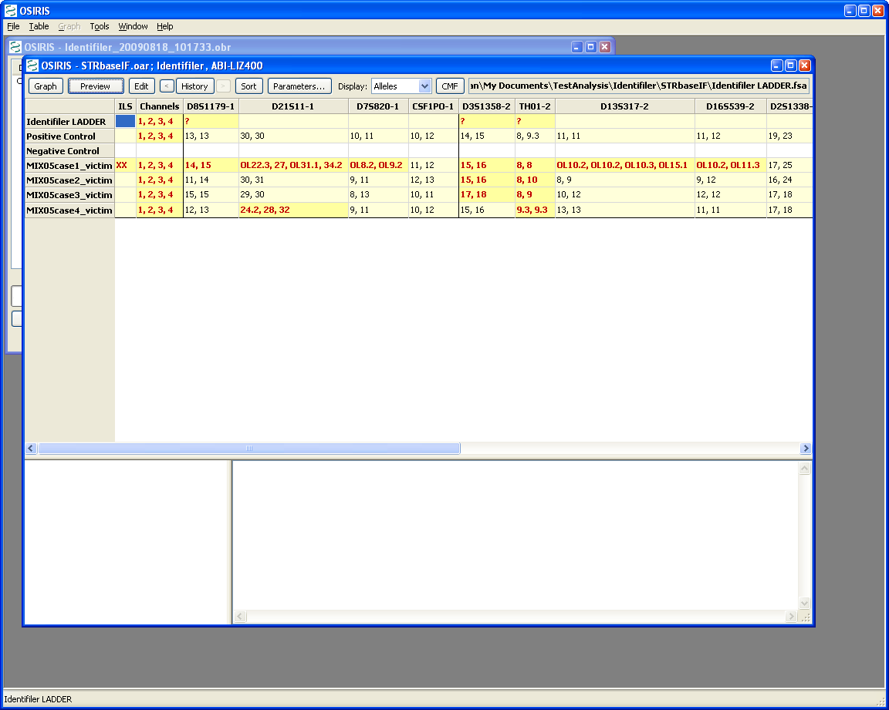

From this table, the user can choose which data to display, view plots containing the data and edit the data. This is accomplished using the toolbar at the top of the window, the pull down menu labeled “Table” on the menu bar, or by right clicking the table cell of interest. Note that when a cell is highlighted on a table, notices and detailed information appear in the area below the table. There is a “Preview” button on the toolbar and pull down menu that toggles the display of a plot showing the peaks of the currently selected sample and allele. Following is an example:

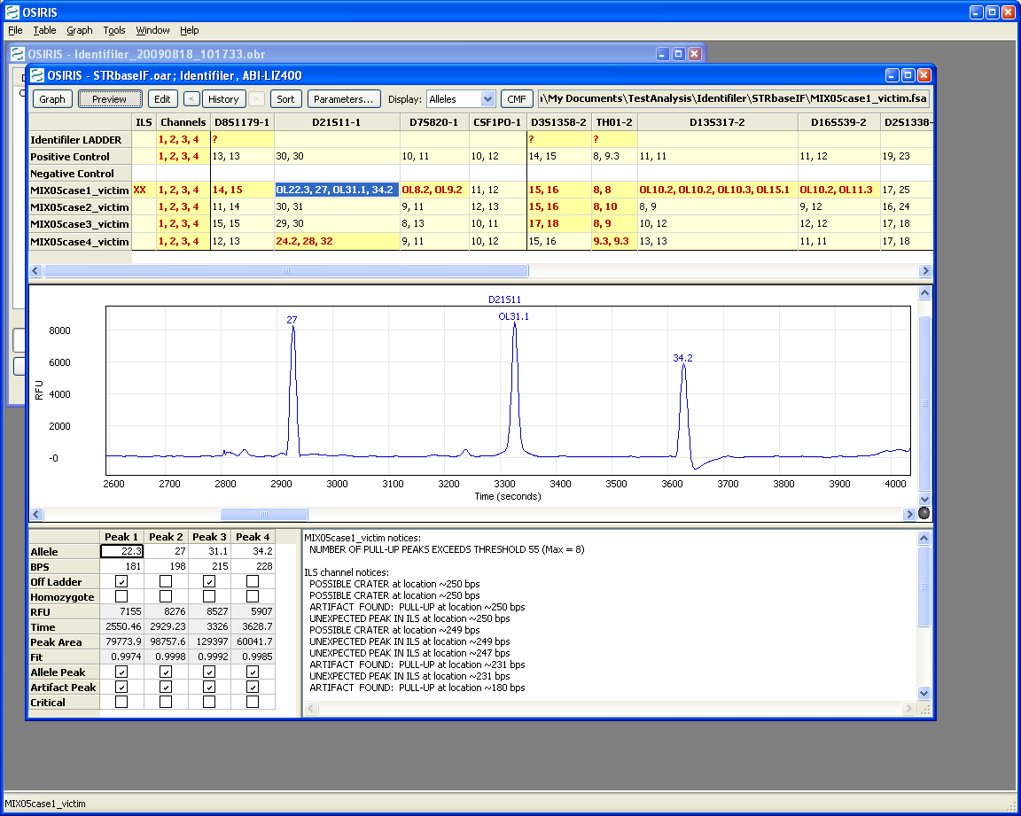

To view a graphical representation of one of the samples, click on the row of the desired sample and select the “Graph” button on the toolbar above the table. Following is an example.

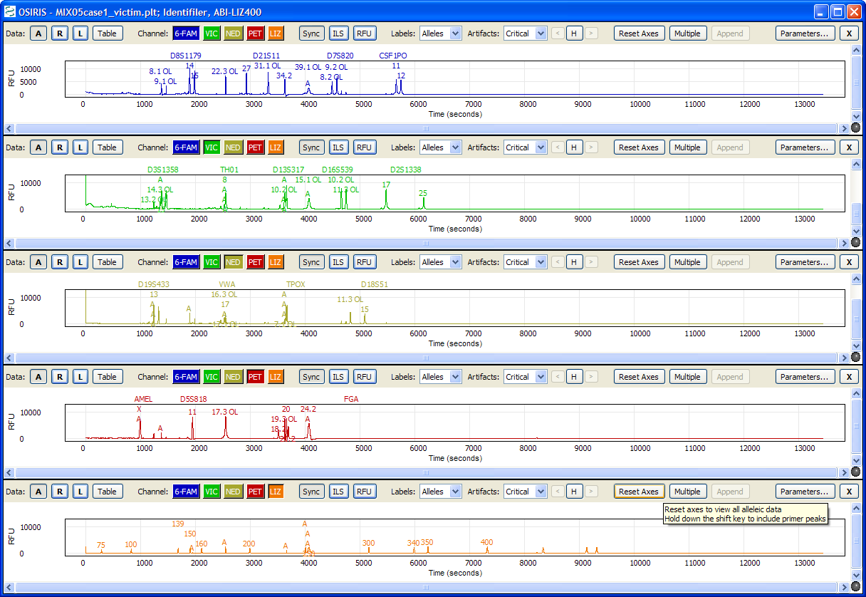

The previous image shows a graph of the electropherograms. By default, there is a separate plot for each channel. The toolbar at the top of each plot as well as the pull down menu labeled “Graph” provides many options which are described in detail in the “Osiris Plot Files” section of this guide.

windowby .

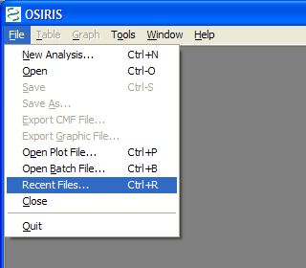

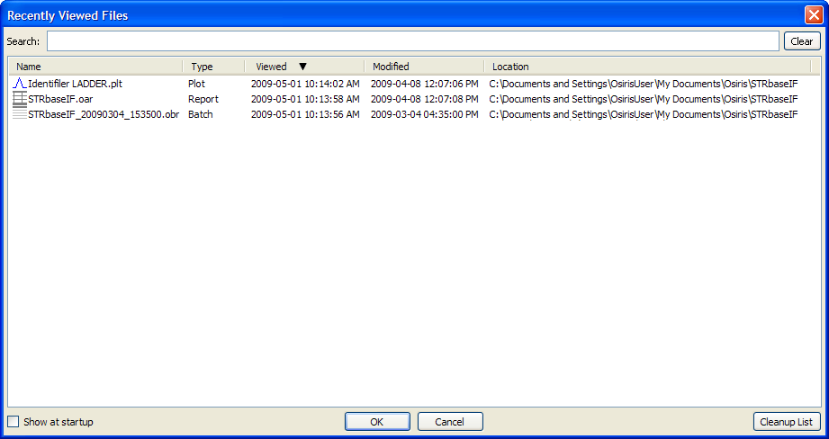

This list shows up to 1000 files that have been viewed by OSIRIS and can be sorted by name, type, last time viewed, modification time, or location. To open a file, double-click on the file name or select one or more files and select the “OK” button. You may select and view up to 10 files at a time. To search for a desired file, simply type part of the file name in the “Search” text box at the top of the window and the list will be updated immediately to filter out all files that do not match the search criteria.

This concludes the quick-start tutorial. More detailed information about OSIRIS’ features can be found in subsequent sections of this guide.

## Configuration

OSIRIS has a number of parameters that can be configured to your laboratory’s specific protocols. OSIRIS default is set so that only the “owner” of the files contained in the OSIRIS installation (that is the user who installed OSIRIS) can modify the lab settings. Other “non-owner” users can only view these settings. It was expected that in forensic laboratories, the Laboratory Director, Technical Leader or Quality Manager would be the likely “owner” of OSIRIS, whereas “ownership” may be more relaxed in diagnostic or research laboratories. A modest modification to the permissions of the file named “GenericLabSettings.xml” in the config subdirectory of the OSIRIS installation directory will permit modifications of the lab settings by other users. This file, “GenericLabSettings.xml,” is created after the “owner” runs OSIRIS and saves the lab settings for the first time. If you do not have a systems administrator available to make the change, the OSIRIS team can help you perform this task if you wish to broaden these permissions. Just contact us at [forensics@ncbi.nlm.nih.gov](mailto:forensics@ncbi.nlm.nih.gov?subject=OSIRIS%20Permissions%20Request) and please put “OSIRIS Permissions Request” in your subject line.

To configure OSIRIS, select the “Lab Settings” option under “Tools” on the menu bar as shown below. This brings up the Lab Settings window with many options including: file naming conventions, RFU thresholds, and allele designations.

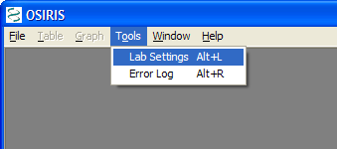

The “Lab Settings” window has three sections or tabs: File Names, Thresholds, and Allele Exceptions.

## File Names

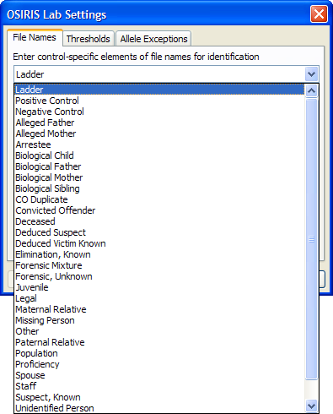

The “File Names” tab is used to determine the type of an .fsa file by its file name. The names shown above include ladder, positive control, negative control, and all types defined by the guidelines for creating CMF files. You cannot add or delete the names from this list per the CMF guidelines. However, you can customize any of the subgroups to names used in your laboratory (see below).

In the following example, OSIRIS identifies a file as a negative control if it finds a name containing one of the character strings in the large text box in the middle of the window below. You can also add any names that are commonly used by your laboratory or remove any names that you don’t want from the OSIRIS default list by editing the list. OSIRIS comes with a number of commonly used file names for standard controls. When OSIRIS encounters any of these strings in a file name it will automatically assign the control name to the file and check to make sure that the control meets expectations. In the example below, any sample with a listed string in its file name will be identified by OSIRIS as a negative control. It will (a) identify that a valid ILS exists for the sample and (b) determine if there are peaks in other channels and notify the user if either of these conditions are violated for the criteria set for negative controls. Similarly, if the negative control string used in your lab is NOT on the list, OSIRIS will warn you there is no negative control in your directory.

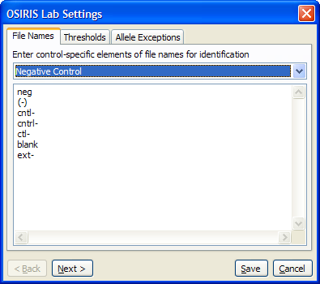

Following are some example file names and whether or not they would be negative controls as per the specification in the previous picture.

**File Name Negative Control**

f001-neg.fsa yes, contains ‘neg’

sample( - ) ctrl.fsa no (spaces within parentheses)

ctl-positive.fsa yes, although the name is misleading

NormanEvanGordon(neg).fsa yes

Ctrl-1.fsa yes, contains ‘ctrl-’

Please note that string names used in more than one control type can introduce difficulties if extra spaces or duplications are introduced. For example, a laboratory string that identifies a negative control as “ctl- positive” and a positive control as “ctl+ positive” is ambiguous to OSIRIS. If this occurs, try shortening your string name cue in the OSIRIS naming box (*e.g.*: just “ctl+” and “ctl-”, or omitting the space between the “ctl-/+” and the word “positive” to disambiguate the samples for the program.

## Thresholds

The “Thresholds” section is used for setting maxima and minima for a number of thresholds. As shown below there are four threshold sections: Ladder, Internal Lane Standard, Sample, and Other Thresholds.

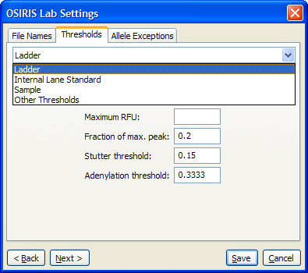

The image below shows the available parameters for “Sample” thresholds. The parameters are the same for Internal Lane Standard and Ladder with the exception of the “Pullup fractional filter” which can only be applied to “Sample” thresholds. There is also a checkbox labeled “Allow User to Override.” If this is not checked, the analyst cannot modify the minimum RFU parameters with each analysis and will only be able to review the sample under the minimum RFU set in the lab settings.

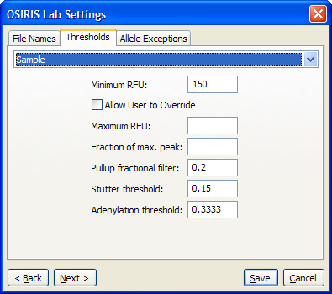

The “Other Thresholds” section determines the laboratory specific limits for OSIRIS to implement. Typically, these parameters target areas where technical concerns about artifacts in multilocus STR analysis commonly occur. Please contact your OSIRIS team with suggestions about additional parameters you feel would be useful in this program ([forensics@ncbi.nlm.nih.gov](mailto:forensics@ncbi.nlm.nih.gov?subject=Lab%20Settings,%20Other%20Thresholds)).

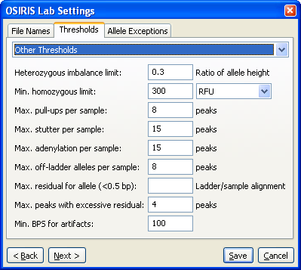

## Allele Exceptions

The “Allele Exceptions” section allows the user to override certain alleles or combination of alleles that would normally be flagged by OSIRIS for human review. When alleles or sets of alleles are placed in these sections OSIRIS treats their appearance as “normal” unless they have significant deviations from other threshold settings. The exceptions are specified separately for each kit and there are four types of exceptions; Off ladder alleles, Sample trialleles, Control trialleles, and positive controls.

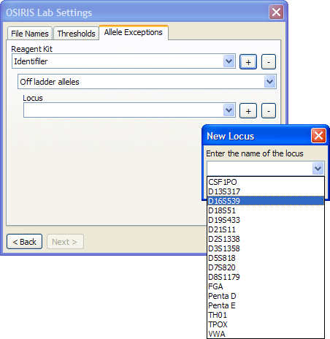

For each section, the actual alleles can be specified for each locus. The following is an example for Off ladder alleles for D16S539:

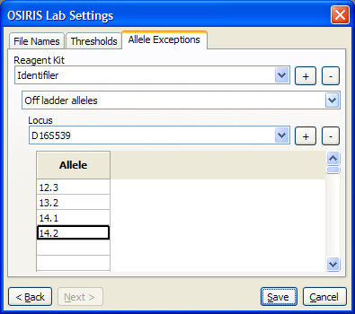

For sample and control trialleles, the alleles are entered in three columns where each row contains an accepted triallele as shown below.

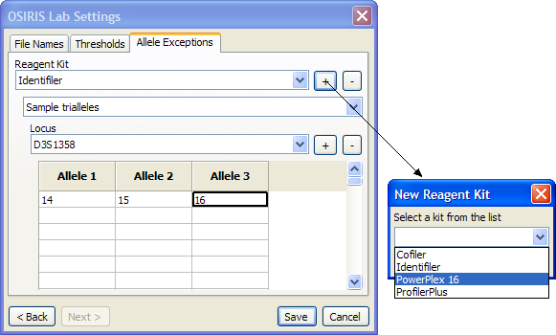

On the right side of each pull down list for a reagent kit or a locus are two buttons, one labeled with a plus sign (+) and the other with a minus sign (-). These buttons are used to add an item (kit or locus) to or remove an item from the list.

Upon completion of the lab settings, the user must press the button labeled “Save” in order to save the settings in a configuration file to be used in any future analysis. As mentioned before, it is important that when OSIRIS is upgraded to a new version, the folder where it is installed must be the same as the previous version in order to retain these settings.

# Analysis

When an analysis is performed, one or more folders containing .fsa files are analyzed and the results are written to a new folder for each .fsa folder. The output of the analysis consists of data containing alleles, artifacts, peak area, and smoothed electropherogram data. These data can be viewed in OSIRIS in the form of a table or spreadsheet with peak information and graphical plots of the smoothed and raw electropherogram data. The tabular data can be exported to a CODIS Common Message Format (CMF) 3.2 file and the graphical data can be exported to a Portable Network Graphics (PNG) file which can then be imported into various applications including most word processing, spreadsheet, and presentation graphics programs or displayed on a web site.

To begin an analysis, open the “Analyze Data” dialog window by selecting “New Analysis…” from the “File” pull down menu as shown below:

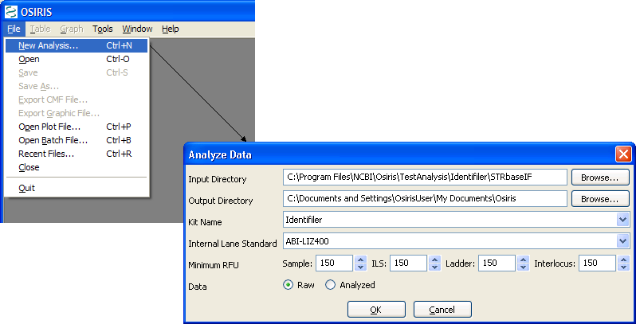

Following is a description of the parameters used for analyzing data:

**Input Directory**. This is the directory or folder which either contains .fsa files or subdirectories that contain .fsa files to be analyzed. OSIRIS will begin looking in the specified directory and traverse all subdirectories searching for .fsa files to be analyzed. Each directory that contains one or more .fsa files will be analyzed.

**Output Directory**. This is the directory or folder that will contain the output files of the analysis. A subdirectory with the same name of the input directory will be created and if more than one input directory containing .fsa files is found, the output directory will have the same hierarchy as the input directory tree. Each analysis will create several output files. OSIRIS will allow the user to view report and plot files, whose filenames have the extension of .oar and .plt, respectively. The report (.oar) file contains the tabular data and there is one plot (.plt) file for each sample. There are also various text files in the output directory with either the .txt extension for viewing in a text editor, or tab delimited (.tab) files which are better viewed with a spreadsheet program. The plot (.plt) files have the same name as their corresponding .fsa input files except for the file name extension. All other output files begin with the name of the output folder or directory, with some containing a suffix before the file name extension.

**Kit Name**. Select the kit or marker set that was used to produce the data being analyzed.

**Internal Lane Standard**. Select the appropriate internal lane standard for your data. This list is updated when the kit selection is modified.

**Minimum RFU**. Select the minimum RFU for samples, ILS, ladder data, and interlocus peaks. The default values are obtained from the lab settings. If the lab settings are specified to not allow the user to override these parameters, then user input to these fields is disabled.

**Data**. Select whether to obtain the raw or analyzed data from the .fsa files. If Analyzed is selected and there is no analyzed data, the results will indicate this condition.

When the “OK” button is pressed, the analysis begins and a new window appears with the status of the analysis as shown below.

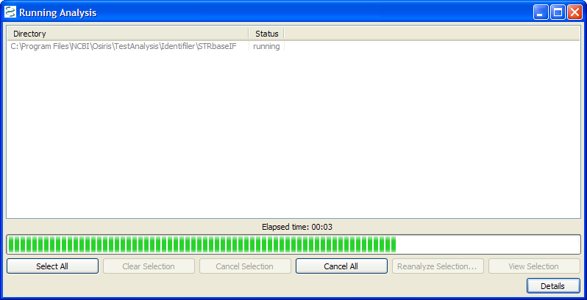

This window shows a list of each directory being analyzed; however our example shows only one item. The status column shows one of the following: pending, canceled, running, failed, or completed. If the status is pending or running, it can be canceled by selecting one or more rows and pressing the ‘Cancel Selection’ button. If the status is ‘failed’ or ‘completed’ the tabular data (.oar file) can be viewed either by double-clicking the item or selecting one or more items and pressing the “View Selection” button. In the lower right corner of the window is a button labeled “Details.” When pressed, the details of analysis are displayed or hidden at the bottom of the window. Once the analysis is complete, the information is stored in a file in the output directory. This file is automatically named beginning with the name of the folder followed by the date and time and finally with the file extension .obr for OSIRIS Batch Report. This file can be viewed later to show the details and/or open the tabular or .oar files. To retrieve an .obr file, select “Open Batch File…” or “Recent Files…” from the “File” pull down menu on the menu bar.

# OSIRIS Report Files

The OSIRIS report files, also known as analysis files, contain information about the peaks found in the electropherogram data including alleles, peak area, RFU, base pairs, mean peak time, artifacts, and alerts of potential problems. The file extension for the report files created by OSIRIS is .oar for “OSIRIS Analysis Report.” The data in these files can be edited and saved with the file extension of .oer for “OSIRIS Edited Report.” To open a report file, select “Open” from the “File” pull down menu on the menu bar and search for the desired file. To open a recently viewed file, select “Recent Files…” from the “File” pull down menu. This will display a dialog window with up to 1000 recently viewed OSIRIS files of all types including report files. When a report file is opened, a window appears with a split pane containing a table or spreadsheet in the top pane and alert info in the bottom. The border between the two panes can be moved by clicking and dragging with the mouse.

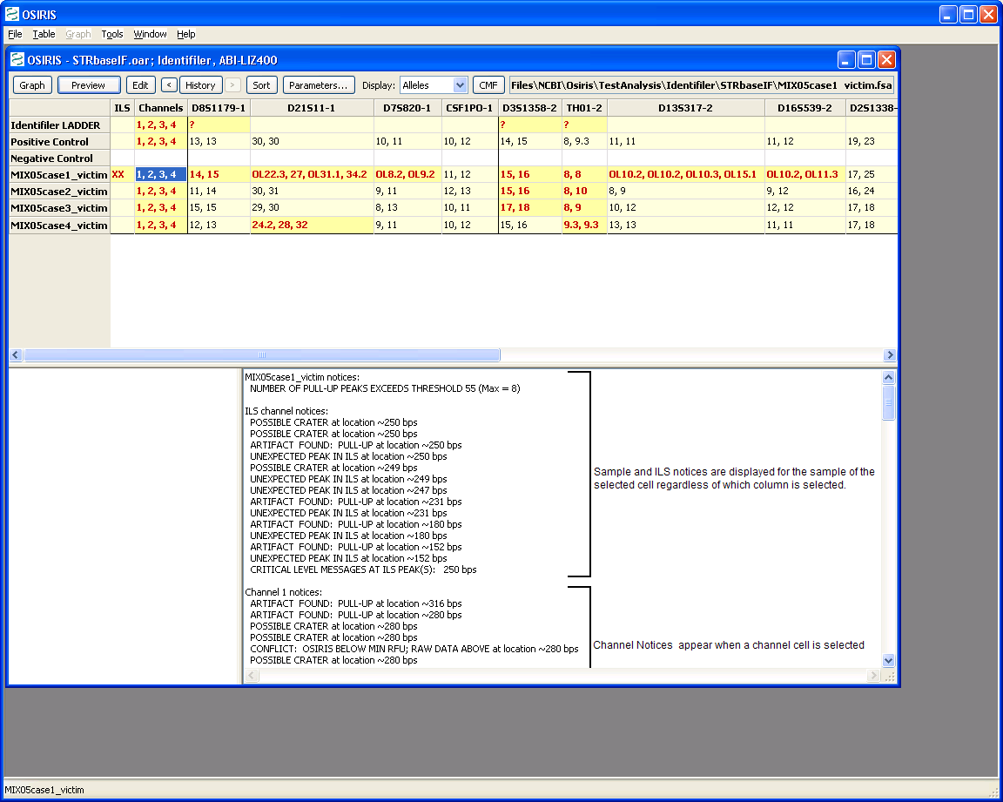

The output of our example analysis is shown above. Each row contains data for one sample. The first column contains “XX” if there are any alerts related to the Internal Lane Standard and is blank if there are no alerts. The second column contains the numbers of all channels that have channel level alerts. All other columns except for the rightmost column are used for locus information with a column for each locus. The locus name followed by a hyphen and the channel number is used for the column heading. The order of the columns is by channel and then location or time of peaks within the channel. The vertical lines separating each column are black where two adjacent columns represent loci in different channels and grey otherwise. The rightmost column contains the name of the positive control when appropriate. The color scheme of the table cells is as follows:

**White background** The entire sample has no alerts.

**Yellow background, bold red text** The selected cell has one or more alerts.

**Pale yellow background, black text** The selected cell has no alerts, but the sample has one or more alerts.

A table cell displayed in italics or with a tilde (~) indicates that the data in the cell has been edited after the analysis has been performed.

## Toolbar and Menu

The toolbar at the top of the window along with the “Table” pull down menu on the menu bar and the context (right click) menu have the following options: Graph, Preview, Edit, History, Sort, Parameters, Display, and CMF. The menu also has an item for showing or hiding the toolbar and the last selection of this item is used as the default when opening subsequent report files.

the in the highlighted table row or cell.

Following is a description of each option in the toolbar and menu:

**Graph** or **Display Graph**. This option will open a plot or graphic window with the electropherogram data of the selected sample. If the selected cell is in a locus column, the plot(s) will be zoomed to the location of that locus; otherwise the entire plot will be shown, excluding primer peak data. The plot window will display one plot for each channel unless the Shift key is pressed when this option is selected. If the Shift key is pressed and if the selected cell is in a column for a locus, the only channel displayed will be that of the selected locus, otherwise all channels will be displayed in the same plot. If the desired effect of the plot is not obtained immediately, the plot window can be manipulated in any way. Details are provided in the following section titled “Osiris Plot Files.”

**Preview**. This option will show or hide a plot panel immediately below the table to show the peaks of the currently selected sample and locus. This plot is automatically updated when the user selected a different table cell.

**Edit,** or **Edit Alleles, Notices, and Notes**. This option allows the user to edit notices and notes relevant to the selected cell. If the selected cell is in a locus column, the alleles and in some cases artifacts can also be edited. The label on the pull down menu item or context (right click) menu is “Edit Alleles, Notices, and Notes” for a locus column, and “Edit Notices and Notes” for the Channel or ILS columns. Following is an example of the window displayed when selecting this option from the ILS or channel columns.

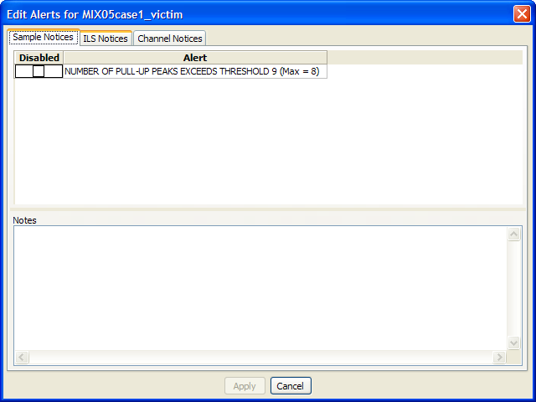

The user can edit or disable any Sample, ILS, or Channel notices in the window. Also, it is encouraged to enter notes to explain the action taken. Following is an example of editing locus or allele peaks:

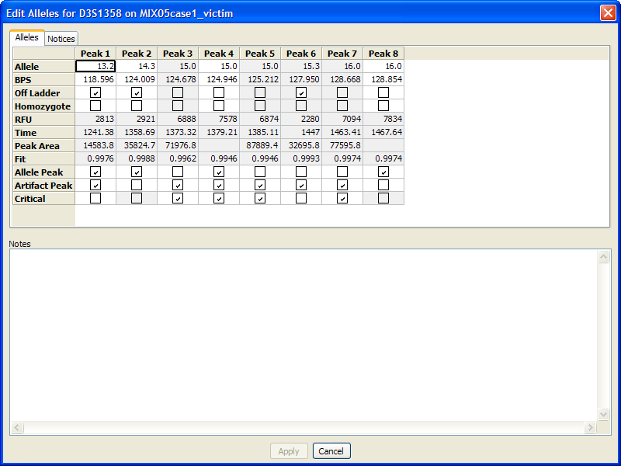

The table above shows a column for each peak found in the selected locus, D3S1358 in this example. The first four rows, Allele, BPS, Off Ladder, and Homozygote, can be edited if the peak is an allele. The bottom three columns, Allele Peak, Artifact Peak, and Critical can be modified to determine if the peak is an Allele, an Artifact, or both and also, for artifacts whether or not they are critical. Whether or not an artifact is critical determines how it is displayed in the plot window which is covered in more detail in the next section. If a peak is not designated as an allele its details are not displayed in the Analysis window and if it is neither an allele nor an artifact, its details are not acknowledged in the Graph window for this sample. The allele notices can also be disabled or edited in the same manner as the sample, ILS, and channel notices by simply selecting the “Notices” tab at the top of the window. Also, as with the sample, ILS, and channel notices, it is encouraged to enter notes describing all changes being made to the locus peaks and notices.

**History**. The history button or menu item is used to display the data as it was saved in previous versions of the file. This is more useful for .oer (OSIRIS Edited Report) files than .oar (OSIRIS Analysis Report) files because .oar files should not be modified. The history button or menu item displays a (sub)menu with a list of dates the file was saved along with “Original” and “Current.” The “Original” selection shows the original data obtained from the analysis before anything was edited. The “Current” selection shows the data with all editing (if any) performed since the last time it was saved. If the file was saved an excessive number of times, some of the dates will appear in the menu with a selection for “More…” which displays a dialog window that allows the user to select from all of the dates/times the file was saved. For the analysis window the first item in the history menu is one of the following depending on the selected cell or row: View Sample Notices, View ILS Notices, View Channel Notices, or Allele Edit History. This selection is enabled only for data that have a history of being edited and it displays a dialog window containing details of the editing performed and saved on the selected cell or sample.

The buttons adjacent to the “History” button are used to display state of the file at the previous and next times the data was saved. If any historic time other than “Current” is selected, the selected time is displayed in the window title.

**Sort**. This allows the user to sort the samples by sample name or severity. When sorting by sample name, the ladders and positive controls are shown at the top followed by each sample in alphabetical order. When sorting by severity, the actual severity is determined by the number of notices for the sample. A sample with no alleles found may be shown at the bottom even though it may be more severe than a sample with many alleles found, but also many notices.

**Parameters…**  This button or menu item displays a popup window containing the parameters used for this analysis. The input and output directories are hyperlinked to enable the user to view the contents. Following is an example:

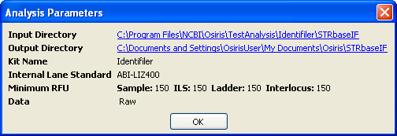

**Display.** This pull down or submenu allows the user to display Alleles, BPS, RFU, Time, or Peak Area in the table cells.

**CMF** or **Export CMF File…** This option allows the user to export the data in a CODIS 3.2 Common Message Format (CMF) file. Please note that if the analysis file has been edited, it must first be saved before exporting a CMF file. If it has not been saved, a window will appear to prompt the user to decide whether to save the file or cancel. When exporting a CMF file, a dialog appears with many options for the file and each sample. Following is an example:

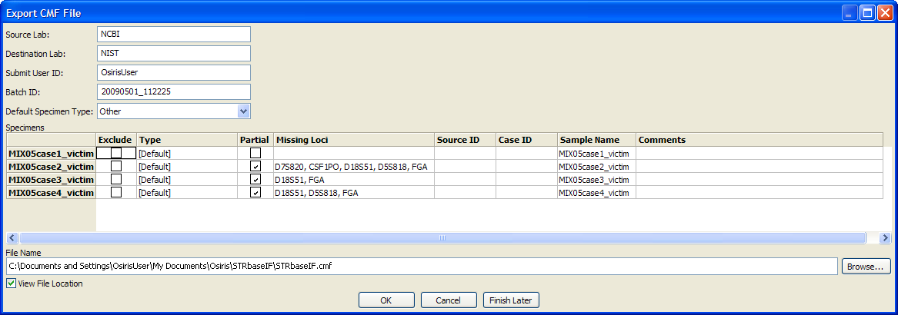

The Source Lab, Destination Lab, Submit User ID, and Default Specimen Types are automatically saved and used as the default for subsequent CMF files. The Batch ID is automatically created using the current date and time. The table contains a row for each sample. The exclude column allows the user to exclude one or more samples. The “Type” is a drop down list of all available types of specimens. If “[Default]” is selected, then the selection for “Default Specimen Type” above is used. “Partial” is selected if one or more loci do not have any allele calls. This can be modified by the user. “Missing Loci” shows a list of all loci that do not have any alleles. “Source ID” and “Case ID” can be edited by the user. “Sample name” is by default the name of the sample taken from the name of the original ABI .fsa file and used in the analysis file. It is also used as the row label on the left, but for purposes of writing a CMF file, it can be edited in the “Sample name” column. The “Comments” column allows the user to enter any desired comments for any sample to be included in the CMF file.

Below the table, the user can specify the name of the output file, which by default is the name and location of the Analysis file except with the file extension changed to .cmf. To find another location or change the file name, the user can select the “Browse…” button to choose from a file dialog window. There is a checkbox labeled “View File Location.” If this is selected, a window with the location of the CMF file is displayed after the file is created in order to access the file from the computer’s operating or window system. The CMF file is created when the user presses the “OK” button. If the user presses the button labeled “Finish Later” then this window will close and return the user to the Analysis window but all changes will be saved and restored if “CMF” is selected again. This is useful if the user needs to examine the data again before exporting the CMF file. If the “Cancel” button is pressed, all changes will be discarded.

# Osiris Plot Files

The OSIRIS Plot Files have an extension of .plt and unlike the report files, they are not intended to be edited. The plot files are used to display a graph of the raw, analyzed, and ladder electrophoresis data with labels for alleles, artifacts, and loci. The curve data and locus location are always obtained from the plot file, but the peak and artifact information can be obtained from either the plot file or a corresponding analysis file. If an analysis file is used to obtain the alleles and artifacts, then any changes made by the user are also reflected in the plot window. There are several ways to open a plot file. To open a plot file as a standalone file (without its corresponding analysis file) select “Open Plot File…” or “Recent Files…” from the “File” pull down menu on the menu bar and select the desired file. A plot file can also be opened from its corresponding report file by selecting the desired sample in the table of the Analysis window and selecting “Graph” from the tool bar if visible or by selecting “Display Graph” from the context menu (right click) or the “Table” pull down menu on the menu bar. If the latter method is used, the peak data displayed in the plot window will be obtained from the report file and the names of the plot and report files will appear in the title bar at the top of the window. When opening a plot file from a report or analysis window the curves and ranges depend on many factors. If the graph is opened when a locus is selected in the table, then the graph will be immediately zoomed to that locus, otherwise it will be zoomed out to show all peak data. If the Shift key is pressed when the graph is initiated, then one plot will be displayed otherwise a separate plot for each channel will be displayed. If the Shift key is pressed and a locus is selected, then the single plot will show only that channel zoomed in to that locus.

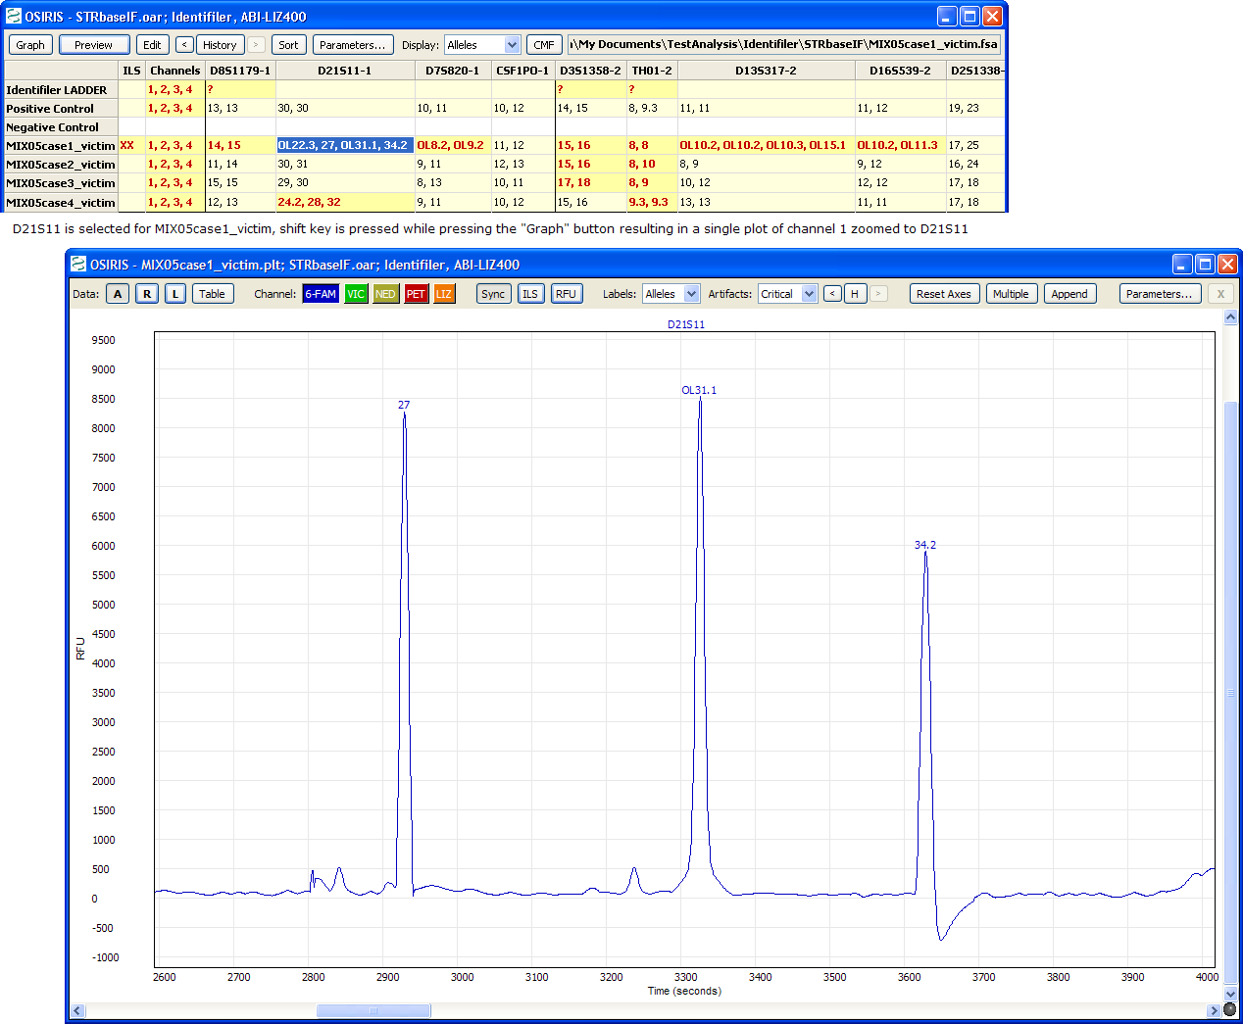

The image above shows the result of selecting the D21S11 locus of sample MIX05case1_victim, holding down the Shift key and pressing the “Graph” button. The plot was zoomed to the selected locus and only one plot was displayed because the Shift key was pressed. Note that two allele peaks displayed in the table are not shown in the plot, 22.3 (OL) and 39.1 (OL). This is because they are outside the range of the ladder for D21S11. These peaks can be shown by zooming out, a topic that will be discussed in detail later in this section.

## Toolbar

The toolbar at the top of each plot along with the “Graph” pull down menu on the menu bar have the following options: Data, Channels, Sync, ILS, RFU, Labels, Artifacts, History, Reset Axes, Multiple, Append, Parameters, and Close Plot (**X**). The menu also has items for showing or hiding the toolbars and scrollbars in the plot and the last selection of these items is used as the default when opening subsequent plot files. Following is a description of each option in the toolbar and menu:

**Data: Raw, Analyzed, Ladder, Table.** The toggle buttons labeled A, R, and L are used to show or hide the curves for Analyzed Data, Raw Data, and Ladder Data. If the shift key is pressed while selecting Analyzed, Raw, or Ladder, then the selection will immediately be used for all plots in the window. The “Table” button shows the window with the report data and selects the row for the sample in the graph window. If there is no report file opened for this graph window, the user is prompted to select a report file or cancel. If a report file is selected, it is used for labeling alleles and artifacts. The “Graph” pull down menu has a submenu for each plot and each of these submenus has a “Data” submenu with entries for these options. In addition to this, the “Graph” pull down menu has a menu item labeled “Show Table” which performs the same action as the “Table” button.

**Channel.** There is a toggle button for each channel labeled by the channel name and its background color corresponds to the color of the channel and its plot. If the shift key is down when pressing a “Channel” button, then only that channel will be display with all other channels hidden.

**Sync** or **Synchronize Axes**. This toggle button or checked menu item is used to synchronize multiple plots when domain and/or range are modified. If this is selected, every time the view is changed, the view is updated on all other plots where this option is also selected.

**ILS** or **Show ILS**. This option shows or hides vertical lines to indicate where the peaks are in the ILS channel. The color of the lines corresponds to the color of the ILS channel. If the shift key is pressed while selecting this option, the setting will be shown in all plots in the window.

**RFU** or **Show Minimum RFU**. This option shows or hides one or more horizontal lines to indicate the location of the minimum RFU selected when the analysis was performed. The actual lines are for the minimum sample and/or ILS RFU depending on the selected channels. If the shift key is pressed while selecting this option, the setting will be shown in all plots in the window.

**Labels**. This option determines how the alleles will be labeled. The options are None, Alleles, BPS, RFU, or Time. If the shift key is pressed while selecting this option, the setting will be shown in all plots in the window. The labels appear above the allele peaks and when the cursor is placed over a label, a box appears with detailed information about the allele. The loci are also displayed at the top of the plot unless “None” is selected. When the user clicks on a locus label, the plot is zoomed to the range and domain of that locus and if “Sync” is selected, all other synchronized plots are zoomed also.

**Artifacts**. This option determines which artifacts are labeled: All, Critical, or None. The artifacts are labeled with an “A” and when the cursor is placed over the label a box appears with detailed information about the artifact. If the shift key is pressed while selecting this option, the setting will be shown in all plots in the window.

**H, History**. The history button or menu item is used to display the data as it was saved in previous versions of the report file. This is more useful for .oer (OSIRIS Edited Report) files than .oar (OSIRIS Analysis Report) files because .oar files should not be modified. This is similar to the history option in the report window, except the button is labeled with only the letter “H” in order to save space. The button or menu item displays a (sub)menu with a list of dates the file was saved along with “Original” and “Current.” The “Original” selection show the original data obtained from the analysis before anything was edited. The “Current” selection shows the data with all editing (if any) performed since the last time it was saved. If the file was saved an excessive number of times, some of the dates will appear in the menu with a selection for “More…” which displays a dialog window that allows the user to select from all of the dates/times the file was saved. If there is no report file opened for this graph window, the user is prompted to select a report file or cancel. If a report file is selected, then the selected report file is used for labeling alleles and artifacts.

**Reset Axes, Show Primer Peaks**. When “Reset Axes” is selected, the plot is zoomed out to show all peak data. If the Shift key is pressed when selecting “Reset Axes” from the toolbar or if “Show Primer Peaks” is selected from the menu, then the plot is zoomed out to show all data including the primer peaks at the beginning of the plot.

**Multiple, Multiple Plots, Remove Other Plots**. When “Multiple” or “Multiple Plots” is selected, a separate plot is displayed for each channel. If the Shift key is pressed when selecting “Multiple” on the toolbar or if “Remove Other Plots” is selected from the menu, then all other plots are removed leaving only one plot displayed.

**Append**. This option appends a new identical plot below the plot whose menu or toolbar is performing the action. The maximum number of plots is equal to the number of channels and when that maximum is reached, this feature is disabled.

**Parameters…**  This button or menu item displays a popup window containing the parameters used for this analysis. The input and output directories are hyperlinked to enable the user to view the contents. This feature is also available when viewing report data. Following is an example identical to the one in the previous section on OSIRIS Report Files:



**X, Remove Plot**. This option removes the specified plot from the window. If this “X” button is pressed on the toolbar while the Shift key is pressed, all plots except this one are removed in the same manner as pressing the “Multiple” button with the Shift key down or selecting “Remove Other Plots” from the menu. If there is only one plot displayed, this feature is disabled.

**Arrows.** If the toolbar is too narrow to accommodate all of its items, then an arrow is displayed at each end and the user can click on the arrow to shift the items on or off the visible portion of the toolbar as shown below.

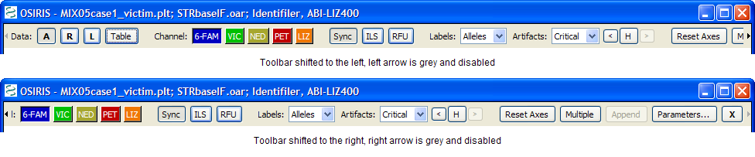

## Resizing Plots

When viewing multiple graphs in a single window, the height of each graph may be too small. The height of each plot can either be fixed to fit into the window or resized to be larger with a new scrollbar added to scroll through the larger plots. This option is chosen by selecting “Resizable Plots” in the “Graph” pull down menu as shown below.

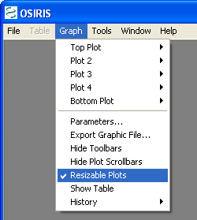

When this is selected, a sash or horizontal bar is displayed between each plot. The plot can then be resized by clicking and dragging this bar to the desired size as shown below.

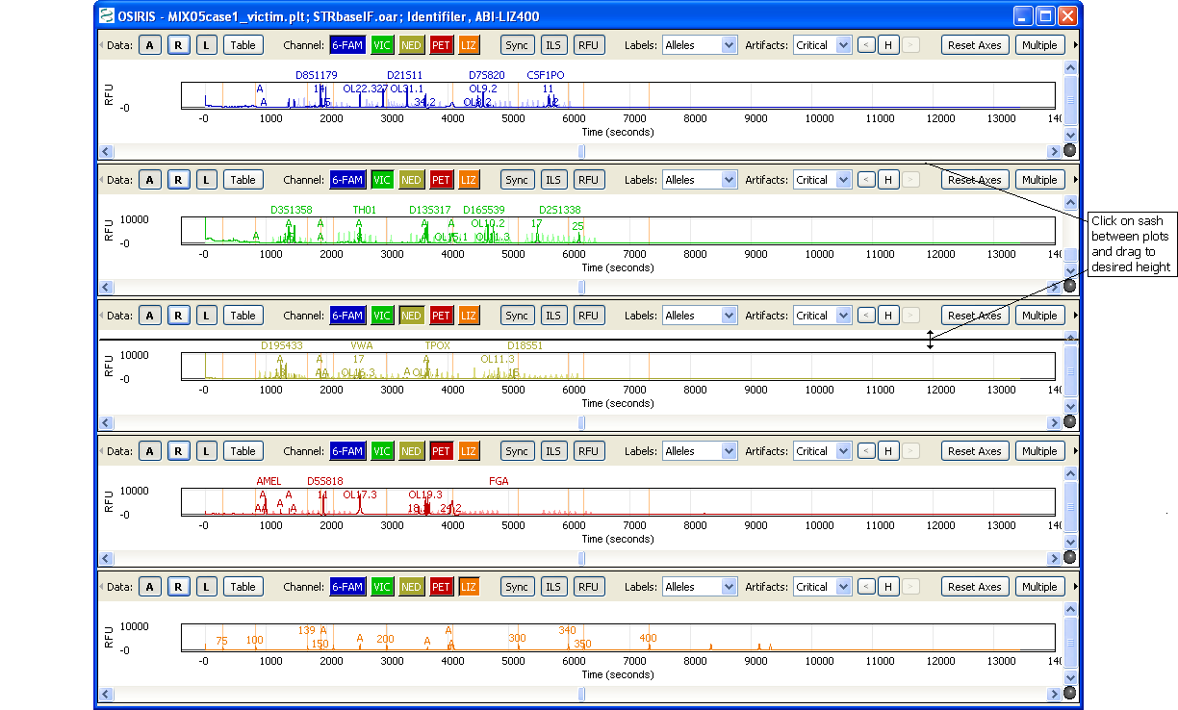

After dragging the sash, **each plot** is resized to the selected height and a scroll bar is shown on the right if the total height exceeds the height of the window.

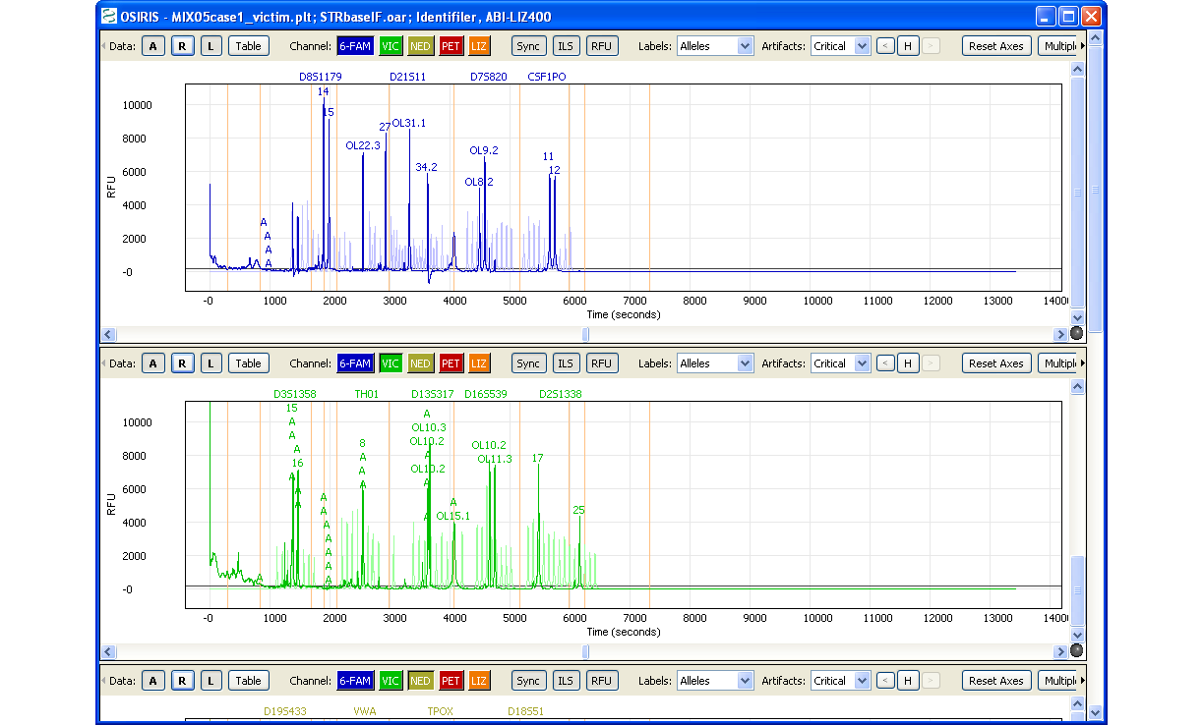

Once the plots have been resized, the new size becomes the default size when opening a new graph window. **Please note:** On the version of OSIRIS for the Macintosh, there is no black line or marker displayed when dragging to resize the plot and it does not appear to be resized until the mouse button is released.

## Viewport and Zooming

When viewing the graph, it is often desirable to zoom and/or pan to a particular locus or peak and there are several ways to do this.

**Reset Axes.** To view all of the allele peaks, select “Reset Axes” on the toolbar or from the plot submenu on the “Graph” pull down menu. This viewport will not include the primer peaks near the origin of the plot. To include primer peaks, hold down the Shift key when selecting the “Reset Axes” button on the toolbar or select “Show Primer Peaks” from the plot submenu on the “Table” pull down menu.

**Zoom To Locus.** To zoom to a particular locus, simply click on the locus name at the top of the plot. This will zoom the X-Axis to the range specified by the ladder and the Y-axis to accommodate all data in that range. This will not display adjacent interlocus peaks, but they can be viewed by clicking on the plot and pressing “a” on the keyboard. Keyboard options for setting the viewport are described later.

**Zoom to Rectangle.** Another method of zooming is to click and drag the mouse in order to draw a rectangle around the desired region. An example is illustrated below:

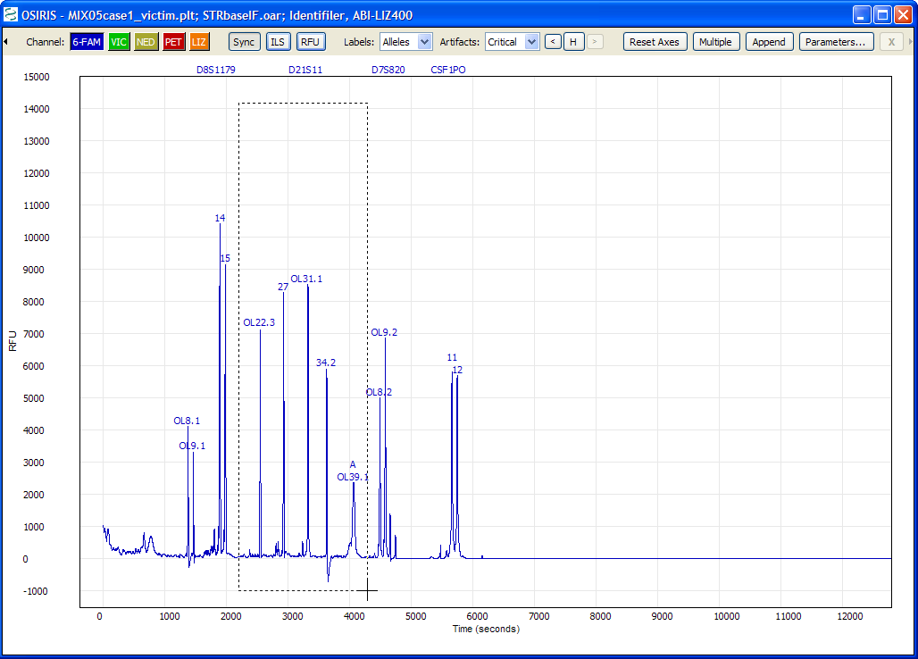

Click on a corner of the desired rectangular region and drag the mouse to see an outline.

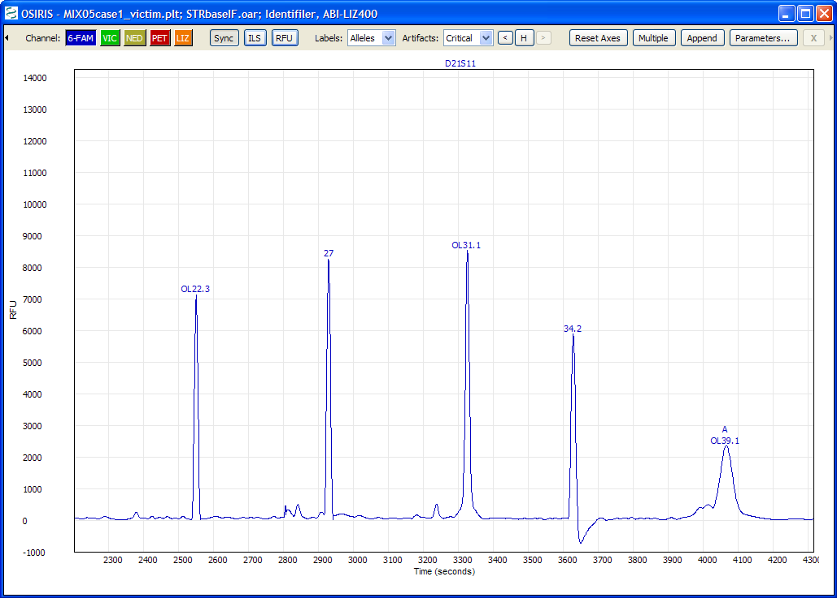

After the mouse button is released, the plot is zoomed to the selected region.

If the results are not as desired, simply reset the axes as described above and try again. You will eventually figure it out if you have any active brain cells.

**Shift Axes.** To shift the X or Y axes, move the cursor over the axis labels and when the cursor changes to two arrows (up and down for the Y-axis, left and right for the X-axis) simply click and drag the mouse to shift the range.

**Keyboard Control.** There are several keys that will change the viewport of the plot. Before using the keyboard it is important to first click on the plot in order to select it for receiving the keyboard input. The alphabetic keys must be lowercase. The keystrokes are as follows:

Arrow/Cursor Keys – Pan by a small amount in the direction indicated by the arrow.

Page Up/Page Down – Pan the Y-Axis up or down by a large amount.

Home – Center the plot around the origin (0,0).

a – Zoom out X-Axis

d – Zoom in X-Axis

x – Zoom out Y-Axis

w – Zoom in Y-Axis

e – Zoom in both axes

z – Zoom out both axes

s – Zoom out to show all data including primer peaks

q – Zoom out X-Axis, zoom in Y-Axis

c – Zoom in X-Axis, zoom out Y-Axis