[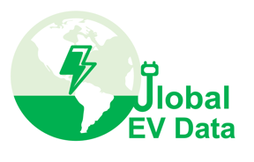](https://globalevdata.github.io/)

# Global EV Data Application Form

(Version 2024.1 revised on 14 December 2024)

Note: This form is used to apply for datasets available through the Global EV Data Initiative (please see its website: <https://globalevdata.github.io/> ). Please fill in this application form and send it to the email address [global.ev.map@gmail.com](mailto:global.ev.map@gmail.com). If you any questions, you may also contact us by email.

1. Institution: Click here to enter text.
2. Title and Name: Click here to enter text.
3. Email: Click here to enter text.
4. Databases you need (multiple choices):

2022 Europe EV Charging Station Database

2024 Europe EV Charging Station Database

2022 USA EV Charging Station Database

2024 USA EV Charging Station Database

2022 China EV Charging Station Database

2024 China EV Charging Station Database

Other datasets (you could also apply for other datasets used in the work published by the Global EV Data Initiative), please specify: Click here to enter text..

1. Justification (no less than 100 words):

|  |
| --- |
| You may explain here why you need these datasets which you are applying for. Please also give details if these datasets will be used in any research projects. |

1. Declaration:

By completing this declaration, I hereby declare that the information included in this application form is true and correct to the best of my knowledge. I understand that any false or misleading information given by me in connection with my application may result in termination of the application process.

**Date: _______________________ Signature: ____________________**