**Android Live TV on DragonBoard 410C**

In this Project, an attempt is made to build the Android TV on Dragonboard 410C. We have tried installing many third party TV apps from play store. Though it plays the Channels, the main objective was to run the TV app utilizing the Andorid TV Input Framework provided by Google. For which, we have used an in-built reference LiveTv App and Sample Input Apps.

Basically the DragonBoard 410C is not designed for TV Platform, but as the Google has added the TV input framework from Android5.1, an attempt is made to enable the TV platform and integrate the TV App and Input apps. The Android TV Input Framework implementation includes the TV Input Manager which allows the communication between the TV App and the Inputs. The TV Input Framework allows different kind of inputs like External STB, Built-in Tuner Input, HDMI Input etc.

To Start with, we have used the Reference LiveTv App building for arm64 as a TV App and the Sample Input apk for the TV Input. The Sample Input allows the user to configure the Channels in two different ways:

1) Simple Input which consist of local video files which acts as different channels

2) Rich TV Input consist of 4 Channels served from Google Cloud Storage comprizing of MP4 Videos, HLS Stream, MPEG - DASH Stream.

**Dependencies:**

An Exoplayer is build and installed in order to play the videos.

**Step by Step Instructions:**

* Compile the project and install the app to your Android TV device (Refer README).
* Start the pre-installed system app Live Tv
* To set up the Rich TV input:
  + Either click Search upon starting Live TV App to search for channels or when running Live Tv app,

Click ENTER to bring out Recent Channels

Click DOWN to enter TV options

Click RIGHT to Channel sources and select it

Click DOWN to select Rich Input and hit ENTER

Click ADD CHANNELS NOW to add 3 channels of MP4 videos, HLS stream etc.

**Below are the Screeshots of the LiveTv**

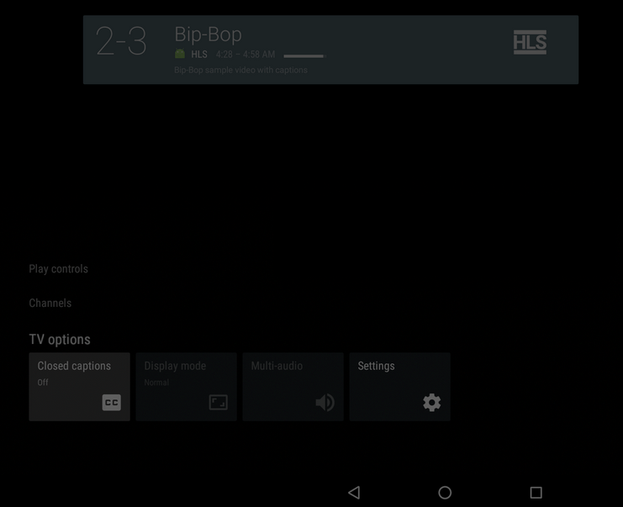

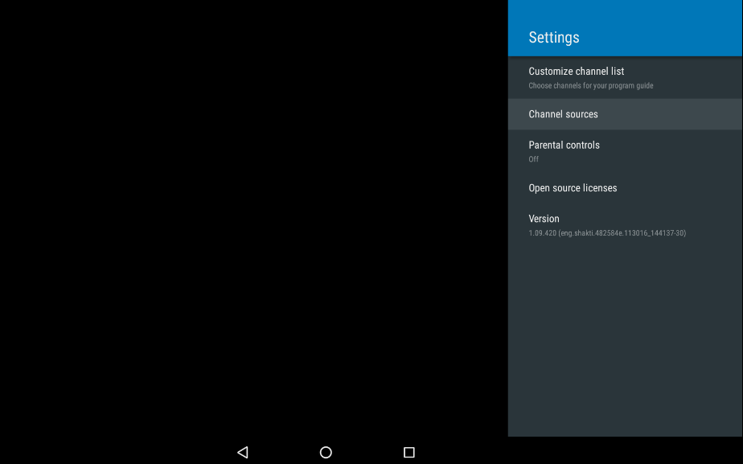

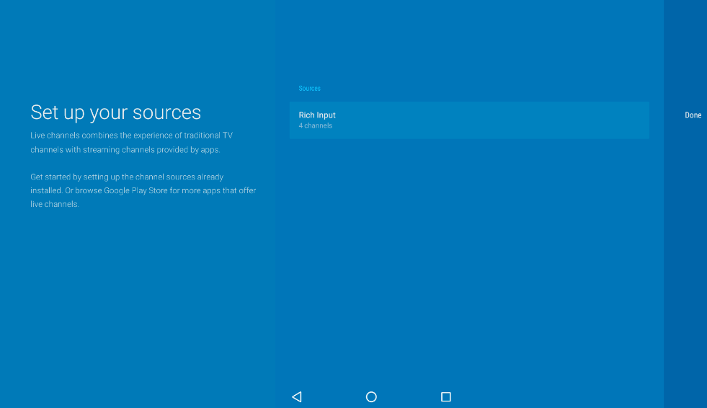

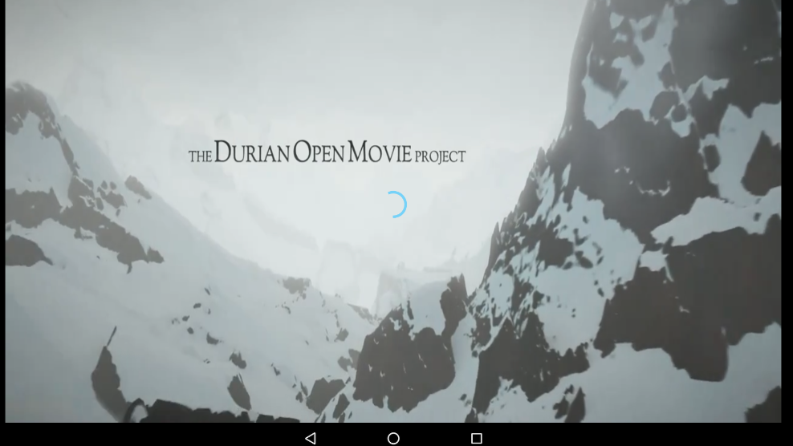

**Further work in Progress**

We are further working on the IR Sensor with Universal Remote Integration on to 410C, PIP Implementation, USB Tuner integration and Customer Launcher Implementation.

**References**

1) <https://source.android.com/devices/tv/reference-tv-app.html>

2) <https://github.com/googlesamples/androidtv-sample-inputs>

3)[https://android.googlesource.com/platform/developers/build//525b558/prebuilts/androidtv/sample-inputs/README.md](https://android.googlesource.com/platform/developers/build/+/525b558/prebuilts/androidtv/sample-inputs/README.md)