This was a 22-person student project using Unreal Engine 5 which was the largest team I had ever worked with. It was the first opportunity I had to work with all disciplines studying at the school. Our version control was a Perforce repository set up by our school’s IT department. My main roles on the team were Quality Advocate and gameplay programmer.
My responsibilities as the Quality Advocate were processing weekly unit tests and maintaining a weekly playable build for our instructors. I enjoyed it. It was a different form of work I wasn’t used to, but it let me work with each member of my team and see ways for us to improve our game together. Together some of my teammates and I would find things that were breaking or just didn’t feel right in terms of quality and experience for the game. Even though I had this role I was still contributing to the game through gameplay implementation.
As a programmer I was working with teammates and leading sprints for the gameplay features, I oversaw and helped complete. This included the implementation of, Companion moths, the Moth Incubator, the Moth Frame, and a Moth Manager alongside data tables containing all the information of the moths so iteration was easy. Additionally, I had a hand in the back-end development of setting up and establishing the pipeline between UI and gameplay and the inventory and gameplay.

Quality Advocate
Each leadership role during this project had a mentor to reach out to for questions and they gave a helping hand to get us started. Our QA (Quality Advocate) mentor provided an example and general idea on what to include for our weekly unit tests to make sure everything worked as intended with a rating: Failed, Partial, Passed. The way to use the spreadsheet was easy since it was just a checklist. The way I would fill it out was by playing through the game thinking like a player at first and then trying to see how fast I could break new features. I would also fill out our weekly build notes in tandem with the sheet to log any outstanding features for our project leads and directors.
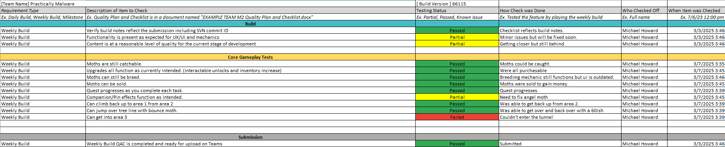
There’s a lot I learned from hindsight alone. One of the mistakes I made was not presenting an easier workflow for my teammates to use to help in filling out the weekly build checklist. I had help with milestones usually but for each other week it was usually just me filling things out at the last moment due to other classes and other projects. If I had created the checklists earlier the team would be able to use them. Reasons for that were usually people needed more time to add something new, otherwise it would end up being the same exact build as before, which did not look good, so our producer tried to have everyone get something added in. The biggest problem I had which also was a mistake was that there were some things I couldn’t test properly since they weren’t my in field at all in terms of what our project lead would be grading on. Specifically, audio andperspective, game were parts I couldn’t test as well or with their experienced perspective; so, I only had the view of a new player for those aspects. One person from each discipline is the best solution for what we were going through. It would have been a great way for my other members to understand how it was interacting with other elements of the game and help keep us all more connected to the game’s original vision.
Moth Data Tables
Using Unreal’s Data Table system I went through a couple iterations of what to include and set it up to work similarly to a C++ std::map. With the data table Designers or I would be able to just change variables like a spreadsheet and the code using it would be able to handle whatever the variables were changed to. This allowed us to change thumbnails, moth models, names, attach companion effects, and modify durations in places like the Incubator all in one place.
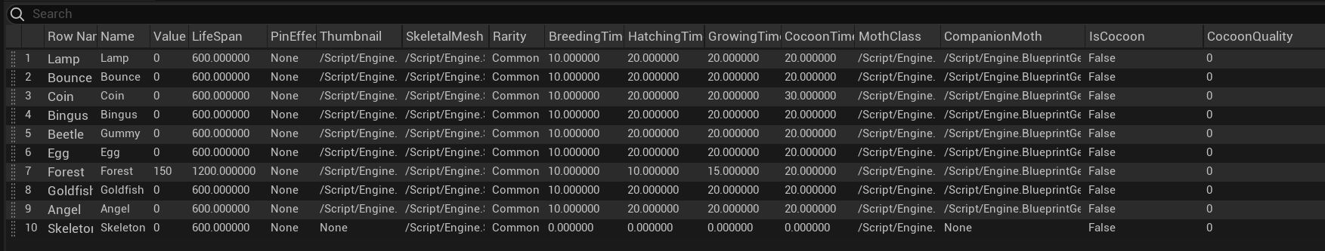
For the Moth Manager I had to create a simplified version of it because as I was figuring out how to use a data table created in the Unreal editor alongside C++ I had to create a similar struct and apply that to the new Data Table. There wasn’t a way to swap out the row struct after it was created so it felt like the best option at the time but hopefully there’s more resource now or a change in a newer version that would allow it.
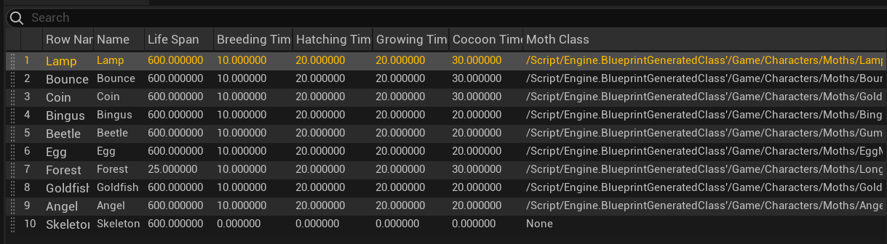
Moth Manager
The Moth Manager was intended to manage a much more complex idea than it ended up as. In early development I had gotten it to manage the mechanic of moth lives essentially. All moths in the world as soon as they are created would have a unique ID and their lives would be on a time and after the timer expired they would be destroyed wherever they were, whether in containers withing the shop or incubator they or the players inventory. This was a pretty convoluted idea and didn’t have enough time to be polished for the end so it was reworked and became only a way to create/destroy moths and give them a unique ID. The unique ID was vital, since we had to compare moths and had sorting in inventories it was the simplest way to make sure it didn’t compare against itself.

Companion Moths
The concept of the companion moths in the game quickly became a big favorite among the team and anyone who saw them in action. The idea stemmed from using them as general idea of progression and game manipulation. Specifically, their abilities that could give incredible jumping power or speedier movement – it gave players a greater sense of control and immersion in the world they were experiencing. The power the moths shared came directly from the quality of it so a quality of 100, the max that can be attained through breeding, was the most extreme experience players would get from a moth. To put in perspective slightly easier if a Bounce Moth of a quality of 10 would increase the player’s jump power by 10 percent and then a quality of 100 would increase it by 100%. It created unique ways to play the game – even stacking if two moths of the same kind are equipped.
Using the Moth Data Tables and Moth Manager moths were much easier to manipulate and ensure they would work correctly. Since this was one of the bigger features I was leading in I designed the backend classes and systems that allowed companions to be changed in menus as well as the general design of the parent to child class relationship that let my teammate and I create the first iteration of all 9 moths within a month.

Breeding Tank
The Breeding Tank was originally planned to contain the entire birth cycle of the moth from the moths breeding to eggs hatching, caterpillars growing and forming cocoons, to then finally be a fully grown moth once their time in the cocoon was up. I created 3 different objects that would be fully contained within themselves and update and progress to the next stage when they were ready. Each stage would have its own constraint whether they could continue progressing like food for caterpillars for instance, which was easy to implement since they updated individually. This also involved a food system where we would define a food object and give it an energy amount or time it takes to be consumed. So every caterpillar in the tank was able to take part in a whole apple.
The features all together became too much for out team to handle since new idea were coming up and were overwriting previous ideas too fast and content inevitably was cut. So, in the end these moths became mammals and only the breeding stage was kept.
Moth Frame
The Moth Frame was quicker to implement considering the difficulty of the other features. In a week I was able to roughly implement the Moth Frame effects for each moth and place the code required in any features they would be effecting. The Moth Frame in essence was a container to create modifiers for gameplay including: breeding time, money earned, bonus money when a moth is caught, and even money over time based on how many moths you have.
The most difficult one was the last one with money based on moths you had. It required adjusting variables within the moth manager and establishing a difference between a caught moth and a wild moth and being able to remove moths from that list without it breaking and there being stragglers in code when they were switched out.
Modifying For Upgrades
The modifications to handle upgrade system in the marker were mostly handled as unlocks for additional inventory slots. The upgrades for companion moths were unlocking the ability itself and then purchasing its extra slot for a max of two companions at once. The upgrade for Breeding Tanks worked similarly and was implemented to reveal extra breeding tanks that you so that you could multitask. Finally, the Moth Frame upgrade was the ability to get more slots so you could have additional bonuses at a time with a max of 9 slots. Both the Companion Moth and Moth Frame upgrades worked by increasing the inventory component size of the inventory slots used to hold moths making it so that the upgrades could be iterated easily to manage adding either another companion moth or even more Moth Frame Slots.
Difficulties
Angel Moth
Team Morale
Final Thoughts

