General Overview:
To give the project a very basic overview: It was a 22-person student project using Unreal Engine 5 which was the largest team I had ever worked with. It was the first opportunity I had to work with all disciplines studying at the school. Our version control was a Perforce repository set up by our school’s IT department. My main roles on the team were Quality Advocate and gameplay programmer.
So, what exactly did I do working on the team? I learned more about responsibility in a leadership position and how to communicate with a team more effectively. Communication between us became very spotty in the end and we had to work through that, but the game still ended in a much better place than I anticipated honestly. My responsibilities as the Quality Advocate were processing weekly unit tests and maintaining a weekly playable build for our instructors. I enjoyed it. It was a different form of work I wasn’t used to, but it let me work with each member of my team and see ways for us to improve our game together. Together some of my teammates and I would find things that were breaking or just didn’t feel right in terms of quality and experience for the game. Even though I had this role I was still contributing to the game through gameplay implementation. Key features I was responsible for setting up the experience for were the Companion Moths, Breeding Tank, and MOTHer 3000 or Moth Frame as I usually called it since that’s just easier to understand. Smaller roles were being a generalized bug fixer and getting unreal to
Quality Advocate
Each leadership role during this project had a mentor to reach out to for questions and they gave a helping hand to get us started. Our QA (Quality Advocate) mentor provided an example and general idea on what to include for our weekly unit tests to make sure everything worked as intended with a rating: Failed, Partial, Passed. The way to use the spreadsheet was easy since it was just a checklist. The way I would fill it out was just by playing through the game thinking like a player at first and then trying to see how fast I could break new features. I would also fill out our weekly build notes in tandem with the sheet to log any outstanding features for our project leads/directors.
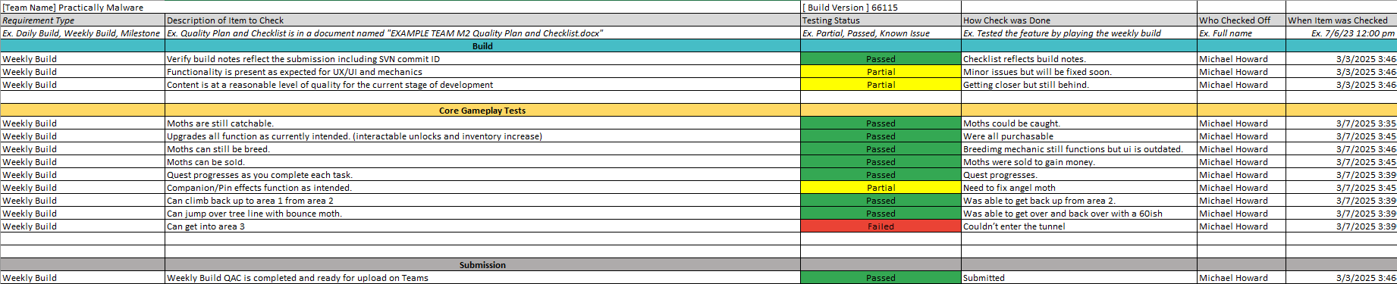
There’s a lot I learned from hindsight alone. One of the mistakes I made was not presenting an easier workflow for my teammates to use to help in filling out the weekly build checklist. I had help with milestones usually but for each other week it was usually just me filling things out at the last moment due to other classes and other projects. If I had created the checklists earlier the team would be able to use them. Reasons for that were usually people needed more time to add something new, otherwise it would end up being the same exact build as before which did not look good, so our producer tried to have everyone get something added in. The biggest problem I had which also was a mistake was that there were some things I couldn’t test properly since they weren’t my field at all in terms of what our project lead would be grading on. Specifically, audio and art for the game were parts I couldn’t test as well or with an attached perspective; so, I only had the view of a new player for those aspects. One person from each discipline is the best solution for what we were going through. It would have been a great way for my other members to understand how it was interacting with other elements of the game and help keep us all more connected to the games original vision.
Moth Manager
Base for managing which moths had been caught
Companion Moths
Key Points: Designed a framework for Louis to work off of and implement the functions for each moth. Implemented some of the creative features myself. Worked on getting animations to play.
What are they?
The concept of the companion moths in the game quickly became a very big favorite among the team and anyone we would show. The idea stemmed from using them a general idea of progression and game manipulation; specifically with abilities such as incredible jumping power and fast paced movement. The power the moths shared came directly from the quality of it so a quality of 100, the soft maximum, created unique ways to play the game – even stacking the same abilities if both moths equipped are the same.
What I did:
There were two important things I needed to design to start both of these off. I previously had put a lot of time into creating the “Moth Manager” system which kept track of existing moths and whether they had been caught which was done before hand Second was the “Companion Manager” in the game. It held every function that would handle triggering when the new moth was equipped or unequipped which was vital in managing when the new behavior was to be applied or removed. Additionally this was a means to play the moths animation of running up the players arm as well as how you could grab the current equipped effect which would later be important for the inventory UI.
Equipping these moths gave the player these abilities and I designed the framework that allowed us to implement these mechanics fast and efficiently. As my first introduction to unreal there is and was a lot for me to learn and I used the opportunity with this mechanic to learn how to use C++ in unreal. I mostly did this through inheritance, starting small with a base class that would then allow my teammate to go through and implement the required function that gave the player the ability. I discussed with him specifically since our plan was to share the work and with the base of the work done, he implemented 8 of the moths while I implemented all the Moth Frame modifiers. The ninth and final moth I implemented and its feature was to add a bonus to the other equipped moth had to dedicate a lot of time to solve since there was a lot situations to consider.
The Angel Moth:
This moth was able to boost the quality of whatever moth you had already equipped based on whatever quality the angel has. Which means that whatever calculation any moth that would or had already been equipped must do it again with a temporary change of quality. A lot of problems came up with the implementation of this moth specifically just because of the influence it would have on the entire system that I unfortunately had not planned ahead enough to edge case this moth specifically. When I first started making it moths still had not been designed yet. Big bugs consisted of: the moth it was equipped alongside stacking additional permanent quality as well as one where they were not getting any bonus if the angel moth had already been equipped.
The solution I came up with became a rushed and maybe scrambled idea, but it managed to work. In the end I created another virtual function within the base class specifically for refreshing with a new quality – which did mean going through every moth again to accommodate the new behavior. Creating a modifier variable in the manager also became a part of the solution so systems that worked outside and within the companion manager were able to see what the change would be. Within the companion manager I would use the modifier for creating the companion moth object which fixed the problem of if an angel moth was already equipped. [consider blueprint examples]
Breeding Tank
Key Points: Calculation for output, quick keys and managing the timers for different stages (deprecated)
For the breeding tank I was responsible for setting up the interactable object that players would see as well as its main feature.
Moth Frame
Found the idea for a singleton class style implementation for stat modifiers.
Final Thoughts
UX and optimization skills are skills I want to develop further due to issues on the game.

This project gave me a great opportunity to experience the workflow and care needed for a 22-person project. I was given the chance to take the role of quality advocate on the team and learned what it meant to be responsible for a large aspect of the game – especially so, since it involved all disciplines on our team. With previous experience as a tech lead for a much smaller project, I had an idea of what would be similar but that under shadowed what I was truly meant to do as I struggled with being truly effective. This was one of the most prominent roles I had on the team but what I genuinely love and was able to learn more about it in Unreal was even more gameplay programming.

