**Updated:** 5/2/2020 6:48 PM

# Overview

* Provides a command line interface for the pa11y engine to run quick accessibility tests using rulesets from axe-core or HTML Code sniffer
* By default, pa11y CLI runs HTML code sniffer rulesets against WCAG 2 AA success criteria
* Install the pa11y CLI globally using npm

# Software required

* Node.js 6+
  + <https://nodejs.org/en/>
* Pa11y CLI tool
  + <https://github.com/pa11y/pa11y>
* <optional> If you want to send results to an HTML file, install **pa11y-report-html**
  + <https://www.npmjs.com/package/pa11y-reporter-html>

# Installation

* Node.js 6 or higher
* Chrome or Firefox Browser
* Pa11y CLI globally:
  + npm install -g pa11y
* Pa11y Reporter <optional>:
  + npm install -g pa11y-reporter-html

# Usage and Syntax

Usage: pa11y [options] <url>

Options:

-V, --version output the version number

-n, --environment output details about the environment Pa11y will run in

-s, --standard <name> the accessibility standard to use: Section508, WCAG2A, WCAG2AA (default), WCAG2AAA – only used  
 by htmlcs runner

-r, --reporter <reporter> the reporter to use: cli (default), csv, json

-e, --runner <runner> the test runners to use: htmlcs (default), axe

-l, --level <level> the level of issue to fail on (exit with code 2): error, warning, notice

-T, --threshold <number> permit this number of errors, warnings, or notices, otherwise fail with exit code 2

-i, --ignore <ignore> types and codes of issues to ignore, a repeatable value or separated by semi-colons

--include-notices Include notices in the report

--include-warnings Include warnings in the report

-R, --root-element <selector> a CSS selector used to limit which part of a page is tested

-E, --hide-elements <hide> a CSS selector to hide elements from testing, selectors can be comma separated

-c, --config <path> a JSON or JavaScript config file

-t, --timeout <ms> the timeout in milliseconds

-w, --wait <ms> the time to wait before running tests in milliseconds

-d, --debug output debug messages

-S, --screen-capture <path> a path to save a screen capture of the page to

-A, --add-rule <rule> WCAG 2.0 rules to include, a repeatable value or separated by semi-colons – only used by htmlcs  
 runner

-h, --help output usage information

### Running Tests

Run an accessibility test against a URL:

pa11y http://example.comRun an accessibility test against a file (absolute paths only, not relative):

pa11y ./path/to/your/file.html

Run a test with CSV reporting and save to a file:

pa11y --reporter csv http://example.com > report.csv

Run Pa11y with the Section508 ruleset:

pa11y --standard Section508 http://example.com

Run Pa11y using [aXe](https://www.axe-core.org/) as a [test runner](https://github.com/pa11y/pa11y#runners):

pa11y --runner axe http://example.com

Run Pa11y using [aXe](https://www.axe-core.org/) and [HTML CodeSniffer](http://squizlabs.github.com/HTML_CodeSniffer/) as [test runners](https://github.com/pa11y/pa11y#runners):

pa11y --runner axe --runner htmlcs http://example.com

### Exit Codes

The command-line tool uses the following exit codes:

* 0: Pa11y ran successfully, and there are no errors
* 1: Pa11y failed run due to a technical fault
* 2: Pa11y ran successfully but there are errors in the page

By default, only accessibility issues with a type of error will exit with a code of 2. This is configurable with the --level flag which can be set to one of the following:

* error: exit with a code of 2 on errors only, exit with a code of 0 on warnings and notices
* warning: exit with a code of 2 on errors and warnings, exit with a code of 0 on notices
* notice: exit with a code of 2 on errors, warnings, and notices
* none: always exit with a code of 0

### Command-Line Configuration

The command-line tool can be configured with a JSON file as well as arguments. By default it will look for a pa11y.json file in the current directory, but you can change this with the --config flag:

pa11y --config ./path/to/config.json http://example.com

If any configuration is set both in a configuration file and also as a command-line option, the value set in the latter will take priority.

For more information on configuring Pa11y, see the [configuration documentation](https://github.com/pa11y/pa11y#configuration).

### Ignoring

The ignore flag can be used in several different ways. Separated by semi-colons:

pa11y --ignore "issue-code-1;issue-code-2" http://example.com

or by using the flag multiple times:

pa11y --ignore issue-code-1 --ignore issue-code-2 http://example.com

Pa11y can also ignore notices, warnings, and errors up to a threshold number. This might be useful if you're using CI and don't want to break your build. The following example will return exit code 0 on a page with 9 errors, and return exit code 2 on a page with 10 or more errors.

pa11y --threshold 10 http://example.com

### Reporters

The command-line tool can report test results in a few different ways using the --reporter flag. The built-in reporters are:

* cli: output test results in a human-readable format
* csv: output test results as comma-separated values
* json: output test results as a JSON array

The Pa11y team maintain some additional reporters which can be installed separately via npm:

* [html](https://github.com/pa11y/pa11y-reporter-html): output test results in a self-contained HTML format (npm install pa11y-reporter-html)
* [tsv](https://github.com/pa11y/pa11y-reporter-tsv): output test results as tab-separated values (npm install pa11y-reporter-tsv)

You can also write and publish your own reporters. Pa11y looks for reporters in your node_modules folder (with a naming pattern), and the current working directory. The first reporter found will be loaded. So with this command:

pa11y --reporter rainbows http://example.com

The following locations will be checked:

<cwd>/node_modules/pa11y-reporter-rainbows

<cwd>/rainbows

A Pa11y reporter must export a property named supports. This is a [semver range](https://github.com/npm/node-semver#ranges) (as a string) which indicates which versions of Pa11y the reporter supports:

exports.supports = '^5.0.0';

A reporter should export the following methods, which should all return strings. If your reporter needs to perform asynchronous operations, then it may return a promise which resolves to a string:

begin(); // Called when pa11y starts

error(message); // Called when a technical error is reported

debug(message); // Called when a debug message is reported

info(message); // Called when an information message is reported

results(results); // Called with the results of a test run

# Examples

## Pa11y-CLI-Command-Ex-01

Single page default test runner (HTML Code Sniffer) and all default rules:

pa11y https://section508coordinators.github.io/BaselineTestPages2/test-cases/TC1005C001.html   
***Console window output:***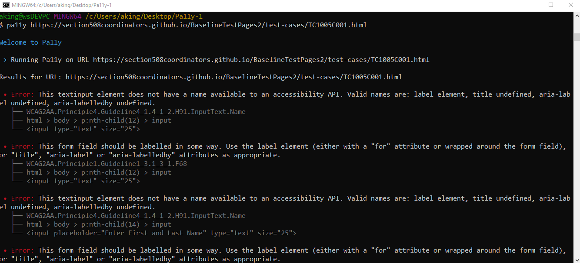

## Pa11y-CLI-Command-Ex-02

Single page test, specific preferred rules only, results saved as an HTML file with the name ***myReport.html***.

pa11y $ pa11y https://section508coordinators.github.io/BaselineTestPages2/test-cases/TC1005C001.html --runner axe --ignore "region;landmark-one-main" --reporter html > myReport.html

***Console window output: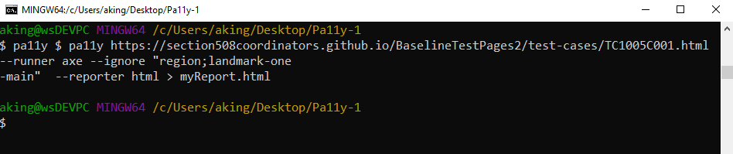 Resulting HTML Report File:***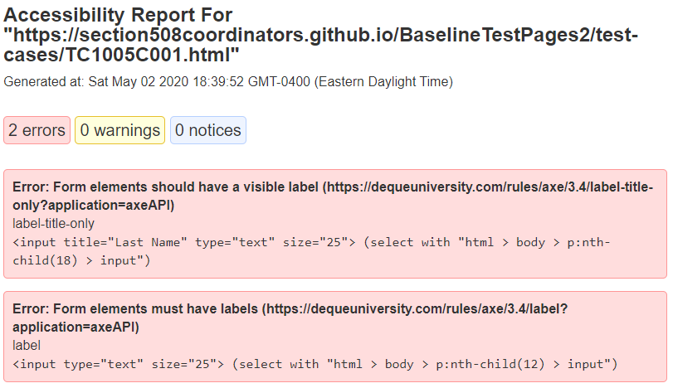

## Pa11y-CLI-Command-Ex-03

Single page test against a file on the local file system (not hosted on web site), specific preferred rules only, results saved as an HTML file with the name ***myReport.html***.

pa11y ///C:/_test/TC1005C001.html --runner axe --ignore "region;landmark-one-main" --reporter html > myReport.html

***Console window output:***  
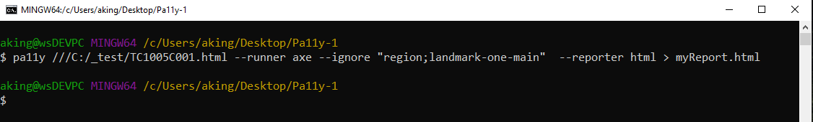 ***Subsequent HTML results file:***