NEWSROOM ENABLEMENT PACK
Data Dumpster: Newsroom Quick Start
A practical field guide for getting from a social signal to a newsroom decision.
AUDIENCE  Reporters, editors, audience, social and leadership | CORE JOB  Find a signal, verify its context and decide what to do next
DEFAULT LANDSCAPE  Boston News Landscape | COLLECTION CADENCE  Automatic, twice daily; screen reads stored data

Start with a question
- What happened? Use Cross-Channel or the Newsroom Screen.
- Why did it happen? Open Top Content, Social Posts or Story Cloud.
- What do we do next? Use the Weekly Report, Briefs or Alerts.
THE DEFAULT READ
Open the Boston News Landscape, choose the last seven complete days and reset company/platform filters before sharing a finding.

Open Data Dumpster
DAILY WORKFLOW
Set the context before you read a number
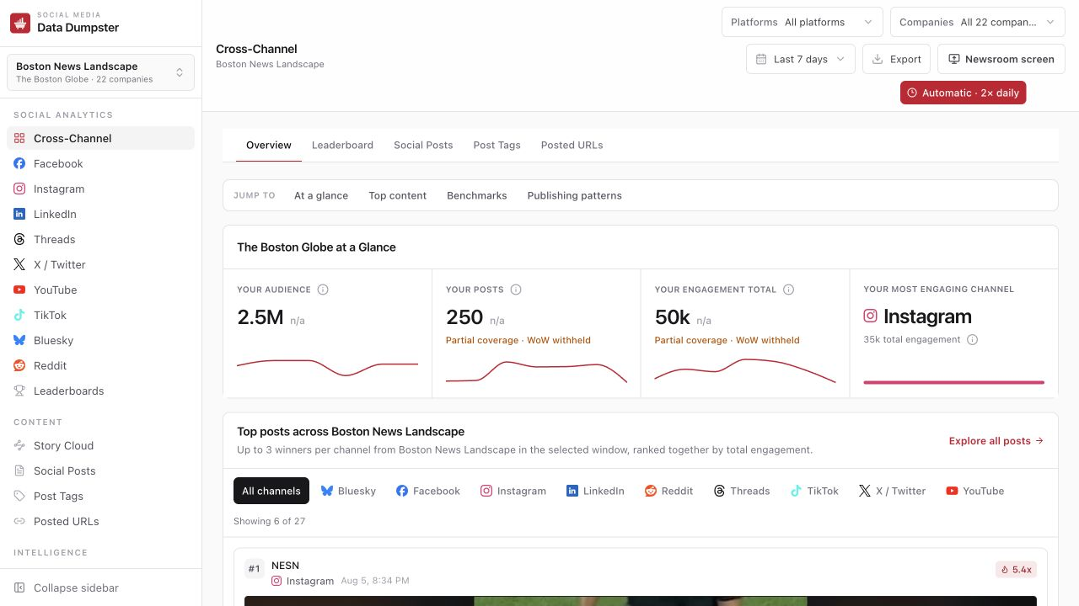
Production interface captured Aug. 7, 2026. Values and coverage labels change as collection progresses.

The three context checks
- Landscape — who belongs in the comparison set, and which company is the focus?
- Date window — are the current and comparison periods aligned?
- Filters — are platform and company filters still narrowing the result?
SHARE THE CONTEXT
A screenshot or spoken finding should carry the landscape, date window, platform and company filter with it.

METRIC CHEAT SHEET
Read the scorecard as a set
Metric | Read it as | Do not
Audience | Latest follower reading inside the selected window. | Add snapshots across days.
Posts | Published posts measured in the window. | Treat missing coverage as zero.
Total engagement | Measured reactions, comments and amplification across posts. | Compare without the same window and filters.
Engagement per post | Total engagement divided by measured posts. | Ignore a very small post count.
Outlier badge | Performance relative to that account’s usual post. | Assume a large multiplier explains why.
WoW change | Current window versus the prior matched window. | Publish it when the product withholds it.

Evidence labels
Label | What it means
Complete | The profile covers the requested window.
Usable, partial | Recent data is usable, but history or snapshots are incomplete.
Source-limited | The vendor cannot certify the full window or metric.
Action required | Configuration, credentials or operator attention is needed.
WoW withheld | The comparison is not trustworthy enough to publish.

NON-NEGOTIABLE
Audience is a stock, not a flow. Use the latest follower snapshot in the window; never sum daily follower readings.

CONTENT ANALYSIS
Move from a winning post to a testable hypothesis

Top Content
- Open the card. The media, copy, link and platform matter.
- Check the denominator. Is it merely a big total or an outlier for that account?
- Name the pattern: topic, format, timing, platform or distribution.
- Choose a response: repeat, repackage, investigate or deliberately do nothing.

Leaderboards
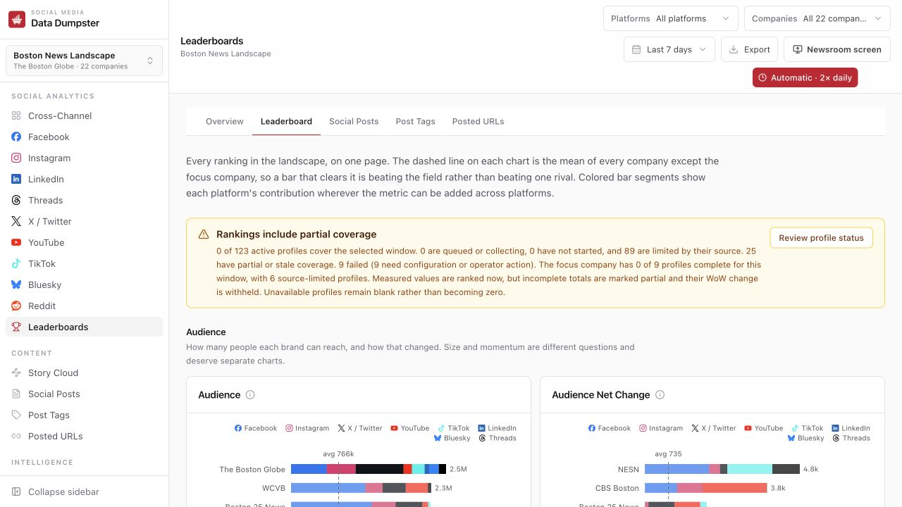
Use rank for relative questions. A visible partial-coverage notice means totals may be provisional.
Visual | How to read it
Rank | Position among measured companies in the selected landscape and window.
Dashed mean | Average of the field excluding the focus company.
Colored segments | Each platform’s contribution when the metric can be added across platforms.

WEEKLY WORKFLOW
Turn analysis into a repeatable leadership readout
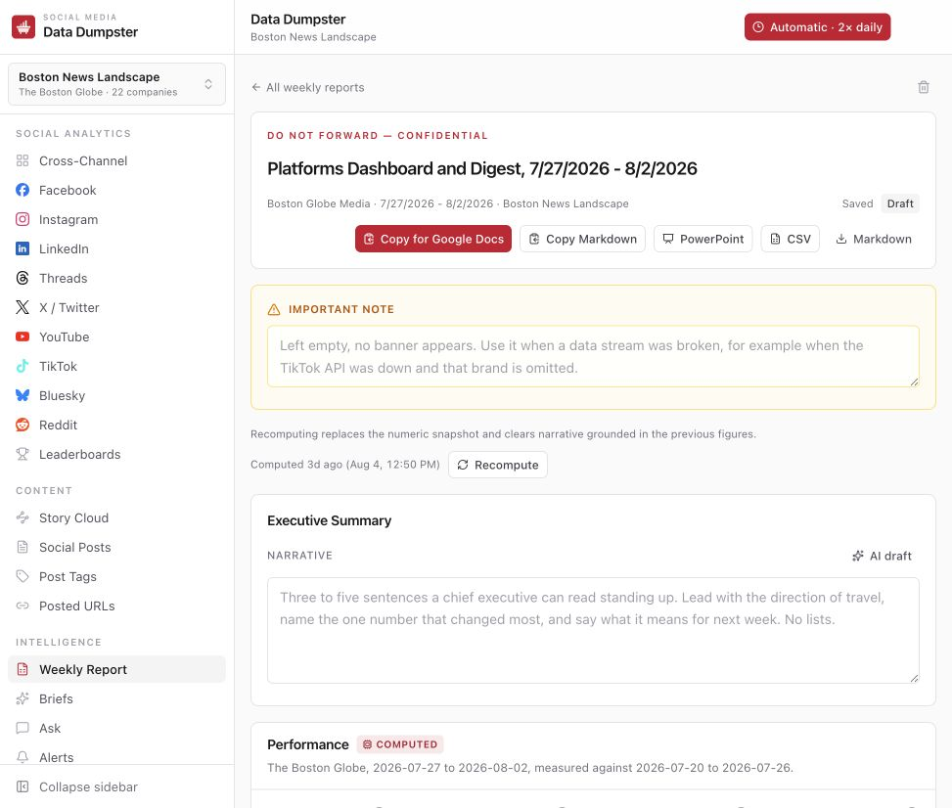
Computed sections are regenerated from stored data; narrative sections add newsroom meaning.
- Recompute first when source data changed. The stored numeric snapshot is replaced.
- Write the meaning. Narrative fields are for direction, consequence and next action—not arithmetic.
- Complete manual inputs only for systems the app cannot read, and keep those sections labeled.
- Export for the audience: PowerPoint for presentation, CSV for analysis, Markdown for reuse.
FACTS BEFORE PROSE
If a numeric snapshot is recomputed, re-read every narrative paragraph grounded in the old figures.

STANDING HUDDLE
Run the Newsroom Screen on a big display
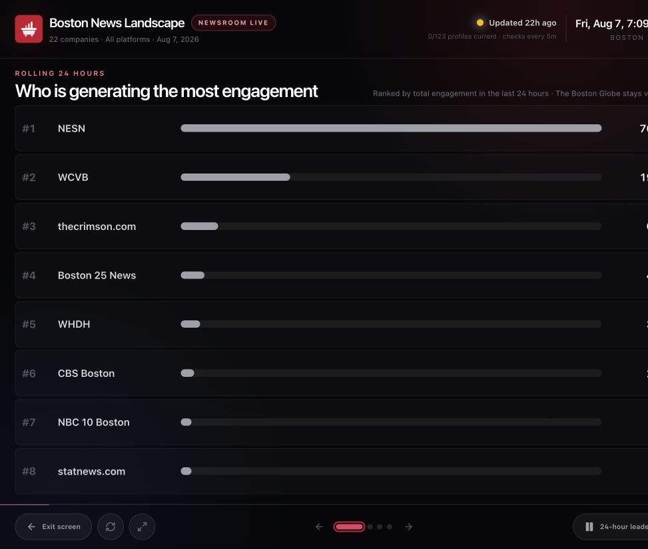
Slide 1 ranks the rolling 24-hour engagement leaders. Slide 2 shows today’s top content by platform.
- Open Newsroom Screen from the Cross-Channel toolbar, then enter fullscreen.
- Use pause when the room needs time on one slide; next/previous advances manually.
- The screen rereads stored database results every five minutes. It does not spend vendor calls.
- Collection still follows the automatic twice-daily schedule.
PRESENT-DAY VIEW
The display is designed around today and the rolling last 24 hours. Use Cross-Channel for longer analysis windows.

DATA HEALTH
Respond to warnings proportionately
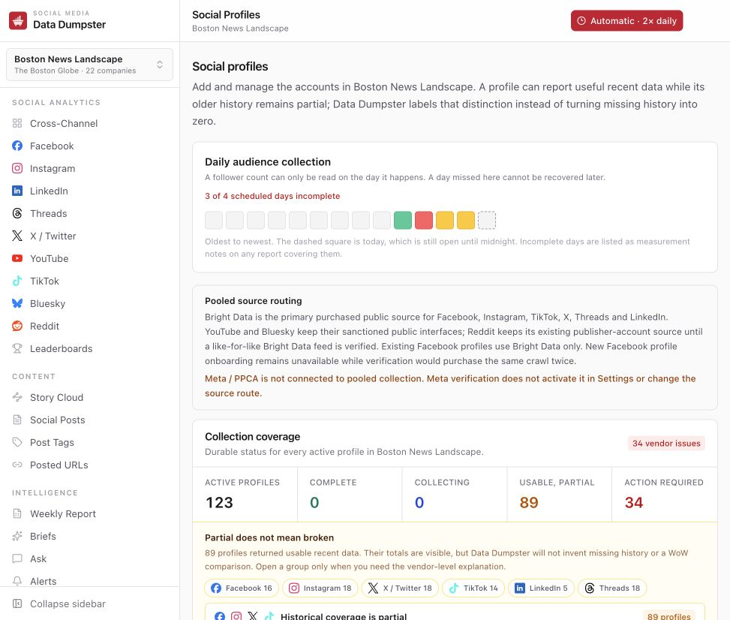
A profile can return useful recent data while older history remains partial.
- Read what is still usable. Partial is not the same as broken.
- Ask whether the missing piece affects the claim you want to make.
- Withhold trend language whenever the product withholds week-over-week change.
- Escalate action-required profiles to an operator; do not troubleshoot vendor credentials in the newsroom.
BLANK IS SAFER THAN A FAKE ZERO
If Data Dumpster leaves a value blank, do not replace it with zero in a deck, spreadsheet or spoken summary.

ONE-PAGE OPERATING CARD
Context → signal → action

Morning huddle
Newsroom Screen → 24-hour leaders → today’s platform winners → one story or format worth watching.

During a story
Social Posts → platform view → competitor filter → decide whether to extend, repackage or hold.

Weekly review
Leaderboards → Weekly Report → export → name the pattern, the caveat and next week’s test.

Ten-minute practice
- Name the current engagement leader and record the context.
- Open one top post and name the topic, format and platform.
- Check the evidence label for the winning profile.
- Propose one action the newsroom can test.
SHARE-OUT FORMAT
Finding · Evidence · Caveat · Next move

Before the finding leaves the room
- Context carried: landscape, date, platform and company filters.
- Evidence supports the claim; explanation is clearly labeled as interpretation.
- No follower snapshots were summed and no blank was changed to zero.
- Withheld comparisons remain withheld.

