** Riphah International University Lahore**

**Lahore Campus**

**Faculty of Computer Science and Information Technology**

**TASK - 3**

|  |  |  |  |  |  |
| --- | --- | --- | --- | --- | --- |
| **Course Title** | Technopreneurship | **Course Code** | **CS** | **Time** | Till Class |
| **Program Name** | BSCS | **Semester** | 6th | **Section** | A |
| **Date** | 18-10-2023 | **TECHNO - ID** | **S24 -005** | **No of Members** | 4 |

|  |  |  |  |
| --- | --- | --- | --- |
| Question | CLO Code | Domain/BT Level | Total Marks |
| Question 1 | 1 | 2 | 10 |

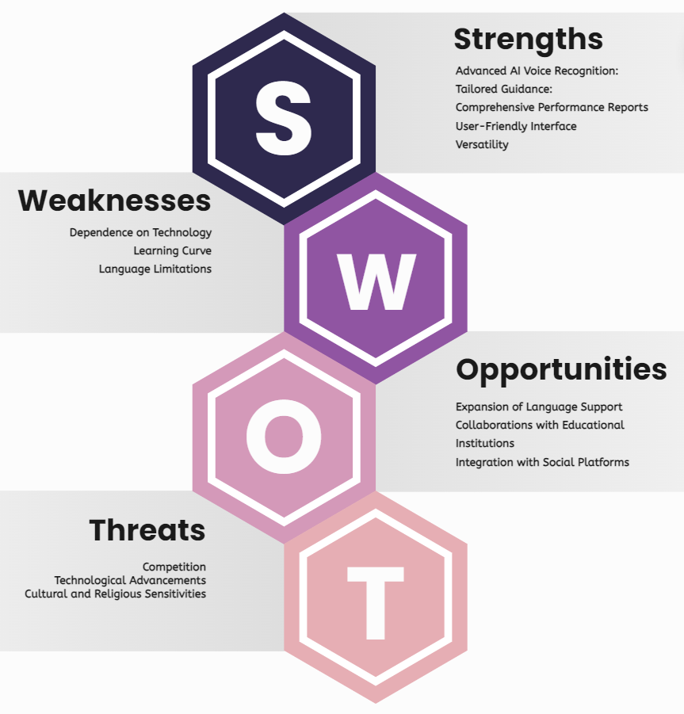

**STRENGTHS**

**Advanced AI Voice Recognition:** The app's AI feature offers real-time feedback on pronunciation accuracy, providing users with immediate guidance to improve their recitation skills.

**Tailored Guidance: Verse Echo** offers personalized guidance to users, regardless of their level of expertise, making it suitable for both seasoned hafiz and novice learners.

**Comprehensive Performance Reports:** Users receive detailed performance reports that highlight areas for improvement, allowing for focused practice and skill development.

**User-Friendly Interface:** The app's easy-to-use interface makes it accessible to a wide range of users, enhancing its appeal and usability.

**Versatility:** Designed for both hafiz and common users, the app caters to a diverse audience, increasing its market potential and relevance.

**WEAKNESSES**

**Dependence on Technology:** The effectiveness of the AI voice recognition feature relies heavily on the accuracy and reliability of the technology, which may encounter occasional glitches or inaccuracies.

**Learning Curve:** While the app is user-friendly, some users, particularly those less familiar with technology, may require time to acclimate to its features and functionalities.

**Language Limitations:** The app's effectiveness may be limited by the languages it supports, potentially excluding users who speak languages not accommodated by the platform.

**OPPORTUNITIES:**

**Expansion of Language Support:** By adding support for additional languages, the app can reach a broader audience and appeal to users from diverse linguistic backgrounds.

**Collaborations with Educational Institutions:** Partnering with schools, mosques, or educational institutions could help promote the app and integrate it into formal or informal Quranic education programs.

**Integration with Social Platforms:** Integrating social sharing features could enhance user engagement and facilitate community-building among users, fostering a sense of belonging and support.

**THREATS**

**Competition:** The market for Quranic recitation apps is competitive, with existing players and potential new entrants vying for market share.

**Technological Advancements:** Rapid advancements in technology could render certain features or aspects of the app obsolete if not continually updated and improved.

**Cultural and Religious Sensitivities:** The app must navigate cultural and religious sensitivities carefully to ensure its content and features are respectful and well-received by its target audience.

|  |  |
| --- | --- |
| MENTOR NAME: TALHA TARI | MENTOR NAME: MAM DUA |