** Riphah International University**

**Lahore Campus**

**Faculty of Computer Science and Information Technology**

**Technopreneurship S-24 005**

**Name: Usama Zahid , Zubair , Muhammad Imran, Muhammad Qasim**

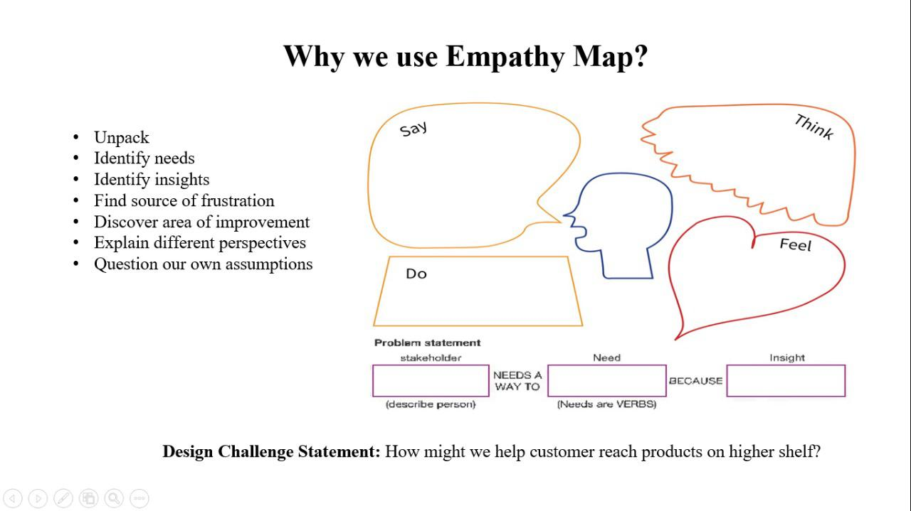**Sap id: 37806 , 36421, 38621, 37137**

Identify Needs:

**Assistance with Recitation:** Hafiz need support in perfecting their recitation and memorization of the Quran.

**Feedback Mechanism:** They require instant and accurate feedback on their recitation to identify and correct mistakes.

**Personalized Learning:** Hafiz seek personalized guidance to improve their Tajweed (pronunciation) skills.

**Performance Tracking:** There is a need for a tool to track their progress and identify areas for improvement over time.

Identify Insights:

**Time Efficiency:** Hafiz often struggle to find time for consistent practice amidst their daily routines.

**Varied Skill Levels:** Hafiz have varying levels of proficiency in recitation and Tajweed, requiring personalized approaches.

**Feedback Gap:** Traditional methods lack instantaneous feedback, hindering quick progress.

**Motivation:** Positive reinforcement and tangible progress indicators are crucial for sustaining motivation.

Source of Frustration:

**Lack of Feedback:** Hafiz may feel frustrated due to the absence of immediate feedback on their recitation errors.

**Difficulty in Tracking Progress:** Without a structured way to monitor their performance, hafiz may struggle to gauge their improvement.

**Limited Resources:** Access to knowledgeable tutors or Tajweed experts might be restricted, leading to frustration in seeking guidance.

**Time Constraints:** Balancing memorization with other responsibilities can be challenging, causing frustration in maintaining consistent practice.

Discover Areas of Improvement:

**Enhanced Feedback Mechanism:** Implementing more detailed and accurate feedback mechanisms to address specific mistakes in recitation.

**Personalization:** Offering tailored learning paths and exercises based on individual skill levels and learning pace.

**Integration of Resources:** Providing access to supplementary materials such as audio recordings, visual aids, and explanations of Tajweed rules.

**Time Management Tools:** Incorporating features to help users efficiently allocate time for practice within their daily schedules.

Explain Different Perspectives:

**User Perspective:** Hafiz seek convenience, accuracy, and personalized support to enhance their Quranic recitation skills efficiently.

**Technical Perspective:** Developers aim to create a seamless user experience with robust AI algorithms for accurate voice recognition and feedback.

**Educational Perspective:** Scholars and educators emphasize the importance of preserving Tajweed rules and providing authentic guidance for Quranic recitation.

**Market Perspective:** Competitors may focus on similar functionalities but differing approaches, such as gamification or social interaction elements.

Question Our Own Assumptions:

1. Are hafiz open to relying on AI technology for Quranic recitation guidance, or do they prefer human interaction?
2. How can we ensure cultural sensitivity and authenticity in providing Tajweed guidance through AI?
3. Are there any potential privacy concerns or ethical considerations regarding the use of voice recognition technology in religious contexts?
4. What strategies can we employ to accommodate users with different learning preferences and backgrounds effectively?