** Riphah International University**

**Lahore Campus**

**Faculty of Computer Science and Information Technology**

**Technopreneurship S-24 005**

**Name: Usama Zahid , Zubair , Muhammad Imran, Muhammad Qasim**

**Sap id: 37806 , 36421, 38621, 37137**

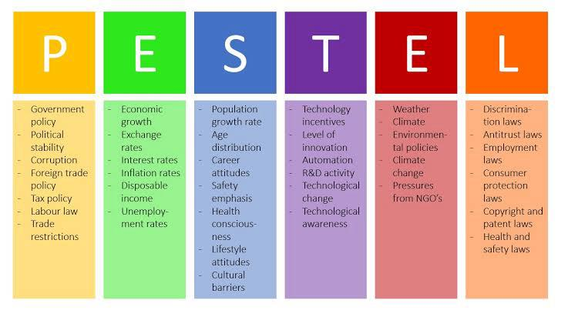

**1. Political:**

* **Government regulations regarding religious apps and content:** Regulations might affect the distribution or usage of **VerseEcho**.
* **Political stability:** Political unrest or instability in regions where the app is popular could impact its usage or development.

**2. Economic:**

* **Economic conditions affecting purchasing power:** Economic downturns may influence the affordability of smartphones and subscription fees for **VerseEcho**.
* **Currency exchange rates:** Fluctuations in currency exchange rates may affect the cost of development and maintenance, especially if outsourcing services or resources.

**3. Social:**

* **Cultural acceptance and attitudes towards technology:** Social acceptance of technology in religious practice may impact the adoption of **VerseEcho.**
* **Demographic trends:** Changes in the demographics of Muslim populations, such as age distribution or migration patterns, could affect the target market for the app.

**4. Technological:**

* **Advancements in AI and voice recognition technology:** Continued advancements could enhance the accuracy and effectiveness of **VerseEcho's** features.
* **Mobile technology trends:** Changes in smartphone technology and capabilities may influence the development and compatibility requirements of the app.

**5. Environmental:**

* **Carbon footprint and sustainability considerations:** Soul Sphere may need to assess and address the environmental impact of server usage and data storage associated with **VerseEcho.**

**6. Legal:**

* **Intellectual property rights:** Ensuring compliance with copyright and intellectual property laws regarding the Quranic content and AI algorithms used in **VerseEcho.**
* **Data privacy and security regulations:** Compliance with data protection laws to safeguard user information and maintain trust in the app.

**7. Ethical:**

* **Respect for religious sensitivities:** Ensuring that **VerseEcho’s** features and content are developed and presented in a manner that respects the sanctity of the Quran and the beliefs of its users.
* **Transparency and accountability:** Maintaining transparency in AI-driven feedback and corrections to uphold user trust and confidence in the app's integrity.