**Installation help for GLG**

1. open the glg build file (File Name : build)  
   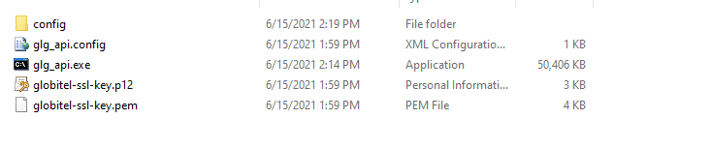  
   then open config/ application.properties ------ Then Change the path for locator.keystore  
   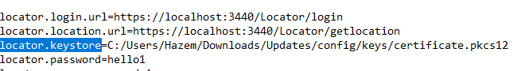  
   Then run glg_api.exe
2. open the glg MLP file (File Name : MLP)

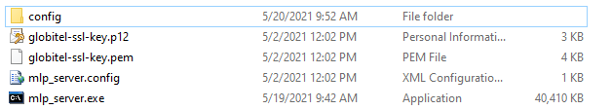

Then run mlp_server.exe

3 - open update file (file name : update)

Then Open config/system.properties and change the path for ws_keyStorePath

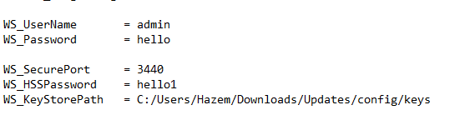

run locator_win64.exe   
Then you need to run this command

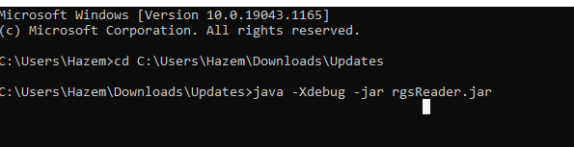

** You can find the command in runrgsreader.txt

1. Open Septel\Application-Data\Locator\run.bat