以Android Studio 为例

1. 将文件GlocashSDK.aar拷贝到libs/文件夹

配置app级别build.gradle,在dependencies中增加以下implementation

implementation(name:'GlocashSDK', ext:'aar') 或者 implementation files('libs/GlocashSDK.aar')

2. 在AndroidManifest.xml文件中添加Activity声明

<activity android:name="com.glocash.payment.GlocashActivity" />

1. 商户私钥分为正式环境和测试环境，可以登录到我们商户端IMG_256https://portal.glocashpayment.com系统找到

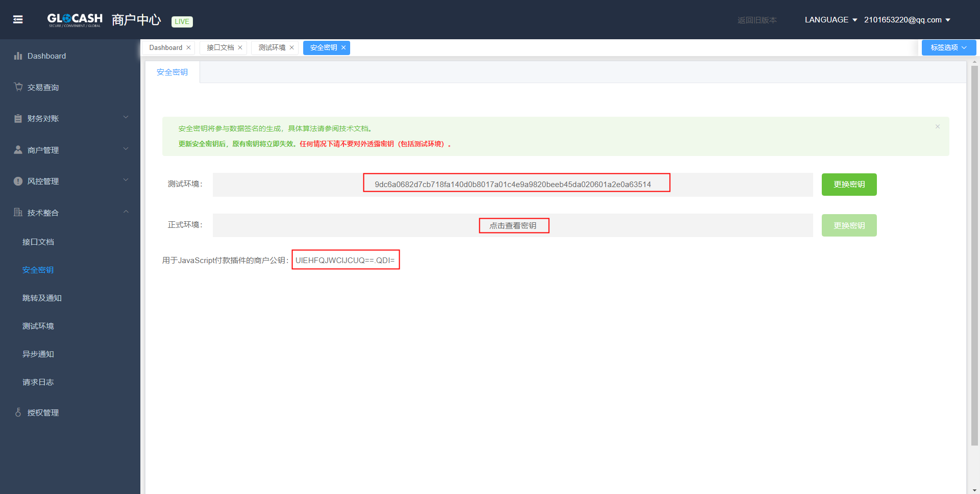

4.在MainActivity通过以下代码创建交易

GlocashPayRequest e=new GlocashPayRequest();

Map<String, String> Parameters= new HashMap<String, String>();

Parameters.put("REQ\_EMAIL", "2101653220@qq.com"); //商户的GC账户邮箱

Parameters.put("REQ\_INVOICE", ""); //订单号（允许数字、大小写字母、符号\_与-）

Parameters.put("REQ\_APPID", "380"); //应用ID

Parameters.put("BIL\_METHOD", "C01"); //交易的支付方式代码

Parameters.put("CUS\_EMAIL", "test@qq.com"); //付款人的邮箱

Parameters.put("BIL\_PRICE", "1.1"); //请求的付款金额

Parameters.put("BIL\_CURRENCY", "USD"); //付款的货币代码（ISO4217）

Parameters.put("BIL\_QUANTITY", "1"); //商品数量

Parameters.put("URL\_SUCCESS", "https://www.merchant77.com/success.php"); //付款成功后的跳转地址

Parameters.put("URL\_PENDING", "https://www.merchant77.com/pending.php"); //付款处理中的跳转地址（非实时到帐）

Parameters.put("URL\_FAILED", "https://www.merchant77.com/failed.php"); //付款失败后的跳转地址

Parameters.put("URL\_NOTIFY", "https://www.merchant77.com/notify.php"); //付款状态通知的请求地址

Parameters.put("BIL\_CC3DS", "1"); //信用卡付款时是否启用3DS验证（非0则启用）

Parameters.put("REQ\_SANDBOX", "ON"); //如果参数值为ON则当前交易处于测试环境下

Parameters.put("SECRET\_KEY", ""); //商户账号的安全密钥

//更多参数请浏览网页

String re=e.setData(Parameters);

//跳转页面

Intent intent = new Intent(MainActivity.this,GlocashActivity.class);

intent.putExtra(GlocashActivity.ACTION\_REQUEST,e);

intent.putExtra(GlocashActivity.ACTION\_CLASS,MainActivity.class);

MainActivity.this.startActivityForResult(intent, 1);

5.处理返回数据

public void onActivityResult(int requestCode, int resultCode, Intent data) {

super.onActivityResult(requestCode, resultCode, data);

Log.v(this.getClass().getSimpleName(), "onActivityResult");

if (resultCode == GlocashActivity.RESULT\_OK) {

if (null != data) {

GlocashPayResponse result = (GlocashPayResponse) data.getSerializableExtra(GlocashActivity.RESULT\_DATA);

String start="";

if (null != result) {

Map<String, String> r=result.getData();

for (Map.Entry<String, String> entry : r.entrySet()) {

Log.i(TAG, entry.getKey()+":"+entry.getValue());

}

start=r.get("BIL\_STATUS");

}

if (start!=null) {

if(start.equals("paid")){

Intent intent = new Intent(MainActivity.this,MainActivity.class);

startActivity(intent);

}

}

}

}

else if(resultCode == GlocashActivity.RESULT\_ERROR){

GlocashPayResponse result=(GlocashPayResponse) data.getSerializableExtra(GlocashActivity.RESULT\_DATA);

if (null != result) {

Map<String, String> r=result.getData();

AlertDialog alertDialog1 = new AlertDialog.Builder(this)

.setTitle("错误")//标题

.setMessage(r.get("message"))//内容

.setIcon(R.mipmap.ic\_launcher)//图标

.create();

alertDialog1.show();

}

}

}

6.文件附上例子examples