Outland Adventures - Milestone #3 Reports

# Group Information

Team Members: Gustavo Lopez. Colten Lamar

# Report 1: Equipment Sales vs Rentals

This report summarizes the number of equipment transactions that were sales versus rentals. It helps determine if equipment sales are frequent enough to continue offering items for purchase.

Summary Table:

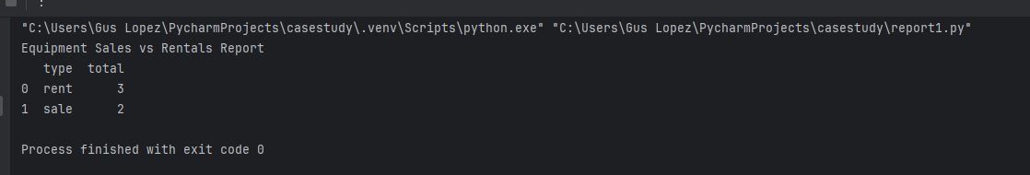

# Report 2: Booking Trends by Region

This report tracks the number of bookings per region by year. It helps identify if any particular region (Africa, Asia, or Southern Europe) shows a downward trend over time.

Summary Table:

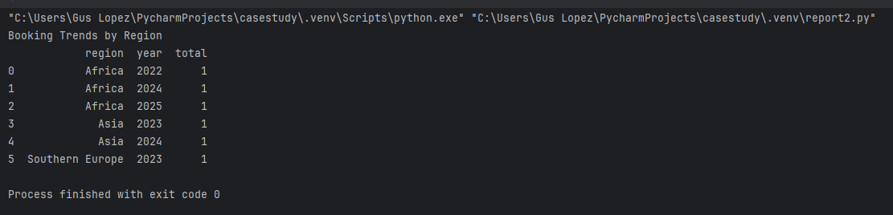

# Report 3: Aged Inventory Items

This report lists inventory items that were purchased over five years ago. It helps identify equipment that may need replacement or removal due to age.

Summary Table:

