Gustavo Lopez

Assignment 2.3

ERD:

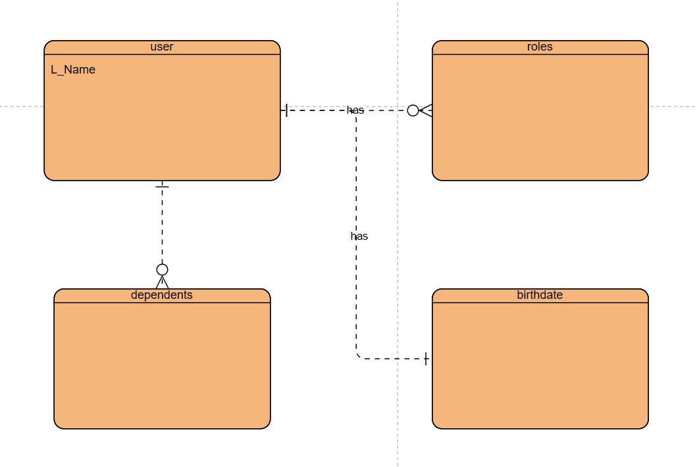

NOsql:

{

"user_id": 1,

"birthdate": "1990-01-01",

"roles": ["admin", "editor"],

"dependents": [

{"name": "Jane", "age": 5},

{"name": "Jack", "age": 3}

]

}