Gustavo Lopez

4/13/2025

Assignment 5.2

1, Count()

**Used:**

It can be used to return the number of rows that match a specified condition.

**SQL Statement:**

SELECT COUNT(*) AS ‘TOTAL RECORDS’ FROM employees;

**Screenshot:**

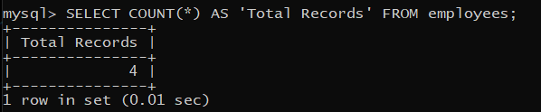

2. AVG()

**Used:**

AVG() is used to calculate the average of a coloumn that has a numeric value. It is mostly used for salaries, sales, etc...

**SQL Statement:**

SELECT AVG(salary) AS’Average Salary’ FROM employees;

**Screenshot:**

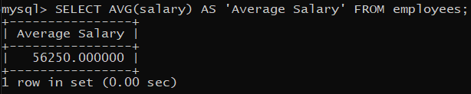

3.SUM()

**Used:**

SUM() is used to calculate the whole total value of a numeric column, mostly it used in sales or for a finaincial report.

**SQL Statement:**

SELECT SUM(SALES) AS ‘TOTAL SALES’ FROM transactions;

**Screenshot:**

