Gustavo Lopez

Module 8.2

Before:

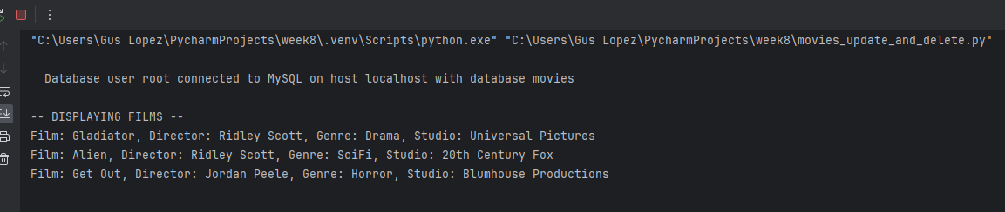After:

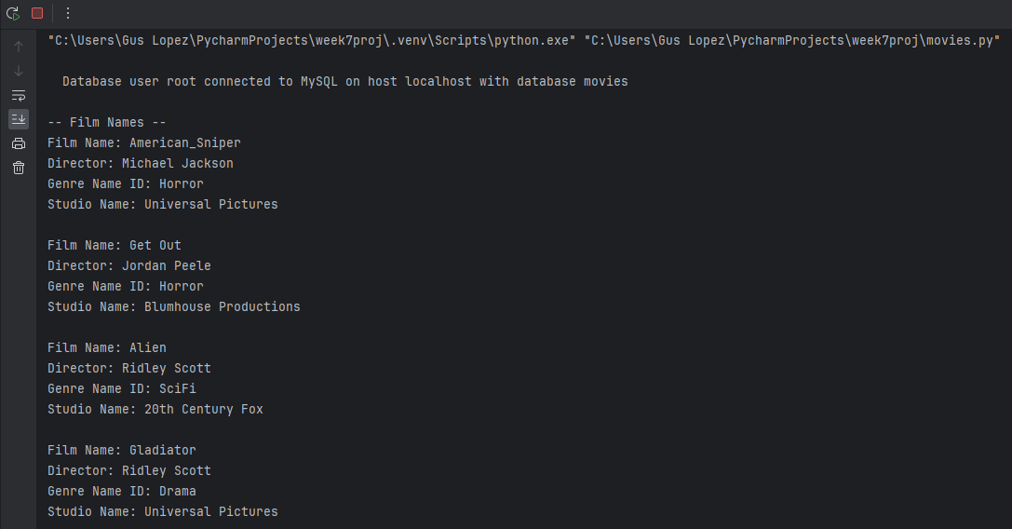Updated to horror:

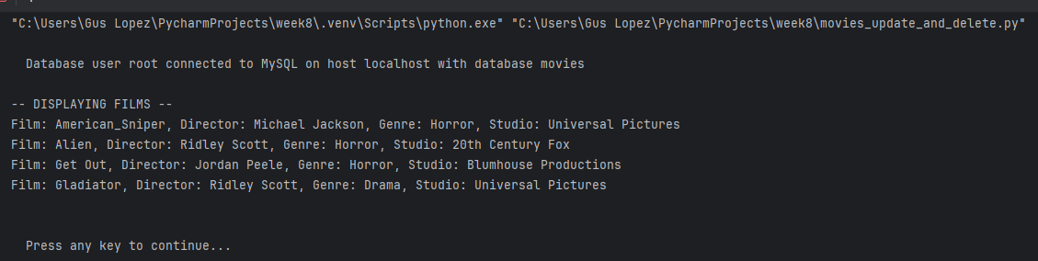After Delete:

