Overtime Wages for
Employees Not Working
Under an Averaging Agreement

Summary
This section explains overtime wage requirements for employees who work over 8 hours per day or 40 hours per week.

Text of Legislation
40. (1) An employer must pay an employee who works over 8 hours a day, and is not working under an averaging agreement under section 37, (a) 1 1/2 times the employee's regular wage for the time over 8 hours, and (b) double the employee's regular wage for any time over 12 hours.
- An employer must pay an employee who works over 40 hours a week,and is not working under an averaging agreement under section 37, 1 1/2 times the employee's regular wage for the time over 40 hours.
- For the purpose of calculating weekly overtime under subsection (2),only the first 8 hours worked by an employee in each day are counted, no matter how long the employee works on any day of the week.

Policy Interpretation
Subsection (1)
Section 40 does not apply to work performed under an averaging agreement
This section does not apply to an employee who has signed and is working under a section 37 averaging agreement.
Employees working under an averaging agreement are required to be paid overtime wages in accordance with section 37 of the Act.
Application of section 40
An employee under this section who works more than 8 hours in a day must be paid 1.5 times their regular rate of pay for any time worked over 8 hours up to 12 hours in a day.
An employee under this section who works more than 12 hours in a day must be paid double their regular rate of pay for any time worked over 12 hours in a day.
This applies even if the employee does not work more than 40 hours in a week.

Example
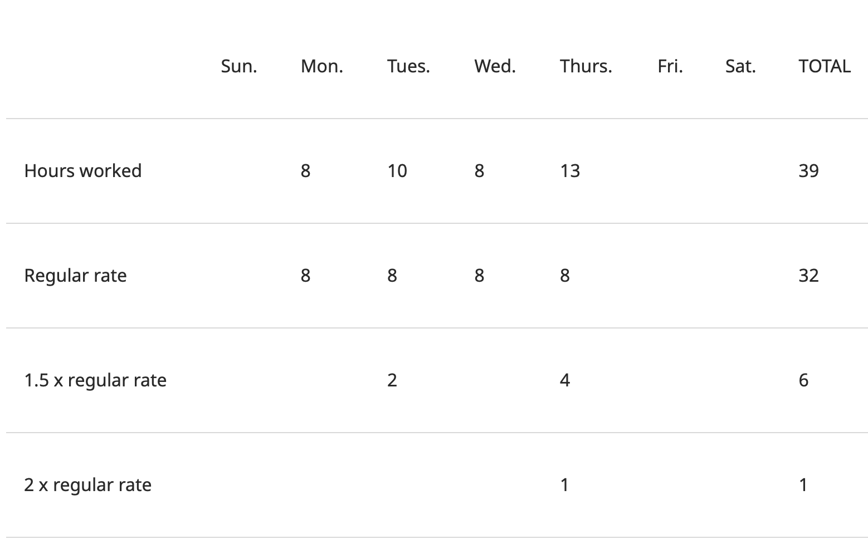
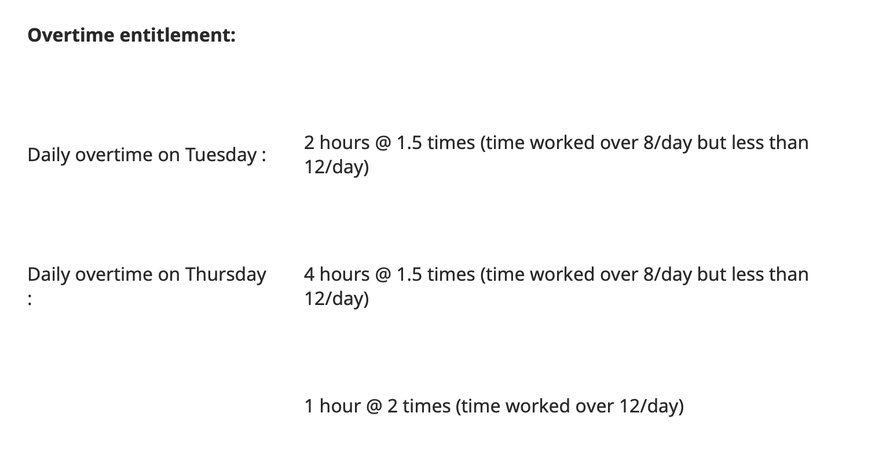
Subsections (2) and (3)
An employee who works more than 40 hours in a week must be paid 1.5 times their regular rate of pay for the time worked over 40 hours in the week. Under section 1 of the Act a “week” for purposes of weekly overtime is a period of 7 consecutive days beginning on Sunday at 12:00 am and ending at midnight the following Saturday.
Only time worked within this 7-day period can be considered for the purposes of overtime. Therefore, if a shift straddling midnight ends on a Sunday the time worked on Sunday will be applied to the time worked on Saturday.
When calculating weekly overtime wages, only the first 8 hours worked each day are counted towards the 40 hours in the week.
Example
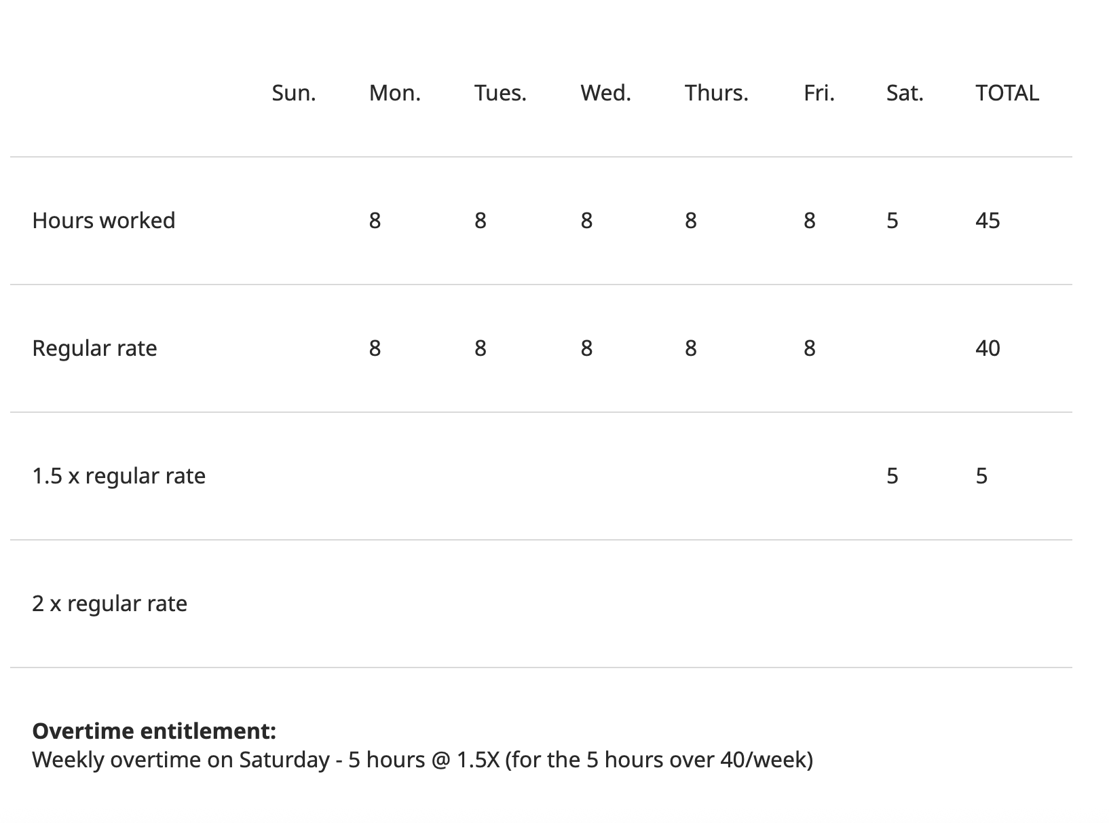

Example
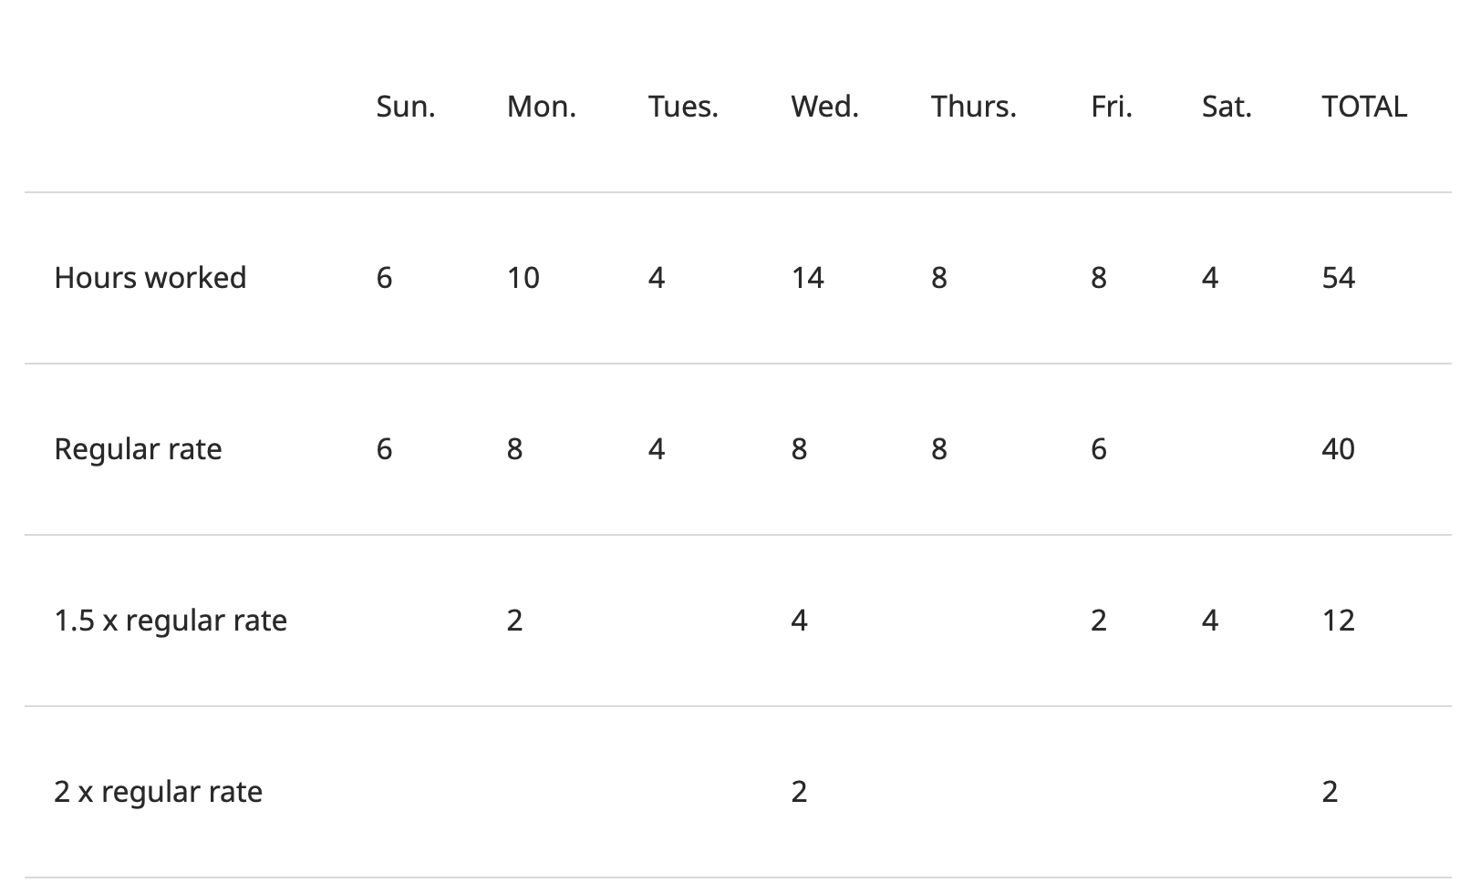
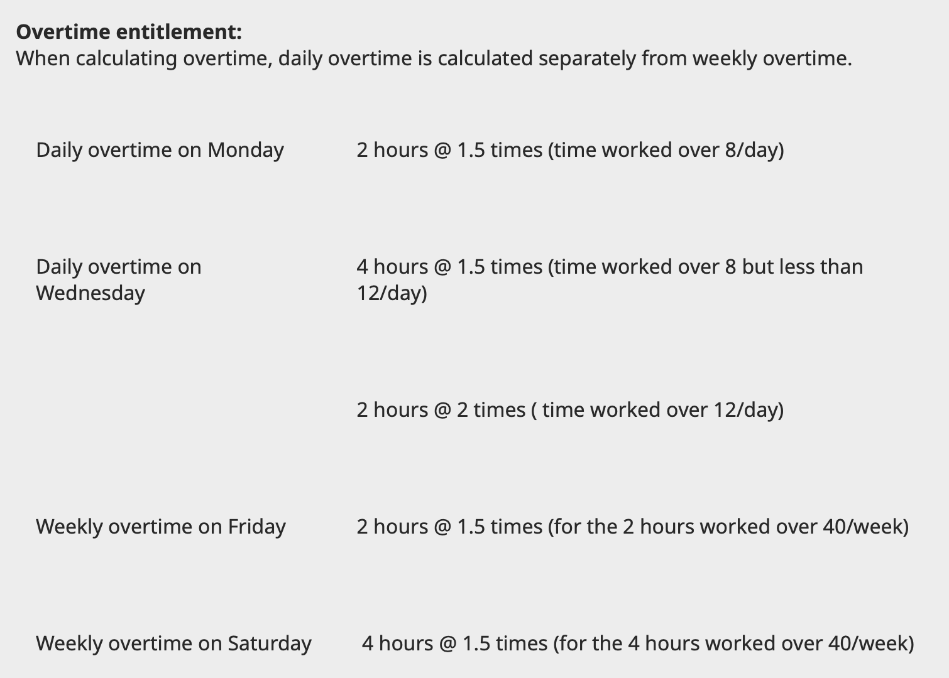
NOTE: In this example, the employee has not been provided with 32 hours free from work during this week as required by Section 36. By paying the employee weekly overtime of 1.5 times their regular rate for the 4 hours worked on Saturday, the employer has also satisfied the requirement to pay 1.5 times the regular rate for not providing 32 hours free from work in the week

Calculating overtime in a week including a statutory holiday
The time worked by an employee on a statutory holiday is counted when calculating overtime for that week. Where the weekly overtime and statutory holiday fall on different days of the week there is a greater monetary benefit to the employee than if the statutory holiday falls on a day where weekly overtime is worked.
Examples:
1. An employee works 8 hours daily Monday to Saturday and the statutory holiday falls on Monday. Employee receives:
- Overtime pay: Saturday: 8 hours X 1.5 (weekly overtime). The time worked on Monday is included in the calculation of weekly overtime.
- Statutory holiday pay: Monday: 8 hours X1.5 regular wage plus an average day’s pay. (See sections 45 and 46 in the Act)
2. An employee works 8 hours daily Monday to Saturday and the statutory holiday falls on Saturday. Employee receives:
- Overtime pay: Saturday: 8 hours X 1.5 regular wage (weekly overtime)
- Statutory holiday pay: An average day’s pay. The 8 hours worked on Saturday have already been paid at 1.5 for the purposes of weekly overtime.
It should be noted that when statutory holiday pay is earned and weekly overtime is also earned, as in Example 2 above, the employer is not required to pay both. Where an employee earns two combined entitlements, they do not ‘double up’ but, rather, the employee would get paid in a fashion that provides the greater benefit to the employee. In this example, 1.5X regular wage is applicable for both; therefore, the employee is paid 1.5X for all hours worked on the Saturday.
See section 1 of the Act “regular wage” for calculations to determine the applicable regular wage for employees paid on a flat rate, piece rate, commission or other incentive basis, or who are paid a weekly, monthly or yearly wage.
Varying this section
In some cases, an employer and any of its employees may wish to submit a written joint application to the Director under section 72 of the Act requesting a variance to section 40.
Employees excluded from this section
The special rules regarding this section of the Act are set out in the
Employment Standards Regulation, Part 7 – Variance and Exclusions. Specifically, subsections 33, 34, 35 & 37 exclude certain employees from the hours of work and overtime provisions.
Employees paid by salary
If an employee is paid by a weekly, monthly or yearly salary, overtime is payable to that employee if they work over 8 hours in a day or over 40 hours in a week. The regular wage should be calculated as set out in section 1 of the Act. For any hours worked over 8 in a day or over 40 in a week, overtime is owed at one and a half times the regular wage. For any hours worked over 12 in a day, overtime is owed at two times the regular wage. An employee cannot agree (even with a signed contract) to have their salary cover all hours worked without being paid overtime as this is contrary to the minimum requirements of the Act.

Managers
An employee who is defined as a “manager” under section 1 of the Employment Standards Regulation is excluded from the hours of work and overtime provisions of the Act, pursuant to section 34 of the Regulation.
Although a manager is excluded from the hours of work and overtime provisions of the Act, they are entitled to be paid for all hours worked. In some cases this could result in a manager being entitled to additional compensation.
Where there is evidence to support findings that the employer and the employee agreed that a specific number of hours of work would be compensated by a specific salary, the employee would be entitled to straight time wages for work performed in excess of what was agreed to. For more information, refer to the Managers factsheet and the definition of “manager” in section 1 of the Employment Standards Regulation.
Employees covered by a collective agreement
If a collective agreement contains any provisions about hours of work or overtime that meet or exceed the requirements of Part 4, those provisions of the collective agreement replace the Act’s requirements for employees covered by the agreement. Otherwise, the Act’s requirements are deemed to be incorporated in the collective agreement.
Where there is a collective agreement, disputes respecting the application, interpretation or operation of Part 4 must be resolved through the grievance procedure, not through the enforcement provisions of the Act.
Certain employees are exempt from this section, or Part 4 entirely, under the Employment Standards Regulation.

