Bitmap Font Importer
Asset store version has been deprecated.
Please install from github.
https://github.com/litefeel/Unity-BitmapFontImporter#install

Bitmap Font Importer is just perfect Unity asset plugin to import any custom bitmap font to your project.
It easy imports any bitmap font generated by third party tools like:littera, bmGlyph, Glyph Designer 2 or ShoeBox
Thiks @Xylph, this origin code form here
Feature list:
- Free
- Auto Import bitmap fonts
- Support XML and Plain text format of .fnt
- Support Multi texture
- Reimport exists bitmap font
- Source Code on Github
- Tested with Unity 5.x
- No runtime resources required
- No scripting required

How to use?
- Import this plugin from Asset Store
- Put .fnt and .png file to Unity Project(example font1.fnt), it will auto convert Font file to same directory(example font1.fontsettings)
- Create new UGUI Text component, named myText
- Drag the Font file to font property of myText.
- Drag the Font Material in font1 to Material property of myText.
- Input some thing to Text property of myText.
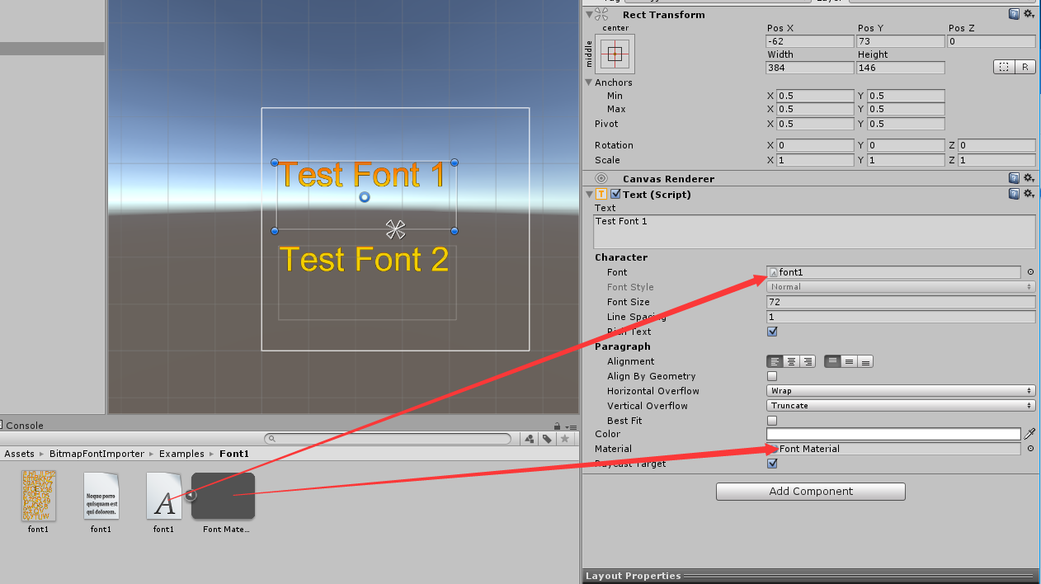
How to convert exsit .fnt file?
Right click .fnt file and select Bitmap Font -> Rebuild Bitmap Font
How to convert all .fnt file?
Right click Assets window and select Bitmap Font -> Rebuild All Bitmap Font
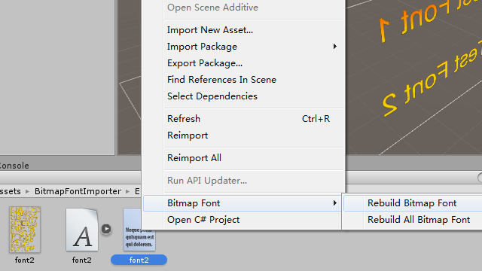

Support
- Create issues by issues page
- Send email to me: litefeel@gmail.com

