# AI in Marketing: Real-World Applications

Glory Macwan

August 4rd, 2024

# Company Profile Creation

**Business Definition**

The goals of Glam Beauty Products are to promote self-care and beauty. Cosmetics, hair care, and skincare products will be provided by the organization. The objective is to establish a brand that is both diverse and of exceptional quality to attract devoted consumers. Morganti et al. (2021) observed that industrial companies engage in intense market competition. To remain competitive and satisfy changing consumer expectations, Glam Beauty Products will need to implement novel methodologies. The corporation is required to navigate fluctuating market conditions in a competitive industry. It is imperative to preserve brand loyalty and consumer gratification.

Hair products will be available for purchase both online and at corporate locations.

Customers will be able to satisfy their hair care needs with a variety of shampoos, treatments, and conditioners. The organization endeavors to cater to the needs of all individuals by customizing its products to meet the preferences of the majority of its clients. For example, the organization intends to create remedies for hair volume, moisture, and damage.

Furthermore, the organization will address any other skin conditions that clients may have. Acne and parched skin products. Serums, facials, and moisturizers are employed to resolve these concerns. The organization provides customized solutions in addition to hair and skin care products. The organization will concentrate on women who desire to enhance their physical appearance. The organization will provide services to women who are both younger and elderly and are technologically adept.

# Goals

* Utilize artificial intelligence (AI) to optimize customer service and analyze data.
* Enhance communication and interactions by implementing chatbots and search engine marketing.
* Evaluate consumer sentiments to comprehend brand perception.

# Enhance Personalized Content

An important step in the adoption of AI by Glam Beauty Products it’s the potential to use it to personalize marketing communication and content. The following is an examination of how artificial intelligence could help the organization personalize its content, analyze customers’ browsing history, and understand their purchase behaviors.

# Personalized Content Delivery

The adoption of AI technologies is expected to ensure an improvement in the content delivery approach adopted by the organization. Haleem et al. (2021) suggest that a large number of companies in the market are constantly adopting AI technologies as a means of analyzing the large amount of data they have at their disposal. Insight from the data analysis can be used to transform the content created by the company and how it communicates with the customer.

# Understanding User Behavior and Purchasing Patterns

The company should be able to understand consumer choices better through an improved capability to analyze the information it collects from its customers. For example, predictive analysis should be possible through leveraging the insight generated from the data collected by the organization. With this information, it should be easy to personalize the messages sent to the customer and transform the shopping experience (Khrais, 2020). The success of the approach will hinge on how effectively the company can collect information and analyze it.

# Browsing History Analysis

Data collected through the analysis of browsing history could also be useful in shaping the direction of the company’s sales. Khrais (2020) demonstrates that substantial insight can be generated from an analysis of browser history. The ability to analyze data collected from browsing history could then be used to make decisions about how to market the products intended to be sold by Glam Beauty Products. This should be beneficial for the longer success of the brand in the market.

# Proposed Upgrades

Implementing a recommendation engine can streamline sales and add value (Fayyaz et al., 2019). Analyzing customer reviews with NLP systems enhances insights for market optimization and dynamic pricing (Kamal & Himel, 2023). Predictive analytics using TensorFlow and Apache Spark can suggest products based on customer preferences.

# Search Engine Optimization (SEO) for Website Content:

**Content Design**

The table below illustrates ten content types in the form of headings, optimized for the website and the social media searches.

|  |  |  |  |
| --- | --- | --- | --- |
| No. | **Content Title** | **Focus** | **Keywords** |
| 1 | Top 10 Skincare Tips for Radiant Skin | General skincare  advice | skincare tips, radiant skin, beauty  routine |
| 2 | How to Choose the Right Hair Care  Products for Your Hair Type | Hair care guidance | hair care products, hair type, best  shampoo |
| 3 | The Ultimate Guide to Anti-Aging Skincare | Anti-aging  solutions | anti-aging skincare, youthful skin,  wrinkle reduction |
| 4 | Natural Ingredients to Look for in Skincare  Products | Product  ingredients | natural skincare, product  ingredients, organic beauty |
| 5 | Step-by-Step Guide to Creating a  Personalized Beauty Routine | Personalized  beauty | personalized beauty routine,  skincare steps, customized beauty |
| 6 | 5 Essential Hair Care Tips for Curly Hair | Curly hair care | curly hair tips, hair care, frizz  control |
| 7 | How to Maintain Healthy Skin During  Winter | Seasonal skincare | winter skincare, healthy skin, dry  skin solutions |
| 8 | Exploring the Benefits of Vitamin C in  Skincare | Skincare  ingredients | vitamin C skincare, skin  brightening, antioxidant |
| 9 | Quick and Easy Skincare Routine for Busy  Mornings | Time-efficient  beauty routines | quick skincare routine, morning  beauty, time-saving tips |
| 10 | Understanding the Different Types of  Sunscreen: Which is Right for You? | Sunscreen  education | types of sunscreen, sun protection,  SPF guide |

# Searching Example

An example of the search results using the search engine code offered is captured below:

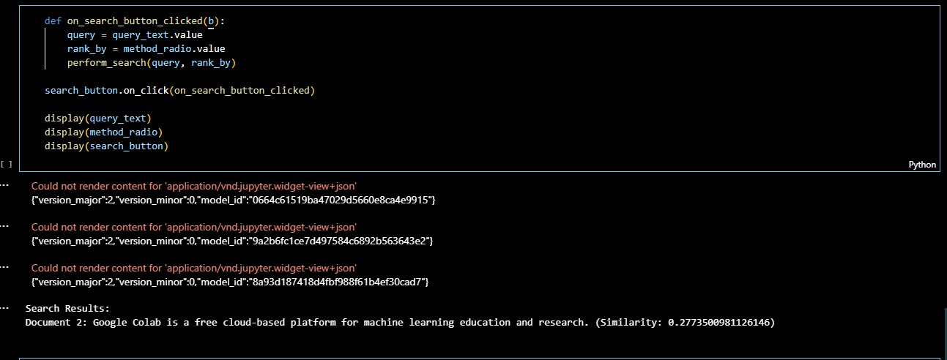

# Performance Analysis

The results from analyzing the performance of the keywords are captured in the table below:

|  |  |  |  |  |
| --- | --- | --- | --- | --- |
| **Keywords** | **Keywor d Search Volume** | **Top of page bid** | **Top of page bid** | **Keyword Results Competition** |
| personal skincare | 1,300 | $3.14 | $11.48 | High |
| Beauty & personal care | 590 | $1.05 | $6.11 | High |
| Beauty and personal care | 590 | $1.05 | $6.11 | High |
| personal care & beauty | 590 | $1.05 | $6.11 | High |
| personal care and beauty | 590 | $1.05 | $6.11 | High |
| personal care beauty | 590 | $1.05 | $6.11 | High |
| beauty cosmetic & personal care | 480 | $1.36 | $3.38 | High |

|  |  |  |  |  |
| --- | --- | --- | --- | --- |
| Beauty cosmetics and personal care | 480 | $1.36 | $3.38 | High |
| list of personal care products | 320 | $0.78 | $2.00 | Medium |
| personalized skincare | 260 | $2.85 | $11.02 | High |

# Chatbot Development for Customer Service

The chatbot will use Gemini AI as its NLP engine. I have made two chatbots: 1) Regular text-to-text chatbot and 2) Image-to-text chatbot.

# Examples Of Chats Using the Products

Here is an example of the chatbot interaction. I have given reference images to the chatbot and tried asking for solutions for the situation. Though it was generic, the response seemed accurate.

|  |  |
| --- | --- |
| **Case 1: Customer asking about their situation regarding hair loss** | |
| Input Image  C:\Users\acer\Downloads\WhatsApp Image 2024-08-04 at 23.45.37.jpeg  Image 1: Hairloss | **Response:** |
| **Case 2: Customer asking questions about acne** | |
| Input Image:  C:\Users\acer\Downloads\acne (1).jpg  Image 2: Acne Face | **Response**:  C:\Users\acer\Downloads\WhatsApp Image 2024-08-04 at 23.56.27.jpeg |
| **Case 3: Informational question asked by the customer** | |
| Text Input:  What are some of the best hair treatment methods? | **Response:**  C:\Users\acer\Downloads\WhatsApp Image 2024-08-04 at 23.50.23.jpeg |

# Sentiment Analysis of Customer Feedback

**Feedback Collection**

The following are ten fictional feedbacks from possible customers about what they felt about utilizing the company’s products.

|  |  |
| --- | --- |
|  | **Feedback** |
| 1 | I love the hair mask sold by the company. I can testify that the natural ingredients used in the hair mask made a difference. |
| 2 | After using the Glow Serum for a week my skin feels radiant after a week of use. |
| 3 | While the face wash was rewarding, it did not offer any major changes to my face. |
| 4 | The hydrating conditioner did not work. My hair feels a little greasy rather than moisturized. |
| 5 | The services offered by the company were excellent. I am glad that I have received my package after one day of ordering it. |
| 6 | The body lotion sold by the company was significantly greater than what is currently available in the market making it perfect for everyday use. |
| 7 | The sunscreen sold by the company was effective but appeared as white cast on relatively dark skin. However, I cannot complain because it does its job. |
| 8 | Unfortunately, the Acne Gel sold by the company didn’t work for me. I expected better results but was still unable to see any positive results after a month of use. |
| 9 | The conditioner sold by the company performed well. I was impressed by how well it left my hair feeling. I am glad I found that alternative. |
| 10 | The packaging of products such as the night cream could be improved further. I have no complaints about the products because they work relatively well. |

# Analysis

An analysis of customer review sentiments was conducted using three approaches: the provided sentiment analysis code, ChatGPT, and a free online sentiment analysis tool. The results are summarized below.

# Sentiment Analysis Code

The output from the sentiment analysis code is provided in the screenshot below.

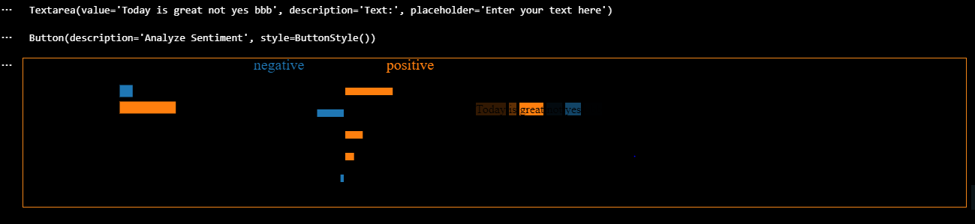

# ChatGPT

The results of the sentiment analysis utilizing ChatGPT were captured in the screenshot below.

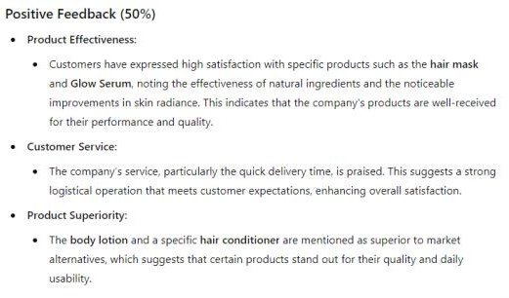 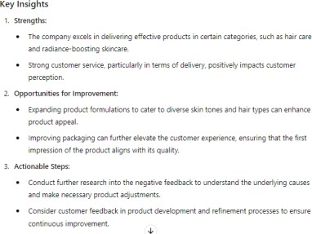

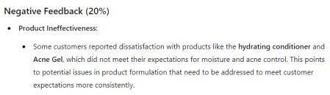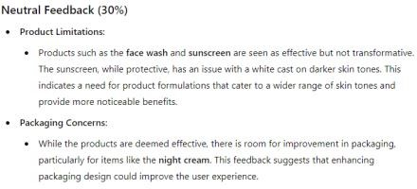

# Online Tool

The screenshot below was captured from Eden AI and highlights the results of the sentiment analysis utilizing its free version.

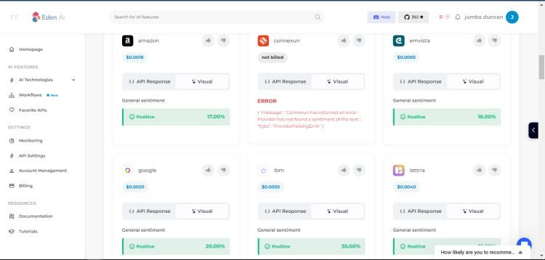

# Discussion On the Effectiveness of The Tools

The assessment of the three tools indicates they are all useful for the brand. ChatGPT was particularly effective, providing a detailed breakdown of problems and actionable steps based on feedback. While all tools measured positive, negative, and neutral sentiments, ChatGPT offered a more insightful analysis compared to the other two.

# Actionable Insight

Based on the results from the analysis, it is evident that Glam Beauty Products should be able to adjust its approach to meet the demands of its customers in the market. First, the company could consider improvements to the products it already sells as a step towards appealing to a larger customer base given that few parties argued that the products were ineffective. The brand should also conduct further sentiment analysis with a larger dataset.

# References

Fayyaz, Z., Ebrahimian, M., Nawara, D., Ibrahim, A., & Kashef, R. (2019). Recommendation Systems: Algorithms, Challenges, Metrics, and Business Opportunities. *Applied Sciences*, *10*(21), 7748. <https://doi.org/10.3390/app10217748>

[Gemini - chat to supercharge your ideas (google.com)](https://gemini.google.com/)

*Google Colab*. (n.d.).

[https://colab.research.google.com/drive/1Ex4OB54q3g2he160vgnecfmZ62XfhT-](https://colab.research.google.com/drive/1Ex4OB54q3g2he160vgnecfmZ62XfhT-I?usp=sharing)

[I?usp=sharing](https://colab.research.google.com/drive/1Ex4OB54q3g2he160vgnecfmZ62XfhT-I?usp=sharing)

Haleem, A., Javaid, M., Asim Qadri, M., Pratap Singh, R., & Suman, R. (2021). Artificial intelligence (AI) applications for marketing: A literature-based study. *International Journal of Intelligent Networks*, *3*, 119-132. <https://doi.org/10.1016/j.ijin.2022.08.005>

Kamal, M., & Himel, A. S. (2023). Redefining modern marketing: an analysis of AI and NLP's influence on consumer engagement, strategy, and beyond. *Eigenpub Review of Science and Technology*, *7*(1), 203-223. <https://studies.eigenpub.com/index.php/erst/article/view/22/27>

Khrais, L. T. (2020). Role of Artificial Intelligence in Shaping Consumer Demand in E- Commerce. *Future Internet*, *12*(12), 226. <https://doi.org/10.3390/fi12120226>

Morganti, P., Morganti, G., Gagliardini, A., & Lohani, A. (2021). From Cosmetics to Innovative Cosmeceuticals—Non-Woven Tissues as New Biodegradable Carriers. *Cosmetics*, *8*(3), 65. <https://doi.org/10.3390/cosmetics8030065>

Chatbot Creation

[https://drive.google.com/file/d/13zjcLda90mvAGHfqOWfvzCbJMGLzCvS8/view?us](https://drive.google.com/file/d/13zjcLda90mvAGHfqOWfvzCbJMGLzCvS8/view?usp=sharing)

[p=sharing](https://drive.google.com/file/d/13zjcLda90mvAGHfqOWfvzCbJMGLzCvS8/view?usp=sharing)

Image Reference: <https://www.shutterstock.com/>