Lisa Hu

Homework Assignment #2

VBA

**Multiple Year Stock Data Screenshots**

**EASY**

2014

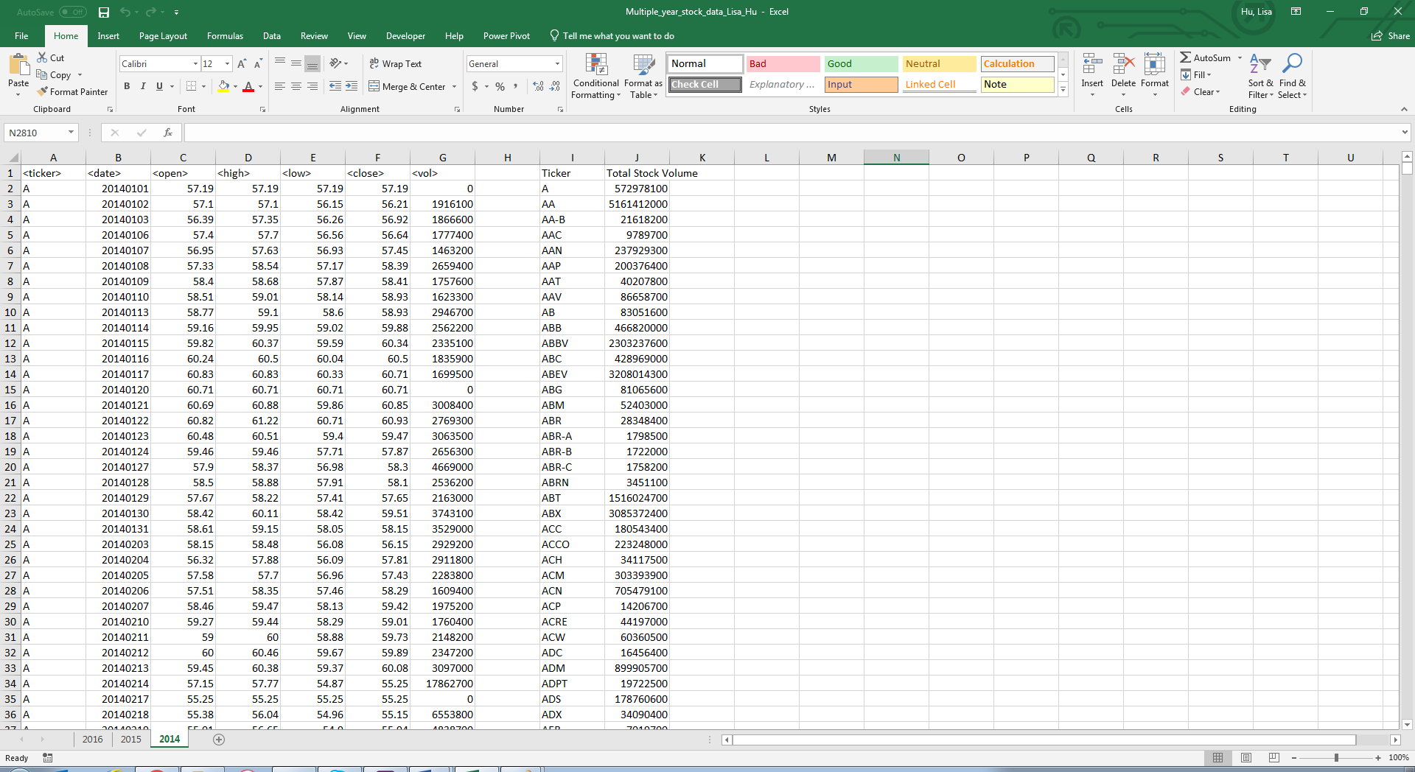

2015

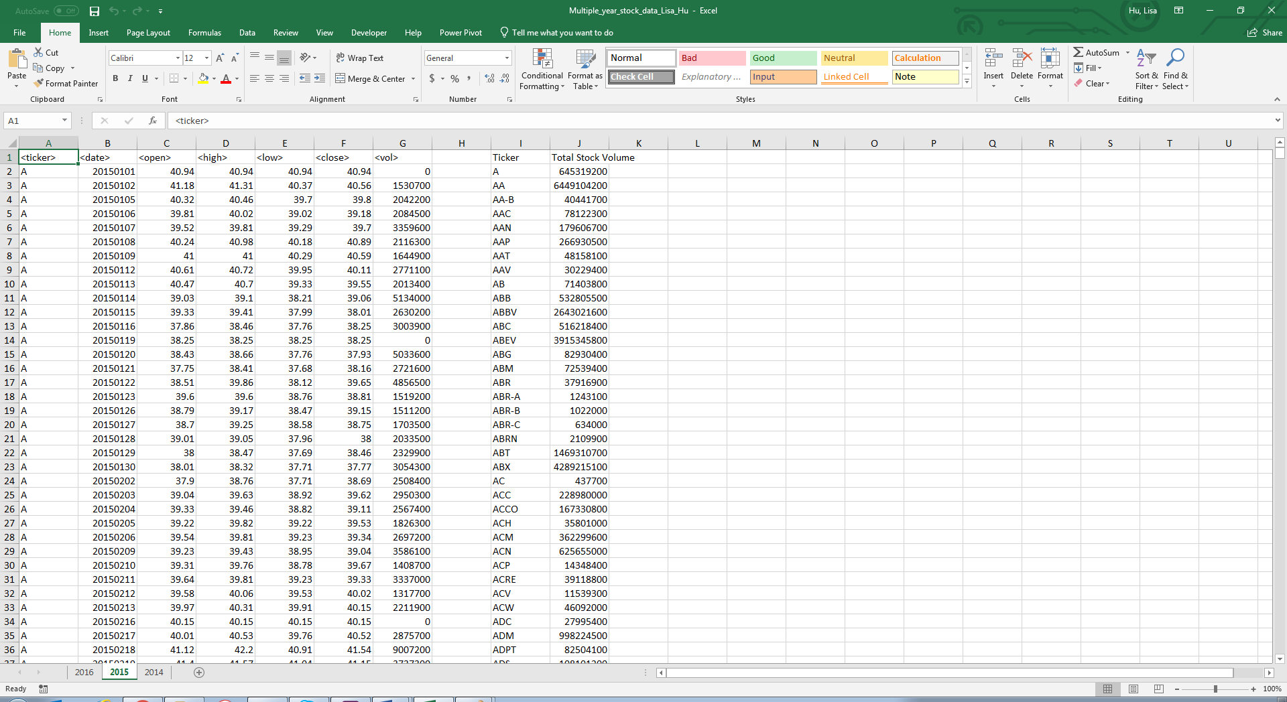

2016

