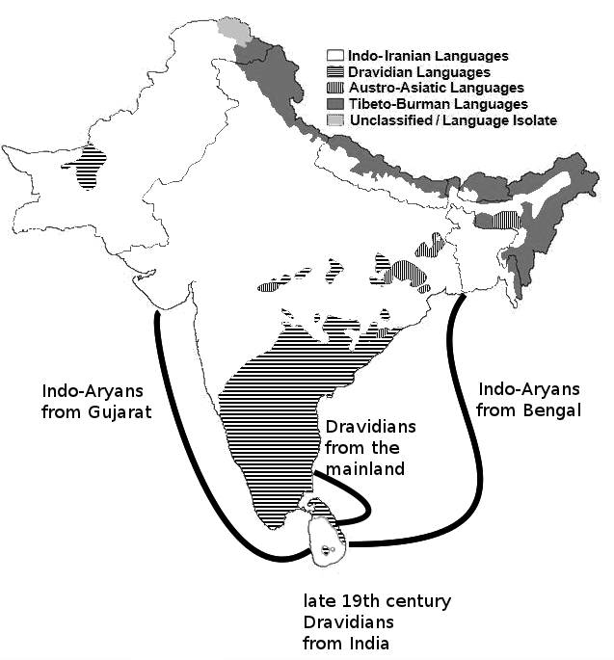
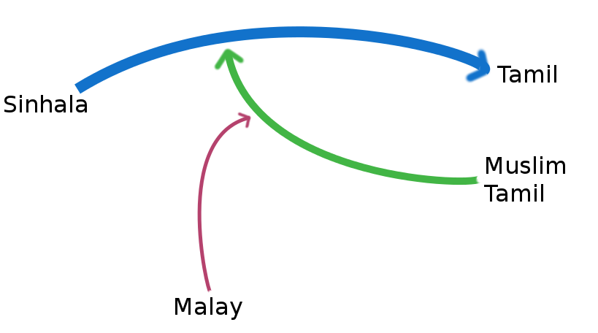
Catch me if you can: Pathways of Dravidian influence in Sri Lanka Malay
Sebastian Nordhoff

Abstract
Discussions of the history of Sri Lanka Malay have so far tried to evaluate the development of Sri Lanka Malay with regard to the relative influence from the adstrates Sinhala and Tamil. This paper shows that such an approach is too coarse-grained and that the dialectal situation of especially Tamil has to be taken into account. After an overview of the dialectal situation we find on the island, three directions of language change are established: 1) Sinhala moves towards a general Tamil typology; 2) South Western Muslim Tamil moves towards Sinhala; and 3) Sri Lanka Malay moves towards South Western Muslim Tamil and/or Sinhala. A discussion of the problematic nature of the assumptions of ‘fixed targets’ in language contact studies emanating from point 3) closes the paper.
Keywords: Sri Lanka, Sri Lanka Malay, Sinhala, Tamil, dialectology, language contact

1 Introduction
Sri Lanka Malay is the language of the descendants of immigrants (mostly soldiers) brought to Sri Lanka by the colonial powers of the Dutch (1656-1796) and British (1796-1948). It is the most divergent variety of Malay and has adopted a thorough South Asian typology with retroflexes, bound morphology, head-final word order and vector verbs.
It is clear that these structures were acquired in the roughly three centuries between the Dutch period and now. A more contentious question is whether the development of these structures is due to (Moorish) Tamil or Sinhala influence. Proponents of Sinhala hold that 80% of the population speak Sinhala, while Moors only make up 6% of the population. Defendants of Tamil influence reply that the Moors had close cultural, religious and familial ties with the Malays, which gave their language a higher impact than numbers alone would suggest.
The debate has so far pitched “Sinhala” against “Tamil”, treating them as inert monoliths. As a first approach, this is eminently sensible, but a closer look reveals that there are a number of language change processes going on within these blocks, which one has to consider when analyzing the structure of Sri Lanka Malay.
Sri Lanka Malay has adopted many structures which are typically Dravidian. The question which arises is how these structures made their way into the language. In order to address this issue, I will proceed as follows: I will start with an overview of the linguistic ecology of Sri Lanka in Section 2. Section 3 will present the dialectal situations of the individual languages in more detail. Section 4 discusses cases of Dravidian influence in Sri Lanka Malay. I will present new findings on language contact in Section 5 and discuss them in Section 6.

2 The Sri Lankan linguistic ecology
The first language spoken in Sri Lanka that we know of is the Vedda language (Geiger 1973:505). Various proposals have been made as to its origins, but as a matter of fact, language attrition has proceeded to a point where little of any substance can be said about the affiliation of this language.

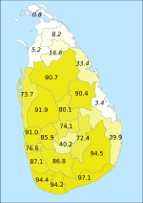 | 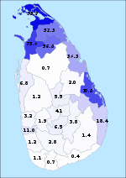
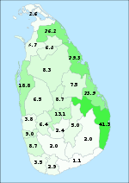 | 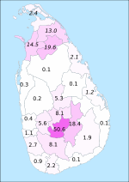

Figure 1: The current distribution of linguistic groups in Sri Lanka. Based on census data from 2001 and 1981.
http://commons.wikimedia.org/wiki/File:Sri_Lanka_Moor.svg; http://commons.wikimedia.org/wiki/File:Sri_Lanka_Sinhalese.svg;
http://commons.wikimedia.org/wiki/File:Sri_Lanka_Indian_Tamil.svg; http://commons.wikimedia.org/wiki/File:Sri_Lanka_Native_Tamil.svg.
All files CC-BY 2.5 Sadalmelik.

Sinhala (Indo-Aryan) and Tamil (Dravidian) both arrived on the island about three millennia ago, although the respective order of arrival is a matter of debate (Gair 1998:4). Sinhala has been shown to share some features with Western Indo-Aryan languages like Marathi and others with Eastern Indo-Aryan languages like Bengali (Geiger 1973). This suggests two waves of immigration, but again the chronological order is unsure (Figure 2).

Figure 2: Migrations from India to Sri Lanka.
based on http://commons.wikimedia.org/wiki/File:South\s\do2(A)sian\s\do2(L)anguage\s\do2(F)amilies.jpg CC-BY-SA-3.0-MIGRATED http://commons.wikimedia.org/wiki/User:BishkekRocks

Sinhala is separated from its Northern cousins by the Dravidian languages of South India and is isolated within the family. Due to prolonged contact with Dravidian languages, Sinhala became much more Dravidianized than any other Indo-Aryan language. In the 19th century, there was some debate as to whether Sinhala was actually Dravidian or Indo-Aryan, but Geiger established the Indo-Aryan nature of Sinhala beyond doubt.
Gair (1994, 2012) adds Sinhala to the South-South Asian Sprachbund, which comprises Southern India, Sri Lanka, and the Maldives. Features which set off Sinhala from the Northern Indo-Aryan languages are absence of aspirates, long ē and ō, conjunctive participles without a same-subject requirement, evidentials, quotatives, and a very thorough left-branching structure. These features are shared with Tamil.
Sinhala is today the majority language of Sri Lanka with about 74% of the population speaking it as first language. Sinhala speakers are Buddhists or Christians. They mainly live in the West, Center, and South of the island, but can be found elsewhere as well. After the end of the Sri Lankan Civil War, there are ideas of settling Sinhala speakers in the Northern regions as well, which are predominantly Tamil.
Sri Lankan Tamil prides itself as a very old and pure form of this language. Tamil is spoken by the Sri Lankan Tamils (Hindu or Christian) mainly in the North, the Moors (Muslim) in the West and in cities, and the Indian Tamils (Hindu or Christian) in the central tea estates and the North. These varieties differ considerably. Altogether, about 25% of the Sri Lankan population speak one variety or another of Tamil as their mother tongue. Sri Lankan Tamil uses the same script and orthography as Indian Tamil, but spoken Sri Lankan Tamil is not intelligible to speakers from India. The differences are so important that speakers from India frequently think that their interlocutor does not speak a variety of Tamil at all, but rather Malayalam. It should also be noted that Tamil is a diglossic language, and that written Tamil differs considerably from any variety of spoken Tamil.
Jaffna Tamil is the most prestigious variety of Tamil on the island. Its main features are archaic phonology and morphology, a threefold deictic contrast, and a more differentiated negation system than Indian Tamil. The other varieties of Tamil on the island tend to be eclipsed by Jaffna Tamil in scholarly domains. We will return to this below.
Sri Lanka Portuguese arrived on the island during the Portuguese period (1503-1656) as a Creole. Due to intermarriage with the local population, the language became thoroughly Lankanized and is now the only Creole with a European lexifier to have thorough SOV word order or postpositions. The Dutch (1656-1798) continued to use Sri Lanka Portuguese as a lingua franca, a practice which continued into the early days of British rule (1798-1948). As a lingua franca, Sri Lanka Portuguese was also acquired by populations which otherwise had no connections to the colonial administration. Today, Sri Lanka Portuguese is spoken on the East Coast (Tamil-dominated) by about 4000 Portuguese Burghers, and by a very small number of Sri Lankan Kaffirs (descendants of slaves) on the West Coast. Smith (1979) shows that the Burghers’ Sri Lanka Portuguese is thoroughly influenced by Tamil. A recent overview can be found in Nordhoff (2013). of Sri Lanka Portuguese in the Sinhala dominated region,
Sri Lanka Malay is the language of the descendants of immigrants brought during the Dutch and British period. It was mainly spoken in the centers of colonial administration, i.e. cities and towns in the center and in the South. Towards the end of the 19th century (Hussainmiya 1990), Sri Lanka Malays were also employed as overseers on the emerging tea estates in the central Hill Country. Sri Lanka Malay has been argued to show influence from Muslim Tamil (Smith & Paauw 2006) and/or from Sinhala (Ansaldo 2008).
Sri Lanka Malay is relatively homogeneous. There is a small pocket of Sri Lanka Malay speakers on the South coast (Kirinda and Hambantota) which has some dialectal peculiarities, but overall mutual intelligibility is good.
The standard view about language contact in Sri Lanka is that all languages that get there converge towards Tamil. This assumption is based on the observation that Sri Lankan Tamil is an archaic variety (Zvelebil 1959b), which suggests that it has not changed a lot. Given that Sri Lanka is a sprachbund (Bakker 2006), potentially within a larger South-South-Asian Sprachbund (Gair 2012), the logical conclusion is that all other members have converged to the most conservative language, Tamil in this case. This is received wisdom for Sinhala (Geiger 1973, Elizarenkova 1972), Sri Lanka Portuguese (Smith 1979) and Sri Lanka Malay (Hussainmiya 1990, Smith & Paauw 2006, Bakker 2006).

3 A closer look at the contact situations
While at first sight, it appears that Tamil provides the typological sink all languages of the island move towards to, a closer look at the actual varieties in question casts doubt on this scenario. I will now delve deeper into the internal diversity of the languages of the island and show that the language change processes are far more complex than presented beforehand.

3.1 Sinhala
Sinhala is quite homogeneous as a language. “We can hardly speak of any dialectal difference of the Sinhalese language in the Island itself” (Geiger 1938:168). This is especially true if we compare it with the wealth of Tamil dialects on the island (see below).
Tamil influence on Sinhala syntax is clear and widely accepted. It is most obvious in dependent structures. Gair (1998 [1976]) states “[S]ubordinate verbal structures as a whole are of a strikingly Tamil and Dravidian character ... the cumulative effect is nothing short of overwhelming.”
The phonological features of long mid vowels and lack of aspiration also distinguish Sinhala from Northern Indo-Aryan languages, and make it appear closer to Tamil. This led Elizarenkova (1972) to argue for an extensive phonological influence from Tamil on Sinhala.
In a very detailed study, however, Gair (1985), drawing on material by Karunatillake (1969), shows that all the mentioned changes towards Tamil are either empirically problematic or were accompanied by changes away from Tamil in the very same periods. For instance, long /e/ and /o/ in Sinhala developed after the eighth century BC. This looks like Tamil influence, since Tamil has this distinction as well. However, before the eighth century, Sinhala had lost all vowel length distinctions altogether. This is a most un-Tamil development. A movement away from Tamil would then be immediately followed by a movement towards Tamil. It is of course possible that the sociodemographic setting changes a lot in short time, and that patterns of language change follow. However, Gair shows that the phonological history of Sinhala is such that movements towards Tamil are usually immediately followed by movements away from Tamil. This would entail a flickering sociodemographic setting,
where Tamil influence is turned on and off in very short intervals, an unlikely explanation.
As for the lexicon, Tamil influence is beyond doubt. The same is true for syntax. Gair (2012) lists the following features which point to clear Tamil influence in Sinhala:
• Question marker appears at the end of sentence (postverbal) as the unmarked location, but may also occur on questioned sentence-internal constituents
• Subordinate clauses marked at the end, by a verbal affix or a conjunctive form of some kind, rather than by initial conjunctions (which are rare or missing altogether except for sentence adverbs)
• Preposed relative clauses (adjectival sentences) as the only or main alternative.
• Correlatives use a WH-word rather than a correlative form of the Indo-Aryan type and are generally restricted to indefinite or conditional contexts and commonly employ a sentence particle (dubitative or question) on the subordinate clause.
• Sentence-final quotative from ‘say’
• Sentences may be nominalized without genitivization (or deletion) of subject, by employing a sentence-final form or verbal affix.
• Focused (nominal cleft) sentences, including those with rightward focus.
• Negatives:
• Negative varies with type of main clause (verbal, equational, existential).
• Negative verbs in subordinate clauses.
• Cleft sentences negated like nominal equational ones.
• Conjunctive participles may occur with overt lexical subjects, not co-indexed with main subject (or agent). [Extent yet to be determined]
• A sentence-final reportative or hearsay particle (unrelated to the quotative).

3.2 Tamil
The internal diversity of Tamil is very high. The first division to be made is between written Tamil and spoken Tamil: Tamil is a diglossic language. There are a number of good grammars of the written language, the spoken language has received less attention. In the context of this paper, written Tamil is not relevant. Spoken Tamil can be divided into Indian Tamil (with further subdivisions) and Sri Lankan Tamil (See Figure 3). There are some descriptions of Standard Spoken Indian Tamil (Lehmann 1989, Schiffman 1999), but the overall description of dialects is dire (Shanmugam Pillai ca. 1986). Furthermore, the Indian Standard does not transpose to Sri Lanka. Schiffman (1999) notes:
In Sri Lanka, the notion of accepting or not accepting the “unifying” ability of S[tandard] S[poken] T[amil] is another matter, since SST is understood but not accepted as an intercaste mode of communication among Sri Lankan Tamils. This matter will not be resolved until the civil war in that island has ended.
Note that Sri Lankans can understand the Indian standard, but the reverse is not true.

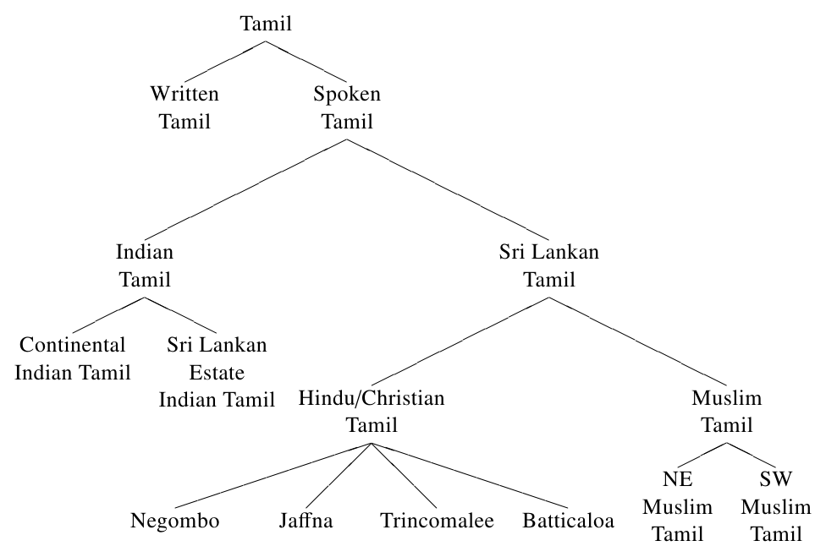
Figure 3: Dialectology of Tamil with special focus on Sri Lanka
Within Sri Lanka, further subdivisions can be made. Gair & Suseendirarajah (1998:170f) state: “There is, in fact, more dialect variation within Tamil in Sri Lanka than there is within the majority (Indo-Aryan) language Sinhala.”
Within Sri Lanka, the most prestigious variety is Jaffna Tamil (Zvelebil 1959b, Kuiper 1962, Shanmugam Pillai 1962, Zvelebil 1966, Gair & Suseendirarajah 1998, Gair et al. 2005, Suseendirarajah 1993), spoken by Hindus and Christians. Zvelebil (1966:137) notes: “It happens quite frequently that, when speaking about Ceylon(ese) Tamil, what authors have really in mind is (one dialect of) Jaffna Tamil. This should of course be avoided.” Next to Jaffna Tamil, the varieties of Trincomalee (Zvelebil 1959a, 1966) and Batticaloa (Zvelebil 1966, Selvarajagopal 1979) also deserve mention. These varieties can clearly be distinguished. Tamil as spoken by Muslims differs from the variety used by the Hindus and Christians. Muslim Tamil itself is divided into a North-Eastern variety, close to Batticaloa Tamil, and a South-Western variety, which is heavily Sinhalized (Nuhman 2007). Zvelebil (1959b, 1966) also mentions ‘Mixed Common Ceylonese’ as a (then) developing standard ( also cf. Gair et al. 2005).
Another Sinhalized variety is Negombo fishermen’s Tamil (Bonta 2004, 2010), which, like South-Western Muslim Tamil has lost verbal agreement.
Things are further complicated by Indian migrant workers in the central tea estates and the Northern provinces, who arrived in the late 19th century. They spoke Indian dialects of Tamil (and other Dravidian languages), and their speech today is still closer to Indian Tamil than to Sri Lankan Tamil. Gair & Suseendirarajah (1998) mention onglides and syncopation as mainland features found in Estate Tamil. Among these dialects, processes of dialect leveling probably took place (Wijeratne 2005), but this is in need of further research.
As far as language change is concerned, the varieties of Jaffna, Trincomalee and Batticaloa are generally seen as archaic, with little or no change towards Sinhala having taken place. All varieties of Muslim Tamil show Arabic influence in the lexicon (Nuhman 2007), and South-Western Muslim Tamil and Negombo fishermen’s Tamil (non-Muslim) show syntactic and phonological influence from Sinhala. Bonta (2010) reports that the following features point towards Sinhala influence in Negombo Fishermen’s Tamil.
• loss of verb agreement†
• first person present tense denotes strong intention
• changes in the semantics of the morphological future
• existential used for possibilitative
• reduplication denotes progressive†
• changes in negatives
• (re)development of a three way deictic system†
• calque of an emphatic construction
• ‘at night’ formed with the dative †
• infinitive + existential for debitive†
The features marked with a dagger † are also found in Sri Lanka Malay. Depending on the variety we look at, Tamil influence in Sri Lanka Malay therefore would vary greatly. The Negombo fishermen dialect is described quite extensively in the relevant domains, and shows to what extent non-standard varieties of Tamil can be Sinhalized. It is clear from the socio-demographic setting (professional occupation, region, religion) that Negombo fishermen’s Tamil did not exert influence on Sri Lanka Malay. Still, it can provide some insights on the extent of possible Sinhalization of other dialects of Tamil. A case in point is South-Western Muslim Tamil. There is consensus that this variety is a highly relevant contact language for Sri Lanka Malay, but it is described in less detail than Negombo fishermen’s Tamil. A number of interesting parallels, however, emerge from the literature. Nuhman (2007:72-79) notes:
• lexical differences in religious vocabulary
• frequent initial voiced plosives (S,†)
• geminate voiced plosives (S,†)
• absence of retroflex liquids (S,†)
• clearer articulation of vowels (S,†)
• lack of agreement (S,†). See Table 1.
• different causative marker; different simultaneity marker
• of 55 kin terms, 25 are shared and 30 are different between the NE and the SW variety
• Sinhala lexical borrowings (S)
An (S) in this enumeration points to features where an explanation involving Sinhala is possible. The dagger denotes, as above, that a feature of Sri Lanka Malay, whose existence could not be explained by recurrence to a more standard form of Tamil, can very well be explained by taking into consideration this dialect of Tamil.
Nuhman focused more on phonology, while Bonta was more interested in morphosyntax. Taken together, however, we get a more complete picture about the influences Sinhala has exerted on non-standard varieties of Tamil.

Table 1: Comparison of NE Muslim Tamil and Souther Muslim Tamil forms from Nuhman (2007:76). Sinhala and SLM added for comparison.
 | NE Muslim Tamil |  | SW Muslim Tamil |  | Sinhala |  | SLM
1sg | naan | poonan | naan | poona | mama | giyaa | see | supii
2sg | nii | poonaay | nii | poona | oba | giyaa | lorang | supii
3sg.m | avan | ponaan | avan | poona | eyaa | giyaa | incayang | supii
3sg.f | avaɭ | poonaɭ | aval
1pl | naanka | poonam | naanka | poona | api | giyaa | kithang | supii
2pl | niinka | pooninka | niinka | poona | oyalaa | giyaa | lorampada | supii
3pl | not given in source |  |  |  | eyaalaa | giyaa | derampada | supii

While at first glance, it appeared that Sinhala was moving towards Tamil, which remained inert, closer inspection reveals that there are some varieties of Tamil which are moving towards Sinhala, similar to walking against the direction of a moving train.

3.3 Sri Lanka Malay
Sri Lanka Malay shows quite a great deal of internal variation, but this variation does not pattern geographically. Serious differences in phonology, morphology or syntax can be found within the same town. The only clear regional differences observed up to now is a much more contracted speech in Hambantota and Kirinda on the South coast as compared to the other varieties and a different unmarked first person pronoun in the North (see) as compared to the south (goo).
Sri Lanka Malay shows some very peculiar structures which are clearly of Lankan origin. We can mention SOV word order, postpositions, retroflex consonants, quantity distinctions in vowels and consonants, clause chaining, and conjunctive participles (Nordhoff 2009, 2012e). These features are almost all absent from other varieties of Malay (Gil 2010, Paauw 2012, Nordhoff 2012c). It is clear that Sri Lanka Malay acquired them after arriving on the island. But did it acquire them from Sinhala (the majority language), or from Tamil. And if it acquired them from Tamil, which variety of Tamil are we talking about? I will now discuss some of these features in more detail.

4 Dravidian features in Sri Lanka Malay

4.1 Phonology

4.1.1 Retroflexes
Sri Lanka Malay has a phonemic distinction between dental and retroflex stops, /t̪/ vs. /ɖ/ and /t̪/ vs. /ʈ/. Examples include koot̪or ‘dirt’ vs. kooʈor ‘idiot’ and d̪aat̪a ‘elder sister’ vs. ɖaapur ‘oven’. The voiced dental stops is almost exclusively found in the onset. Since this phonemic distinction is not found in other varieties of Malay, language contact is an obvious explanation. Sinhala and Tamil both have the dental/retroflex opposition as well. I have argued in Nordhoff (2012a) that Tamil influence is unlikely for the development of this opposition in the onset, as Tamil disallows voiced onsets, but as ɖaapur ‘oven’ shows, voiced stops are also found in initial position in SLM. This is against received views of Tamil phonology. This view cannot be held up in light of the dialectal diversity of Tamil. The first and foremost argument is that d̪aat̪a is itself a loanword from Muslim Tamil. In Muslim Tamil (especially South Western Muslim Tamil), and unlike in Hindu/Christian varieties, voiced onsets are easily found (probably due to Arabic influence in the vocabulary). Next to daata, Nuhman (2007:74) cites bakiru ‘stomach’, dotangaa ‘orange’, goovaa ‘cabbage’, and jannal ‘window’.
Therefore, Tamil influence, in what concerns voiced retroflexes, is as likely as Sinhala influence.

4.1.2 Vowel length
Sri Lanka Malay has phonemic length distinctions for the 5 main vowels /a, e, i, o, u/. This is of course what is typical of Dravidian languages, but not of Northern Indo-Aryan languages, where the mid vowels /e/ and /o/ typically do not show this length distinction. This thus looks like a clear parallel with Dravidian languages. But, incidentally, also with Sinhala, which is uncommon among the Indo-Aryan languages in having a length distinction in mid vowels as well (e.g. eka ‘one’ vs. eeka ‘this one’ and mola ‘brains’ vs. moola ‘mill’, Karunatillake 2004:xviii). Elizarenkova (1972) argued that Sinhala acquired this distinction through influence from Tamil. Even if her analysis is debatable, vowel length can serve as an illustration of a pattern we will encounter more often in the course of this paper: What looks like a clear case at first sight becomes muddled upon inspection of the actual varieties at hand.

4.2 Morphology
Sri Lanka Malay developed an infinitive (1) and a conjunctive participle (2). Both structures are also found in Tamil and Sinhala.
(1) Mama eyaa=ʈa ya -nɖa kiyalaa kivvaa Sinhala
Naan avar=ukku po -ha solli sonn -een Tamil
Se incayang=nang má- pi katha subiilang Slm
1sg 3sg=dat inf- go inf quot say.pst 1sg
‘I told him to leave.’

(2) Kumaar metenʈa ävillaa, maʈa kataa.keruvaa Sinhala
Kumaar ingee vandu, ennai kuuppiʈʈaan Tamil
Kumaar siini asdhaatang, seeyang supanggel Slm
Kumaar here cp.come me called
'Kumaar came here and called me.'

The development of postnominal case markers (3) is also a clear instance of language contact.

(3) Ammaa lamayaa=ʈa salli denavaa Sinhala
Amma pillai=kku paɳam kudukkirr -aaɭ Tamil
Mma aanak=nang duwith arakaasi Slm
Mother child=dat money pres.give -3sf
‘The mother gives money to her child’

The domain of case has been taken as an instance to distinguish between Sinhala and Tamil influence. Ansaldo (2008:32,35) argued that the conflation of instrumental and ablative is found in both SLM and Sinhala, but not in Tamil. It is true that the distinction between instrumental and ablative is not found in the morphology sections of Sinhala grammars. But this is due to the orthographic tradition of Sinhala, which spells in̆dalaa (the ablative marker, actually the conjunctive participle of the existential) as a separate word whereas Tamil spelling attaches -runtu (the ablative marker, and also the conjunctive participle of the existential) to its host. The two forms are exactly parallel in the system but differ in orthographical convention. An overview of the cases is given in Table 2.

Table 2: Cases in Tamil, Sinhala, and SLM. Parentheses mark morphemes indicating thematic role which are not phonologically integrated.
 | Tamil | Sinhala | SLM
NOM | ∅ | ∅ | ∅
ACC | -ei | -va | =yang
DAT | -kku | =ʈa | =nang
INSTR | -aale | =geng / =ing / (atiŋ) | =dering
ABL | -runtu | =geng / =ing / (in̆dalaa) | =dering / (asà-duuduk)

A final case of Dravidian influence is the development of the clitics le ‘additive’, so ‘dubitative’ and si ‘interrogative’, which mirror what we find in Tamil and Sinhala.

4.3 Syntax
While all other varieties of Malay are verb-medial, Sri Lanka Malay is verb-final. This is of course a typical South Asian feature. See (3) for a typical example. In line with the order of the elements of the clause, Sri Lanka Malay has head-final NPs, as have Sinhala and Tamil.
Finally, Sri Lanka Malay has Vector Verbs of the South Asian type (4) (see Nordhoff 2012d). These are more prevalent in Tamil, so that this is a more likely source, but they can also be found in Sinhala (obviously through influence from Tamil).

(4) ziharath-yang su- picakan thaaro Slm
ziyaratt-e oɖe -cc -i pooʈ -ʈ -aanga Tamil
shrine-acc pst- break -past -ptcp put -pst -agr
‘They tore down the shrine.’ (Smith & Paauw 2006:171)

4.4 Semantics
Semantic influence is abundant. A striking example is the combination of WH-words with certain clitics: in direct combination, they yield a pronoun, with an intervening noun, they serve to establish certain kinds of reference or quantification. An example is given in (5).
(5) Koyi gedara =t kusiya -k tiyenavaa Sinhala
Ellaa uuɖu -ha =ll =um kusini irukku Tamil
Mana ruuma =ka =le kusiini aada Slm
which house pl loc assoc kitchen indef exist.inanim
‘Every house has a kitchen.’

4.5 Some notable absences
The preceding sections have shown that we find a lot of Dravidian influence in Sri Lanka Malay, but that the precise pathways of these influences are not always easy to trace. There are two notable absences of Dravidian influence in Sri Lanka Malay: agreement and retroflex sonorants ɭ and ɳ. One could expect that SLM would copy these features from Tamil as well as the ones just mentioned. However, this cannot be taken as an argument against Tamil influence: first, absence of a feature does not preclude influence in other domains. Second, and more importantly, the relevant varieties of Muslim Tamil underwent Sinhala influence and lost both agreement and retroflex sonorants. The absence of these features from SLM is therefore expected, but only after looking at the relevant varieties in some more detail.

5 Language contact in Sri Lanka revisited
Wrapping up what has been said in the previous section, we get the following list:
1. Sri Lanka Malay changes towards South-Western Muslim Tamil
2. South-Western Muslim Tamil changes towards Sinhala
3. Sinhala changes towards Tamil
If we take point 1, we can say that Sri Lanka Malay changes towards (a variety of) Tamil, which is received wisdom. If we add point 2, it suddenly appears that Sri Lanka Malay changes towards Sinhala, via South-Western Muslim Tamil. But if we finally add point 3, it appears that the ultimate target is Tamil again. It is thus very difficult to catch the exact language change target of Sri Lanka Malay, as the target is ever-moving, and none of the relevant varieties are static enough to allow firm conclusions.
Figure 4: Illustration of the ‘directions’ of language change. Sinhala changes towards Tamil, but Muslim Tamil changes towards Sinhala. Sri Lanka Malay changes towards Muslim Tamil and/or Sinhala.

6 Discussion
We started this paper by alluding to the open question whether Sri Lanka Malay was more influenced by Tamil or by Sinhala. The discussion of the dialectal situation on the island has shown that the question is actually more complicated, because Tamil, and even Moorish Tamil, shows internal dialectal variation which is more complex than previously assumed. Especially, South-Western Muslim Tamil is heavily influenced by Sinhala, which makes disentangling the respective influences even more difficult. While it is of course possible to claim that one language had a more important influence than the other, the intricate dialectal situation makes it difficult to see how influence of any of the languages could be discarded on structural grounds. The null hypothesis would remain that both languages exerted some influence, whether jointly (during periods of trilingualism) or separately, in successive layers of bilingualism of Malay + X (cf. Nordhoff 2012c).
Next to this rather pessimistic outlook, a further, more theoretically relevant point is that there are no fixed targets in language contact. Inert targets are of course tempting as they make the analysis more succinct. But as the examples of Sinhala moving towards Tamil, and South-Western Tamil moving towards Sinhala, have shown, at least in Sri Lanka, we are dealing with moving targets.
Mattheier (1996) argued that the term ‘convergence’ is often mistaken, because usually there is one language which changes towards the other, while the target language is not at all influenced in return. He proposes that ‘advergence’ might be a better term for one language asymptotically approaching another one. In the Sri Lankan case, it appears that we have several layers of advergence. Sinhala adverges towards a general Dravidian model, exemplified by Hindu/Christian varieties of Tamil. These varieties of Tamil do not change towards Sinhala. South-Western Muslim Tamil adverges towards Sinhala, while Sinhala is not influenced in return by the Muslim dialect. Sri Lanka Malay, finally, changes towards both Sinhala and SW Muslim Tamil, while the latter varieties are not influenced by SLM. Mattheier’s rejection of the term ‘convergence’ is sensible for the Sri Lankan situation, where it is not the case that the languages all move towards a common goal where they would meet. But ‘advergence’ in its original sense does not seem to be a very good term either, as this term suggests that there are languages which do not move. What we are dealing with in Sri Lanka is rather a case of ‘catch me if you can’, where every target language is in turn on its way of trying to catch up with yet another language.

7 Conclusion
Sri Lanka Malay has acquired many Dravidian structures. These structures do not stem from Standard Tamil, but either from Sinhala or South-Western Muslim Tamil. Information about dialects and sociolects in Sri Lanka has improved our understanding of the language change processes going on on the island. We are now able to see that most varieties are moving, but that they do not share a common goal (i.e. convergence). Rather, every variety has its own target, and may in turn be target for yet another variety. We are not dealing with inert, static targets; instead the target languages are moving themselves. This makes the language change processes more difficult to model or analyze, but at the same time it gives good insights into the dynamics of Sri Lankan languages.

References
Ansaldo, Umberto. 2008. Sri Lanka Malay revisited: Genesis and classification. In A. Dwyer, D. Harrison & D. Rood (eds.) A world of many voices: Lessons from documented endangered languages, Studies in Language, 13–42. Amsterdam, Philadelphia: John Benjamins.
Bakker, Peter. 2006. The Sri Lanka Sprachbund: The newcomers Portuguese and Malay. In Yaron Matras, April McMahon & Nigel Vincent (eds.) Linguistic Areas – Convergence in Historical and Typological Perspective, 135–159. Houndmills, New York: Palgrave Macmillan.
Bonta, Steven. 2004. Negombo Fisherman’s Tamil: A Case of Contact-Induced Language Changefrom Sri Lanka. Ph.D. thesis, Cornell University.
Bonta, Steven. 2010. Negombo Fishermen’s Tamil: A Case of Indo-Aryan Contact-Induced Change in a Dravidian Dialect. Anthropological Linguistics, vol. 52(3-4), 310–343.
Deumert, Ana & Stephanie Durrleman (eds.) . 2006. Structure and Variation in Language Contact. Amsterdam: John Benjamins.
Elizarenkova, T. 1972. Influence of Dravidian Phonological System on Sinhalese. International Journal of Dravidian Linguistics, vol. 1(2).
Gair, James W. 1985. How Dravidianized Was Sinhala Phonology: Some Conclusions and Cautions. In R. L. Leed & V. Acson (eds.) Festschrift for Gordon H. Fairbanks, 37–55. Honolulu: Oceanic Linguistics, University of Hawaii. Reprinted in Gair (1998), pp. 185–199.
Gair, James W. 1994. Universals and The South-South Asian Language Area. Keynote Address SALA (South Asia Language Analysis). University of Pennsylvania, May 20 1994.
Gair, James W. 1998. Sinhala and Other South East Asian Languages. New York, Oxford: OUP.
Gair, James W. 1998 [1976]. Selections from “The Verb in Sinhala, with some Preliminary remarks on Dravidianization. In Gair (1998). Appeared originally in International Journal on Dravidian Linguistics 5(2):259-273.
Gair, James W. & S. Suseendirarajah. 1998. Some Aspects of the Jaffna Verbal System. In Gair (1998), 170–181.
Gair, James W., W. Suseendirarajah & W. S. Karunatillake. 2005. An introduction to spoken Tamil. Colombo: Godage and Brothers.
Gair, James Wells. 2012. Sri Lankan Languages in the South-South Asia Linguistic Area: Sinhala and SL Malay. In Nordhoff (2012b), 165–194.
Geiger, Wilhelm. 1938. A Grammar of the Sinhalese Language. Colombo: Royal Asiatic Society, Ceylon Branch.
Geiger, Wilhelm. 1973. Kleine Schriften zur Indologie und Buddhismuskunde, Glasenapp-Stiftung, Veröffentlichungen, vol. 6. Wiesbaden: Steiner.
Gil, David. 2010. Malay/Indonesian dialect geography and the sources of Sri Lankan Malay. Paper presented at the workshop "Past, present and future of Sri Lanka Malay".
Hussainmiya, B. A. 1990. Orang Rejimen: The Malays of the Ceylon Rifle Regiment. Universiti Kebangsaan.
Jayawardena-Moser, Premalatha. 1996. Aufbauwortschatz Singhalesisch - Deutsch. Wiesbaden: Harrassowitz, 3 edn.
Karunatillake, W. S. 1969. Historical Phonology of Sinhalese from Old Indo-Aryan to the 14th century A.D. Ph.D. thesis, Cornell University.
Karunatillake, W. S. 2004. An Introduction to Spoken Sinhala. Colombo: Gunasena, 3rd edn.
Kuiper, F. B. J. 1962. Notes on Old Tamil and Jaffna Tamil. Indo-Iranian Journal, vol. 1, 52–64.
Lehmann, Thomas. 1989. A Grammar of Modern Tamil. Pondicherry: Pondicherry Institute of Linguistics and Culture.
Mattheier, Klaus J. 1996. Varietätenkonvergenz: Überlegungen zu einem Baustein einer Theorie der Sprachvariation. Sociolinguistica, vol. 10, 31–52.
Nordhoff, Sebastian. 2009. A Grammar of Upcountry Sri Lanka Malay. Ph.D. thesis, University of Amsterdam.
Nordhoff, Sebastian. 2012a. Establishing and dating Sinhala influence in Sri Lanka Malay. Journal of Language Contact, vol. 5(1), 23–57.
Nordhoff, Sebastian (ed.) . 2012b. The genesis of Sri Lanka Malay – A case of extreme language contact. Leiden: Brill.
Nordhoff, Sebastian. 2012c. The genesis of Sri Lanka Malay as a multi-layered process. In Nordhoff (2012b), 251–280.
Nordhoff, Sebastian. 2012d. Multi-verb constructions in Sri Lanka Malay. Journal of Pidgin and Creole Languages, vol. 27(2).
Nordhoff, Sebastian. 2012e. Synchronic grammar of Sri Lanka Malay. In Nordhoff (2012b), 13–49.
Nordhoff, Sebastian. 2013. The current state of Sri Lanka Portuguese. Journal of Pidgin and Creole Languages, vol. 28(1).
Nuhman, M A. 2007. Sri Lankan Muslims – Ethnic Identity within Cultural Diversity. International Centre for Ethnic Studies: Colombo.
Paauw, Scott. 2012. The Lexical Sources of Sri Lanka Malay Revisited. In Nordhoff (2012b), 149–164.
Schiffman, Harold. 1999. A Reference Grammar of Spoken Tamil. Cambridge: CUP.
Selvarajagopal, K D. 1979. tamilk kilɭaimoli oliyaniyal Ayivu maʈʈakkaɭappukkilai moli (Research on Tamil dialect phonemics: The Batticaloa Dialect). Master’s thesis, Vidyalankara Campus of the University of Ceylon. Date and author are not indicated on the copy but had to be inferred. The copy is located at the Institut für Indologie und Tamilistik in Cologne.
Shanmugam Pillai. 1962. A Tamil Dialect in Ceylon. Indian Linguistics, vol. 23, 90–98.
Shanmugam Pillai, M. ca 1986. Tamil Dialectology. Unpublished manuscript. Copy available at the Institute for Indian and Tamil Studies, University of Cologne.
Smith, Ian. 1979. Convergence in South Asia: A Creole example. Lingua, vol. 48, 193–222.
Smith, Ian R. & S. Paauw. 2006. Sri Lanka Malay: Creole or convert. In Deumert & Durrleman (2006), 159–182.
Suseendirarajah, S. 1973. Phonology of Sri Lanka Tamil and Indian Tamil Contrasted. Indian Linguistics, vol. 34(3), 171–179.
Suseendirarajah, S. 1993. Jaffna Tamil (I) Phonology and Morphology. Jaffna: University of Jaffna.
Wijeratne, W. M. 2005. Estate Tamil: A New Variety of Tamil. Paper presented at the 10th International Conference on Sri Lankan Studies, Kelaniya, Sri Lanka.
Zvelebil, Kamil. 1959a. Dialects of Tamil-I. Archiv Orientalni, vol. 27, 272–317.
Zvelebil, Kamil V. 1959b. Dialects of Tamil II-III. Archiv Orientalni, vol. 28.
Zvelebil, Kamil V. 1966. Some Features of Ceylon Tamil. Indo-Iranian Journal, vol. 9(2), 113–138.

Abbreviations
acc | accusative
agr | agreement
assoc | associative
cp | conjunctive participle
dat | dative
dubit | dubitative
inanim | inaninmate
indef | indefinite
inf | infinitive
loc | locative
pl | plural
pres | Present
ptcp | participle

Disregarding Dhivehi (Maldivian), which is an offshoot of Sinhala.
(also cf. Jayawardena-Moser 1996:xii).
These remarks are concerned with diatopic variation of the spoken language. As an anonymous reviewer points out, due to diglossia, there is obviously diastratic variation with the written language.
Elizarenkova gives more features which argue for Tamil influence, but they are all empirically problematic.
It is not clear how this influence in morphosyntax could be reconciled with the claimed absence of influence in phonology.
On a subphonemic level, the distinction can be found.
Suseendirarajah (1973) even argues that loanwords in Jaffna Tamil undergo intial devoicing (pas < bus).
The sixth vowel, schwa, does not have this distinction.
And Sinhala conformed to the Dravidian model through Tamil influence here and the syntax of these constructions is quite different from Northern Indo-Aryan languages. For instance, there is no same-subject-restriction for conjunctive participle constructions.
And Negombo Tamil.
Mathematically speaking, Sinhala → Tamil can be seen as an asymptote and SW Muslim Tamil → Sinhala as a curvilinear asymptote. The terms ‘advergence’ and ‘asymptote’ cannot be applied to the SLM → SWMT/Sinhala case, as there are two targets, Sinhala and SW Muslim Tamil.

