Full disclosure: Open Business Data and the Publisher's Cookbook
Sebastian Nordhoff
Language Science Press
Felix Kopecky
Language Science Press
Text of the abstract
Open Access, monographs, business model

Heading 1
1 Key objectives
This short paper will present the three main outcomes of the OpenAire project "Full disclosure: replicable strategies for book publications supplemented with empirical data": a fully specified business model; accountacy data; and a “cookbook” containing recipes how to set up a resilient community-based book publisher. The provision of these items available for free reuse will allow other publishing projects to understand, adapt, and modify the community-based model of Language Science Press.
2 Introduction
Language Science Press is a community-based platinum OA publishing initiative for monographs and edited volumes in linguistics. Since its inception in 2014, 45 books have been published, about 120 more are in the pipeline.
After initial funding provided by the Deutsche Forschungsgemeinschaft, Language Science Press is now relying on a supporter network of 100 institutions worldwide, which contribute to meeting its running costs.
Adema & Stone (2017: 79) suggest a “Best practice toolkit”, which would help Academic-Led Presses (ALP) in the setting up the publishing platform (also see Ferwerda, Pinter & Stern (2017: 10)). To our knowledge, no such toolkit
exists at the time of writing.
Language Science Press has a strong commitment to openness and is always happy to share. Next to all books being CC-BY, the source code of all books is available on GitHub, the LaTeX class is available on CTAN, all software is 100% Open Source. This means that the technical setup could easily be replicated.
This being said, a software stack alone is not sufficient to run a publishing house. Next to the technical infrastructure, know-how in the domains of finance and community management is also required. In the project "Full disclosure",
Language Science Press shares its business model complemented by granular business data as Open Data. This will allow projects in other disciplines to evaluate in how far the model (or parts thereof) are suitable for their discipline. The business data provided can serve as a yard stick to gauge the attractivity of different revenue streams when planning for a post-grant future. These documents centered on financial and legal aspects are complemented by a “cookbook” with step-by-step recipes.
The provision of a schematic HowTo squared with actual business data will allow for the empirical evaluation of the proposed recipes and some benchmarking. Estimations of costs for OA monographs vary wildly (between 950 EUR and 129,909 USD, Maron et al. 2016) and there is a dire need for some empirical data in this discussion.
Furthermore, the provision of empirically tested-business models is a desideratum, as evidenced by Johnson et al. (2017: 65).
The availabilty of financial calculations will allow to offset one of the main advantages the traditional publishers have over new projects: experience in handling accountancy matters.
3 Business model
The business model starts with analyses of the product, the customers, and the value propositions made to the various groups. One important aspect is that the “customer” in academic publishing is actually no straightforward to pin down. A case can be made that authors, readers, universities, libraries, and the general public are indeed all potential “customers” of Open Access publication platforms in the sense that they derive a benefit from the existence of such platforms.
The model then describes the different channels how different groups of “customers” can participate in the operational costs of a publishing project. For instance, the group of readers can be made to pay via paywalls or print margins; the group of authors could be made to pay via authors fees; libraries can become institutional supporters.
Additional channels also exist.
Each channel comes with an overhead in administration. For instance, institutional memberships require effort to liaise with libraries, and to get the fiscal setup right. This means that less than 100% of the sum on the invoice will
be available for book production. But ideally each channel will provide some net contribution towards financing the core task of producing books.
The descriptive part of the business model is complemented by a freely available spread sheet with a 5-year projection, where publishing projects can enter their estimates about projected number of books; time needed for various tasks; flat costs like rent; and estimated sales/author fees/downloads/institutional memberships. With all estimates filled in, the spreadsheet will show whether the project will be sustainable 5 years down the road.
4 Open Business Data
The model is complemented by all business data from Language Science Press in 2017 in *.csv format. This shared data resource (possibly called “Accountancy Commons”) includes all download figures, all sales figures, all expenses (design, travel, salaries, as far as privacy laws permit), and a breakdown of time spent. This data can be squared with the original business model and allows its empirical evaluation. It will allow other interested disciplines to estimate the costs in their field, adjusting for particular usages of theirs. For instance, a field with mainly prose text might reduce the typesetting estimates compared to linguistics, while a field with heavy use of photographs will have to add additional budget for this.
5 Cookbook
The final element is the “cookbook” of how to set up a community-based publisher with recipes, timelines, and pitfalls to avoid. This is based on the setup of Language Science Press since 2012. Aspects discussed are the generation and
the signalling of prestige; governance; the creation of a community spirit; gamification; community proofreading; marketing; and generating revenue.
References

Heading 2
Vide, quantum,

Heading 3
Circa hos
Quis enim
Illustration table
Xx | Yy | Zz
Xx | Yy | Zz
Xx | Yy | Zz
Xx | Yy | Zz
Cumque
Illustration title
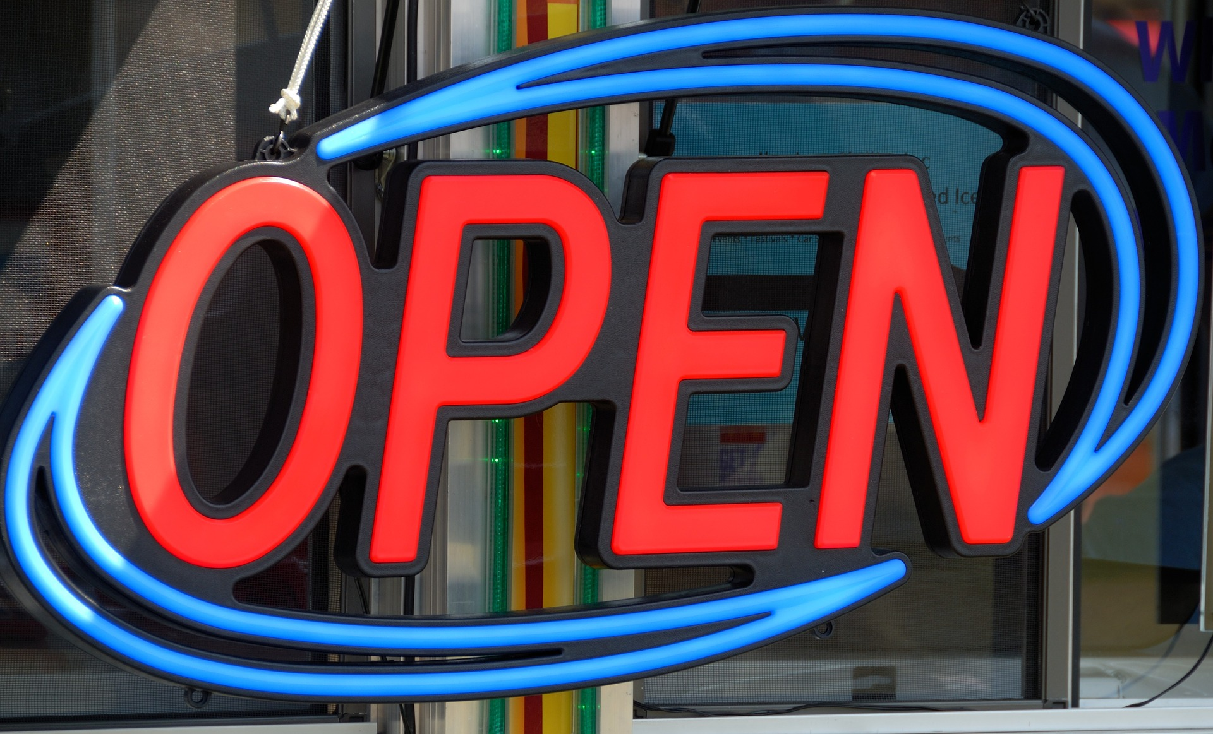
(Illustration coyprights)

Heading 1
Circa hos s infidos, cum iam neutris gratiam referre posset.
Qui cum venisset ob haec festinatis itineribus Antiochiam, praestrictis palatii ianuis, contempto Caesare
Cumque

References
Adema, Janneke & Graham Stone. 2017. Changing publishing ecologies: A landscape study of new university presses
and academic-led publishing. http://repository.jisc.ac.uk/6666/1/Changing-publishing-ecologies-report.pdf.
Ferwerda, Eelco, Frances Pinter & Niels Stern. 2017. A landscape study on open access and monographs: Policies, funding
and publishing in eight European countries. Knowledge Exchange. https://doi.org/https://doi.org/10.5281/zenodo.
815932.
Johnson, Rob et al. 2017. Towards a competitive and sustainable OA market in Europe – A study of the open access
market and policy environment. Research Consulting. https://blogs.openaire.eu/wp-content/uploads/2017/03/OA-
market-report-28Final-13-March-201729-1.pdf.
Maron, Nancy L. et al. 2016. The costs of publishing monographs: toward a transparent methodology. https://doi.org/https:
//doi.org/10.18665/sr.276785.

Clark, H.H. (1973). Space, time, semantics and the child. In T.E. Moore (Ed.), Cognitive development and the acquisition of language. New York : Academic Press, 27-63.
Deane, P. (1993). At, by, to and past : an essay in Multimodal Image Theory. In Proceedings of the Annual Meeting of the Berkeley Linguistic Society, 19 : 112-124.
Talmy, L. (2000). Towards a cognitive semantics. Cambridge, MA : The MIT Press.

