Requirements

**Task manager**  
  I'm a person who passionate about own productivity and punctuality. I want to schedule my tasks and see them in calendar. I need simple tool that support me in controlling my task-flow.

**Functional requirements**

* I want to be able to schedule tasks to my calendar
* I want to be able to reschedule/delete tasks from my calendar
* I want to be able to set length for my task

**Technical requirements**

* It should be WEB application
* For the client side must be used: HTML5, CSS3 (any libs as Twitter Bootstrap,  
  Blueprint ...), JavaScript (jQuery, Backbone.js)
* It should have client side validation.
* 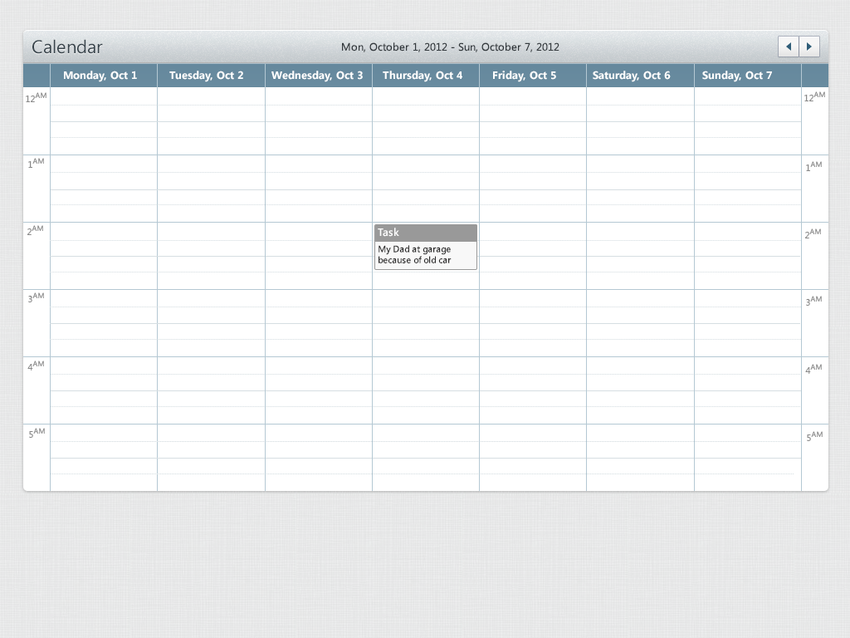It should look like on screens (see attached file).

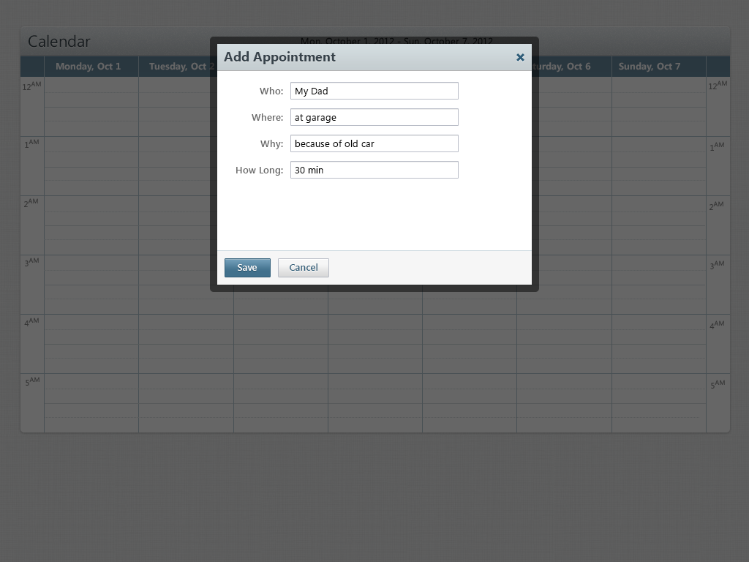

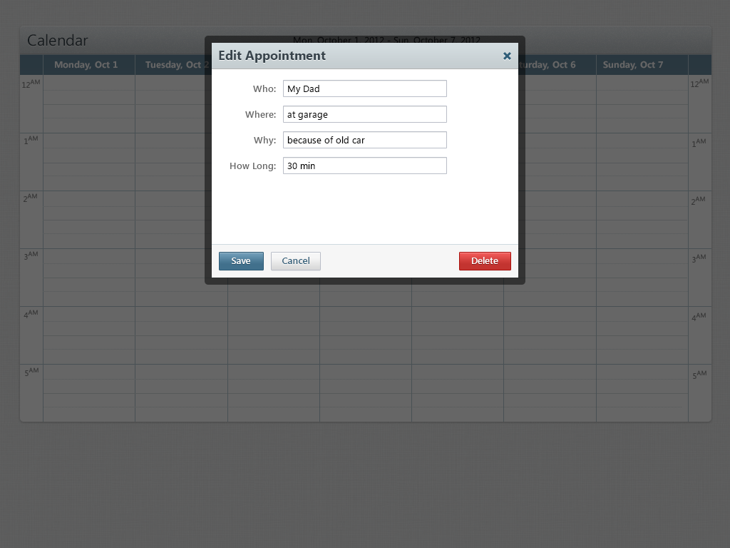

**Additional functionality**  
● It should work like one page WEB application and should use AJAX technology, load  
and submit data without reloading a page.  
● It should have unit tests for all functionality.