Non-functional **Software Requirement Specification**



*Design documentation*

Version 0.01

Authors

|  |  |
| --- | --- |
| Name | Function |
| Jan Roozemond | Intern |

24th October 2022

Table of contents

Contents

Introduction 3

Goal 3

Target Group 3

Scope 3

Assumptions & Constraints 3

1. Non-Functional Requirement Categories 4

1.1 Functional Suitability 5

1.2 Performance Efficiency 5

1.3 Compatibility 6

1.4 Usability 6

1.5 Reliability 7

1.6 Security 7

1.7 Maintainability 8

1.8 Portability 9

Introduction

This document contains the non-functional specifications for the transaction type screens of the Mobility Concept portal web application made by COAS Software Systems.

This document described the detailed non-functional requirements based of the transaction type admin screen of the Mobility Concept Portal web application developed by COAS Software Systems.

The requirement analysis will be executed on a proof-of-concept of the transaction type screen made in a new front-end solution resulting in less concrete or in-depth requirements.

This document is based upon the quality characteristics of the newest ISO version which is 25010 at the time of writing.

Goal

To research and document the non-functional requirements of the existing screen to be implemented with the goal to learn about requirement documenting with ISO and progress the intern’s report.

Target Group

The intended communication target for this document are the following stakeholders:

* Mobility Concept Software team supervisor
* School supervisor

Scope

The scope of this project is limited to:

* Defining the non-functional requirements.
* Defining the product qualities the system must contain.

# Assumptions & Constraints

The documentation will not go in depth into the development process of the screen and the scope is explicitly limited to the functionality of only the given screen.



**Non-Functional Requirements**

Non-functional requirements describe the quality requirements and constraints imposed on the system. They don't describe *what* the system should do, but *how* the system should work. Issues such as performance, maintenance, safety and reliability will be defined. The main purpose of functional requirements is to make the software run more efficiently and thus improve the user experience.

## Non-Functional Requirement Categories

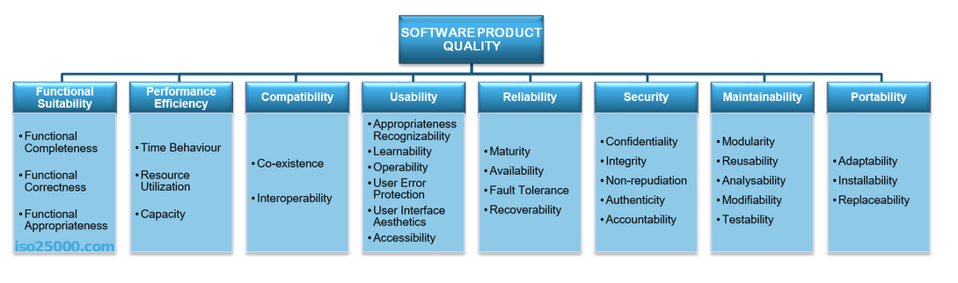The non-functional requirements defined in this document are based on the characteristics as defined in the quality framework ISO/IEC 25010.

## Functional Suitability

Functional suitability is the degree to which a product or system provides the functions correctly as required of the system.

|  |  |
| --- | --- |
| Sub-Category | Definition |
| Functional completeness | *Degree to which the functionality of the system covers all specified tasks and user objectives*.  Will get data from a webAPI.  Will use a translating service. |
| Functional Correctness | *Degree to which the system provides the correct results.*  Will not create new results. |
| Functional Appropriateness | *Degree to which the functions accomplish executing tasks and objectives.*  Will use Httpclient to get API data. |

## Performance Efficiency

Performance efficiency is performance relative to the amount of resources used under stated conditions.

|  |  |
| --- | --- |
| Sub-Category | Definition |
| Time-behaviour | *Degree to which the response and processing times of the system meets the requirements.*  Small requests: 1 seconds.  Medium requests: 2 seconds. Large requests: 5 seconds. |
| Resource Utilization | *Degree to which the amount and type of recourses used by the system meets the requirements.*  Inapplicable. |
| Capacity | *Degree to which the maximum limits of the system meets the requirements.*  Inapplicable. |

## Compatibility

Compatibility is the degree to which a product, system or component can exchange information with other products, systems or components, and/or perform its required functions, while sharing the same hardware or software environment.

|  |  |
| --- | --- |
| Sub-Category | Definition |
| Co-existence | *Degree to which the system can perform its functions efficiently using a shared resource without impact on other systems.*  Not specified. |
| Interoperability | *Degree to which two or more systems or components can exchange and use exchanged information.*  Not specified. |

## Usability

Usability is the effectiveness, efficiency and satisfaction in a specified context of use. Usability can either be specified or measured as a product quality characteristic in terms of its sub-characteristics.

|  |  |
| --- | --- |
| Sub-Category | Definition |
| Appropriateness Recognizability | *Degree to which users can recognize whether the system provides what is needed.*  Not specified. |
| Learnability | *Degree to which the system enables the user to learn how to use it effectively and efficiently.*  Out of scope. |
| Operability | *Degree to which the system is easy to operate and control.*  Not specified. |
| User Error Protection | *Degree to which the system protects the user against making errors.*  Not specified. |
| User Interface Aesthetics | Degree to which the interface of the system is pleasant to the user.  Will use Mobility Concept design. See Mobility Concept Portal. |
| Accessibility | *Degree to which the system can be used by users capable to do so.*  Not specified. |

## Reliability

Reliability is the degree to which a product, system or component performs specified function under specified condition for a specified period of time.

|  |  |
| --- | --- |
| Sub-Category | Definition |
| Maturity | Degree to which the system or a component … |
| Availability | *Degree to which the system is operational and accessible when required for use.*  Will be functional if the Mobility Concept domain is accessible. |
| Fault tolerance | *Degree to which the system or a component operates as intended during the presence of hardware or software faults.*  Not specified. |
| Recoverability | *Degree to which, in the event of an interruption or failure, the system can recover the data directly affected and re-establish the desired state of the system.*  Not specified. |

## Security

Security is the degree to which a product or system protects information and data so that persons or other products or systems have the degree of data access appropriate to their types and levels of authorization.

|  |  |
| --- | --- |
| Sub-Category | Definition |
| Confidentiality | *Degree to which the system ensures that data is only accessible to those authorized with access.*  Out of scope. |
| Integrity | *Degree to which the system or a component prevents unauthorized access or modification of data.*  Out of scope. |
| Non-repudiation | *Degree to which actions or events within the system are logged.*  Not specified. |
| Accountability | *Degree to which the actions of a user can be traced back to the user.*  Out of scope. |
| Authenticity | *Degree to which a resource can be identified.*  Only specified resources are used. |

## Maintainability

Maintainability is the degree of effectiveness and efficiency with which a product or system can be modified by the intended maintainers. Modification can include corrections, improvements or adaptation of the software to changes in environment.

|  |  |
| --- | --- |
| Sub-Category | Definition |
| Modularity | *Degree to which the system is built in a way that it is minimally impacted by the changes to a single component.*  All components will be independent by Angular structure design. |
| Reusability | *Degree to which an asset can be used in more than one system or in building other assets.*  Not specified. |
| Analysability | *Degree of effectiveness and efficiency with which it is possible to assess the impact on the system for an intended change to one or more of its parts, or to diagnose causes of failures and parts to be modified.*  Out of scope. |
| Modifiability | *Degree to which the system can be effectively and efficiently modified without introducing defects or degrading existing product quality*.  Not specified. |
| Testability | *Degree of effectiveness and efficiency with which test criteria can be established for the system or a component.*  Not specified. |

## Portability

Portability is the degree of effectiveness and efficiency with which a system, product or component can be transferred from one hardware, software or other operational environment to another

|  |  |
| --- | --- |
| Sub-Category | Definition |
| Adaptability | *Degree to which the system can effectively and efficiently be adapted to a different or evolving hardware, software or other operational or usage environment*  Not specified. |
| Installability | *Degree of effectiveness and efficiency in which the system can be successfully installed and or uninstalled in a specified environment.*  The system will be rolled out on webserver and Azure. |
| Replaceability | *Degree to which the product can replace another specified software product for the same purpose in the same environment.*  Will be a proof-of-concept for the purpose of replacing the knockout razor equivalent of the Mobility Concept Portal. |