A1Cognito
Module Architecture, Folder Structure & Team Ownership
1. Full Flowchart
The diagram below shows the complete pipeline: what goes in, the four core modules with their technical and medical explanation, sub-modules, and the team member who owns each module, and what comes out.
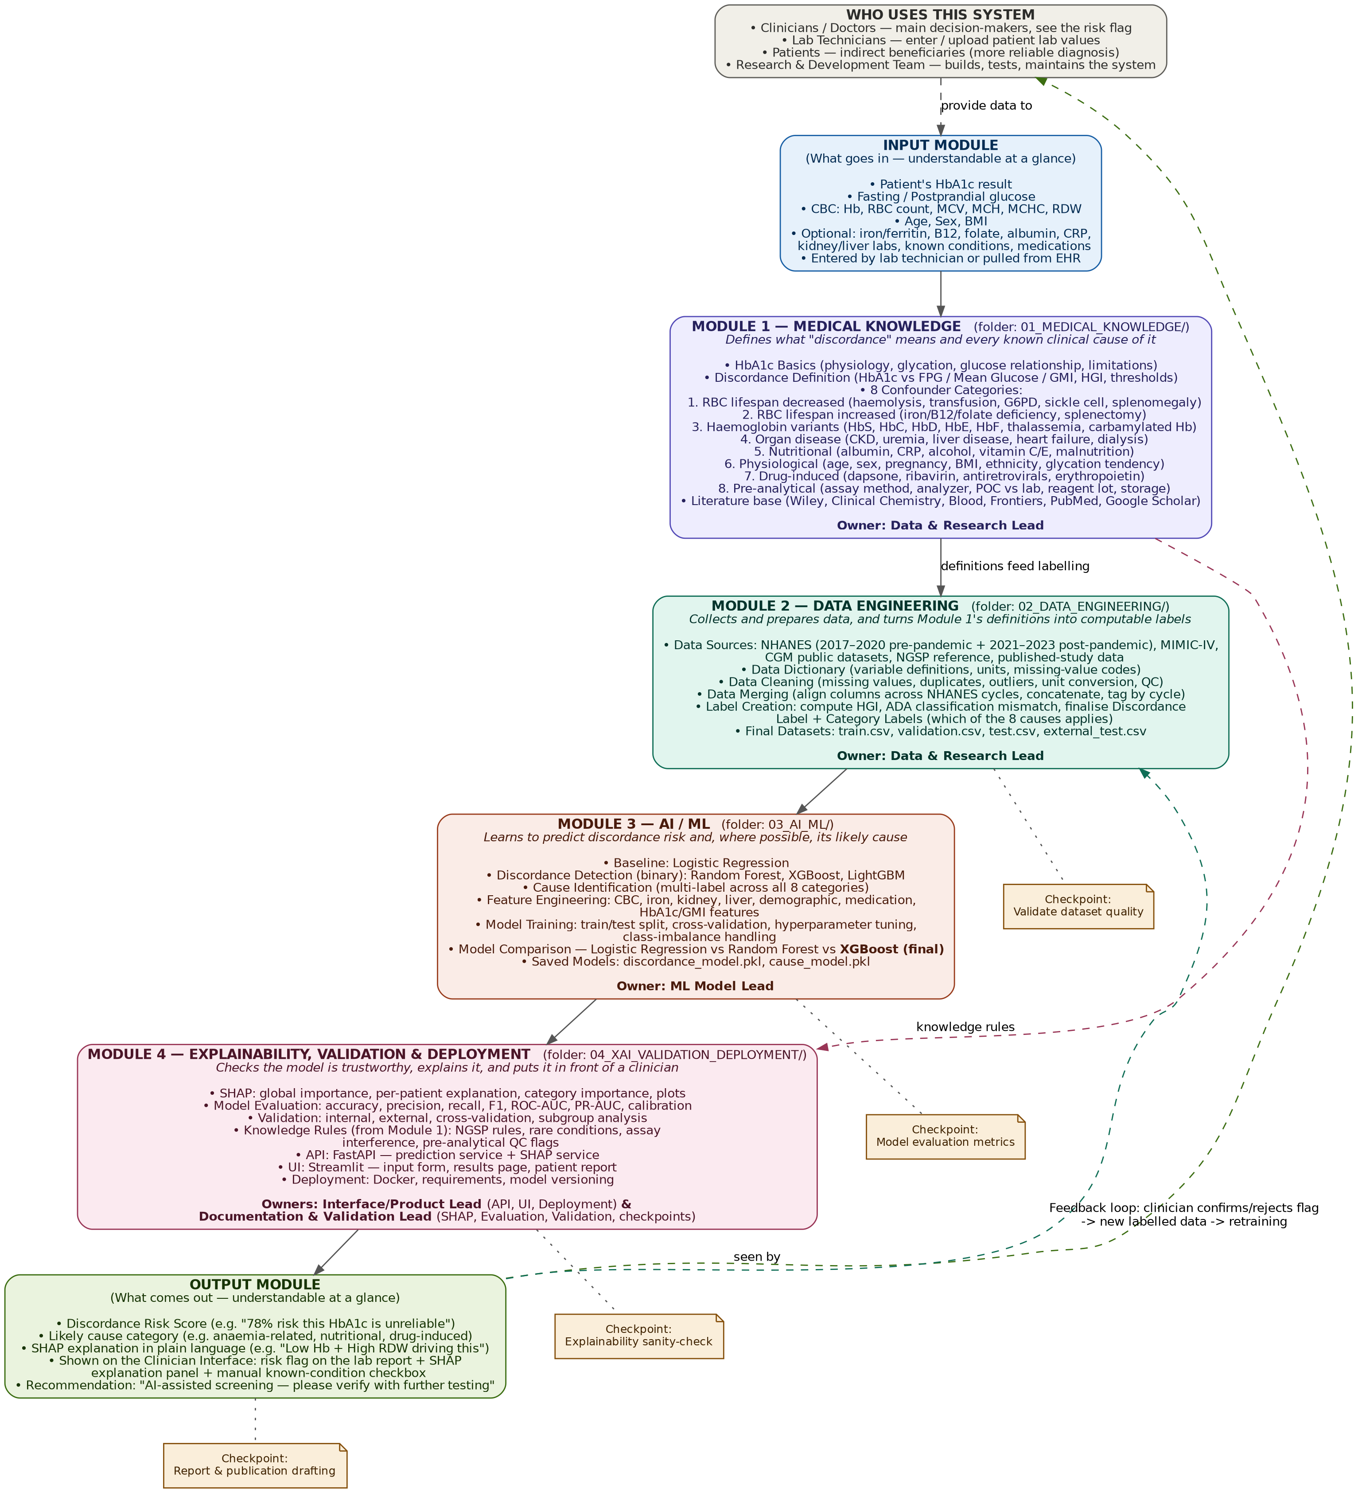
2. Folder Structure (Real, Downloadable)
This exact folder skeleton has been created and is provided as a downloadable ZIP alongside this document, so every member can start working directly inside their assigned folder from day one.
A1Cognito/
|-- README.md
|-- 00_INPUT_INTERFACE/ (Shared)
|-- 01_MEDICAL_KNOWLEDGE/ (Module 1 - Data & Research Lead)
| |-- 01_HbA1c_Basics/
| |-- 02_Discordance_Definition/ (vs FPG / Mean Glucose / GMI, HGI)
| |-- 03_Category_1_RBC_Lifespan_Down/ (haemolysis, transfusion, G6PD...)
| |-- 04_Category_2_RBC_Lifespan_Up/ (iron/B12/folate deficiency...)
| |-- 05_Category_3_Hb_Variants/ (HbS, HbC, HbD, HbE, HbF...)
| |-- 06_Category_4_Organ_Disease/ (CKD, liver disease, heart failure)
| |-- 07_Category_5_Nutritional/ (albumin, CRP, alcohol, vitamins)
| |-- 08_Category_6_Physiological/ (age, sex, pregnancy, BMI)
| |-- 09_Category_7_Drugs/ (dapsone, ribavirin, ART, EPO)
| |-- 10_Category_8_Preanalytical/ (assay method, reagent lot...)
| |-- 11_Literature/ (Wiley, Blood, PubMed, Scholar)
|-- 02_DATA_ENGINEERING/ (Module 2 - Data & Research Lead)
| |-- 01_Data_Sources/ (NHANES, MIMIC-IV, CGM, NGSP)
| |-- 02_Data_Dictionary/
| |-- 03_Data_Cleaning/
| |-- 04_Data_Merging/
| |-- 05_Label_Creation/ (GMI, Discordance & Category labels)
| |-- 06_Final_Datasets/ (train / val / test / external)
|-- 03_AI_ML/ (Module 3 - ML Model Lead)
| |-- 01_Baseline/ (Logistic Regression)
| |-- 02_Discordance_Detection/ (Random Forest, XGBoost, LightGBM)
| |-- 03_Cause_Identification/ (multi-label, 8 categories)
| |-- 04_Feature_Engineering/
| |-- 05_Model_Training/
| |-- 06_Model_Comparison/
| |-- 07_Saved_Models/
|-- 04_XAI_VALIDATION_DEPLOYMENT/ (Module 4 - Interface/Product Lead +
| | Documentation & Validation Lead)
| |-- 01_SHAP/
| |-- 02_Model_Evaluation/
| |-- 03_Validation/
| |-- 04_Knowledge_Rules/ (links back to Module 1)
| |-- 05_API/ (FastAPI)
| |-- 06_UI/ (Streamlit)
| |-- 07_Deployment/ (Docker, versioning)
|-- 05_OUTPUT_INTERFACE/ (Shared)
|-- docs/
|-- literature_review/
|-- proposal/
|-- review_presentations/
|-- flowcharts_diagrams/

(Full detail: 174 folders total across all categories and sub-conditions -
see the attached ZIP for the complete, ready-to-use structure.)

3. Who Uses This System
User | Role in the system
Clinicians / Doctors | Primary decision-makers — see the discordance risk flag and SHAP explanation, decide whether to order further tests
Lab Technicians | Enter or upload patient lab values (HbA1c, glucose, CBC) that feed the Input Module
Patients | Indirect beneficiaries — receive a more reliable diagnosis as a result of the screening
R&D Team (all 4 members) | Builds, trains, validates, and maintains the entire system

4. Module-to-Member Assignment
Module | Folder | Owner | What they build
Input Interface | 00_INPUT_INTERFACE/ | Shared (all 4) | Schema of patient data the system accepts
Module 1 — Medical Knowledge | 01_MEDICAL_KNOWLEDGE/ | Data & Research Lead | Defines discordance + all 8 confounder categories from literature
Module 2 — Data Engineering | 02_DATA_ENGINEERING/ | Data & Research Lead | Collects, cleans, merges data; creates discordance labels
Module 3 — AI/ML | 03_AI_ML/ | ML Model Lead | Builds and compares models to predict risk + likely cause
Module 4 — XAI, Validation & Deployment | 04_XAI_VALIDATION_DEPLOYMENT/ | Interface/Product Lead + Documentation & Validation Lead | Explainability, evaluation, validation, API, UI, deployment
Output Interface | 05_OUTPUT_INTERFACE/ | Shared (all 4) | Risk score + explanation report format

Note: Module 4 is split between two roles because it covers two distinct concerns — the Interface/Product Lead owns the API, UI, and deployment (getting the system in front of a clinician), while the Documentation & Validation Lead owns SHAP, model evaluation, validation, and the review checkpoints (proving the system can be trusted).
5. Tools, Techniques & Knowledge to Build Over 2 Years
- Programming: Python (pandas, numpy), Jupyter notebooks, Git/GitHub for version control and team collaboration.
- Data handling: merging/cleaning multi-file datasets, handling missing values, unit conversions, working with public health datasets.
- Classical ML: logistic regression, decision trees, random forest, XGBoost/LightGBM, scikit-learn.
- Deep learning: basics of neural networks, MLPs, tabular deep learning (PyTorch or TensorFlow).
- Model evaluation: AUROC/AUPRC, calibration curves, cross-validation, subgroup/fairness analysis.
- Explainability: SHAP and/or LIME for feature attribution.
- Deployment/prototype: Streamlit or Flask for a simple clinician-facing report or dashboard.
- Domain knowledge: basic understanding of diabetes, HbA1c, CBC parameters, and how doctors interpret them — enough to explain results meaningfully, not to replace clinical training.
- Research skills: literature review, reading clinical/ML papers, writing a proper research report and defending it in reviews.
- Soft skills: task division, Git-based team workflows, presenting technical work to a non-technical review panel.

Note: the ZIP file provided alongside this document (A1Cognito_v2_folder_structure.zip) contains all 174 folders shown above in full, each with a README placeholder, ready to commit to Git immediately.

