A1Cognito
Module Architecture, Folder Structure & Team Ownership
1. Full Flowchart
The diagram on the following page shows the complete pipeline, laid out the same way as the original architecture flowchart: team roles, users, input, every module's real content in sequence, the parallel model comparison, checkpoints, the feedback loop, and the resources used to build it. It is placed on its own large page so nothing is cut off — print it separately (e.g. as an A2/poster page) if you need a wall or presentation copy.

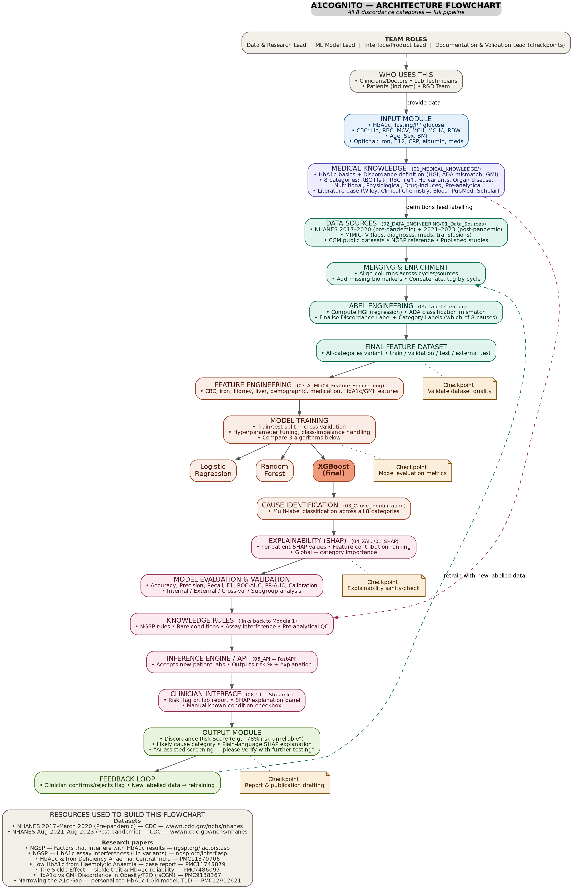

2. Folder Structure (Real, Downloadable)
This exact folder skeleton has been created and is provided as a downloadable ZIP alongside this document, so every member can start working directly inside their assigned folder from day one.
A1Cognito/
|-- README.md
|-- 00_INPUT_INTERFACE/ (Shared)
|-- 01_MEDICAL_KNOWLEDGE/ (Module 1 - Data & Research Lead)
| |-- 01_HbA1c_Basics/
| |-- 02_Discordance_Definition/ (vs FPG / Mean Glucose / GMI, HGI)
| |-- 03_Category_1_RBC_Lifespan_Down/ (haemolysis, transfusion, G6PD...)
| |-- 04_Category_2_RBC_Lifespan_Up/ (iron/B12/folate deficiency...)
| |-- 05_Category_3_Hb_Variants/ (HbS, HbC, HbD, HbE, HbF...)
| |-- 06_Category_4_Organ_Disease/ (CKD, liver disease, heart failure)
| |-- 07_Category_5_Nutritional/ (albumin, CRP, alcohol, vitamins)
| |-- 08_Category_6_Physiological/ (age, sex, pregnancy, BMI)
| |-- 09_Category_7_Drugs/ (dapsone, ribavirin, ART, EPO)
| |-- 10_Category_8_Preanalytical/ (assay method, reagent lot...)
| |-- 11_Literature/ (Wiley, Blood, PubMed, Scholar)
|-- 02_DATA_ENGINEERING/ (Module 2 - Data & Research Lead)
| |-- 01_Data_Sources/ (NHANES, MIMIC-IV, CGM, NGSP)
| |-- 02_Data_Dictionary/
| |-- 03_Data_Cleaning/
| |-- 04_Data_Merging/
| |-- 05_Label_Creation/ (GMI, Discordance & Category labels)
| |-- 06_Final_Datasets/ (train / val / test / external)
|-- 03_AI_ML/ (Module 3 - ML Model Lead)
| |-- 01_Baseline/ (Logistic Regression)
| |-- 02_Discordance_Detection/ (Random Forest, XGBoost, LightGBM)
| |-- 03_Cause_Identification/ (multi-label, 8 categories)
| |-- 04_Feature_Engineering/
| |-- 05_Model_Training/
| |-- 06_Model_Comparison/
| |-- 07_Saved_Models/
|-- 04_XAI_VALIDATION_DEPLOYMENT/ (Module 4 - Interface/Product Lead +
| | Documentation & Validation Lead)
| |-- 01_SHAP/
| |-- 02_Model_Evaluation/
| |-- 03_Validation/
| |-- 04_Knowledge_Rules/ (links back to Module 1)
| |-- 05_API/ (FastAPI)
| |-- 06_UI/ (Streamlit)
| |-- 07_Deployment/ (Docker, versioning)
|-- 05_OUTPUT_INTERFACE/ (Shared)
|-- docs/
|-- literature_review/
|-- proposal/
|-- review_presentations/
|-- flowcharts_diagrams/

(Full detail: 174 folders total across all categories and sub-conditions -
see the attached ZIP for the complete, ready-to-use structure.)

3. Who Uses This System
User | Role in the system
Clinicians / Doctors | Primary decision-makers — see the discordance risk flag and SHAP explanation, decide whether to order further tests
Lab Technicians | Enter or upload patient lab values (HbA1c, glucose, CBC) that feed the Input Module
Patients | Indirect beneficiaries — receive a more reliable diagnosis as a result of the screening
R&D Team (all 4 members) | Builds, trains, validates, and maintains the entire system

4. Module-to-Member Assignment
Module | Folder | Owner | What they build
Input Interface | 00_INPUT_INTERFACE/ | Shared (all 4) | Schema of patient data the system accepts
Module 1 — Medical Knowledge | 01_MEDICAL_KNOWLEDGE/ | Data & Research Lead | Defines discordance + all 8 confounder categories from literature
Module 2 — Data Engineering | 02_DATA_ENGINEERING/ | Data & Research Lead | Collects, cleans, merges data; creates discordance labels
Module 3 — AI/ML | 03_AI_ML/ | ML Model Lead | Builds and compares models to predict risk + likely cause
Module 4 — XAI, Validation & Deployment | 04_XAI_VALIDATION_DEPLOYMENT/ | Interface/Product Lead + Documentation & Validation Lead | Explainability, evaluation, validation, API, UI, deployment
Output Interface | 05_OUTPUT_INTERFACE/ | Shared (all 4) | Risk score + explanation report format

Note: Module 4 is split between two roles because it covers two distinct concerns — the Interface/Product Lead owns the API, UI, and deployment (getting the system in front of a clinician), while the Documentation & Validation Lead owns SHAP, model evaluation, validation, and the review checkpoints (proving the system can be trusted).
5. Tools, Techniques & Knowledge to Build Over 2 Years
- Programming: Python (pandas, numpy), Jupyter notebooks, Git/GitHub for version control and team collaboration.
- Data handling: merging/cleaning multi-file datasets, handling missing values, unit conversions, working with public health datasets.
- Classical ML: logistic regression, decision trees, random forest, XGBoost/LightGBM, scikit-learn.
- Deep learning: basics of neural networks, MLPs, tabular deep learning (PyTorch or TensorFlow).
- Model evaluation: AUROC/AUPRC, calibration curves, cross-validation, subgroup/fairness analysis.
- Explainability: SHAP and/or LIME for feature attribution.
- Deployment/prototype: Streamlit or Flask for a simple clinician-facing report or dashboard.
- Domain knowledge: basic understanding of diabetes, HbA1c, CBC parameters, and how doctors interpret them — enough to explain results meaningfully, not to replace clinical training.
- Research skills: literature review, reading clinical/ML papers, writing a proper research report and defending it in reviews.
- Soft skills: task division, Git-based team workflows, presenting technical work to a non-technical review panel.

Note: the ZIP file provided alongside this document (A1Cognito_v2_folder_structure.zip) contains all 174 folders shown above in full, each with a README placeholder, ready to commit to Git immediately.

