**Index:**

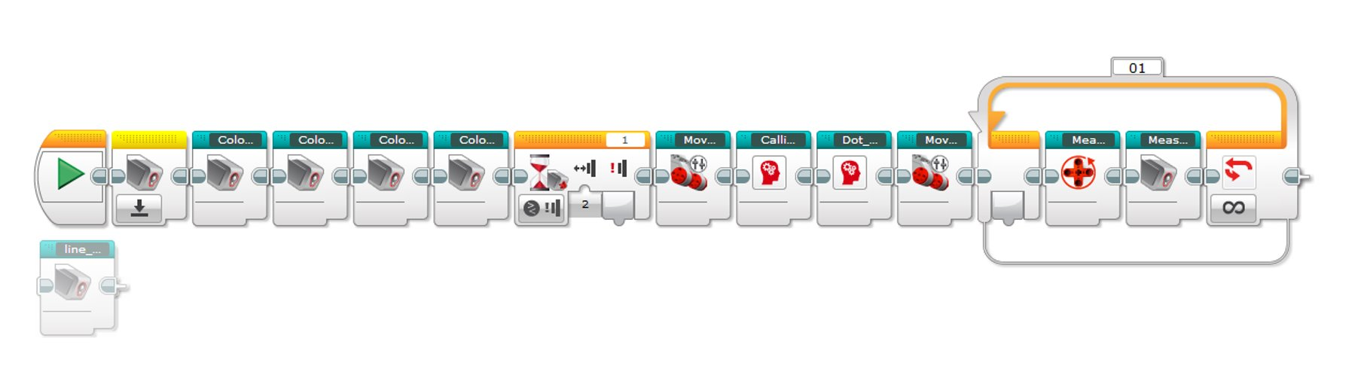

(1) Main window.

----------------------------------------------------------------------------------------------

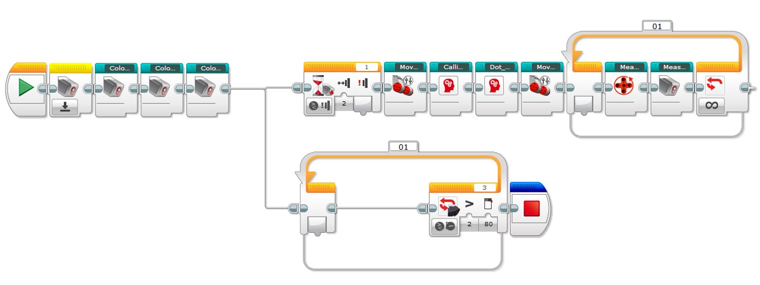

(2) Main window development 2, includes ultrasonic sensor running in parallel.

----------------------------------------------------------------------------------------------

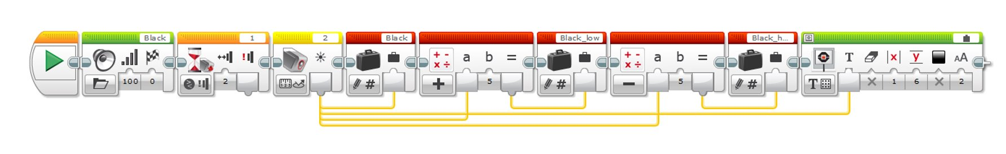

(3) How colours are handled, this is black but all colours are handled in the exact same manner.

----------------------------------------------------------------------------------------------

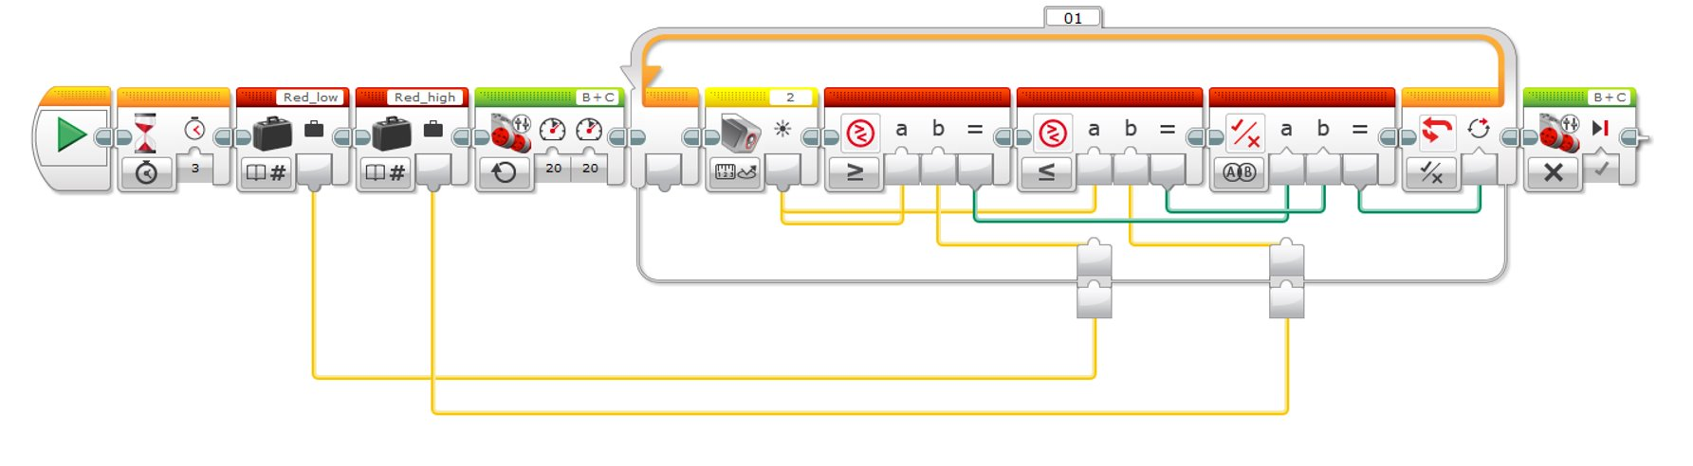

(4) Move until red.

----------------------------------------------------------------------------------------------

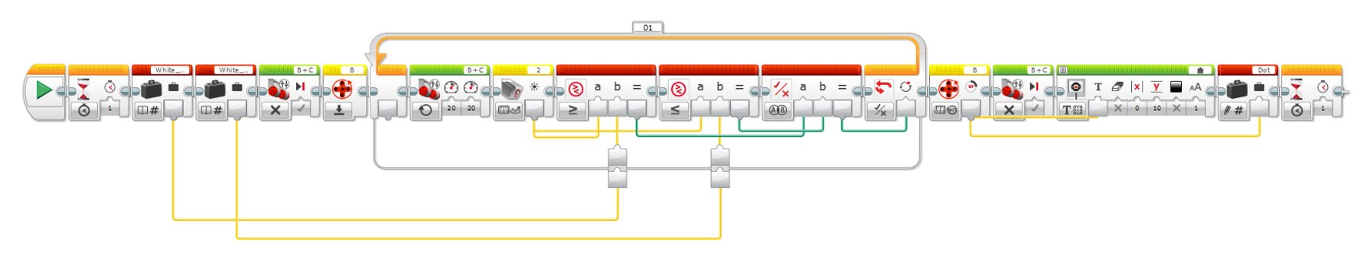

(5) Calibrate dot

----------------------------------------------------------------------------------------------

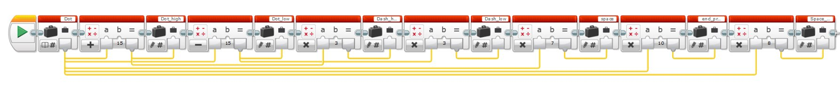

(6) Dot dash range

----------------------------------------------------------------------------------------------

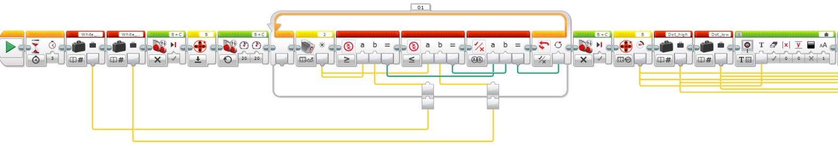

(7) Measure red space pt.1

----------------------------------------------------------------------------------------------

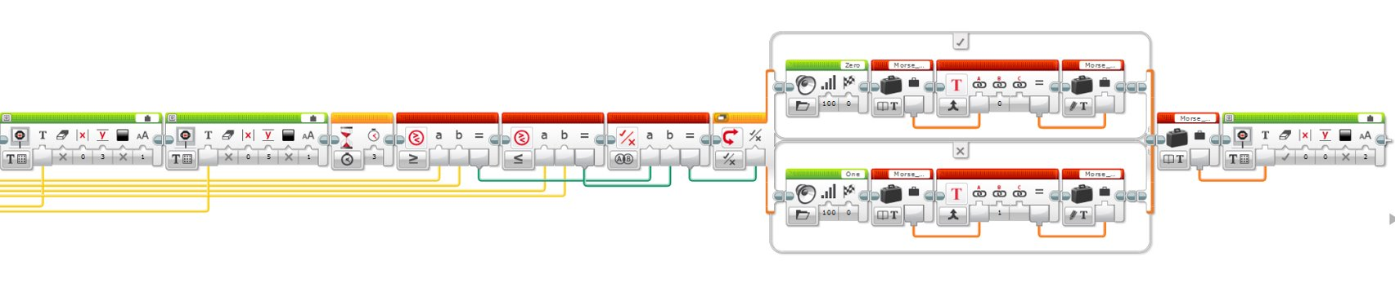

(8) Measure red space pt.2

----------------------------------------------------------------------------------------------

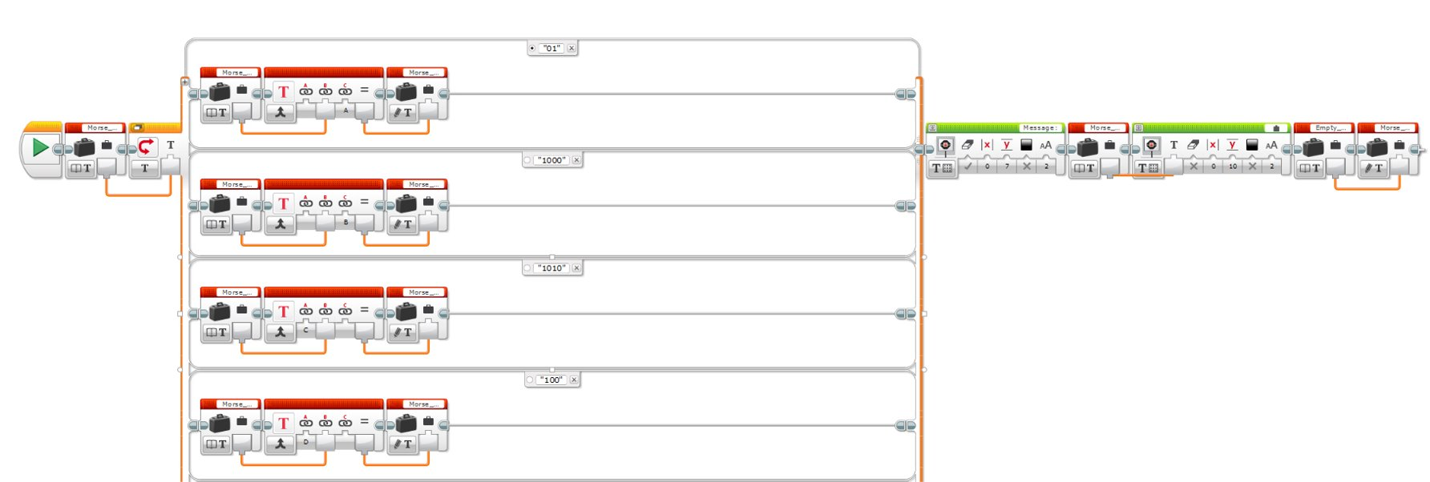

(9) Morse code alphabet.

----------------------------------------------------------------------------------------------

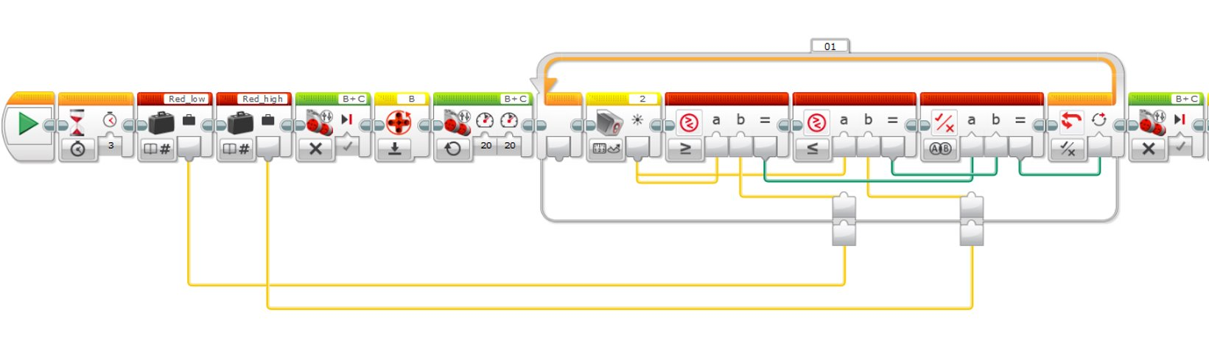

(10) Measure white space pt.1

----------------------------------------------------------------------------------------------

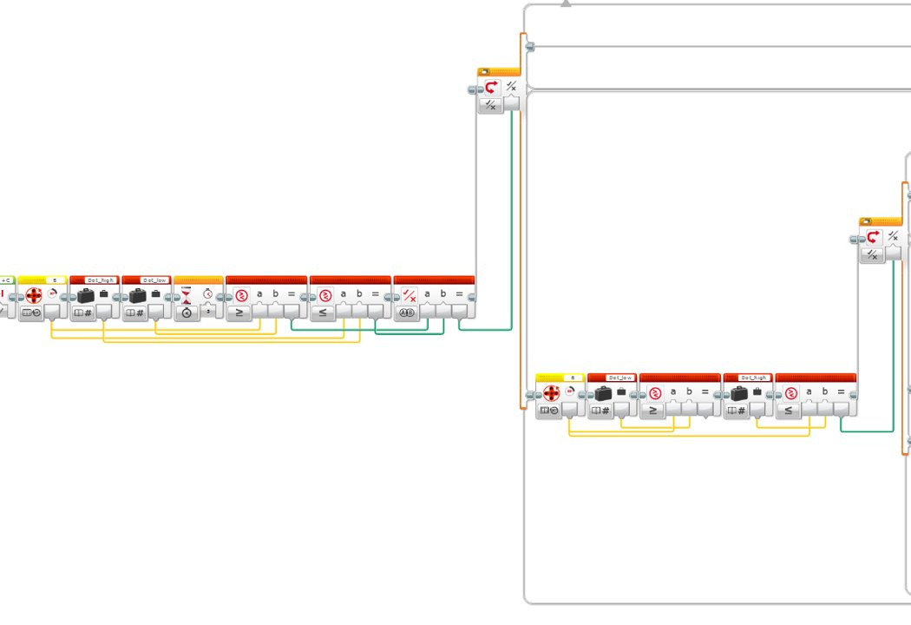

(11) Measure white space pt.2

----------------------------------------------------------------------------------------------

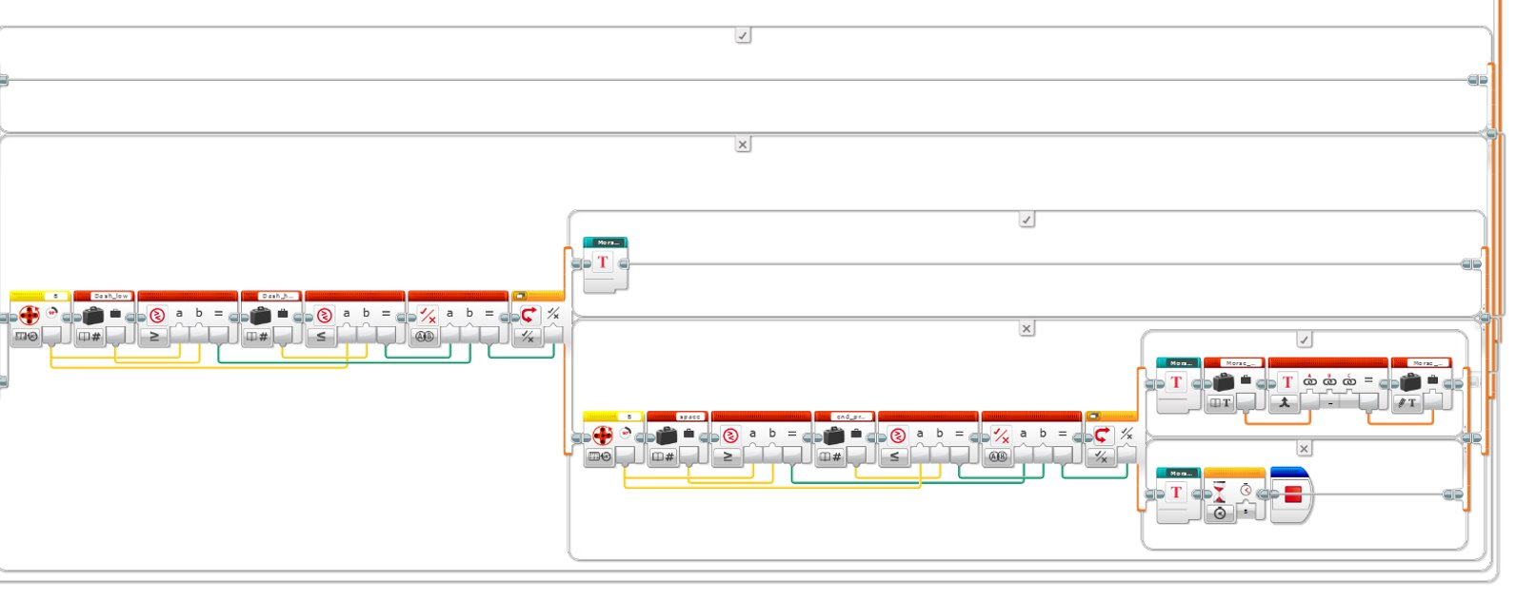

(12) Measure white space pt.3

----------------------------------------------------------------------------------------------

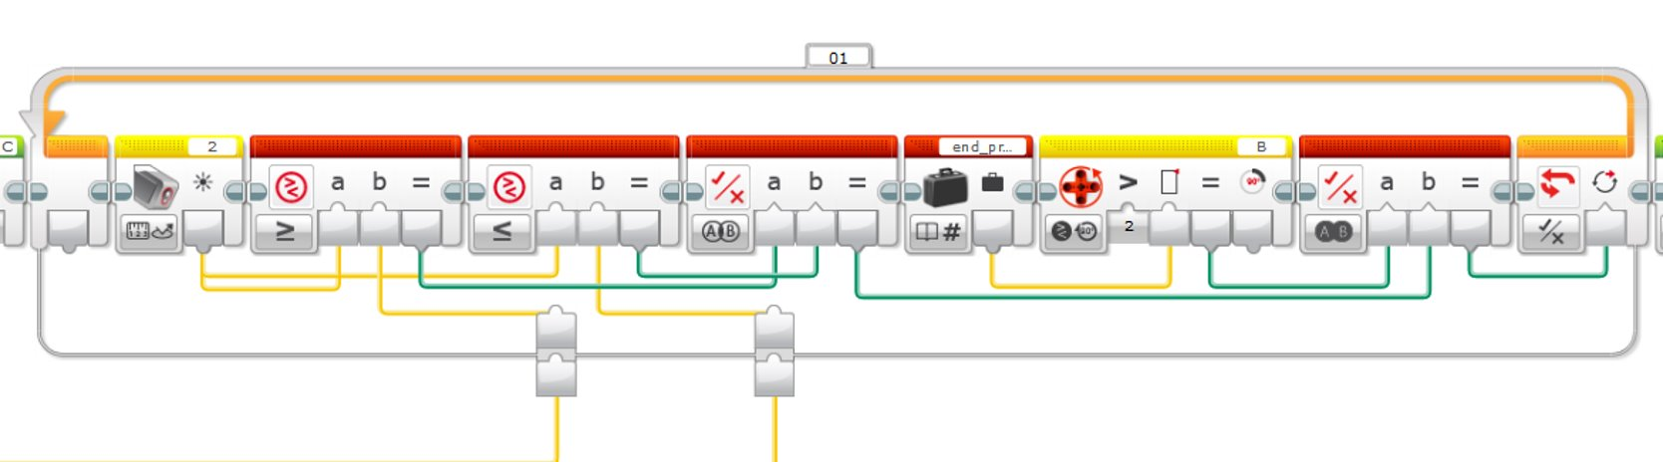

(13) Measure white space fix pt.1 (Implementing an exit condition for when the space is longer than 10).

----------------------------------------------------------------------------------------------