gamification research
Threa

Golden glass games

Research goals
Our research goals are as follows:
- Define our target groups current skill set and preferences.
- Define our target groups current level of knowledge, on global warming and climate change.
- Define the awareness gap between the targets groups and draw conclusions on how to bridge said gap.
- Define the epic meaning of our game and how we can integrate it in a meaningful way.
- Define learning goal for our product based on our findings.

Target Group definition
We are trying to teach 3 target groups with our product:
- Primary School Children M/F, ages 4-12.
- High School Teenagers M/F, ages 12-16.
- Adults M/F, aged 16+.

Target groups current skill set and preferences
When looking at the user’s skill set and preferences, we have to look at three crucial factors, Gender, Age and Player Type:
Gender:
Boy Preferences | Girl Preferences
Mastery (Challenge) | Mastery (Meaningful)
Fantasy Role | Meaningful Role
Domination | Co-Operation
Emotion from winning | Interpersonal Emotion
Destruction | Nurturing
Spatial Puzzles | Dialog/Verbal Puzzles
Trial and Error | Learning by example
Even when looking at Gender we can further break it down into a number of key topics.
Real World: This refers to the setting, story, and the role of the player in the game. Girls generally like games that are connected to the human world and fulfilling meaningful and co-operative roles. Boys prefer to play in fantasy worlds and roles which are more dominating for example soldiers in a war game.
Mastery: This refers to mastering things, Boys enjoy mastering things even if they are not important or useful as long as it’s challenging. Girls are only interested in mastery when it has meaningful purpose i.e. Related to the real world. Mastery enables pride, so in short, Boys experience pride in artificial goals and Girls experience pride with meaningful goals.
Competition: This refers to two people or groups of people working against each other. Boys enjoy competing against each other to prove they are the best. For Girls, the negative feelings of losing often outweigh the positive feelings of winning. Boys like to win and dominate, and Girls as stated above, enjoy the social aspect of games, the co-operation.
Emotions: This refers to the feelings the game invokes from its players. Girls like experiences that explore the richness of human emotion. Boys enjoy emotions as a result from competition or mastery.
Destruction: Boys enjoy destroying things, they are usually motivated by revenge, this makes video games perfect for them as it allows for destruction beyond their realistic means. Girls only approve destruction only when its meaningful, i.e. to save a relationship etc.
Nurture: Girls enjoy playing a more nurturing role and helping other players and NPC’s. Girls are perfectly willing to give up a leading position in a game to help a weaker player.
Spatial Puzzles: Boys have stronger spatial reasoning skills than Girls, this makes puzzles involving 3D space intriguing to Boys and frustrating to Girls.
Dialogue/Verbal Skills: Girls talk first and act later, Boys act first and talk later. Girls are attracted to pop-ups, dialogue trees and cut scenes. Boys prefer gameplay.
Tutorial: Boys learn by trial and error; they gain pleasure through experimentation. Girls prefer to learn by example, clear to tutorials and step by step guides.
Age:
 | Age 0 – 3 | Age 4 – 6 | Age 7 – 9 | Age 10 – 18 | Age 18 – 24 | Age 25 – 50 | Age 50 +
Toys; No Goals | x
Player changes rules |  | x
Reasoning |  |  | x
Player thinks through all options |  |  | x | x
Personal taste & Spending |  |  | x | x | x
Focus on Family & Friends; Casual Games |  |  | x | x | x | x
Social Games |  |  | x | x | x | x | x
0-3: Toddlers at this age are interested in toys not games, this means they cannot handle any form of complexity and problem solving. They can only handle simple playful manipulation; add, remove, alter, and relocate.
4-6: Preschool is the first age that kids begin to have interest simple games and they enjoy bending or breaking the rules to keep things interesting. These games only have simple goals.
7-9: This what is known as the age of reason, kids this age can read, think things through and solve harder problems. This is also the first ages where they begin to make choices for themselves and not just accepting what their parents give them.
10-13: This is what is known as the age of obsession. It is a time of great neurological growth and these pre-teens are able to think more deeply and with nuance. They are very passionate about their interests, as stated above boys are often interested in games to prove their dominance, while girls are interested in more social things.
13-18: At this age people start becoming interested in exploring new kinds of experiences and the genders distinctly define themselves around this age too.
18-24: This age is when people establish their tastes and preferences firmly, they also have time and money on their hands.
25-35: This age is the peak family formation stage and games at this age is normally causal or playing games with their young children.
35-50: People at this age are very caught up in their career and family responsibilities, when they play games, they are looking for experiences to involve the whole family.
50+: This age group is known as ‘empty nesters’ as their children have left home and will soon be facing retirement. They are interested in games that have a strong social component.

Player Type:
Richard Bartle divided players in to four distinct types in 1996, knowing what these for types are will help us appeal to a wide variety of players.
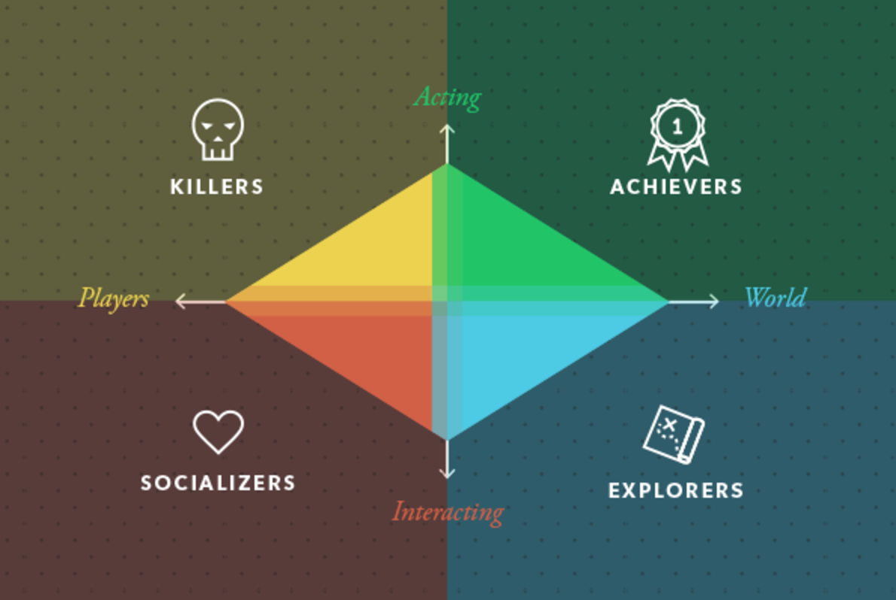
(Zenn, 2017)
Killer: These players like to cause or impose drama on NPCs or other players, in the space provided to them in virtual world. Trolls, hackers, cheaters, and attention farmers belong in this category, but so to do the most skilful PVP (Player VS Player) players on the game. Their main objective is to dominate.
Explorer: These players like to explore the game, not just the world but the finer details of its mechanics, these players may end up knowing how the game works better than the developers. They know all mechanics short cuts, tricks and glitches and they are driven by discovering them.
Achiever: These players are competitive and enjoy beating difficult challenges whether they are set by the game or by themselves. The more challenging the game the more rewarded they feel.
Socializer: These players are more interested in formulating relationships (real world or virtual). They are also often involved in the community or discussion aspect of the game.

Target Groups current knowledge
Research: “Generation C” about climate change: Summary of a study on children in the age of 8 to 12 years that attend primary school.
“Generation C” means Generation Climate and describes the first generation that will directly notice the effects of climate change while also being able to influence it themselves.

How was the study built up?
Great, representative study with 767 children of the age from 8 to 12 participating. 387 boys and 380 girls participated.
The goal of the study was to find out what children of this age group and those that attend primary school, know about climate change, what they think about it and what they do about it themselves.
The quantitative research of this study exists of the representative sample of at least 750 children. As described above, in the end, more children participated. They were invited to the study via their parents and filled in an online form.
The qualitative part of the study existed out of multiple conversations with small groups of a few children that didn’t know each other.
The “How” and “Why” were central questions during this study. The children were asked to make drawings of what can be done against climate change. Many children liked the topic and wanted to know more about it.

What do children know about climate change?
74% of the children have already heard about climate change. When asked to explain, they had multiple kinds of answers. The earth heats up, the earth is more dirty, the climate changes due to the earth warming up, the ice on the north pole is melting, the greenhouse effects heats up the earth, summers are hotter and winters are colder, the climate is confused, etc.
91% of the children learned about climate change in school. Many children also learned about it on TV. It is noteworthy that it seems like the children do not talk about the topic with their families at home very often.

What do children think about climate change?
During the qualitative research phase of the study, the children were shown a short video that explains climate change in a factual and neutral way.
88% of the children states that they saw things they didn’t know yet.
25% of the children say that (almost) everything in this video was new to them.

Mostly, they already knew some things and learned some new things as well. The reactions to the video were very diverse. The children were interested, shocked, worried, found it hard to process, were frustrated with humanity, wanted to take action against it, overwhelmed, etc.

What do children think about the consequence’s climate change will cause?
The children were asked to rate various changes that are coming up due to climate change. They were first asked about consequences in the Netherlands, then about consequences for the whole world.
Change 1: It will be warmer in the Netherlands.
Almost 2/3rd of the children liked this change.

Change 2: The rivers and the sea will flood more often, and the water can flow into buildings and cars.
Almost all the children did not like this.

Change 3: The winters will be less cold and there will be less ice and snow.
71% of the children did not like this.

Change 4: It will rain more often and more extreme.
Almost all the children did not like this.

Change 5: There will be more heat waves during the summers.
The reactions to this differ. 47% of the children liked this, 45% did not.

Consequences in the rest of the world:
Change 6: The ice on the north pole will further melt.
About 9/10 of the children did not like this.

Change 7: Some animal species (e.g. polar bears) could go extinct.
Almost all the children did not like this.

Change 8: There will be more storm and hurricanes:
Almost all the children did not like this.

Change 9: In some countries there will be more rain and they will be able to grow more food.
Most of the children like this.

Change 10: In other countries, there will be less rain and they won’t be able to grow as much food anymore.
Almost all the children did not like this.

What feeling does climate change give to the children?
The first reactions to the short video showed that most children feel bad about it, in fact 69% of the children have a bad feeling when it comes to climate change.
They think it is a big problem that the earth heats up because they understand that if it gets warmer, that threatens the nature, animals and humans living on this earth.

What can we do about it?
86% of the children found it very important that we do something about climate together.
They believe that everything in the world is somehow linked together and understand the principle of consequences. However, most children do not exactly know what to do about it. Nevertheless, there are some thing they do: Recycling, shower and bathe shorter, take the bike to school, buy local vegetables and fruits, eat less meat, eat biological food, grow food themselves, bring their own bags to the shop, don’t waste food, save energy, second hand clothing, less heating, solar panels, no trash in the nature, etc.

What would they like to do?
Almost all the children are willing to walk or bike to school (93%). However, they struggle with eating less meat (55%).

In the qualitative research, the children repeatedly said that they think it’s important that everyone does something about climate change. What they do at home or in their own environment is just a drop in the ocean, so to say.

They repeatedly mentioned that it should be fun to do something about climate change as this will help to have more people act.

What do they expect from the government and companies?
The children were asked to rate some ideas for actions the government and companies should be taking: Making agreements with other countries about climate change (68%), use more solar panels (58%), make trains and busses free to use (57%), use more windmills (44%), build higher dikes (31%), etc.
It is noteworthy, that generally, the children are not supportive of making restrictions to “bad” things, like e.g. cars and planes. The topic of eating less meat is complicated for them. Restricting the use of cars seem to have practical objections.

Furthermore, the children offered some own ideas what the government or companies could do:
Rewards actions that are good for the climate, make “good” things cheaper as they tend to be more expensive, set a good example, make the factories cleaner, etc.

Almost half of the children want companies to also take action against climate change, however many children struggle to formulate concrete ideas about this.
They seem to have this image of factories blowing out harmful smoke and want this to be less. They also want them to produce less waste, make higher quality products so they won’t need to be replaced so fast, have companies balance their good and their bad actions, have companies save energy (turn off computer, no air conditioning, turn of advertisement lights, etc.), reward employees that go to work on their bikes, rather produce one brand than 100 and thus have less factories, etc.

Conclusion
Children do not worry about climate change all the time and that is how it should be. However, 74% knows what climate change is and 86% think it is important that we all act and responsibility. 50% of the children do not know what to do about it. Many topics that are related to climate changes are complicated (e.g. eating less meat, restrictions on using a car, etc.). Generally, the children think that the government should make clear and good agreements on this topic.

Children’s perspectives on sustainability
This topic is closely connecting to the topic of climate change and the research described above. In this case, it is about the perspectives on the topic of sustainability of 9 to 12-year-old children.

Most children tend to behave and live very sustainable. 75% of the children are paying attention to save water where possible. 2/3rd of the children eats or drinks local products from time to time. Half of the children uses Fairtrade products from time to time. A little less than half of the children consumes biological products. Concerning mobility, 2/3rd of the children show a good mindset and tend to prefer riding the bike than being brought somewhere with the car. Almost half of the children pays attention to save energy where possible. 1/3rd of the children prefers to wear warmer clothing than to turn on/up the heating.

Children seem to be struggling to understand the reciprocal dependencies in the world. Another thing that is noteworthy is that children seem to be worried about the rest of the world than about the Netherlands. 1/6 Children are worried about food and water scarcity in the Netherlands, whereas double the amount of children are worried about this scarcity throughout the world. 25% of the children are generally worried about flooding as a consequence of climate change.

80% of the children states to want to take good care of the earth so that it can be inhabited in the future as well. 44% of the children says that they actively want to participate in thinking about the future of this earth. A vast majority thing that handling this topic is something all the countries in the world should do together. Older children tend to have more confidence in their capacity to participate and they are not often in need of participation via a third party. This corresponds well to the fact that more older children than younger children think that they can change something about climate change themselves.

All in all, sustainability is an important topic that is often discussed in the group of children this age. Although they want to participate and contribute to this topic, it seems that they struggle with understanding exactly how climate change works. It is hard for them to concretely think of thing they can do about it. It would be beneficial if parents and teachers would make the topic more relatable by e.g. giving them examples out of their own direct environment. Thinking about this topic together and sharing the knowledge and experiences in class is a good way to bring this topic closer. It’s helpful if there is a clear connection of the environment and situation of e.g. dutch children and children from other parts of the world. Those children can learn from each other’s experiences and solutions which will broaden their global notion and feeling about the topic.

How do High school students think about climate change?

1100 high school students from Amsterdam participated in this study. The study focusses on quantitative research.
The average high school student from Amsterdam does not doubt the fact that there is climate change and they believe it is the greatest threat for the future of this world. However, the consider the risks to be moderate.

The high school students consider the risks to be both national and global, however they do not implicate the risks on themselves often.

The willingness to act against climate change differs, especially in relation to their climate awareness. Most high school students appreciate the topic of recycling, but many are not quite ready to buy less thing themselves. The same principle applies to flying, most high school students realize that planes are very harmful for the climate, yet most of the students are not prepared to fly less.

There is a great discrepancy in the risk awareness of climate change between the high school students of various school types. Dutch VWO students have a much higher climate awareness. There is also a meaningful discrepancy in students that have or have no western migrations background.

What influences the opinion on climate change of high school students?
Knowledge about climate change, feelings of anxiety and the opinion of the parents influence high school students immensely.
Knowledge about the consequences of climate change and feelings of anxiety determine the risk perception.
Concerning the willingness to take measures, mostly the knowledge of the measures and the opinion of the parents have a great influence.

Education about climate change should consider that there are differences between students of various school types, ethnicities, home situations, etc.

As mentioned, high school students tend to see climate change as a great global issue and not so much as a personal problem.
The fact that their willingness to take measures is relatively low, has directly linked to this perception. High school students tend to not feel responsible themselves but rather leave it up to the earlier generations.

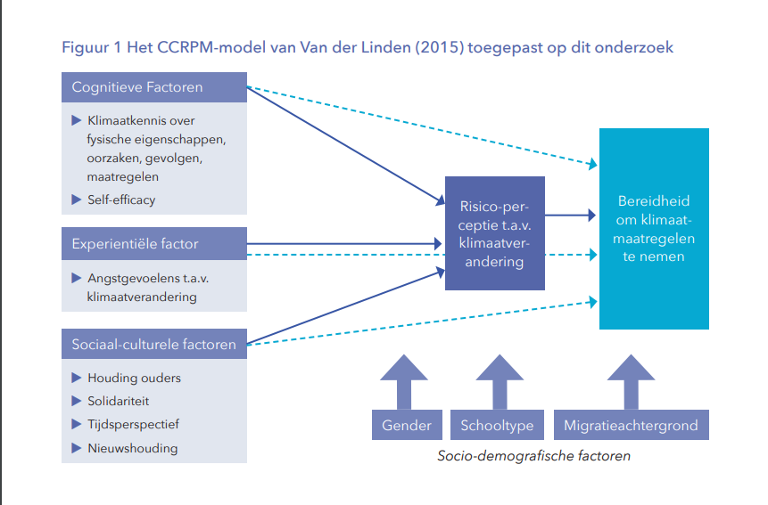

(Bosschaart & Hogeschool van Amsterdam - Kenniscentrum Faculteit Onderwijs en Opvoeding, 2019)
This figure originates from the report “Ecorexia of klimaatapathie? Hoe denken Amsterdamse leerlingen over klimaatverandering?” written by Adwin Bosschaart and published by Hogeschool Amsterdam.
It shows the CCRPM model from Van der Linden (2015) applied to high school students in Amsterdam and what they think about climate change.
On the left there are three distinctions:
- On the top: Cognitive factors:
  - Knowledge of climate change and its physical characteristics, causes, consequences and measures
  - Self-efficacy
These cognitive factors directly influence the risk perception concerning climate change and indirectly influence the willingness to take measures.
- In the middle: Experiential factors:
  - Feelings of anxiety about climate change
This factor directly influences the risk perception concerning climate change and indirectly influences the willingness to take measures.
- On the bottom: Social-cultural factors
  - Opinion of parents
  - Solidarity
  - Time perspective
  - News perspective
Again, these factors directly influence the risk perception and indirectly influence the willingness to take measures.

At the bottom of the right there are three more factors displayed that both influence the risk perception and the willingness to act. These factors are socio-demographic factors: Gender, School type and migration background.

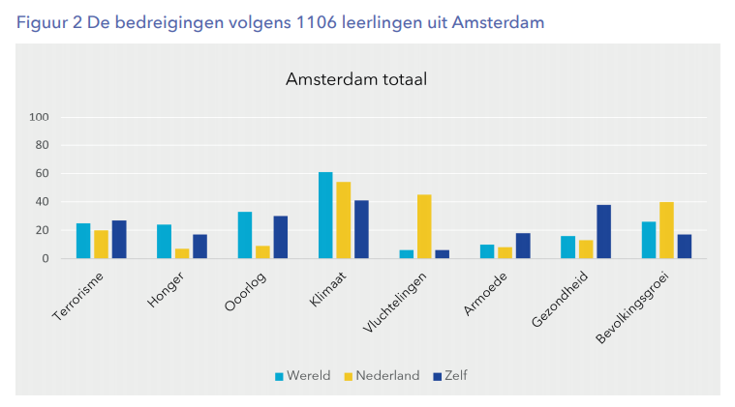
(Bosschaart & Hogeschool van Amsterdam - Kenniscentrum Faculteit Onderwijs en Opvoeding, 2019)
This figure originates from the same report as mentioned above for the previous figure.
It shows how the 1106 high school students form Amsterdam rate threats.

The light blue color describes threats to the world. The yellow color describes threats to the Netherlands. The dark blue color describes threats to oneself.

From left to right the threats are:
Terrorism, Hunger, War, Climate, Refugees, Poverty, Health, Population growth.

It is very clear to see that the climate change is the most threatening situation.

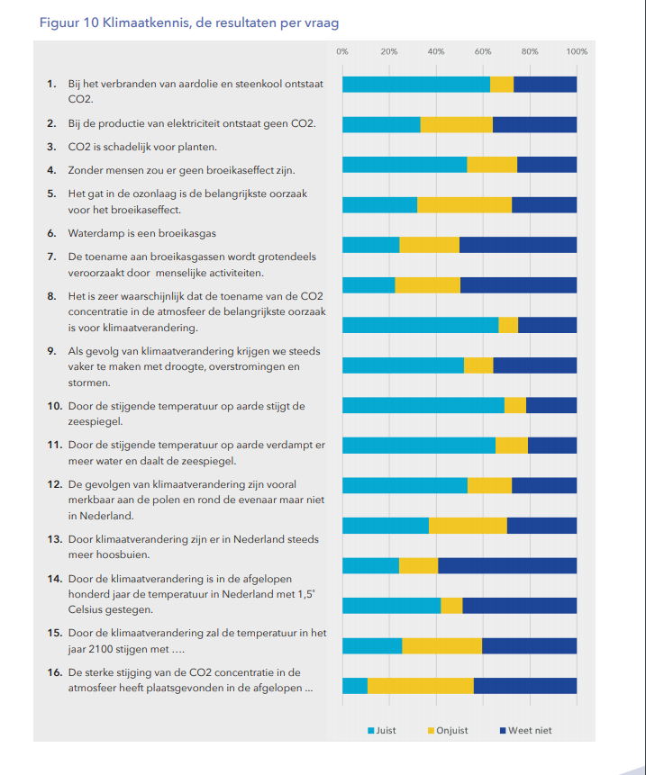

(Bosschaart & Hogeschool van Amsterdam - Kenniscentrum Faculteit Onderwijs en Opvoeding, 2019)
This figure originates from the same report as mentioned above. The graph shows a test about the climate awareness and knowledge the high school students have. The light blue color shows how many students gave a correct answer. The yellow color shows how many students have an incorrect answer. The dark blue color shows how many students did not know the answer.

From top to bottom the questions were:
- By burning natural gas and coal, CO2 arises.
- During the production of electricity, there arises no CO2.
- CO2 is harmful for plants.
- Without humans, there would be no greenhouse effect.
- The hole in the ozone layer is the most important cause of the greenhouse effect.
- Water vapor is a greenhouse effect.
- The increase of greenhouse gases is mainly caused by human activity.
- It is very presumable that the increase of CO2 concentration in the atmosphere is the most important cause of climate change.
- As a consequence of climate change, we will increasingly have to deal with drought, flooding and storms.
- Due to the rising temperatures on earth the sea level rises.
- Due to the rising temperatures on earth the water evaporates, and the sea level decreases.
- The consequences of climate change are mainly noticeable in the pole areas and around the equator but not in the Netherlands.
- Due to climate change there are more downpours in the Netherlands.
- Due to climate change, the temperature in the Netherlands increased with 1,5° C over the last hundred years.
- Due to climate change, by the time of 2100, the temperature will be increased by…
- The immense increase of CO2 concentration in the atmosphere took place in the last…

This figure shows that the average knowledge of the high school students about climate change is not much. They do not only learn about climate change in school, but also via media and conversations at home, however this may differ depending on the home situation.

Research on climate change experience under young adults (18 – 25+ years)

Most of the young adults (34%) are not worrying too much about the consequences of climate change frequently.
However, 67% of young adults believe that climate change threatens the society. 53% of young adults believe that it will change society in the nearby future.

86% of the young adults think that climate change will rather change the society in a further away future. Nevertheless, 82% also claims that they notice some consequences of climate change already. Only 11% of young adults claim to notice drastic consequences, most of these are extreme weather situations and a shift of seasons.

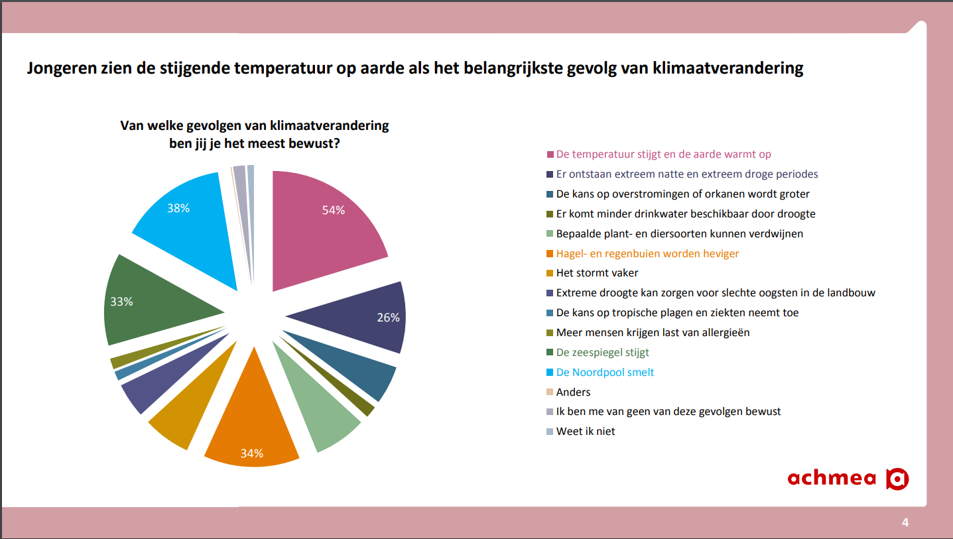
(Gfk i.o.v. Achmea, 2016)
In this graphic young adults mostly notice the rising temperatures and more extreme weather situations. The melting of the ice on the north pole and the rising sea level are also noticed well.
Other things that are noticed are the increasing chances of flooding and hurricanes, a scarcity of drinking water, the risk of plant and animal species going extinct, increasing amount and intensity of rain and hail storms, a generally increase of storms, extreme drought causing the harvest to fail, a chance of more tropical plagues and diseases, more people getting allergies, etc.

77% of young adults think that they themselves do not or barely contribute to climate change happening. The generally think that the government (73%) and the companies (72%) contribute to it mostly. There are less expectations about a climate summit. Only 33% of young adults believe that a climate summit will contribute something to the fight against climate change.

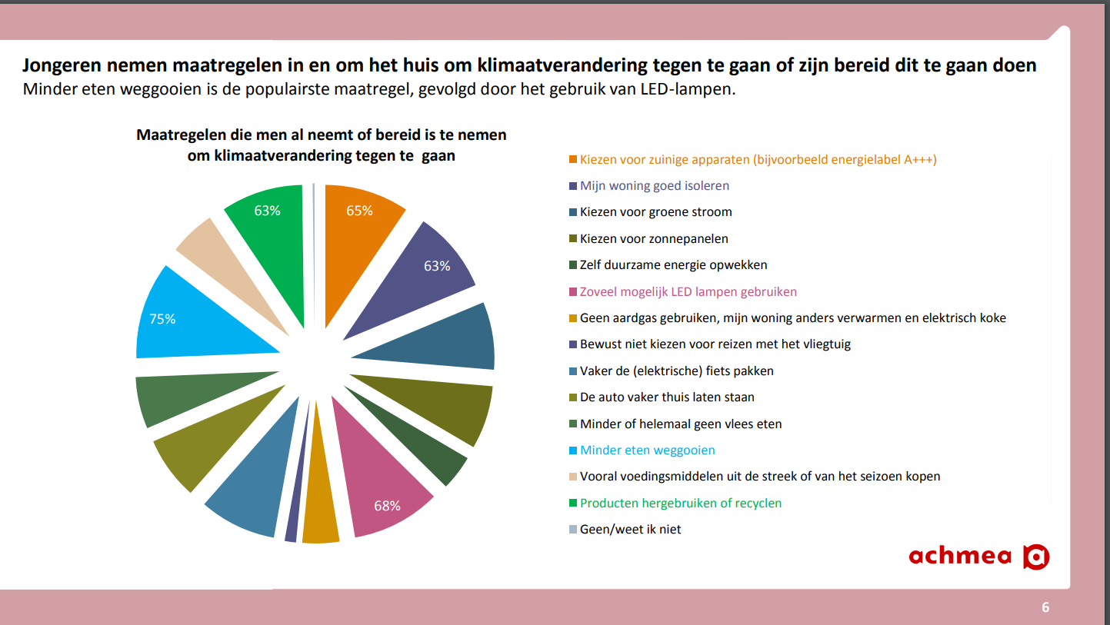
(Gfk i.o.v. Achmea, 2016)
In this graph it can be seen what actions young adults take at home and in their direct environment to fight climate change. The most popular measures are not wasting food and the use of LED lights. Other popular measures is the use of energy sparing devices, have a well isolated apartment, use solar panels and recycling. Furthermore, there are measures like generate sustainable energy themselves, not using natural gas but rather use electricity for heating and cooking, choosing not to fly with a place, using the bike more often instead of the car, eating no or less meat, buy local products, etc.

Generally, young adults are more aware about the consequences of climate change throughout the world, consequences like the rising temperatures, the melting ice on the north pole, the rising sea level, etc. The average Dutch is more aware of consequences that are more nearby, like flooding, more intense hail and rainstorms, etc.

More young adults than the average Dutch (23% vs 17%) believe that they personally can do something against climate change. Young adults also think more than the average Dutch that this task is mainly for the government and companies.

The average Dutch tends to take more action against climate change than young adults, however, young adults show a higher willingness to act and fight climate change than the average Dutch.

Conclusion
Primary school students understand what climate change is and know that it is happening, however, they struggle to understand the correlation between various effects and consequences of climate change. They have a basic understand of what is bad or good for the climate, e.g. factories are seen as being bad for the environment. They are overwhelmed by the topic and are unsure how to react. The children are very clear that they want all the people in the world, including the government and companies, to do something about the problem.
High school students know about climate change and realize that it’s a global risk, however, they do not know the details of how climate change works. They generally know that temperatures and sea levels are rising, but they struggle to fully understand the effects of CO2. Furthermore, they struggle to completely understand the greenhouse effect and what the holes in the ozone layer influence. Another thing many high school student are unaware of are the exact global effects on the earth and how it will influence the earth and its inhabitants (e.g. drought, flooding, heat waves, hurricanes, etc.)
Adults are way less aware of climate change than younger age groups. They know that it is happening, and they are aware of the consequences throughout the worlds (e.g. rising temperatures, melting ice caps, rising sea levels etc), however they do not see it as a direct risk. They tend to believe that the consequences of climate change will happen in a farther away future and feel only partially responsible to do something about it.

The Awareness Gap
Now that it is clear what the target group knows and is unaware of, it is important to define the awareness gap. It is essential to know what the gap is between what the target group knows and what we are trying to teach.
As described, primary school students know the basics of climate change and global warming. However, it is a difficult topic for them. Our game wants to teach them how various factors influence each other, e.g. how a factory pollutes the earth, but a nature reserve helps to balance the pollution. The game can use visuals to make the concept more tangible, which will help them to better see what climate change and global warming is. Primary school students are very clear in the message that they think everyone needs to do something about global warming and our game reinforces this idea.
High School students know more about global warming but do not have much awareness about the effects of CO2 and how the ozone layer is affected. They also struggle to see the direct results for inhabitants, animals and nature. Our game can give them more knowledge about this by showing what industry harms the earth with CO2, that there are methods for saving energy (e.g. solar panels) and thus emitting less C02. We can show them visually how the ozone layer is affected by C02 and will get holes in it when the earth is polluted, and they can observe how rising sea levels will destroy buildings and make less land available. The game shows them that the rising sea levels are caused by melting ice caps by visually making these things happen in the simulation.
Adults know most about climate change but often are not aware how urgent it is, they believe it will be a slow process and will happen in a far away future. Our game shows the process of climate change and global warming just within 5 minutes and simulates various outcomes based on the player’s actions. This will help the adults to become more aware of the fast consequences that their actions cause.

Epic meaning
It is important that we have an epic meaning in our game. This gives the user a reason to interact with our product, it will make the user feel motivated. The epic meaning will make the user believe that they are engaged in something bigger than themselves and they will feel the urge or need to be part of this topic that is bigger than themselves.
There are multiple ways of accommodating an epic meaning within a game. However, it is essential to think about which method will be used as it can backfire as well. It is important to find a fitting method of applying epic meaning to a game to the product.
One method of applying epic meaning to a game is to tie the game to a good cause. This way the player feels like a hero and feels like they are doing something important for humanity, as their action of playing the game will help a good cause. This is a great method but unfortunately not applicable to this project.
Another method of applying epic meaning is Elitism. It can be a good method to distinguish between the player and other groups in the game and giving a feeling of superiority, but it would be the wrong method for our product. In fact, it would very much contradict with the message we want to teach: All people need to work together to take action against global warming and climate change. Everyone has the same responsibility and in order for the actions to works, we all need to work together.
Giving the player the feeling that they are “chosen” to fulfil a task in the game could be a way to show the epic meaning in the game. But this would again contradict very much with the message we are trying to teach. In fact, we want the user to know that anyone can do something about climate change and global warming, there are no requirements that make some persons more suitable than others.
Lastly, there is the method giving a narrative at the start of the game. By offering context to the player, the important question of why is given an answer. The player knows what they have to do and can tie the content they experience to the narrative and context given at the start of the game. This shows the bigger meaning of all, which is the epic meaning of the game. The player will realise the importance of the topic and will feel the drive to be part of it.
Concretely, this means that at the beginning of our game, we need to explain to the user that there is a planet that can be built on. The player needs to know that building and inhabiting this planet has consequences and that some actions are polluting while other actions are not harming the planet.
The design of our product is also tied to this meaning. The fact that the user can zoom out and look at the planet as a whole, seeing the bigger scale effect, but can also zoom in and see more local effects, shows the bigger picture. Being able to see the both global and local effects shows the importance and the complexity of global warming and climate change.
Furthermore, by giving the player the power to control a whole planet shows the responsibility every person has. The player’s actions alone can save or destroy the planet. The end screen of the game will also compare the player’s actions and consequences to other player’s actions and consequences, which will help the player to learn from their actions and reflect on their consequences.
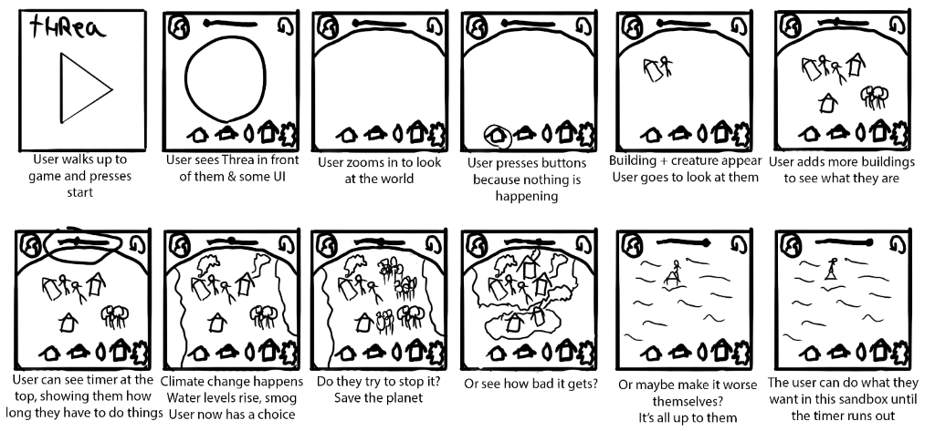
https://i.imgur.com/78fcncl.png

The user journey portrayed above shows how the epic meaning can be applied. First, they receive some context and afterwards, there is time to experiment. The player has the power to do what they want but will see how their actions have consequences for the planet. It will make them feel important and powerful and will teach them what important decisions mean in the bigger picture of climate change and global warming.

Product learning goals

Primary school students
We would like to teach primary school students what kind of industry pollutes.

High School students
We would like to teach high school students what effects pollution has on a global scale.

Adults
We would like to teach adults that global warming and climate change will have consequences sooner than they think.

References
Klostermann, M., & Huitema, P. (2018). Game Design: Ideate on Players and Mechanics [Slides]. Retrieved from https://leren.saxion.nl/bbcswebdav/pid-2242498-dt-content-rid-56584395_4/institution/ACT/CMGT/2018-2019/JR1/GameDesign/CMGT%20Game%20Design%20Lecture%201.1.4.pdf
Nand, K., Baghaei, N., Casey, J., Barmada, B., Mehdipour, F., & Liang, H. N. (2019). Engaging children with educationalcontent via Gamification. Retrieved from https://link.springer.com/content/pdf/10.1186/s40561-019-0085-2.pdf
Personality And Play Styles: A Unified Model. (n.d.). Retrieved June 8, 2020, from https://www.gamasutra.com/view/feature/134842/personality_and_play_styles_a_.php
Zenn, J. (2017, September 21). Bartels Player Types [Graph]. Retrieved from https://gameanalytics.com/blog/understanding-your-audience-bartle-player-taxonomy.html
Bosschaart, A., & Hogeschool van Amsterdam - Kenniscentrum Faculteit Onderwijs en Opvoeding. (2019). Ecorexia of klimaatapathie? Hoe denken Amsterdamse leerlingen over klimaatverandering? Retrieved June 8, 2020, from https://www.hva.nl/binaries/content/assets/subsites/urban-education/projecten/hoe_denken_scholieren_over_klimaatverandering-adwin_bosschaart-2019.pdf?1557854212316
Gfk i.o.v. Achmea. (2016, October). Resultaten onderzoek naar klimaatbeleving. Retrieved June 8, 2020, from https://nieuws.achmea.nl/download/256228/achmea-resultaten-gfk-klimaatonderzoek-jongeren-2016.pdf
NCDO. (2013, September). Perspectieven van kinderen op duurzaamheid - Onderzoeksreeks 12. Retrieved June 8, 2020, from http://kaleidosresearch.nl/publication/perspectieven-van-kinderen-op-duurzaamheid-samenvatting/
Kreutzer (OneTwentyone), P., & Sikkema (Qrius), P. (2015, October). ‘Generatie C’ over klimaatverandering - Samenvatting van een onderzoek onder kinderen van 8 t/m 12 jaar die op de basisschool zitten, in opdracht van Natuur & Milieu/Ministerie van Infrastructuur & Milieu. Retrieved June 8, 2020, from https://www.natuurenmilieu.nl/wp-content/uploads/2015/11/151103-Rapportage-gecombineerde-onderzoeken-Generatie-C.pdf

