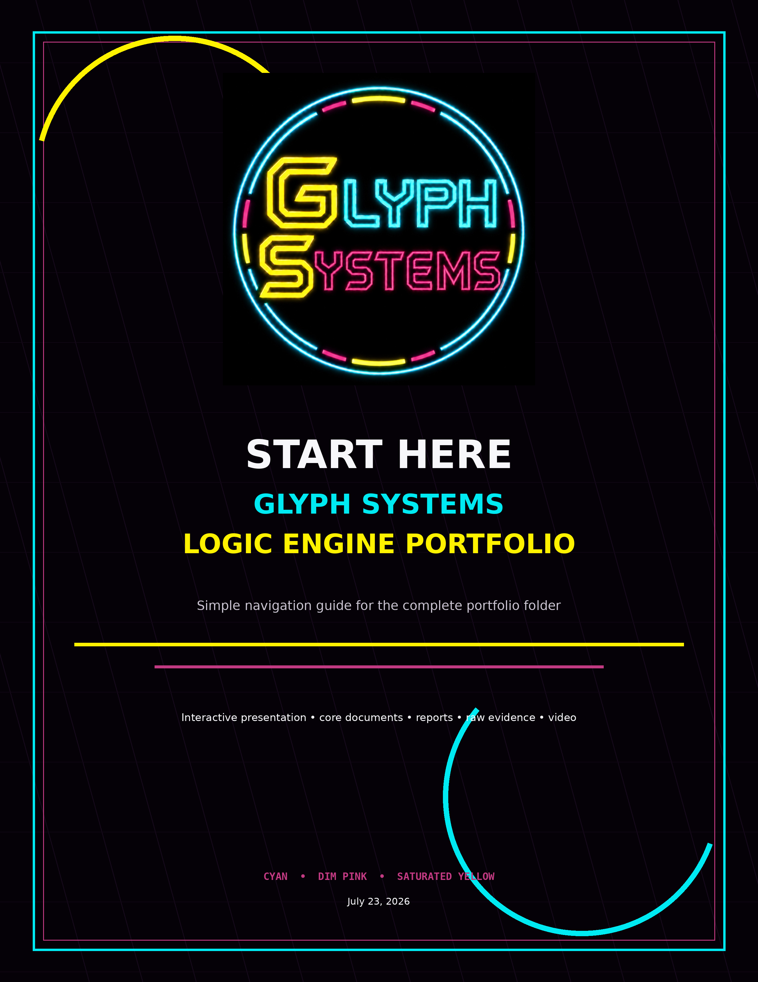

Start Here
Two ways to review the Glyph Systems Logic Engine portfolio.
GUIDED BROWSER VIEW  Open the Glyph_Systems_Interactive_Portfolio_Demo folder and double-click OPEN_PORTFOLIO.bat.  This opens the complete presentation in a browser with the documents and evidence arranged in order. | MANUAL FOLDER VIEW  Open the seven Word documents at the top level, then use the HTML Files, PROGRAMS DOC INFO, Screen Shots, and Screen Recording folders.  Each evidence folder contains its own detailed reading guide.

Recommended folder name: GLYPH_SYSTEMS_LOGIC_ENGINE_PORTFOLIO. Keep this README at the top level and name it 00_READ_ME_FIRST so it sorts first.

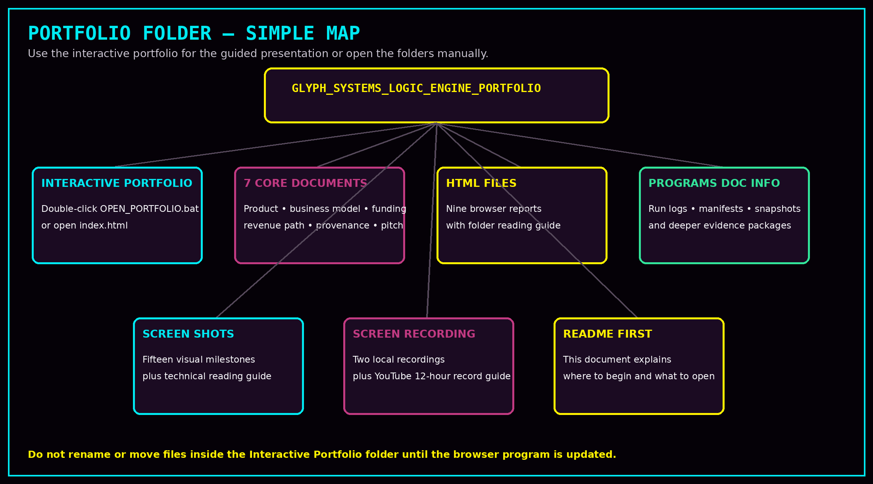

What Is in the Folder
The folder is organized from presentation material into increasingly detailed evidence.
Folder or section | What it contains
Seven Core Documents | The main product, business, funding, evidence, revenue-path, data-origin, and progressive-pitch documents. These are the core presentation records.
Glyph_Systems_Interactive_Portfolio_Demo | The browser program. Open OPEN_PORTFOLIO.bat on Windows, or open index.html directly. It contains browser-ready copies of the portfolio materials.
HTML Files | Nine human-readable program reports. Open READ_ME_HTML_EVIDENCE_FOLDER.docx before reviewing them manually.
PROGRAMS DOC INFO | The deeper technical evidence packages: run-log JSON files, manifests, hashes, and frozen public-input snapshots. Open READ_ME_PROGRAM_EVIDENCE_FOLDER.docx first.
Screen Shots | Fifteen visual milestone images and the detailed Screenshot Folder Technical Guide.
Screen Recording | Two local video records and the guide containing the full twelve-hour Program 35 YouTube record.

Programs 41 and 42 are continuing live runs. Their twelve-hour milestone reports are valid contained evidence. The separate zero-round files are startup/preflight records only.

Recommended Review Order
A simple route for investors, business reviewers, or technical evaluators.
- 1. Open the Progressive Pitch Script and choose the amount of time available: 10 seconds, 90 seconds, five minutes, or ten minutes.
- 2. Read What Is Logic Engine? and How Logic Engine Makes Money.
- 3. Read Data Origin and Reproducibility and the Test Screenshot Evidence document.
- 4. Read From Investment to First Commercial Revenue and the Commercialization Funding Plan.
- 5. Open the interactive portfolio or review the HTML evidence reports manually.
- 6. Use the screenshot and video folders for visual continuity.
- 7. Use PROGRAMS DOC INFO only when deeper technical verification is needed.

Important evidence boundary
The portfolio documents controlled matched testing, long-duration continuity, and modeled operational-recovery differences. Modeled values are not realized customer revenue or guaranteed future savings. The next commercial gate is independent technical review and an authorized read-only customer shadow pilot using pre-agreed measurement rules.

Before uploading to GitHub
- Keep the current original evidence files unchanged.
- Do not rename files inside the interactive program until its file references are updated.
- Keep public materials separate from private source code and protected internal architecture.
- Confirm that the README, browser program, seven core documents, and each evidence-folder guide open correctly.
This README is the first file a reviewer should open. It gives the route through the portfolio without forcing anyone to understand the full technical archive immediately.

