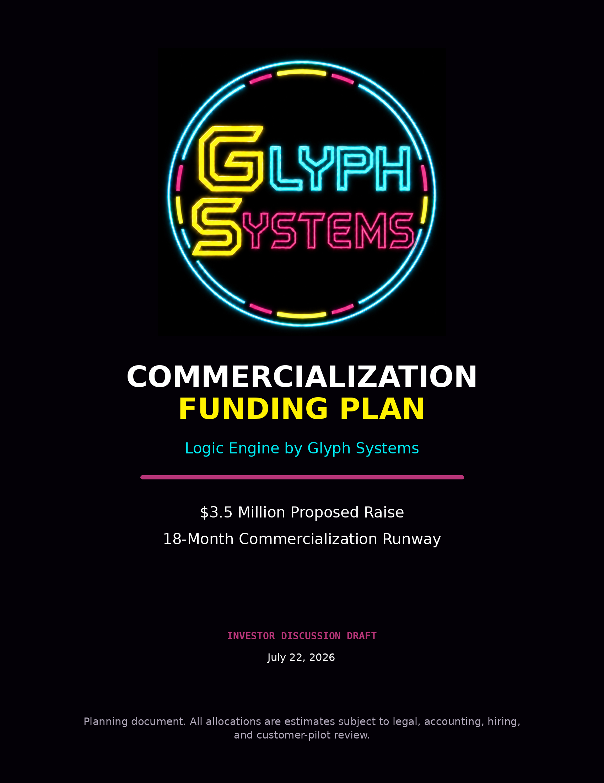

Commercialization Funding Plan
Glyph Systems is seeking approximately $3.5 million in committed capital to move Logic Engine from controlled technical evidence into independent validation, secure customer pilots, and commercial operation.
The proposed funding provides an estimated 18-month commercialization runway. The company will use this period to protect the underlying intellectual property, harden the technical architecture, complete independent security and performance reviews, build a specialized operating team, and establish the first authorized customer deployments.
Funding objective: build the people, validation, security, infrastructure, legal protection, and customer-pilot capability required to convert controlled evidence into independently verified commercial performance.

1. Funding Objective
Logic Engine has already produced a substantial controlled evidence record across short calibration tests, multi-hour endurance runs, and multi-day operating demonstrations. Those results are modeled and controlled; they are not yet realized customer savings.
The next proper gate is independent review followed by read-only customer shadow pilots under agreed measurement rules. The proposed raise is designed to finance that transition without forcing premature production deployment or weakening protection of the core architecture.
- Proposed raise: approximately $3.5 million
- Planned runway: approximately 18 months
- Primary objective: independent proof, secure pilots, and commercial readiness
- Commercial boundary: no performance payment without measured and verified savings

2. Funding Assumptions
The compensation figures in this plan are gross annual base salaries. They are not take-home amounts. Glyph Systems will separately budget for employer payroll obligations, benefits, insurance, recruiting, equipment, and related employment costs.
- Role compensation is tied to defined, accountable operating responsibilities rather than personal distributions.
- Final employer costs will depend on hiring location, employment structure, benefit design, insurance, and professional payroll advice.
- The proposed category allocations are planning estimates and may move as independent reviewers, customers, and hiring requirements become clearer.
- Personal living or relocation expenses are handled through agreed compensation; legitimate company infrastructure and operating expenses remain separate.

3. Initial Leadership and Engineering Team
Glyph Systems requires a focused initial team capable of moving a protected financial-recovery system from controlled evidence into professional validation, customer integration, and repeatable operation.

Founder and Chief Architect
Planned gross annual base salary: $160,000
The Founder and Chief Architect retains responsibility for the protected architecture, product direction, and final technical decisions.
- Protected Logic Engine architecture and technical direction
- Research, product decisions, and continued system development
- Protection of the proprietary decision system
- Coordination with the principal engineer and commercial leadership
- Final approval of architecture-sensitive implementation decisions

Chief Business Officer and Strategic Partnerships
Planned gross annual base salary: $160,000
This role leads major business communication and financial-sector relationship development, assuming a defined, full-time, and accountable operating role.
- Investor communication and strategic presentations
- Financial-sector relationships and qualified introductions
- Commercial partnerships and major proposals
- Business-development strategy
- Translation of technical evidence into clear commercial language

Head of Commercial Operations
Planned gross annual base salary: $200,000
This position is broader than a traditional manager. It coordinates the day-to-day commercial execution needed to turn qualified relationships into active pilots and contracts.
- Customer outreach, sales operations, and relationship management
- Proposal development and customer follow-up
- Pilot coordination and execution oversight
- Internal operating systems, scheduling, and hiring support
- Movement of qualified prospects toward active commercial opportunities

Principal Logic Engine Engineer
Planned gross annual base salary: $250,000
This is a specialized deep-technology role rather than a conventional software-development position.
- Protected-core implementation and reliability engineering
- Customer integration and secure interface development
- Test automation, documentation, and code maintenance
- Deployment architecture and technical quality control
- Translation of the founder's architecture into a professionally operated commercial system
Combined annual gross base salary: approximately $770,000. Total annual employer-cost planning range: approximately $950,000 to $1 million, depending on employment structure and benefits.

4. Proposed Use of Funds
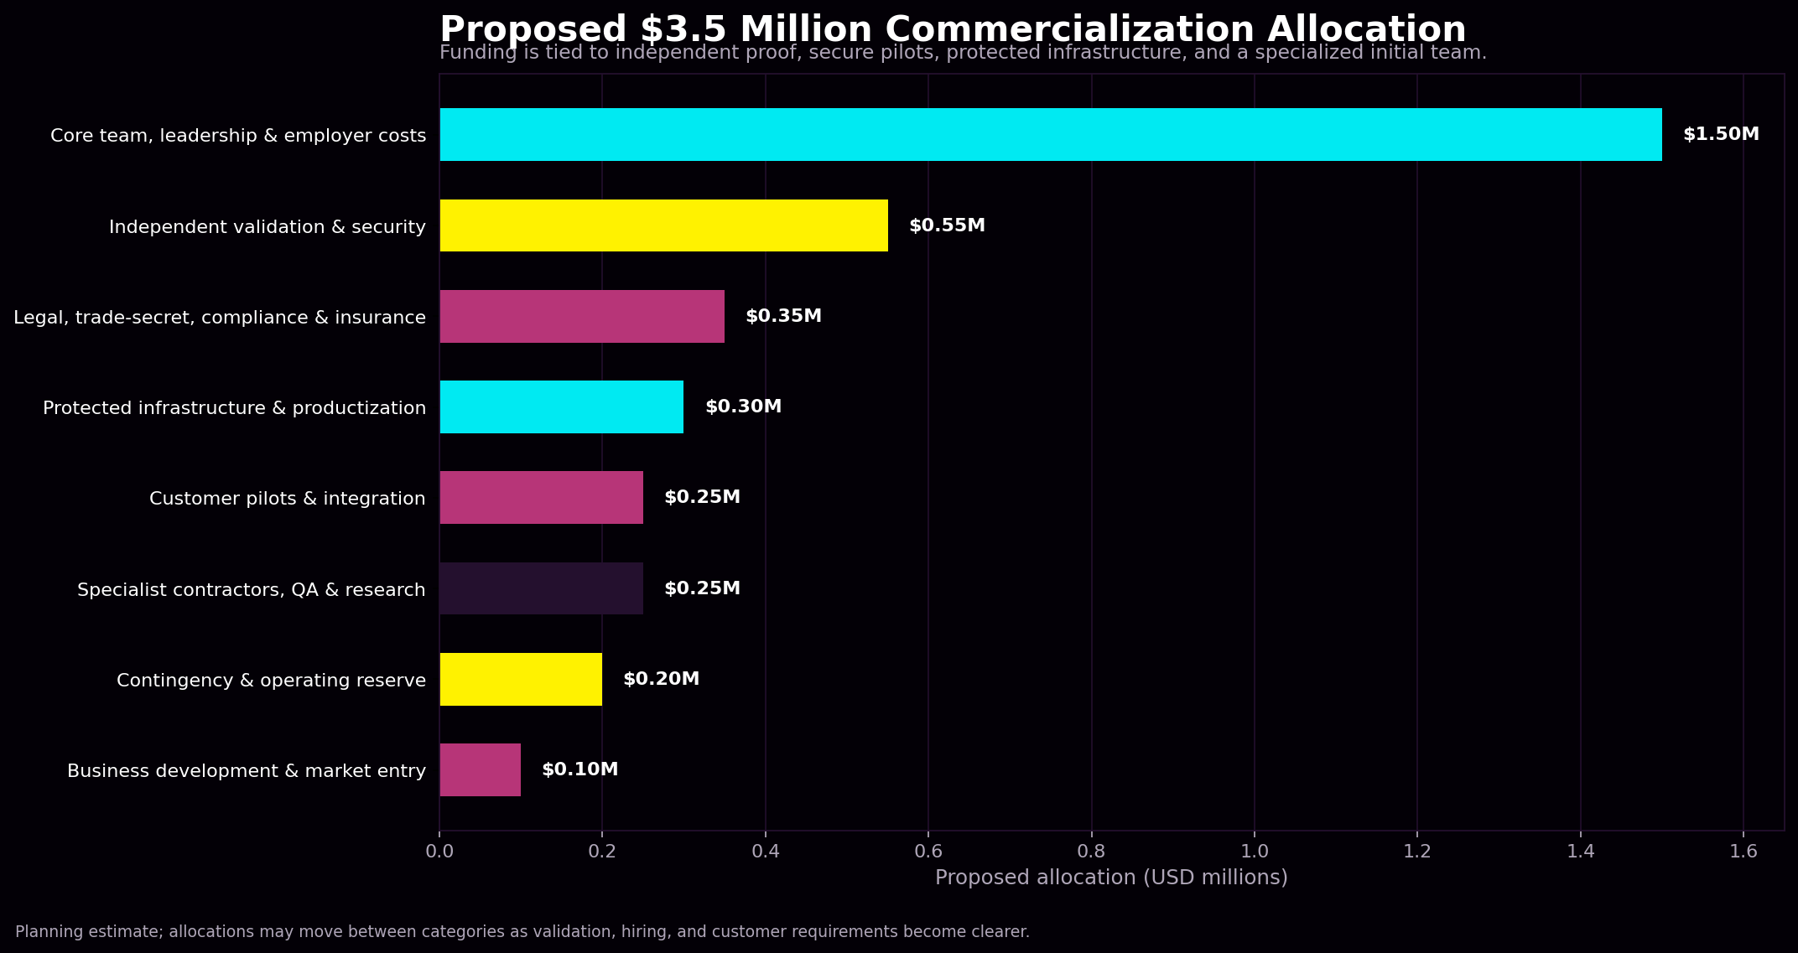
Funding category | Allocation | Share
Core team, leadership & employer costs | $1,500,000 | 42.9%
Independent validation & security | $550,000 | 15.7%
Legal, trade-secret, compliance & insurance | $350,000 | 10.0%
Protected infrastructure & productization | $300,000 | 8.6%
Customer pilots & integration | $250,000 | 7.1%
Specialist contractors, QA & research | $250,000 | 7.1%
Contingency & operating reserve | $200,000 | 5.7%
Business development & market entry | $100,000 | 2.9%
Total proposed raise | $3,500,000 | 100.0%
The largest allocation supports the specialized initial team and associated employer costs. The remainder funds the assurance, legal, infrastructure, customer-integration, and operating work required before a financial customer should rely on the system.

5. Detailed Allocation

Core Team, Leadership, and Employer Costs — $1,500,000
This category supports approximately 18 months of compensation and employer-related costs for the initial leadership, commercial, operational, and engineering functions.
- Gross base salaries
- Employer payroll costs and benefit allowances
- Recruitment, onboarding, and employment administration
- Basic employee equipment and operating needs

Independent Validation and Security — $550,000
A financial system cannot rely solely on internal testing. Glyph Systems will establish a layered independent-assurance program.
- Independent technical architecture review
- Review of measurement rules and modeled-savings calculations
- Secure-development and code review
- Penetration testing and professional red-team engagements
- Customer-gateway, tenant-isolation, encryption, and key-management testing
- Restart, backup, recovery, and incident-response exercises
- Security and assurance readiness work

Legal, Trade-Secret Protection, Compliance, Accounting, and Insurance — $350,000
- Corporate legal counsel and company governance
- Trade-secret policies, access controls, and intellectual-property strategy
- Employment, contractor, customer-pilot, and commercial agreements
- Confidentiality, privacy, and data-handling review
- Accounting, tax support, insurance, and financial controls

Protected Infrastructure and Productization — $300,000
- Protected private Logic Engine infrastructure
- Customer-facing gateway development
- Secure regional deployment capability
- Authentication, access controls, logging, and monitoring
- Backups, recovery systems, data storage, and secure development environments
- Hardware, networking equipment, software licenses, and operational setup

Customer Pilots and Integration — $250,000
The first commercial deployments will begin as controlled, read-only shadow pilots.
- Customer-specific connectors and technical onboarding
- Historical and live read-only data integration
- Baseline measurement and pilot configuration
- Customer-specific testing, monitoring, and reporting
- Travel and meetings tied to qualified pilot opportunities
- Independent verification of measured savings

Specialist Contractors, Quality Assurance, and Research — $250,000
- Security and DevOps specialists
- Quality assurance and test engineering
- Data engineering and interface development
- Technical writing and measurement support
- Project-based implementation assistance before permanent roles are justified

Business Development and Market Entry — $100,000
- Investor and customer materials
- Professional proposals and demonstrations
- Industry meetings, conferences, and targeted outreach
- Customer education, communications, and sales-support tools
- Travel for qualified commercial opportunities

Contingency and Operating Reserve — $200,000
A protected reserve reduces the risk that unexpected security, legal, infrastructure, pilot, hiring, or validation costs force premature deployment or unfavorable financing.

6. Commercialization Milestones
Phase | Timing | Primary outputs
Phase 1 | Months 0-3 | Company formation, employment structure, trade-secret controls, frozen validation plan, protected development environment.
Phase 2 | Months 3-6 | Core team onboarding, independent architecture review, measurement review, gateway and protected-core hardening.
Phase 3 | Months 6-9 | Security testing, red-team work, pilot connectors, repeatable deployment and evidence procedures.
Phase 4 | Months 9-12 | First authorized read-only shadow pilots, agreed baselines, customer-specific reporting, remediation of findings.
Phase 5 | Months 12-18 | Independent measurement of commercial results, repeatable onboarding, documented operations, and performance-revenue conversion.

By the end of the planned runway, Glyph Systems intends to have:
- A formally established and professionally operated company
- A documented trade-secret and intellectual-property protection program
- A hardened protected-core and customer-gateway architecture
- Independent technical and security findings
- A repeatable read-only customer pilot process
- Customer-specific connectors and integration procedures
- One to three serious authorized shadow pilots
- At least one independently measured commercial result
- Documented deployment, monitoring, backup, and incident-response procedures
- A credible path toward recurring performance-based revenue

7. Revenue Model
Controlled evidence → independent review → read-only shadow pilot → agreed baseline comparison → independently verified savings → performance-based revenue.

The intended commercial model is based on measurable customer value rather than a fixed claim that the system will always produce the same result.
Customer retained portion | 50% of independently verified savings
Glyph Systems portion | 50% of independently verified savings
No performance payment is earned unless measurable savings are produced under the agreed verification rules. The protected Logic Engine core remains under Glyph Systems ownership and control.

8. Investment Outcome
Glyph Systems is not seeking capital merely to continue experimentation. The proposed commercialization round is intended to produce a protected, independently reviewed, securely deployable company with a credible path to verified customer value.
Protection: Formal trade-secret controls, contractual boundaries, and protected-core architecture.
Independent proof: External review of architecture, measurement rules, security, and recovery behavior.
Secure deployment: A controlled customer-facing gateway separated from the protected Logic Engine core.
Customer validation: Read-only shadow pilots measured against agreed customer baselines.
Commercial conversion: Performance revenue only after independently verified savings.

Conclusion
The proposed $3.5 million commercialization round is designed to build the people, security, infrastructure, legal protection, customer integrations, and independent evidence required to turn Logic Engine into a professionally operated financial-recovery company.
The existing controlled evidence establishes a reason to continue. The funding plan establishes a disciplined path toward independent proof, secure customer operation, and verified commercial revenue.
The central investment proposition is straightforward: protect the architecture, prove the claims independently, test through authorized customer pilots, and earn revenue only when verified value is produced.

All figures in this document are planning estimates and should be finalized with qualified legal, accounting, payroll, security, and insurance professionals before investment documents or employment agreements are executed.

