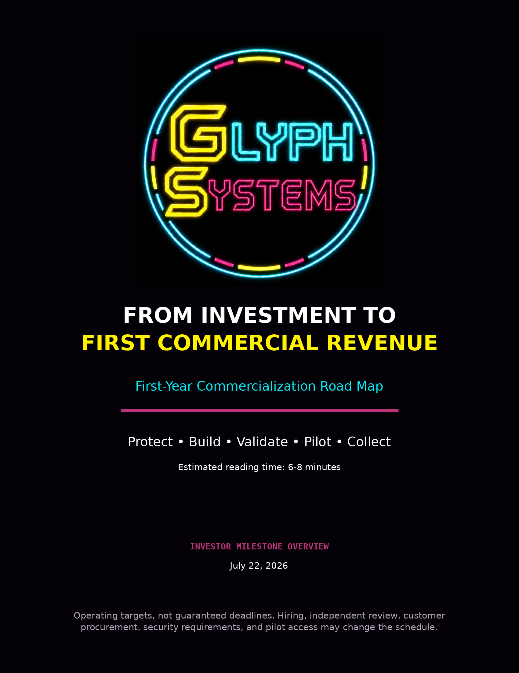

From Investment to First Commercial Revenue
This road map explains how Glyph Systems intends to convert investor capital into a protected, independently reviewed, customer-testable product and then into its first collected commercial revenue.
The first year is organized around three milestone stages. Capital first establishes the company, protects the technology, and builds the initial team. The second stage hardens and validates the customer-facing platform. The third stage qualifies a customer, runs a read-only shadow pilot, verifies savings, and collects payment.
The commercial finish line is not a positive internal dashboard. It is the first customer payment collected by Glyph Systems.

1. First-Year Objective
The purpose of the first funded year is to move Logic Engine from controlled founder-led evidence into a professionally operated commercial system that a financial organization can responsibly evaluate.
- Protect the proprietary architecture through a formal trade-secret and intellectual-property strategy
- Hire and train the initial operating and engineering team
- Build the protected Logic Engine interface and customer-facing fourth-node gateway
- Complete independent technical, security, and measurement reviews
- Qualify a customer with measurable recovery friction and usable data
- Run an authorized read-only shadow pilot
- Verify customer-specific savings under rules agreed before the pilot
- Invoice and collect the first commercial performance payment
This document does not repeat the detailed compensation plan or the complete product explanation. It focuses only on the sequence of execution and the gates an investor should expect to see.

2. Twelve-Month Milestone Timeline
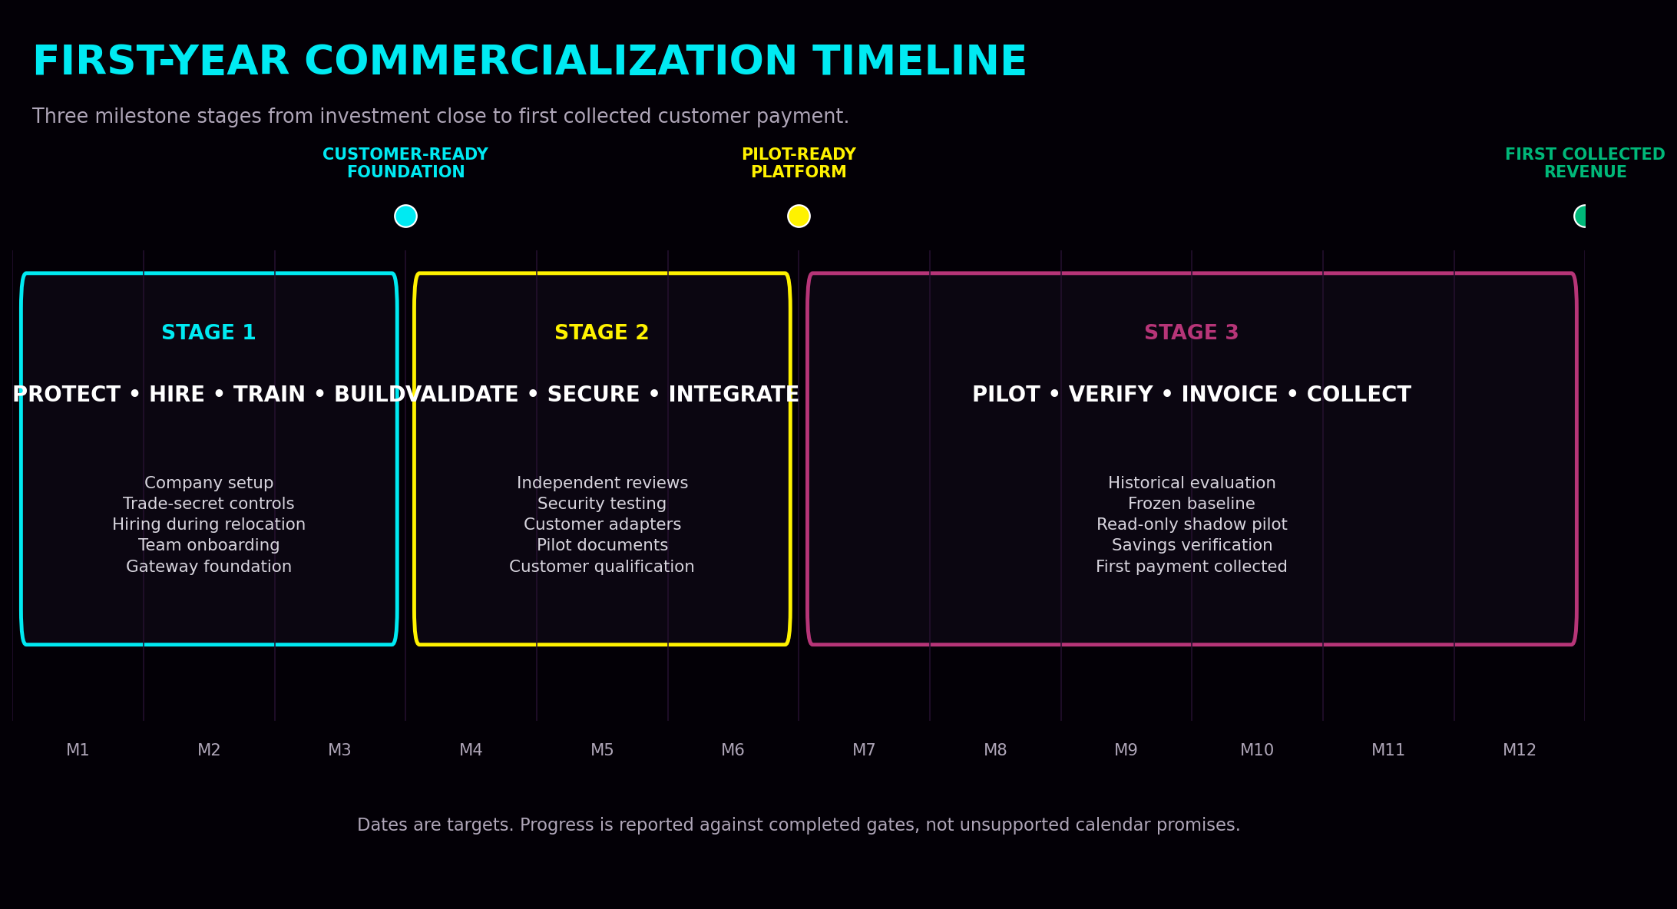
The dates are operating targets rather than guarantees. Hiring quality, independent review, customer procurement, security requirements, and access to pilot data may move the schedule. Progress should be reported against completed gates.

3. Stage 1 — Protect, Hire, Train, and Build
Approximate operating window: Months 0-3

Month 1 — Investment close and parallel setup
- Close the financing and establish governed company banking, accounting, payroll, insurance, and reporting
- Begin Eugene's planned relocation while continuing founder-level technical work and evidence organization
- Begin structured interviews for the high-level operator and principal systems and integration engineer
- Engage intellectual-property and trade-secret counsel
- Begin confidentiality, access-control, employment, contractor, and auditor protection documents
- Identify independent technical, security, and measurement reviewers
- Freeze and preserve the pre-investment evidence package for future comparison
Relocation and hiring proceed in parallel. A one-month move does not need to pause the company; it creates a practical window for interviewing, reference checking, legal setup, and selection of the right people rather than hiring the first available candidates.

Months 1-2 — Select the initial team and define boundaries
- Select the high-level operator responsible for company execution
- Select the principal engineer responsible for the commercial outer platform
- Finalize Brian's approved business-development, pitch, and relationship role
- Define which information each role may access
- Establish the protected-core black-box interface
- Create the first-year operating calendar, hiring plan, vendor plan, and validation schedule

Months 2-3 — Onboard, train, and begin productization
- Provide at least one month of structured team training before independent representation of the product
- Train the team on public explanations, evidence boundaries, security obligations, and escalation rules
- Begin the customer-facing fourth-node gateway
- Build authentication, validation, encryption, logging, monitoring, rate limits, and disconnect controls
- Create backups, restart procedures, fallback behavior, and incident-response foundations
- Finalize the independent assurance and customer-pilot preparation plan
Stage 1 gate: a trained initial team, protected architecture, documented access rules, working gateway foundation, and approved validation plan.

4. Stage 2 — Validate, Secure, Integrate, and Qualify
Approximate operating window: Months 3-6
- Complete the first customer-facing fourth-node deployment
- Create regional gateway deployment options near approved customer infrastructure to reduce network latency and improve operational isolation
- Conduct architecture review and independent review of the controlled test methodology
- Conduct penetration testing and authorized red-team work
- Test authentication, tenant separation, access controls, logging, fallback behavior, restart, backup, and incident response
- Review the customer savings methodology, attribution rules, exclusions, and audit trail
- Build reusable customer adapters, telemetry connections, and evidence exports
- Prepare the historical-data evaluation and read-only shadow-pilot agreement
- Begin formal customer qualification and procurement conversations

Customer qualification standard
- A measurable recovery or transaction-flow problem
- Usable historical or live operational telemetry
- Identifiable operating costs or credible cost proxies
- Authority to approve a controlled evaluation
- A suitable environment for read-only testing
- Willingness to agree on measurement, attribution, verification, and dispute procedures
Early financial-industry conversations may occur before this stage is complete. Those conversations help identify the evidence, security, integration, and procurement requirements that the market will demand. A strong industry reviewer or introducer does not have to be the investor to materially improve the commercialization path.
Stage 2 gate: a secured, independently reviewed, customer-testable platform and a qualified organization prepared to enter a controlled evaluation.

5. Stage 3 — Pilot, Verify, Invoice, and Collect
Approximate operating window: Months 6-12
Commercial step | What must happen
Historical or synthetic evaluation | Use approved customer data in an isolated environment to confirm that enough measurable signal exists to justify a live shadow pilot.
Freeze the existing baseline | Measure the customer's actual retries, duplicate conflicts, queue behavior, recovery duration, unresolved processing, manual intervention, and relevant operating costs.
Freeze the commercial rules | Agree in advance on what counts as savings, what is excluded, how attribution works, the pilot duration, the verification process, disputes, invoicing, and the 50/50 performance split.
Run the read-only shadow pilot | The customer's existing system remains in control while Logic Engine receives approved signals and produces timestamped, logged comparison outputs.
Measure the operational difference | Compare what the existing system did with what Logic Engine recommended under the same conditions.
Verify attribution and value | Determine whether Logic Engine caused the difference and what financial value is supported by the frozen rules.
Accept, invoice, and collect | Exclude uncertain or disputed savings, obtain the required acceptance, issue the invoice, and collect the payment.
Stage 3 gate: Glyph Systems receives its first customer payment based on measurable and verified operational savings.

6. How Investor Capital Converts Into Revenue
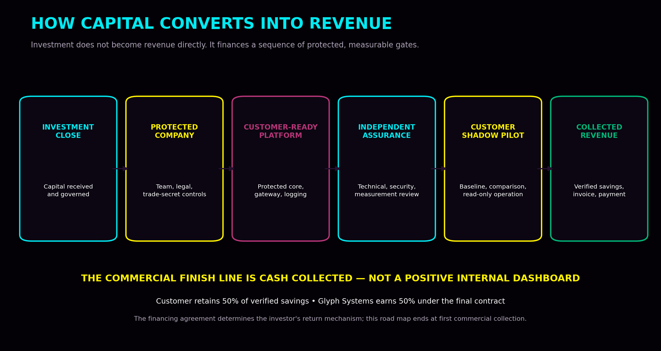
Capital-conversion stage | Investor meaning
Investor capital | Funds commercialization, institutional trust, hiring, protection, validation, infrastructure, and pilots.
Protected company | Creates governance, trade-secret controls, contracts, financial administration, and accountable operating roles.
Customer-ready platform | Creates the protected core interface, fourth-node gateway, secure integrations, logging, monitoring, and fallback controls.
Independent assurance | Tests the architecture, security, evidence method, measurement rules, and customer boundary.
Authorized customer pilot | Creates customer-specific evidence under a frozen baseline and agreed commercial rules.
Collected commercial revenue | Begins only after verified savings are accepted, invoiced, and paid.

7. First-Year Milestone Gates
Gate | Completion standard
Gate 1 — Company and protection established | Governance, financial administration, legal protections, preserved evidence, and defined access boundaries.
Gate 2 — Initial team trained | Operator, principal engineer, business lead, and outside professionals understand their roles and approved information boundaries.
Gate 3 — Customer-ready foundation | Protected interface and fourth-node gateway operate with authentication, validation, logging, monitoring, and disconnect controls.
Gate 4 — Independent review completed | Technical, security, and measurement findings are documented, with material issues remediated or clearly bounded.
Gate 5 — Pilot contracted | A qualified customer signs the scope, data boundary, baseline, attribution, verification, dispute, and payment rules.
Gate 6 — Shadow pilot completed | Customer-specific comparison evidence is produced without initial control of live customer funds.
Gate 7 — Savings accepted | The supported amount survives customer and required independent review.
Gate 8 — Revenue collected | Glyph Systems receives payment under the commercial agreement.

8. What Could Move the Schedule
Schedule or commercial risk | Required response
Hiring takes longer | The company should prioritize quality, references, trust, and technical fit over filling an expensive role quickly.
Legal protection requires more work | Counsel may recommend additional trade-secret controls, narrower disclosures, or selective patent review.
Independent reviewers identify defects | Material findings must be corrected before a customer is asked to rely on the platform.
Customer procurement is slow | Financial organizations may require security review, legal review, vendor onboarding, insurance, and data approvals.
Customer data is insufficient | A historical evaluation may show that the proposed customer cannot support a credible measurement process.
Pilot results are mixed or negative | The evidence must be preserved and the system improved rather than forcing an unsupported savings claim.
Savings cannot be attributed | No performance revenue should be claimed when the value cannot be defensibly linked to Logic Engine.
The first-year plan is designed to discover these issues before broad production deployment. A delayed milestone is preferable to an insecure deployment, weak measurement, or disputed revenue claim.

9. Investor Reporting
Investors should receive concise milestone reporting rather than a stream of technical activity. A practical monthly report can show:
- Current gate and percentage of required work completed
- Hiring and vendor status
- Trade-secret and legal milestones
- Independent review work completed and material open findings
- Fourth-node and customer-integration progress
- Qualified customer and pilot pipeline
- Cash used, remaining runway, and changes to forecast
- Decisions or risks requiring investor or board attention
The investor should be able to see how capital is becoming protection, capability, independent confidence, customer access, and eventually collected revenue.

10. Short Investor Summary
After funding closes, Glyph Systems will use the first three months to establish the company, protect the trade secret, hire and train the initial team, and build the customer-facing gateway around the protected Logic Engine core. During Months 3-6, the company will complete independent technical and security reviews, strengthen the deployment, build customer adapters, and qualify a pilot organization. During Months 6-12, Glyph Systems will establish the customer's real baseline, freeze the measurement and attribution rules, run Logic Engine in read-only shadow mode, verify any supported savings, invoice the contractual performance share, and collect the first commercial payment. The schedule is milestone-driven and will not treat modeled internal results as customer revenue.

Conclusion
The first-year commercialization road is intentionally simple: protect the system, hire and train the right team, build the secure customer-facing platform, complete independent review, qualify a customer, run a controlled shadow pilot, verify the value, and collect payment.
This sequence gives investors a clear way to judge progress without relying on unsupported revenue curves or vague promises. Each stage ends with a concrete gate that must be completed before the company moves forward.
Funding → protected company → trained team → independently reviewed platform → customer shadow pilot → verified savings → first collected revenue.

This document is an operating plan, not a guarantee of timing, customer access, pilot success, revenue, investor return, or regulatory approval. Final financing terms, legal protections, hiring agreements, security requirements, customer contracts, accounting treatment, and payment procedures require qualified professional review.

