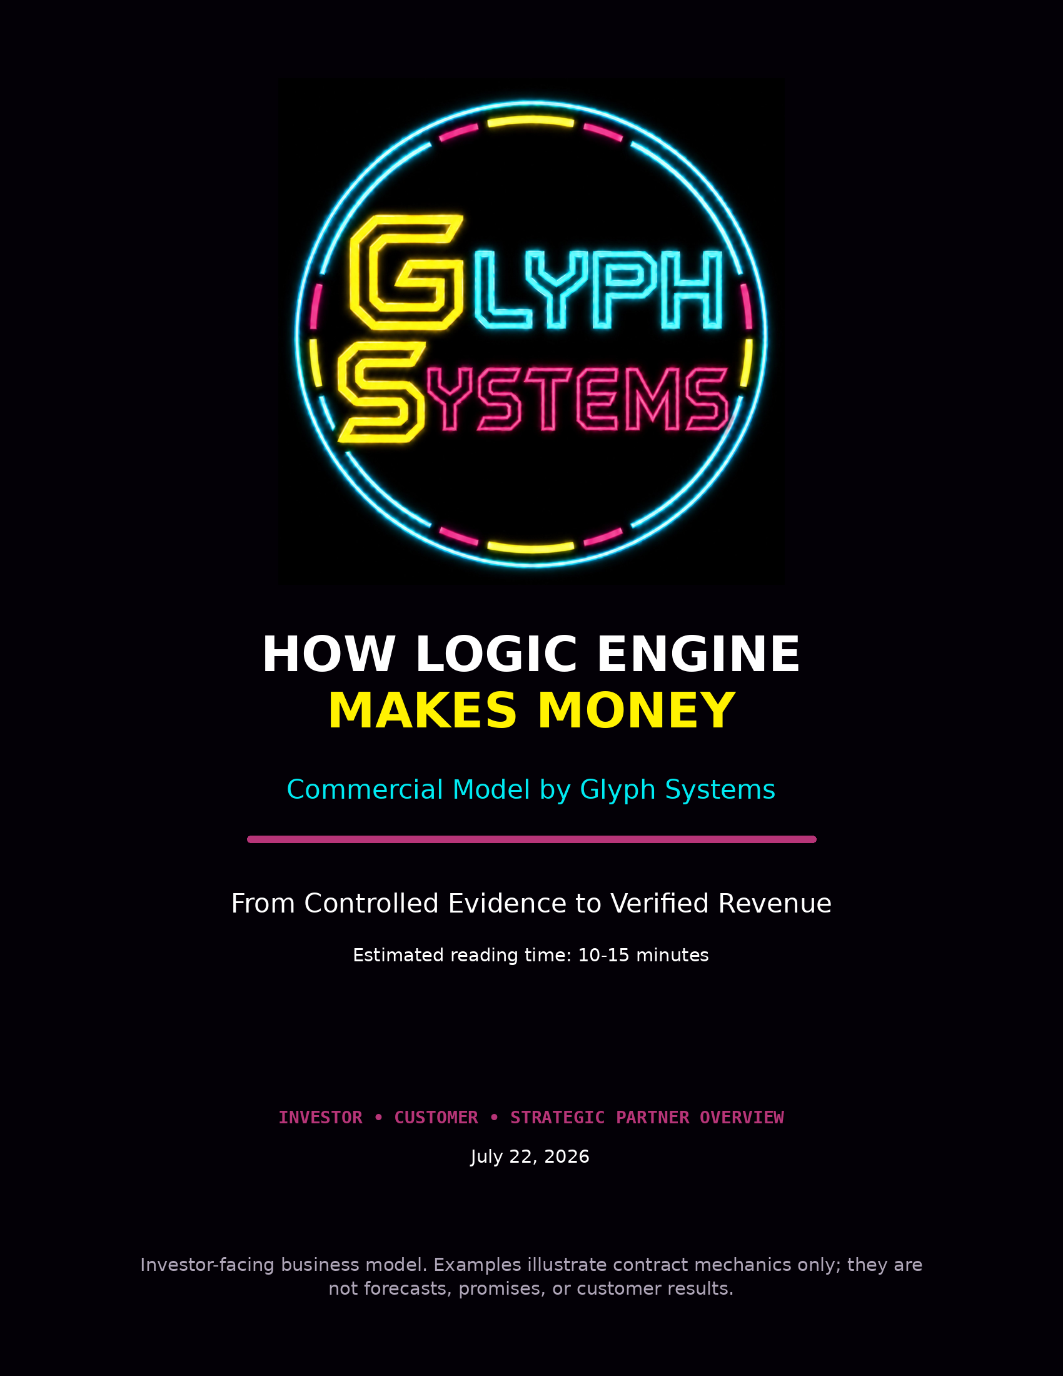

How Logic Engine Makes Money
Glyph Systems intends to earn revenue by sharing in measurable customer savings created by Logic Engine. The company is not asking customers to purchase the protected source code, take ownership of the engine, or pay an upgrade fee every time the system improves.
The proposed commercial path is disciplined: establish the customer's real baseline, agree on measurement and attribution rules before testing begins, run Logic Engine beside the customer's existing recovery process, verify the result, and split accepted savings 50/50. If no verified savings are produced, Glyph Systems does not earn a savings-based performance payment.
Core business model: verified customer savings × 50% = Glyph Systems performance revenue.

1. What the Customer Is Buying
The customer is not buying an unknown invention and being asked to hope that it works. The customer is buying access to a protected recovery capability and a contractually measured outcome.
- A controlled evaluation against the customer's existing recovery process
- A defined input and security boundary
- A read-only shadow deployment before any active authority is considered
- Pre-agreed operational and financial measurement rules
- Logs and evidence showing where Logic Engine agreed or disagreed with the existing process
- A share of the measurable value created, without receiving the protected source code
Glyph Systems continues to own Logic Engine, the protected source code, the internal architecture, future improvements, and the proprietary decision process. The customer receives the agreed service and financial benefit.

2. Why a Customer Would Pay
The customer is not being asked to surrender money it already keeps. The model is designed to recover or prevent losses that are currently occurring through operational friction.
- Unnecessary retries and repeated processing
- Duplicate remediation and reconciliation
- Stale information and acknowledgement uncertainty
- Queue delay and unresolved processing
- Failed or incomplete recovery
- Manual investigation and incident-response labor
- Infrastructure strain and customer-service costs
Without a better recovery decision, the customer may continue absorbing those costs. With Logic Engine, the customer retains half of the newly verified savings while avoiding the need to own, rebuild, or expose the protected engine.
The model aligns incentives: Glyph Systems earns more only when the customer creates more measurable value.

3. The Four Forms of Money
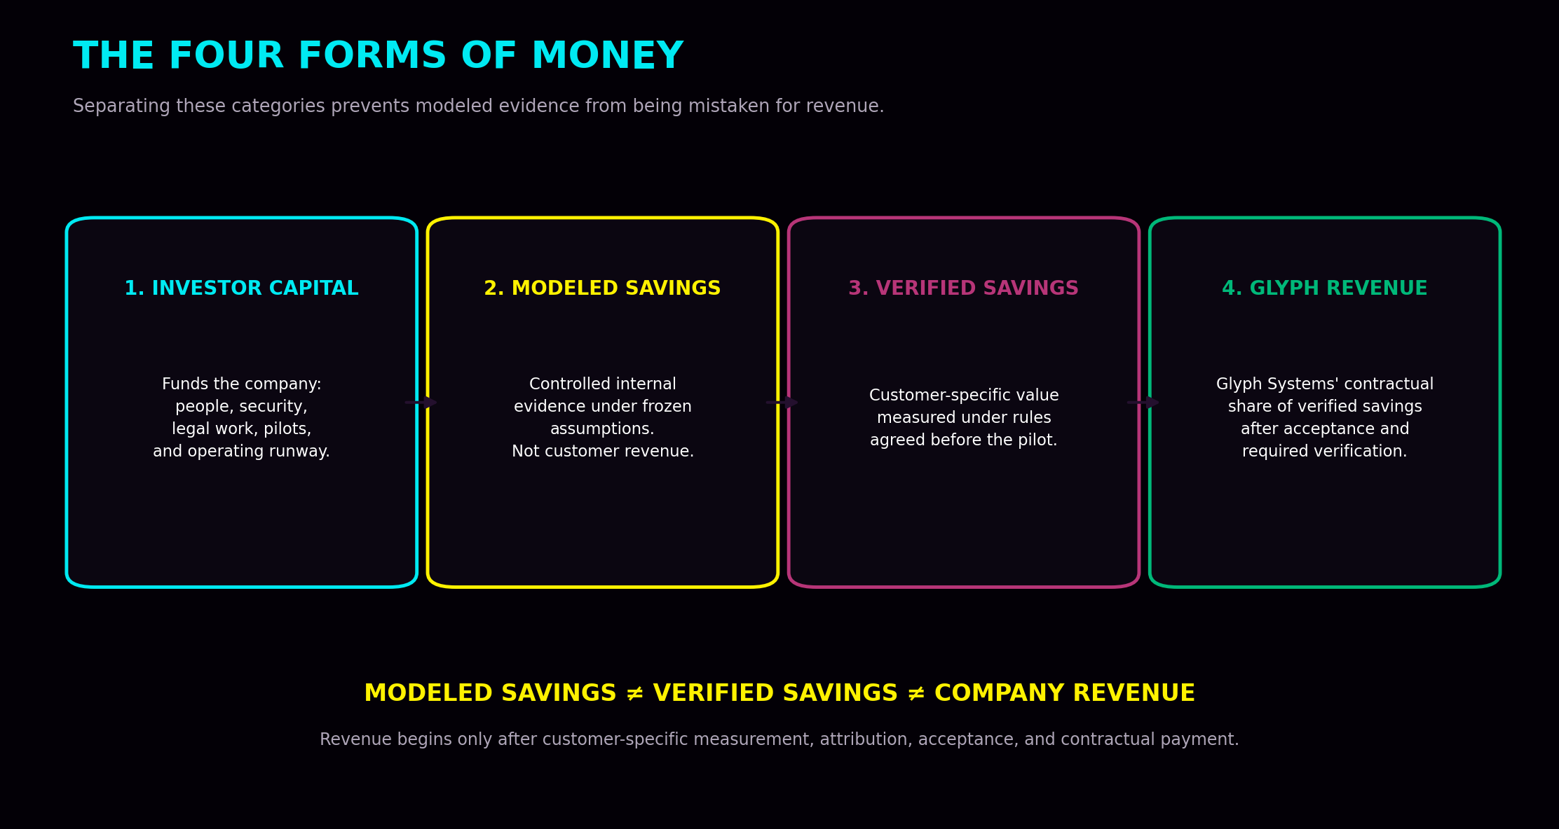
Money category | Meaning
Investor capital | Funds people, legal work, auditing, security, infrastructure, customer pilots, and operating runway. It is not customer revenue.
Internally modeled savings | Controlled evidence showing what the system may be capable of under frozen assumptions. It is not money earned.
Verified customer savings | Customer-specific financial improvement documented under measurement rules agreed before the pilot.
Glyph Systems revenue | The company's contractual share of verified customer savings after acceptance and required verification.
A credible investor presentation must never convert modeled savings directly into a revenue forecast.

4. The Revenue Contract
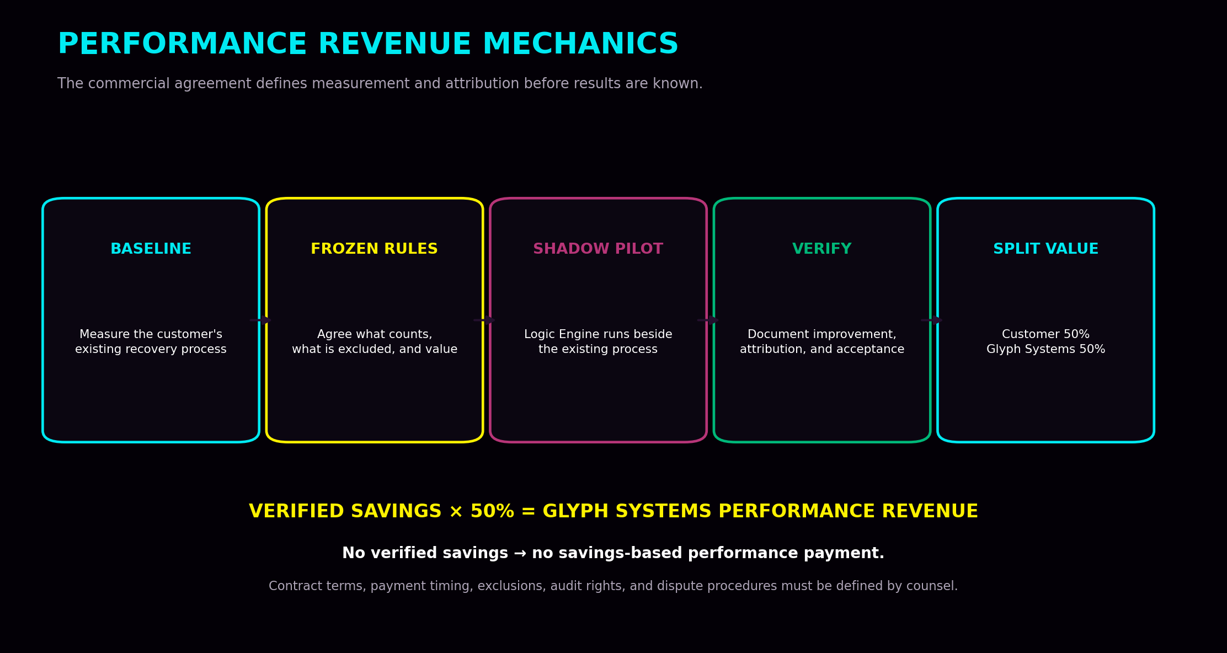

The baseline
Before Logic Engine is evaluated, the parties measure the customer's actual existing process. The baseline may include retry behavior, duplicate rate, recovery time, unresolved volume, queue behavior, stale-state problems, manual intervention, and current operating costs.

Frozen savings rules
The parties decide in advance which costs count, how each cost is calculated, the pilot period, and what qualifies as a saving. The rules cannot be rewritten after the result is known merely because one side prefers the number.

Attribution
The audit trail must connect the input condition, the customer's existing action, Logic Engine's proposed action, the operational difference, and the agreed economic value. Savings should not be attributed to Logic Engine when they came from lower volume, staffing changes, infrastructure upgrades, another tool, or unrelated external conditions.

Verification and disputes
The agreement should define raw-log access, independent review, treatment of uncertain savings, correction of measurement errors, reconciliation periods, and what happens when the parties disagree. Glyph Systems should be paid for defensible value, not numbers that cannot survive review.

Payment
Once the verified savings amount is accepted, the customer retains 50% and Glyph Systems receives 50%, subject to the final contract, invoicing, payment timing, tax treatment, and legal review.

5. Illustrative Economics
The examples below show only how the split works. They are not forecasts, promises, or evidence that a specific customer will save these amounts.
Verified customer savings | Customer retains | Glyph Systems revenue
$100,000 | $50,000 | $50,000
$1,000,000 | $500,000 | $500,000
$10,000,000 | $5,000,000 | $5,000,000
The actual customer economics depend on the customer's volume, disturbance frequency, current recovery quality, cost structure, pilot scope, measurement period, and the proportion of the observed improvement that can be defensibly attributed to Logic Engine.

6. From Investment to Revenue
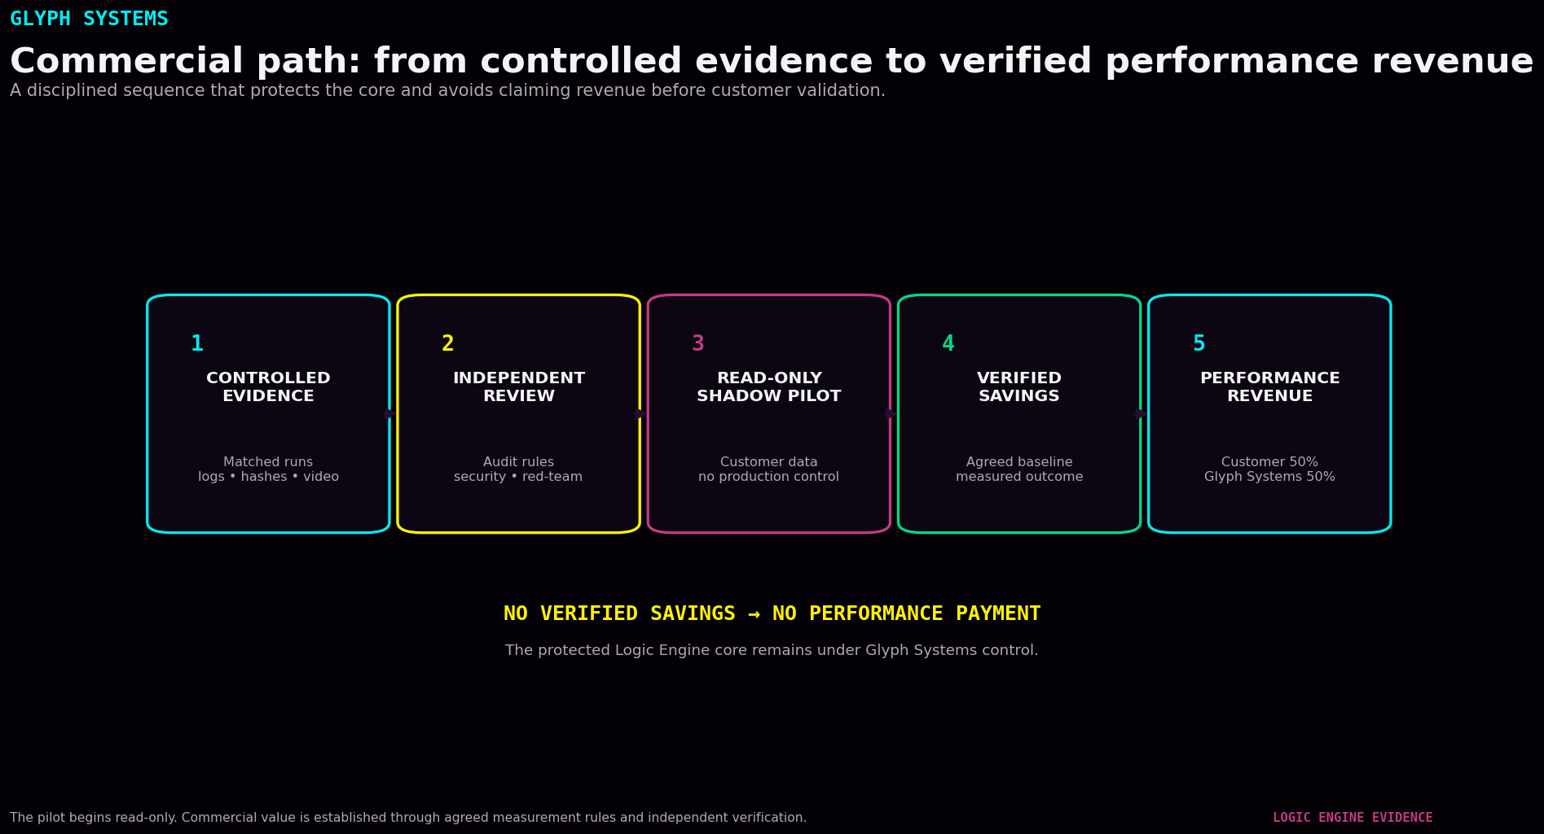
Commercial step | Purpose
1. Fund commercialization | Investment capital pays for the team, protected infrastructure, legal work, independent auditing, security testing, integrations, and runway.
2. Build the professional outer platform | A senior engineer builds customer adapters, APIs, the controlled gateway, secure communications, telemetry, dashboards, logs, monitoring, and fallback controls.
3. Establish institutional trust | Independent reviewers examine the measurement method, architecture, security boundary, savings rules, access controls, and failure behavior.
4. Qualify a pilot customer | The first customer should have measurable friction, usable data, identifiable costs, and authority to approve a controlled evaluation.
5. Agree on the rules | Scope, baseline, data boundary, cost coefficients, exclusions, attribution, duration, audit rights, and payment mechanics are frozen in advance.
6. Run read-only shadow mode | The customer's existing system remains in control while Logic Engine produces logged comparison outputs.
7. Measure and verify | The parties determine whether the difference created measurable, attributable, and accepted financial value.
8. Invoice the performance share | Glyph Systems receives its contractual share of verified savings.
9. Expand carefully | A successful customer may add transaction types, recovery functions, volume, locations, or limited production authority after new validation gates.

7. Customer Qualification
Not every company is a good first customer. The earliest customer should not necessarily be the largest institution. The best first customer is one that can make a pilot decision and measure the result clearly.
- Measurable transaction or recovery activity
- Identifiable operational friction
- Usable historical or live telemetry
- Clear operating costs or agreed cost proxies
- A controlled environment suitable for shadow testing
- Management authority to approve the measurement rules
- Willingness to provide logs and participate in verification
A poor pilot target is one with no usable baseline, no authority to approve the test, no credible cost data, or a procurement process that cannot support a controlled early-stage evaluation.

8. Revenue Recognition Discipline
The company should not count a theoretical dashboard value as revenue. For planning and investor reporting, the following stages must remain separate:
Stage | Accounting and investor meaning
Pipeline opportunity | A potential customer has been identified. No revenue should be forecast as committed.
Qualified evaluation | The customer has a measurable problem and sufficient authority and data to consider a pilot.
Contracted pilot | The parties have signed the scope, baseline, measurement rules, data boundary, and verification process.
Measured savings | The pilot has produced a customer-specific result, but it may still be subject to review or dispute.
Verified and accepted savings | The amount has passed the agreed acceptance and verification process.
Invoiced performance revenue | Glyph Systems has issued an invoice under the contract.
Collected revenue | Payment has been received by Glyph Systems.
Investor projections should be built from customer count, pilot conversion, measurement periods, verified savings, collection timing, and retention—not by multiplying one internal modeled result across an entire market.

9. How the Business Scales
The first customer is the hardest because Glyph Systems must establish security, measurement rules, deployment procedures, legal agreements, attribution, verification, and trust.
After a successful engagement, the company can reuse parts of the commercial system:
- Customer qualification criteria
- Data-intake and connector templates
- Security questionnaires and deployment controls
- Pilot agreements and frozen measurement procedures
- Audit exports and evidence packages
- Invoice and reconciliation processes
- Monitoring, support, and incident-response procedures
The protected engine remains centrally controlled while customer-facing gateways, connectors, and configurations are adapted to each customer. This creates the possibility of repeatable deployment without distributing the proprietary core.

Why future improvements matter
Major internal improvements may be described as later generations, but the customer is not expected to repurchase the engine each time. A better engine may create more verified savings. Under the performance model, the customer and Glyph Systems both benefit when verified value increases.

10. Cost Structure and Margin Logic
The physical compute cost of running Logic Engine may be small relative to the operational losses it is intended to reduce. However, the commercial cost is not merely server electricity or one Python program.
The material costs of operating the business include:
- Independent validation and security review
- Customer-specific integration and data work
- Trade-secret protection, legal agreements, insurance, and compliance
- Monitoring, logging, backups, and incident response
- Engineering, customer support, commercial operations, and verification
- Sales cycles, procurement, customer onboarding, and payment collection
Until real pilots establish integration cost, support burden, payment timing, customer retention, and required assurance work, Glyph Systems should not publish a fixed gross-margin promise.
The attractive long-term possibility is a high-value protected utility with relatively low marginal compute cost. The unproven part is the real cost of winning, integrating, validating, supporting, and retaining financial customers.

11. What Would Make the Model Fail?
A serious investor should be able to see the conditions under which the business model would not work.
Risk | How it could invalidate the business
No transferable performance | Internal results do not reproduce on customer data or against the customer's real baseline.
Savings cannot be attributed | The operational improvement cannot be separated from unrelated customer changes or external conditions.
Savings are too small | Verified value does not justify integration, security, audit, legal, and support costs.
Customer risk is too high | Financial customers will not permit the required data access or shadow deployment.
Sales cycles are too long | Procurement and review take longer than the company's available runway.
Verification disputes are frequent | The contract and measurement process do not produce accepted, collectible amounts.
The protected core cannot be secured | The gateway, infrastructure, staff access, or supply chain exposes unacceptable risk.
The team cannot productize the system | The company cannot convert founder-controlled research into a stable, supportable commercial service.
The commercialization plan is designed to test these risks early through independent review and limited pilots rather than assuming they have already been solved.

12. What Must Be Proven Before a Credible Revenue Forecast
- At least one independent review of the measurement methodology and evidence
- A secure, repeatable read-only deployment process
- A customer baseline with credible cost inputs
- A signed pilot defining attribution, exclusions, and verification
- A completed customer-specific comparison
- Accepted and collectible verified savings
- Known integration and support costs
- Evidence that the result can transfer to a second customer
Before those gates are passed, the business case is a performance-based commercialization thesis supported by controlled evidence—not a proven recurring-revenue forecast.

13. Investor Diligence Questions
Diligence question | Answer
What exactly creates the savings? | Reduced retries, duplicates, backlog, unresolved processing, failed recovery, manual remediation, or other pre-agreed operational costs.
How is the baseline protected from manipulation? | The customer's actual process and measurement window are frozen before Logic Engine results are evaluated.
How do we know Logic Engine caused the improvement? | The pilot requires an audit trail linking inputs, existing actions, Logic Engine outputs, operational differences, and agreed economic value.
Who verifies the result? | The customer and Glyph Systems review the evidence; an agreed independent reviewer may be required.
When does revenue exist? | After savings are verified, accepted, invoiced, and ultimately collected.
Why would the customer accept 50/50? | The customer keeps half of newly created value without purchasing or rebuilding the protected technology.
What protects the IP? | A separated customer gateway, protected core, controlled access, legal agreements, trade-secret processes, and independent security testing.
What is the first commercial proof? | A customer-specific shadow pilot that produces defensible, accepted, and collected performance revenue.

14. Simple Explanation
Glyph Systems does not sell Logic Engine or transfer the protected source code. Before a customer pilot begins, Glyph Systems and the customer agree on the baseline, measurement rules, attribution, exclusions, and verification process. Logic Engine then runs beside the customer's existing recovery system, initially in read-only shadow mode. If the system produces measurable and verified savings, the customer keeps 50% and Glyph Systems receives 50%. If no verified savings are produced, there is no savings-based performance payment. Better future versions can create more value for both sides without requiring the customer to repurchase the engine.

Conclusion
Glyph Systems is building a performance-based financial-recovery company. The company intends to create revenue by improving measurable customer outcomes, not by selling ownership of the protected engine or presenting internal modeled values as money already earned.
The commercial model can be summarized as a sequence of proof: qualify the customer, freeze the baseline and economic rules, run a read-only comparison, document the operational difference, verify attribution, accept the savings amount, and collect the contractual performance share.
The model becomes credible only when internal evidence is converted into customer-specific, independently defensible, collected revenue.

This document is a planning overview, not a binding offer, revenue forecast, accounting opinion, tax plan, or legal agreement. Final customer contracts, verification procedures, payment terms, risk allocation, and revenue recognition policies require qualified legal, accounting, tax, security, and customer-specific review.

