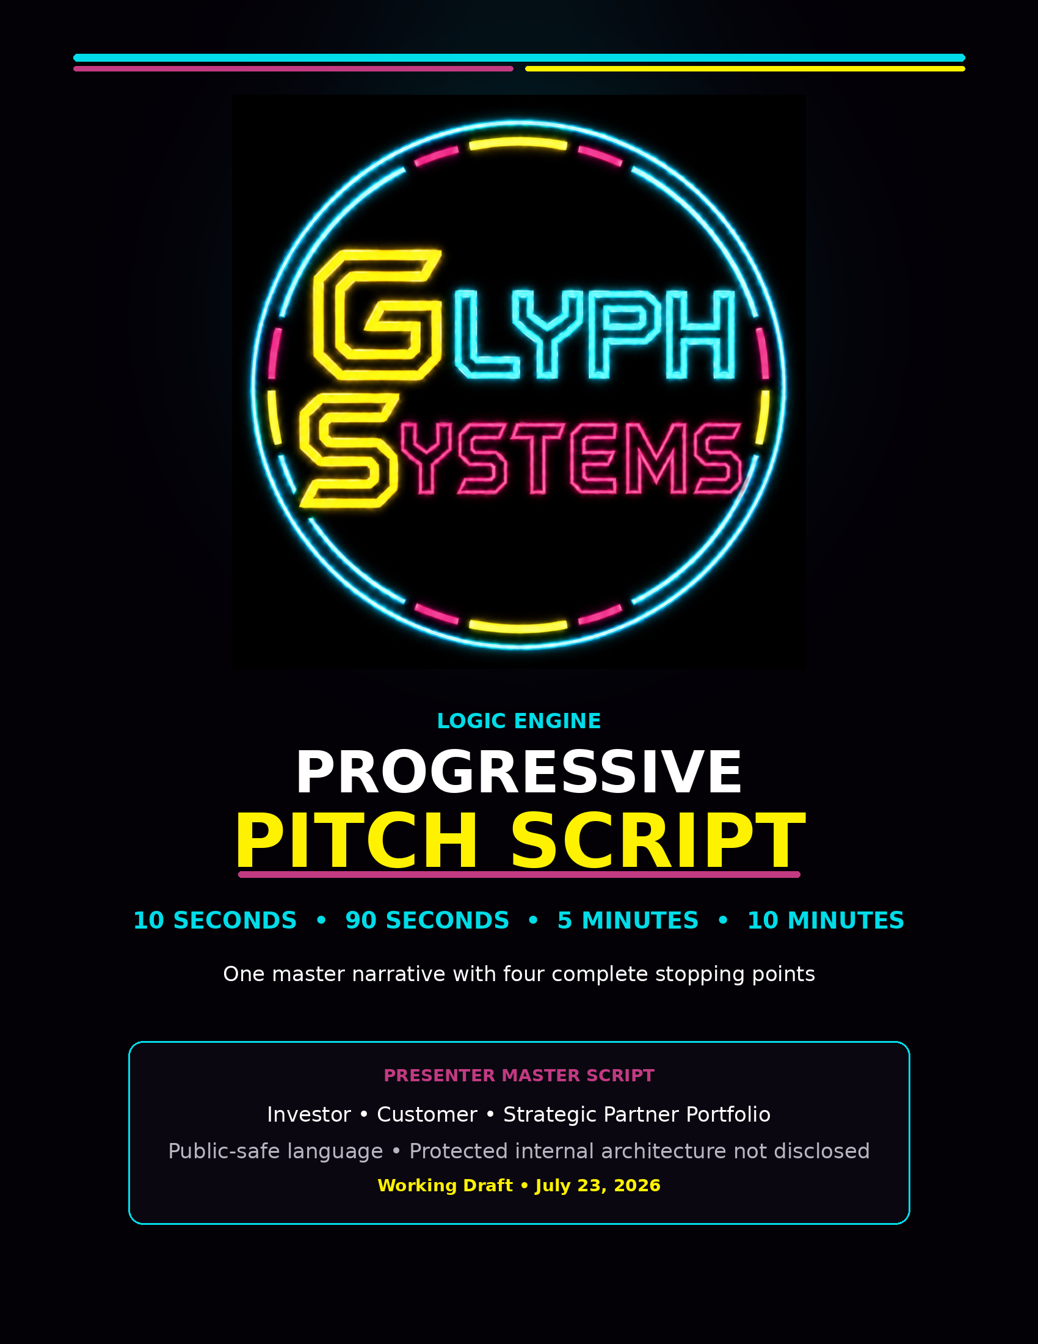

How to Use This Script

This is one cumulative pitch. Each longer version begins at the first sentence and continues forward. The presenter may stop at 10 seconds, 90 seconds, five minutes, or the full ten minutes without restarting or repeating the introduction.

Recommended speaking pace: approximately 145–155 words per minute, with brief pauses at each stopping point.
Cumulative Time | Section | What the Listener Receives
10 seconds | Core Promise | What Logic Engine is, the problem it addresses, and the outcome-aligned payment model.
90 seconds | Product + Revenue Model | The customer problem, read-only shadow deployment, independent measurement, and 50/50 verified-savings split.
5 minutes | Evidence + Commercial Path | Controlled testing, evidence boundaries, customer baseline, shadow pilot, verification, and first revenue.
10 minutes | Full Investment Case | Protected deployment architecture, market, team, funding, milestones, and investment-to-revenue path.

The stopping-point sentences are part of the script. They give the presenter a natural close when time is limited. When more time is available, the presenter simply continues into the next section.

0:00–0:10 | 10-SECOND PITCH  BEGIN HERE • COMPLETE AT 10 SECONDS OR CONTINUE

Glyph Systems built Logic Engine, a protected financial-recovery system that reduces transaction delays, duplicate processing, retry waste, and operational losses—and gets paid only from independently verified savings.

STOPPING POINT
That is Logic Engine in ten seconds.

0:10–1:30 | CONTINUE TO 90 SECONDS  READ THE 10-SECOND OPENING FIRST • THEN CONTINUE HERE

Financial systems rarely fail in one dramatic moment. More often, losses build quietly through delayed transactions, lost acknowledgements, repeated retries, duplicate actions, growing queues, stale information, and slow recovery.
Logic Engine is designed to watch those changing conditions, preserve the state history that matters, and improve how a financial operation responds when normal flow begins to break down.
The first customer deployment would be read-only. Logic Engine would operate beside the customer’s existing process rather than replacing it or taking control of customer funds. Both systems would receive the same approved conditions, and the measurement rules would be agreed upon before the test begins.
We would compare recovery time, duplicate processing, retry volume, unresolved transactions, queue pressure, and measurable financial loss. An independent reviewer would verify the accepted result.
When verified savings are produced, the customer keeps 50 percent and Glyph Systems receives 50 percent. The customer does not buy an unproven promise. Glyph Systems earns revenue by producing a measurable result.
STOPPING POINT
That is the product, the customer, and the commercial model.

1:30–5:00 | CONTINUE TO FIVE MINUTES  READ EVERYTHING BEFORE THIS SECTION • THEN CONTINUE HERE

The reason we believe this deserves commercial validation is that Logic Engine has already completed a growing body of controlled matched testing.
These tests were not customer deployments, and the modeled savings were not customer revenue. They were designed to answer a narrower and important question: when Logic Engine and a strong comparison system face the same conditions, does Logic Engine recover with less operational friction?
The testing progressed in stages. We began with short calibration runs to confirm that the measurement system, logging, and comparison rules behaved correctly. We then moved into longer endurance tests representing small payment-processing environments, medium financial-processing environments, high-volume transaction networks, and high-value treasury and payout scenarios.
Some runs exceeded 60 hours. Others exceeded 150 hours. The purpose was not to create one exciting screenshot. The purpose was to see whether the advantage remained present through ordinary operation, pressure events, recovery periods, negative rounds, and long-duration use.
Logic Engine did not win every individual moment, and we do not hide the negative rounds. The important questions were whether the average result remained positive, whether the system recovered more effectively, and whether every conclusion could be traced back to its source.
Every serious run preserves an evidence chain: the source and classification of the input, the frozen configuration, the run identifier and deterministic seed, the matched comparison rules, raw logs and structured data, final reports, screenshots, videos, and hashes showing that the evidence was preserved.
That boundary matters. Glyph Systems is not claiming that controlled testing guarantees customer savings. The testing shows a repeated signal strong enough to justify independent review and an authorized customer shadow pilot.
The commercial path is deliberately staged.

First, we select a customer with measurable transaction-recovery friction. That could be a payment processor, treasury operation, payout platform, financial-infrastructure provider, or another organization handling large volumes of time-sensitive transactions.
Second, we establish the customer’s normal baseline. Before the pilot begins, we agree on what counts as a delay, duplicate, retry, unresolved event, recovery cost, or avoided loss.
Third, Logic Engine is connected through a controlled customer-facing node. The protected core remains isolated, while approved data moves through a limited, logged, and auditable interface.
Fourth, the system runs in shadow mode. The customer continues operating normally while Logic Engine produces its own recovery decisions and measurements beside the existing process.
Fifth, the result is independently reviewed. Only accepted and documented savings become billable.
Measure the existing loss.
Run Logic Engine beside the existing system.
Verify the difference.
Split the accepted savings 50–50.

The customer receives lower operational loss without purchasing the protected core. Glyph Systems retains ownership of its technology and earns performance revenue.
Once the measurement process, security controls, customer connector, and deployment method are proven with the first customer, the same structure can be adapted for additional customers and transaction environments.
The larger opportunity is not simply another dashboard. Logic Engine is intended to become a protected recovery utility that financial systems can use when transaction flow becomes delayed, duplicated, unstable, or expensive.
The work completed so far gives Glyph Systems a controlled evidence base. The next stage is to convert that evidence into independent validation, secure customer integration, and the first collected performance revenue.
STOPPING POINT
That is the evidence, the customer deployment path, and the route from controlled testing to verified revenue.

5:00–10:00 | CONTINUE TO THE FULL TEN MINUTES  READ EVERYTHING BEFORE THIS SECTION • THEN CONTINUE TO THE FULL CLOSE

To reach that stage, the company is being designed around a small protected core and a larger conventional commercial shell.
The protected Logic Engine remains inside a private environment. Customer-facing regional nodes can be positioned near approved customer infrastructure to reduce latency, improve responsiveness, and create cleaner operational isolation. Those nodes handle authentication, approved data intake, logging, rate limits, tenant separation, and controlled delivery of results. They do not contain the protected internal architecture.
This design does not make the system unhackable, and we will never present it that way. It reduces the exposed surface and limits the damage that a public-facing failure could cause. Before customer use, the architecture still requires professional code review, penetration testing, gateway and tenant-isolation testing, incident-response planning, backup and recovery validation, and independent review of the measurement model.
The immediate market is made up of organizations where small recovery improvements can become meaningful at scale: payment processors, treasury and payout systems, transaction networks, settlement operations, and financial platforms managing large volumes of delayed, retried, duplicated, or unresolved activity.
Glyph Systems does not need to replace those systems. It needs to prove that it can sit beside them, recognize costly recovery patterns, and produce decisions that reduce measurable loss.
That creates several advantages for the customer.
The pilot begins read-only, so the customer can test the value without handing over operational control. The measurement rules are frozen in advance, so Glyph Systems cannot redefine success after seeing the result. Independent verification protects both sides. Performance-based pricing aligns the company’s revenue with customer benefit. And the protected core is delivered as an operated utility rather than sold or licensed as a recipe.
The first collected payment is the most important commercial milestone. It proves not merely that a model produced an interesting number, but that a real customer accepted the measurement, accepted the benefit, received an invoice, and paid it.
From there, the company’s focus shifts from proving one result to proving repeatability: a second customer, a second approved integration, recurring performance revenue, stronger security controls, and a deployment process that can be repeated without exposing the core.
Glyph Systems is preparing to raise approximately $3.5 million to fund an 18-month commercialization runway.

That capital is not being raised to continue brainstorming indefinitely. It is intended to convert the existing evidence into a protected, independently reviewed, customer-ready platform.
A substantial portion funds the specialized leadership, commercial, and deep-technology team required to protect, validate, integrate, and commercialize Logic Engine. The initial structure includes the founder and chief architect, a chief business officer focused on strategic partnerships, a head of commercial operations responsible for pipeline and pilot execution, and a principal Logic Engine engineer responsible for protected implementation, reliability, integration, and technical documentation.
The round also funds independent validation and security work; trade-secret, legal, compliance, accounting, and insurance support; infrastructure and productization; customer pilots and integrations; specialist contractors and quality assurance; business development; and contingency.
The 18-month milestones are clear.

First, protect the intellectual property and formalize the company, governance, security boundaries, and customer contracts.
Second, build and harden the commercial platform: the protected core, customer-facing node, authentication, encryption, logging, kill controls, monitoring, customer adapters, evidence preservation, and deployment procedures.
Third, complete independent architecture, measurement, code, and security reviews.
Fourth, secure an authorized customer, establish the baseline, run the read-only shadow pilot, and obtain independent acceptance of the measurement.
Fifth, invoice and collect the first performance revenue.
Sixth, convert the first successful deployment into a repeatable commercial process with additional customers and recurring revenue.
The investment-to-revenue path is therefore direct:

Investment Capital → Protected Commercial Platform
Protected Platform → Customer Shadow Pilot
Shadow Pilot → Independently Verified Savings
Verified Savings → Collected Performance Revenue
Repeatable Revenue → Investor Return Mechanism

The exact investor return structure—equity, debt, convertible financing, or a negotiated combination—will be established in the financing documents. We will not use vague language such as ‘the investor gets paid off’ until that structure is selected. What matters at this stage is that the operating plan connects capital to measurable milestones and collected revenue.
The company’s long-term opportunity is larger than a single pilot. A protected financial-recovery utility can be deployed across multiple transaction environments, while the core remains centrally protected and each customer receives an isolated, approved interface.
But the near-term objective is disciplined and measurable: protect the system, validate the evidence, earn the first customer’s trust, produce accepted savings, collect the first payment, and repeat the process.
Glyph Systems has already completed the difficult early transition from an idea to a working body of controlled evidence. The next transition is from controlled evidence to independent validation and real customer revenue.
We are not asking investors to accept a guaranteed outcome. We are asking them to fund a structured commercialization program around a repeatable signal, a protected architecture, a performance-aligned business model, and a clear path to verification.
Logic Engine is designed to help financial systems recover with better judgment when normal transaction flow begins to break down. Glyph Systems succeeds only when the customer can measure the difference.
That is the full Glyph Systems investment case: protect the core, prove the result, share the verified value, and build a repeatable financial-recovery utility.
STOPPING POINT
That is the full Glyph Systems investment case.

Presenter Boundaries

NOT PART OF THE TIMED PITCH

Controlled evidence, not customer revenue. The long-duration runs support commercial validation. They do not represent realized customer savings or guaranteed outcomes.
Public product language only. Use state history, recovery, retries, duplicates, queues, latency, operational friction, and measurable financial loss. Do not disclose protected internal geometry or origin architecture.
Read-only first deployment. Logic Engine operates beside the customer system during the initial pilot. It does not take control of funds or replace the existing operation.
Independent measurement. Measurement rules are agreed in advance. Only accepted, independently reviewed savings become billable.
50/50 commercial model. The customer keeps 50 percent of accepted savings and Glyph Systems receives 50 percent. This is company revenue, not personal founder income.
Funding language. The approximately $3.5 million raise is a working commercialization target for an 18-month runway. Final financing terms and investor return mechanics remain subject to negotiation and legal documentation.
Core close: Protect the core. Prove the result. Share the verified value. Build a repeatable financial-recovery utility.

