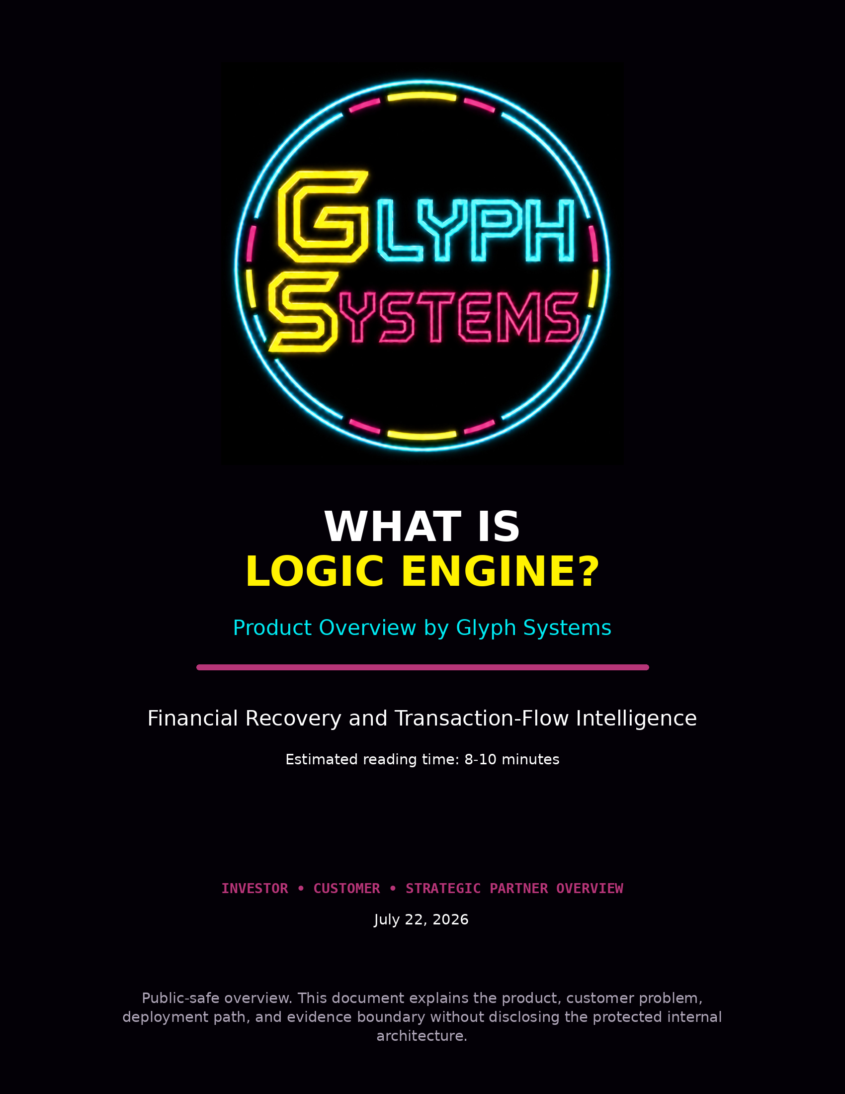

What Is Logic Engine?
Logic Engine by Glyph Systems is a proprietary financial-recovery and transaction-flow intelligence system. It is designed to help payment and financial operations respond more intelligently when transactions are delayed, acknowledgements are lost, queues grow, retries increase, information becomes stale, or services become unstable.
The product does not replace a bank, payment processor, ledger, exchange, treasury platform, or settlement network. It works alongside existing infrastructure as a recovery-decision layer. Its purpose is to reduce avoidable operational friction by improving the judgment used during disruption and recovery.
In one sentence: Logic Engine helps a financial system recover with better judgment instead of reacting to every problem in the same way.

1. Company and Product Identity
Name | Meaning
Glyph Systems | The company that owns, protects, develops, validates, and commercializes the technology.
Logic Engine by Glyph Systems | The customer-facing financial-recovery and transaction-flow product.
Spiral Logic | The protected internal architecture. This term is not normally required in public explanations.
Glyph | The brand meaning is simple: a shape with meaning. The name reflects a system that turns changing operational patterns into useful decisions.
Public explanations should remain conventional and outcome-focused. Customers and investors need to understand the problem, the approved inputs, the outputs, the security boundary, the evidence, and the commercial path. They do not need access to the protected internal mechanism.

2. The Problem Logic Engine Addresses
Large financial and transaction systems are designed to process work efficiently when conditions are normal. The harder problem is what happens when conditions are uncertain.
- A transaction may be delayed without being lost.
- An acknowledgement may disappear even though the original instruction completed.
- A queue may temporarily grow faster than the system can process it.
- A service may slow down, pause, or partially recover.
- State information may be outdated or contradictory.
- A retry may be necessary in one situation and harmful in another.
Traditional recovery rules often use fixed responses: wait a certain amount of time, retry a fixed number of times, reject the item, move it to another queue, or mark it unresolved. Those rules can be useful, but they may not fully account for how the entire operating condition is changing.
The same visible event can require a different response depending on recent history, direction, acknowledgement certainty, queue behavior, and recovery progress.

3. What Logic Engine Actually Does
Logic Engine receives approved operational signals from the surrounding system. It evaluates those signals across time, rather than treating each event as an isolated incident. It then returns controlled recovery information or recommendations.
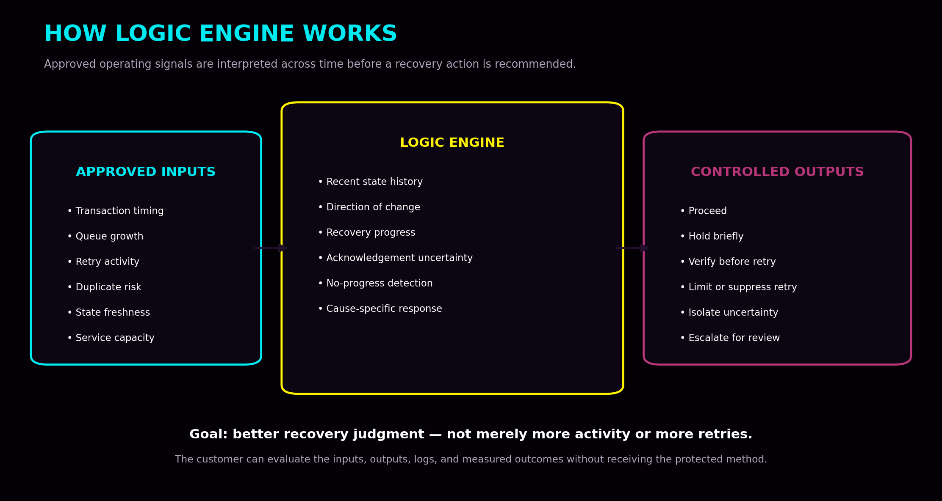

Core operating principle
Many recovery systems primarily ask, “What happened?” Logic Engine adds context by asking:
- What has been happening?
- What direction is the system moving?
- Has this action already been attempted?
- Did the previous action improve the condition?
- Is the system recovering, degrading, or remaining stuck?
- Could the apparent failure be an information problem rather than a transaction failure?
That additional context is intended to improve the quality of recovery decisions under uncertainty.

4. Inputs, Outputs, and Recovery Functions
Approved signal category | Examples
Transaction flow | Timing, transaction state, completion, acknowledgement status, retries, duplicate or idempotency status.
Queue behavior | Current depth, direction of change, age, throughput, waiting time, and capacity limits.
Service condition | Availability, latency, error rates, degraded components, processing capacity, and recovery status.
State quality | Freshness, version mismatch, missing acknowledgements, contradictory status, and repeated no-progress events.
Recovery history | Action taken, timing, outcome, and whether the action improved or worsened the condition.

Potential outputs
- Proceed with normal flow
- Hold briefly while uncertainty clears
- Verify before retrying
- Retry under defined limits
- Suppress duplicate action
- Isolate an uncertain transaction
- Release previously held work
- Continue monitoring
- Escalate for human review

Primary recovery functions
Function | Purpose
Retry control | Distinguishes between a genuine need for another attempt, an acknowledgement problem, a stale-state problem, a service that needs time to recover, and a repeated action that is no longer producing progress.
Duplicate suppression | Uses acknowledgement history, timing, transaction state, retry sequence, and idempotency information to reduce unnecessary duplicate work. It complements proper idempotency controls; it does not replace them.
Queue stabilization | Tracks whether a queue is growing, shrinking, blocked, overloaded, or recovering. The objective is controlled recovery rather than simply processing as aggressively as possible.
Stale-state management | Recognizes when available information may be outdated, incomplete, or inconsistent and can recommend verification, delay, isolation, or limited retry behavior.
No-progress-cycle detection | Identifies repeated actions that consume time or compute without materially improving the operating condition.
Adaptive state retention | Preserves a limited amount of verified recent context so the system does not repeatedly relearn the same condition. Retained state must remain controlled, auditable, resettable, and protected.

5. Why This Matters Financially
Operational failure is expensive even when no money is directly stolen. Financial value can be lost through:
- Excessive retries and duplicate remediation
- Growing queues and delayed settlement
- Unresolved processing and failed recovery
- Manual investigation and reconciliation
- Infrastructure strain and repeated no-progress work
- Customer complaints, compensation, and service-level penalties
- Employee time and incident-response overhead
Logic Engine is designed to reduce some of this avoidable waste. The financial value does not come from predicting markets or trading money. It comes from helping an existing operation handle disruption more effectively.
The product is designed to recover value that is currently being lost through operational friction.

6. What Logic Engine Is Not
Boundary | Meaning
Not a payment processor | Works beside existing financial infrastructure; it does not replace it.
Not a trading or prediction system | Does not predict prices, choose exchanges, speculate, or profit from market movement.
Not unrestricted control over money | Begins read-only; the customer retains control of funds and production systems.
Not a guaranteed-savings promise | Controlled results justify further testing; they do not promise the same outcome for every customer.
Not a public source-code license | Customers receive a protected service and measurable outputs—not ownership of the core.
Not a replacement for auditing | Independent technical, security, and financial review remains required.

7. Safe Customer Introduction
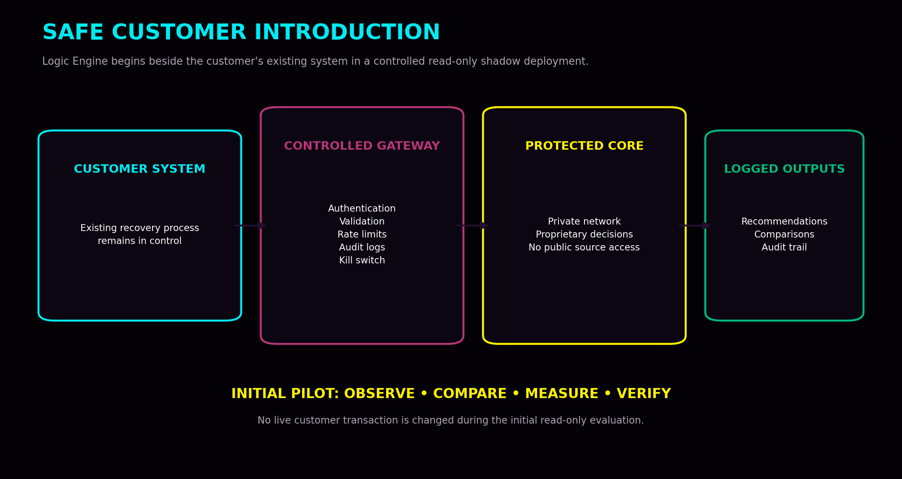

Stage 1 — Historical or synthetic evaluation
The customer provides approved historical or synthetic data. Logic Engine processes the data in an isolated environment. No production access is required.

Stage 2 — Read-only shadow pilot
The customer’s existing system remains in control. Logic Engine observes approved signals, produces its own recovery outputs, and logs those outputs for comparison. It does not initially change live transactions.

Stage 3 — Independent validation
Before active use, the system may require architecture review, code review, penetration testing, financial-model validation, failure-mode testing, privacy review, logging review, and legal protection of the trade secret.

Stage 4 — Limited production authority
Only after successful validation would Logic Engine receive narrowly defined authority, such as one transaction category, one recovery function, capped volume, automatic fallback, and immediate customer kill-switch access.
Logic Engine should never begin with unrestricted authority.

8. Controlled Evidence Produced So Far
Glyph Systems has developed matched recovery harnesses in which Logic Engine and comparison controllers receive the same workload, disruption schedule, service conditions, capacity limits, queue limits, retry conditions, and frozen financial assumptions.
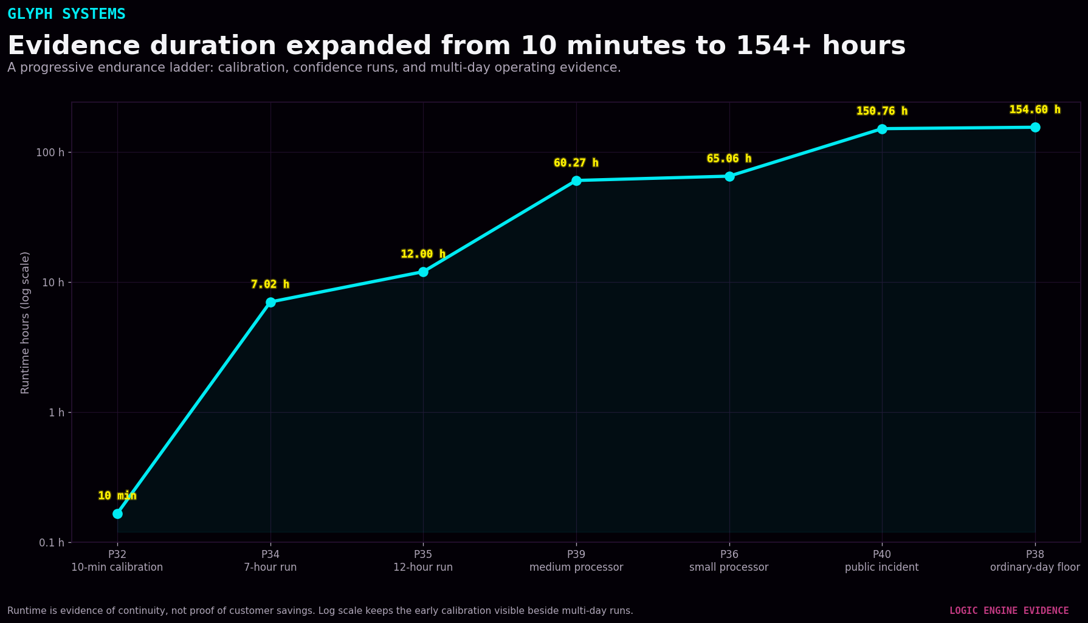
Evidence layer | What it demonstrates
Program 32 — 10-minute calibration | Lower duplicate conflicts and backlog, retries within 5% of the strong baseline, and lower modeled operational loss under a fixed dense-fault workload.
Program 34 — 7.02 hours | 42 independent complete rounds; all positive inside the controlled model.
Program 35 — 12.00 hours | 72 independent complete rounds; all positive; continuous public video record exists.
Program 36 — 65.06 hours | 390 complete rounds in a small-payment-processor profile; no negative complete rounds.
Program 39 — 60.27 hours | 361 complete rounds in a medium-financial-processor profile; 359 positive rounds.
Program 38 — 154.60 hours | 927 complete rounds in an ordinary-day floor profile; 917 positive rounds.
Program 40 — 150.76 hours | 904 complete rounds in a public-incident-driven profile; 902 positive rounds.
Long duration matters because a commercially useful system must be evaluated across ordinary operation, elevated pressure, severe incidents, weak rounds, and negative tails—not only the strongest moment.

9. A Technical Example of Improvement
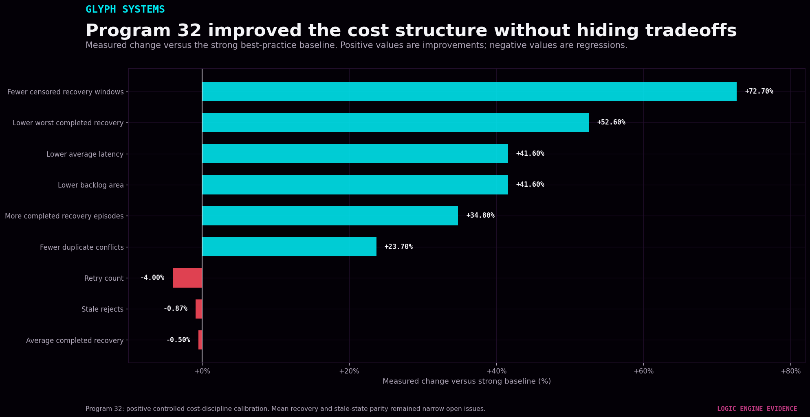
Program 32 was designed to test whether Logic Engine could preserve low latency and low backlog while reducing the duplicate and retry churn seen in earlier calibration work. Against the strong comparison controller, the full Program 32 system showed:
- 23.7% fewer duplicate conflicts
- 41.6% lower average transaction latency
- 41.6% lower accumulated backlog area
- 52.6% lower worst completed recovery duration
- More completed recovery episodes and fewer censored recovery windows
- Retry activity within the predefined 5% tolerance
The same run also preserved mixed evidence: stale rejects were slightly above the strong comparison, and the simple average of completed recovery episodes was approximately 0.5% slower. Those results remain visible because negative or mixed findings are part of a credible evidence record.

10. Current Evidence Boundary
Evidence level | Meaning
Level 1 — Controlled evidence | Internal matched tests in controlled environments. This level exists now.
Level 2 — Independently validated evidence | Outside review confirms the design, measurements, assumptions, boundaries, and reporting.
Level 3 — Customer-verified savings | A customer test under agreed rules confirms real operational savings in that environment.
Glyph Systems is currently building the path from Level 1 toward Levels 2 and 3.
Controlled modeled savings are not customer revenue, guaranteed future performance, or money already earned.

11. Where Logic Engine Fits
The strongest early customers are not necessarily the largest financial institutions. The best initial customer is one with a measurable problem, usable telemetry, clear operating costs, and authority to approve a controlled pilot.
- Payment processors and transaction platforms
- Treasury and payout systems
- Settlement and reconciliation operations
- Financial infrastructure and fintech providers
- High-volume transaction networks
- Organizations with measurable retry, duplicate, queue, and recovery costs
Logic Engine does not need to replace the customer’s existing systems to create value. It may create value by improving decisions during the moments when those systems are uncertain, overloaded, delayed, or recovering.

12. What the Customer Receives
- A defined input contract and controlled customer-facing gateway
- Timestamped and logged recovery outputs
- Read-only historical or live shadow evaluation
- Comparison against the customer’s actual existing process
- Agreed operational and financial measurement rules
- Independent validation where required
- A measurable result without receiving the protected source code
The customer buys access to a protected recovery capability and a measurable outcome. Glyph Systems retains ownership of the engine, internal architecture, future improvements, and proprietary decision process.

13. One-Minute Explanation
Logic Engine by Glyph Systems is a proprietary financial-recovery and transaction-flow system. It helps payment and financial operations respond more intelligently when transactions are delayed, acknowledgements are lost, queues grow, retries increase, or services become unstable. Instead of treating every disruption the same way, it tracks how conditions are changing and helps control retries, duplicates, stale information, unresolved processing, and recovery decisions. The goal is to reduce measurable operational waste. We begin in a read-only shadow environment, compare the results against the customer’s existing process, and only count savings that are agreed upon and independently verified.

Conclusion
Logic Engine is a stateful adaptive recovery system designed to improve decision quality under operational uncertainty. It evaluates transaction-flow conditions across time, rather than reacting only to isolated events. It is designed to improve retry decisions, reduce duplicate conflicts, identify stale information, stabilize queues, recognize repeated no-progress behavior, and improve recovery completion.
The current controlled evidence supports the next stage: independent technical and security review followed by an authorized read-only customer shadow pilot. The protected decision architecture remains isolated. Commercial value must be established through secure deployment, frozen measurement rules, independent validation, and verified customer results.
The product promise is not unlimited automation. It is better recovery judgment, measured honestly and introduced safely.

This overview is informational and does not constitute a guarantee of performance, a financial projection, a security certification, or a substitute for customer-specific technical, legal, financial, and regulatory review.

