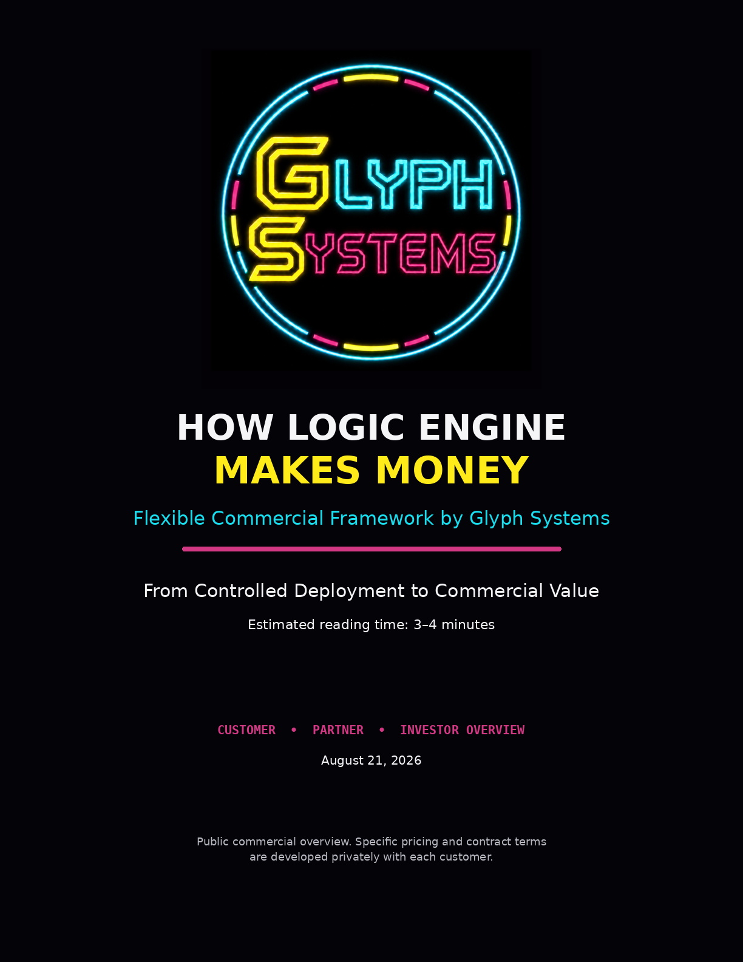

How Logic Engine Makes Money
Glyph Systems is commercializing Logic Engine through customer-specific agreements built around controlled deployment, measurable operational improvement, and clearly defined commercial terms.
The public model is intentionally simple: customers evaluate Logic Engine in an agreed operational setting, the parties measure what changes, and any commercial relationship is negotiated around the deployment, validation process, risk, support requirements, and value created.
Commercial principle
Glyph Systems does not publish a fixed percentage, universal fee, or one-size-fits-all pricing formula. Specific terms are developed privately with each customer.

1. What the Customer Is Buying
The customer is not buying the protected source code or ownership of Logic Engine. The customer is buying access to a controlled financial-recovery capability and the professional deployment, measurement, and support surrounding it.
• A controlled evaluation against the customer’s existing operation
• A defined input, data, and security boundary
• Read-only or shadow deployment when appropriate for the first stage
• Agreed measurement and review procedures
• Customer-specific integration, monitoring, and operational support
• Access to future improvements under the terms of the commercial relationship
Glyph Systems retains ownership of Logic Engine, its protected source code, internal architecture, proprietary methods, and future improvements.
2. How the Commercial Relationship Develops
QUALIFY  Confirm the operational lane and fit. | DEFINE  Set scope, access, controls and measurement. | DEPLOY  Run in the agreed environment. | REVIEW  Measure operational difference and value. | AGREE  Apply the negotiated commercial terms.

This sequence keeps the commercial discussion connected to a real customer environment instead of forcing a public pricing formula onto every organization before the deployment is understood.

3. How Terms Are Set
Commercial terms can vary because customers vary. A small controlled pilot, a larger payment operation, a treasury environment, or a deeper production integration may create very different security, integration, support, verification, and risk requirements.
Before work begins, the parties can define the items that matter for that deployment:
• Operational scope and data access
• Baseline and measurement method
• Security and deployment responsibilities
• Validation and review process
• Integration and support requirements
• Commercial structure, invoicing, and payment timing
• Expansion, renewal, or deeper-integration options
Why keep the terms flexible?
Because the goal is to build a structure that fits the customer, the deployment, and the value created — not to negotiate every future contract inside a public portfolio.

4. When Revenue Becomes Real
Internal modeled testing is evidence of development and system behavior. It is not customer revenue. A commercial opportunity becomes meaningful only when a customer relationship moves through real deployment, agreed evaluation, contractual obligations, invoicing, and collection.
• Internal test: development evidence only
• Customer evaluation: real operational comparison, not automatically revenue
• Commercial agreement: terms and obligations are defined
• Invoice: the contract has triggered a billable amount
• Collected revenue: payment has been received by Glyph Systems
5. Why the Model Can Scale
Logic Engine is intended to remain a centrally protected capability while customer-facing integrations, controls, configurations, and support can be adapted to each deployment. As the company completes real customer work, reusable deployment and commercial infrastructure can reduce the friction of later engagements.
The long-term business is therefore not based on selling copies of a static program. It is based on deploying a protected recovery capability, improving it over time, and building durable customer relationships around measurable operational performance.

6. Simple Explanation
In one sentence
Logic Engine is offered through flexible, customer-specific commercial agreements designed around the deployment, validation process, and value created.

The company’s commercial objective is straightforward:
• Identify operational friction or recoverable loss.
• Run Logic Engine in a controlled customer environment.
• Measure what changes under agreed rules.
• Establish commercial terms appropriate to the customer and deployment.
• Expand only when the evidence and customer relationship justify it.
7. What This Document Does Not Do
This public overview does not set a universal percentage, guarantee a customer outcome, forecast revenue from internal testing, or bind Glyph Systems to a single pricing structure. Those decisions belong in customer-specific commercial agreements developed with appropriate legal, accounting, security, and operational review.
Conclusion
Glyph Systems intends to make money by commercializing Logic Engine as a protected financial-recovery capability. The company will keep public pricing flexible, evaluate real customer deployments under agreed rules, and develop commercial terms that fit the specific relationship rather than publishing a rigid formula in advance.
Find the loss. Restore the flow.
Logic Engine by Glyph Systems — Financial Recovery System

