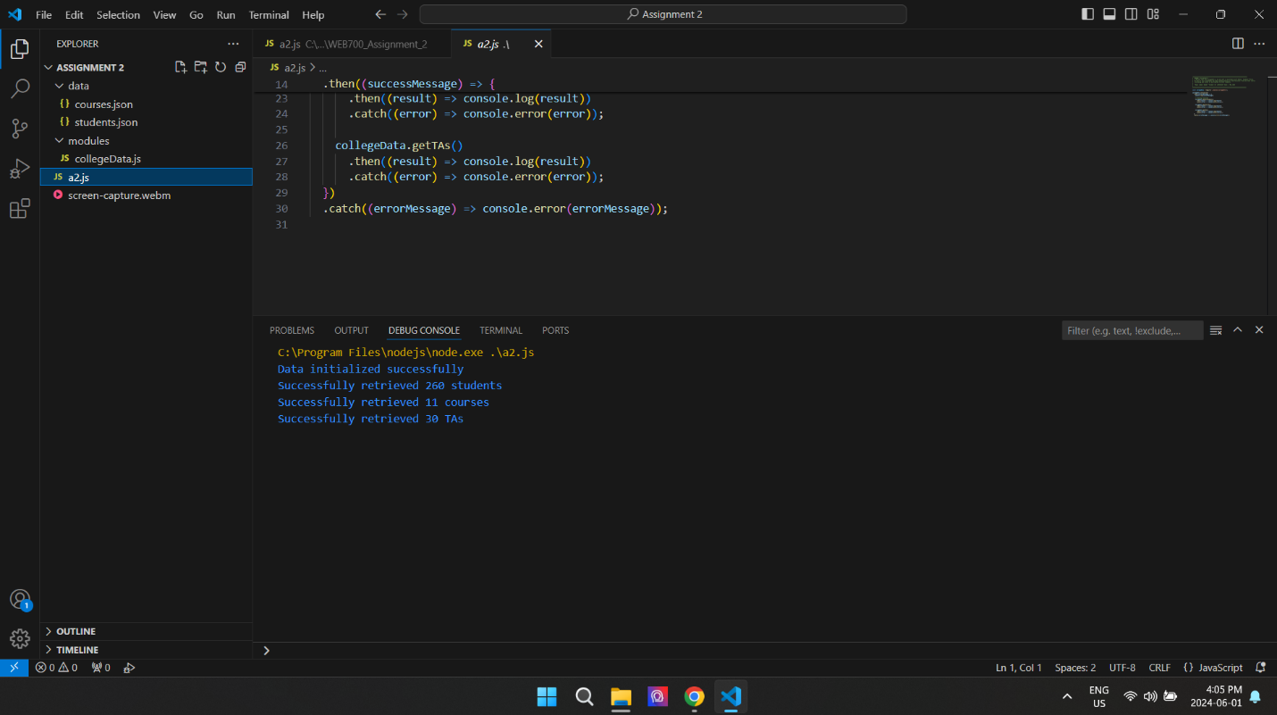

Github repo: https://github.com/GmSabbirAhmed/Assignment-2.git