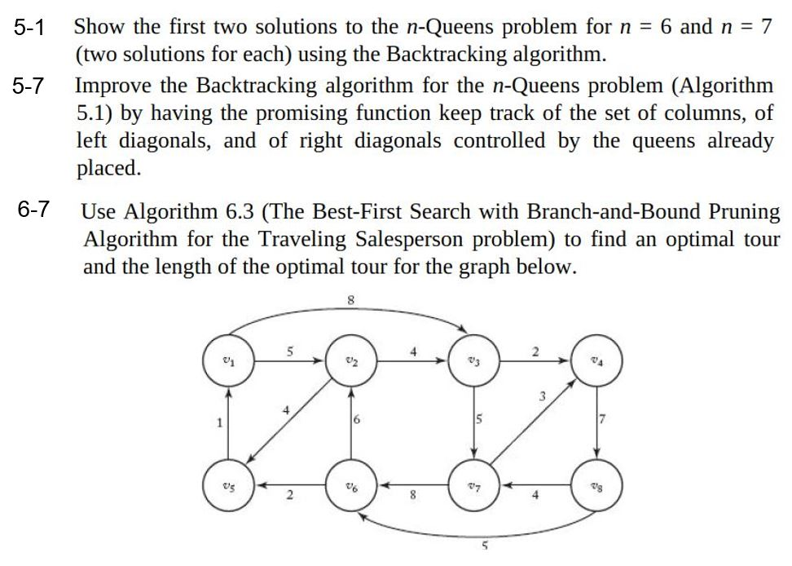

N=6:

<1, 2>, <2, 4>, <3, 6>, <4, 1>, <5, 3>, <6, 5>

<1, 3>, <2, 6>, <3, 2>, <4, 5>, <5, 1>, <6, 4>

N=7

<1, 1>, <2, 3>, <3, 5>, <4, 7>, <5, 2>, <6, 4>, <7, 6>

<1, 1>, <2, 4>, <3, 7>, <4, 3>, <5, 6>, <6, 2>, <7, 5>

bool promising (index i)

{

index j;

bool switch;

j=1;

switch = true;

while (j<i && switch == true){

if(vindex[i]==vindex[j] || abs (vindex[i] - vindex[j])==i-j || vindex[i] == -69 || vindex[j]== -69){

vindex[i] = -1;

vindex[j] = -1;

switch = false;

j++

}

return switch;

}

}



**Min Length : 32**

**Path: [v1,v2,v3,v7,v4,v8,v6,v5,v1]**

First min length found=32

[1,3] still feasible

Childs of [1,3] lower than min length

Algorithm ends