**PD group**

**Observed Chao1 Shannon Simpson**

**p.value 0.1860148 0.3241064 0.3632941 0.7691126**

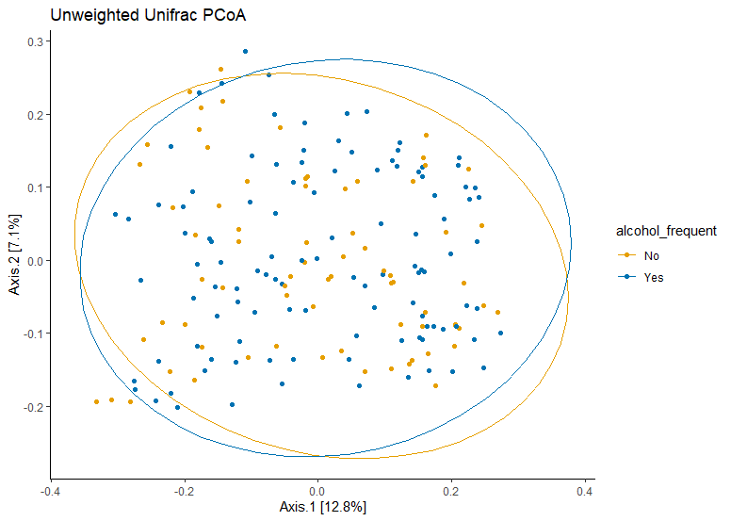

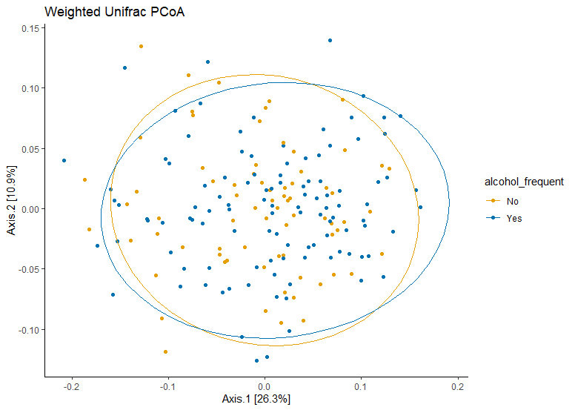

**metric p.value**

**1 canberra 0.506**

**2 unweighted-UniFrac 0.801**

**3 weighted-UniFrac 0.363**

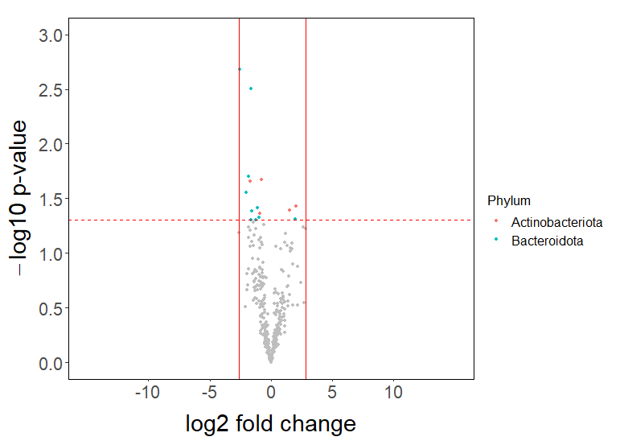

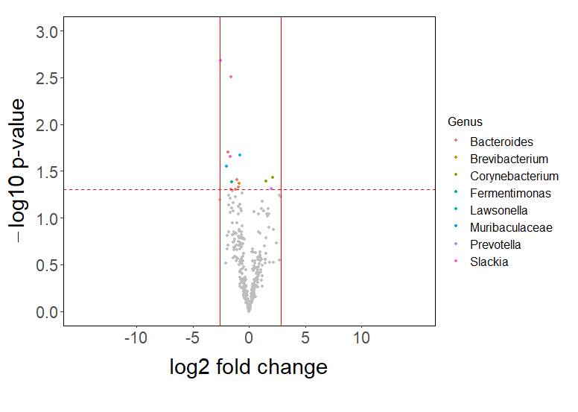

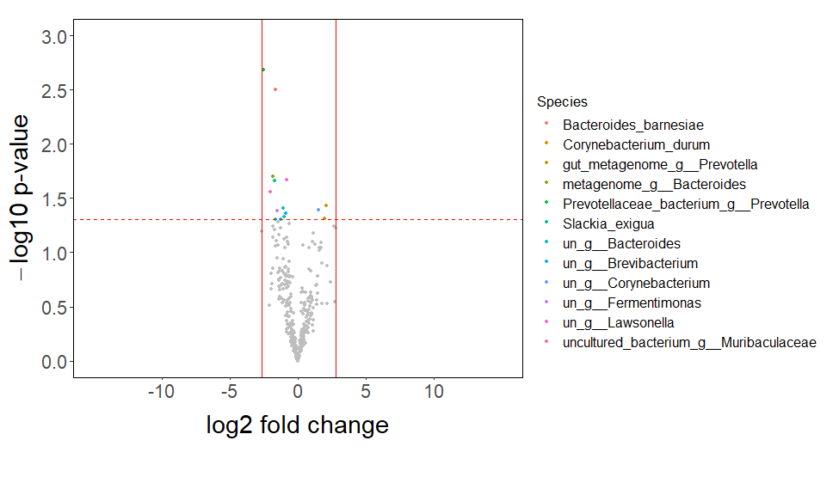

**Control Group**

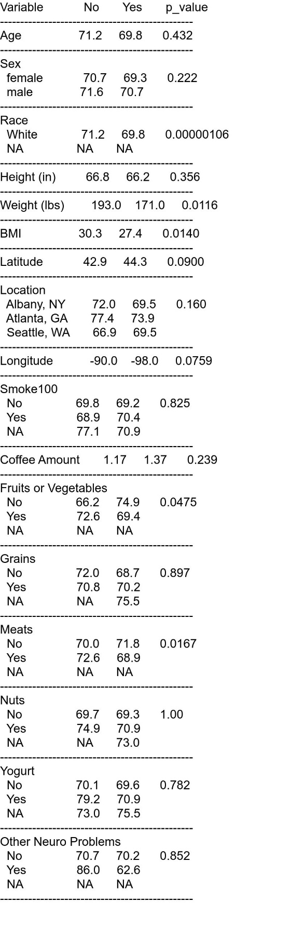

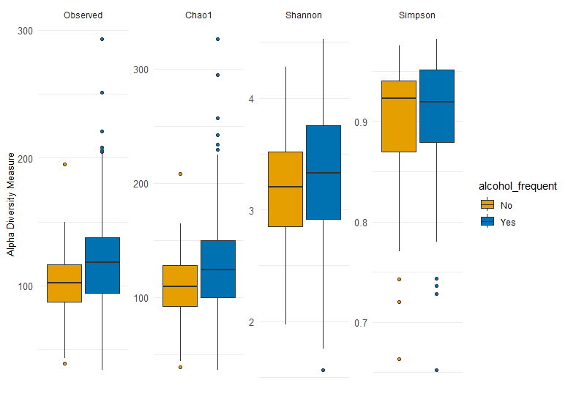

**Observed Chao1 Shannon Simpson**

**p.value 0.009391524 0.008160922 0.1061915 0.272795**

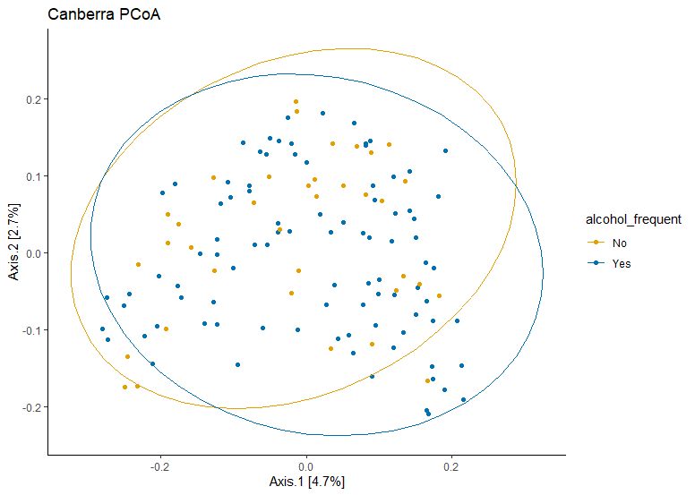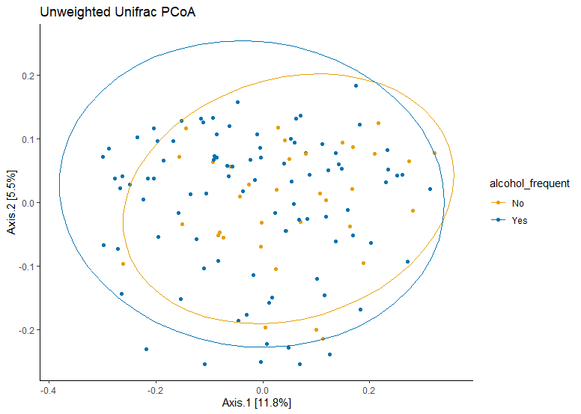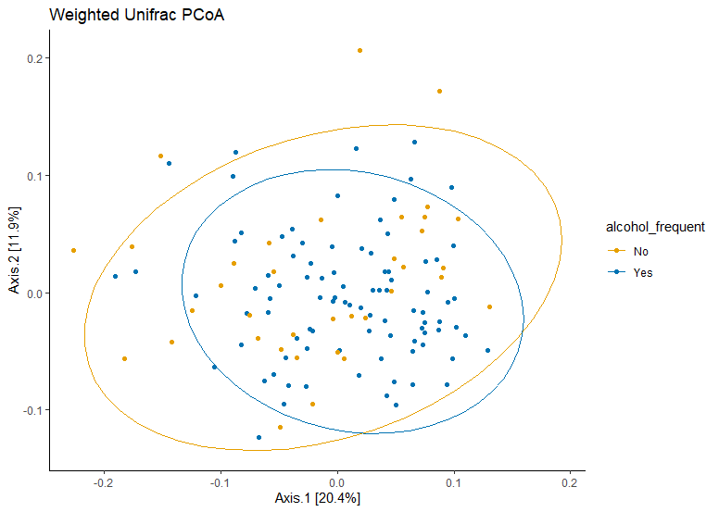

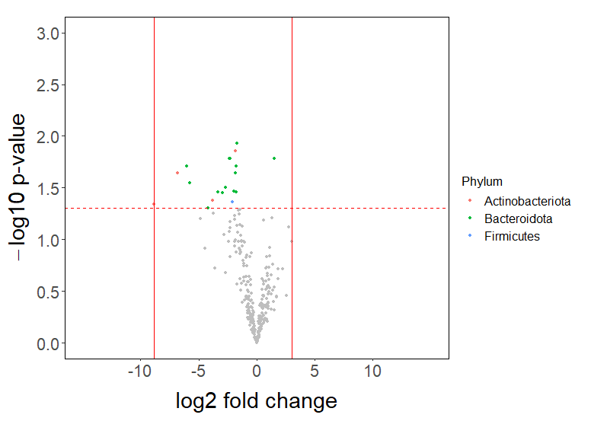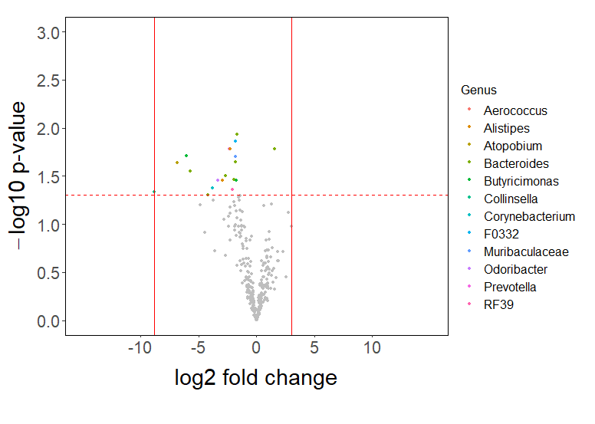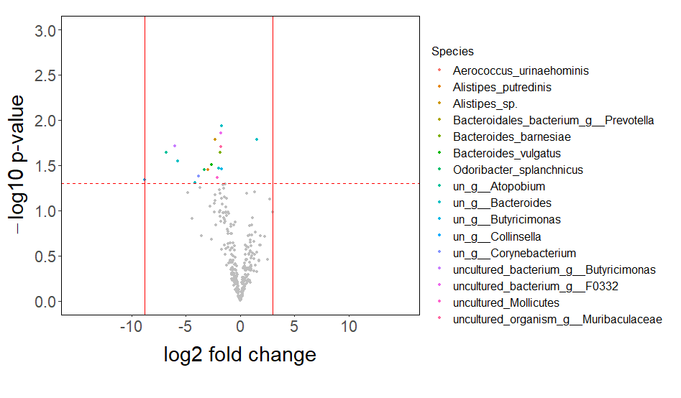

**metric p.value**

**1 canberra 0.069**

**2 unweighted-UniFrac 0.008**

**3 weighted-UniFrac 0.032**

**All participants with PD and without PD**

Control

PD

Bacteroides

Prevotella

Corynebacterium

**Metabolic pathways**

**Volcano plots**