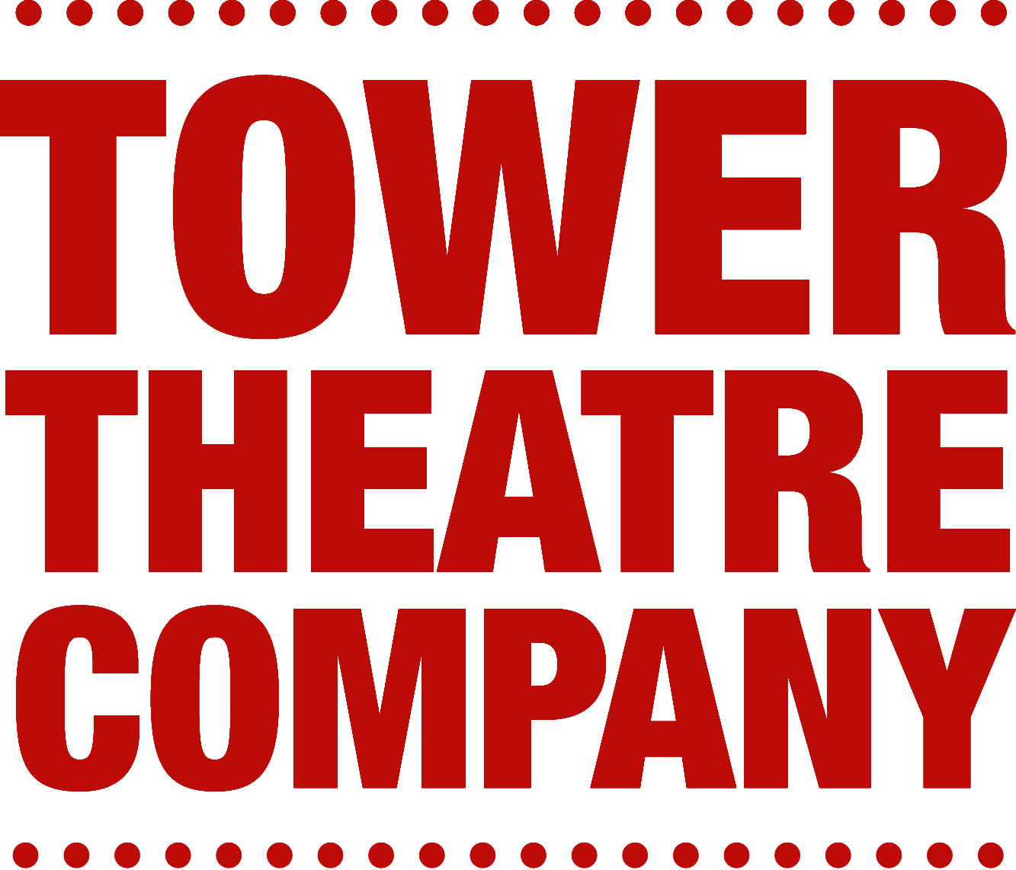  Audition Information  If you are planning to audition, please print off, complete and take along this audition slip with you to the audition. | Your Name :  Production :  I wish to read for these parts (or ‘as cast’) :
THIS AUDITION IS OPEN TO ANYONE, BUT IF YOU ARE NOT A TOWER THEATRE COMPANY MEMBER YOU MUST PAY A £20 AUDITION FEE BEFORE AUDITIONING
(Contact the Tower Office on 020 7353 1700 to do this)

Address

Phone Number(s)

Email
Preferred method of contact to let you know about the results if the audition | Phone call  Email  Text message

I am not available on (dates)
If you are not cast, would you be interested in crewing/working backstage? | Yes / No
How did you find out about this audition? | Email / Website / Mailing / Other

