[SELECT](http://127.0.0.1/openserver/phpmyadmin/url.php?url=https://dev.mysql.com/doc/refman/8.0/en/select.html) `Name`, `Phone`, `Salary` FROM MainTable;

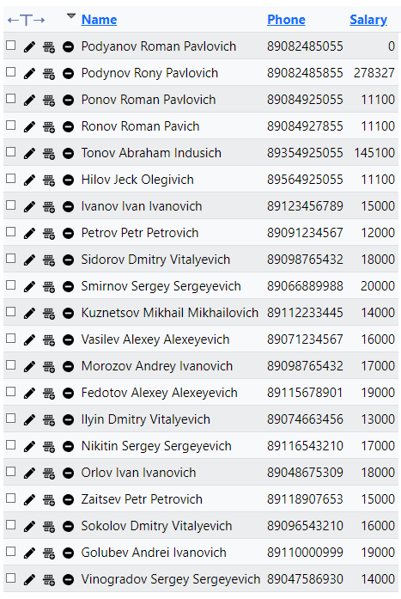

[SELECT](http://127.0.0.1/openserver/phpmyadmin/url.php?url=https://dev.mysql.com/doc/refman/8.0/en/select.html) `Name`, `Address` FROM MainTable ORDER BY `Address` ASC;

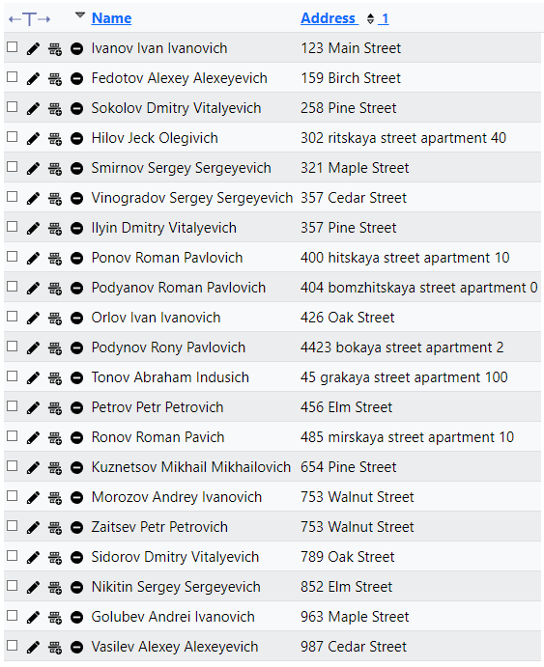

[SELECT](http://127.0.0.1/openserver/phpmyadmin/url.php?url=https://dev.mysql.com/doc/refman/8.0/en/select.html) Name, TIMESTAMPDIFF(Year, Experience, NOW()) AS Experience FROM MainTable WHERE TIMESTAMPDIFF(Year, Experience, NOW()) > 4;

