COLLEGIUM DA VINCI
Faculty of Applied Sciences
Major: INFORMATION TECHNOLOGY
first-cycle studies
Illia Dolbnia, album no. 30151
Kseniia Kushlak, album no. 30081
Volodymyr Biletskyi, album no. 29934
Anastasia Leonova, album no. 29945
Smart Pet Care Assistant
Inteligentny asystent opieki nad zwierzętami
Engineering thesis
Thesis supervised by
Dr. Engineer Michał Janowski
Poznań [YEAR]

Table of contents / Spis treści
Right-click and update this field in Word.
DRAFT INSTRUCTION: Update the table of contents after all headings and page breaks are final.

Introduction
WHO WRITES THIS: Illia assembles; all authors provide and review the description of their contribution.
TIP: Briefly explain the pet-owner problem, project objective, method, evaluated scope, main contribution, limitations, and chapter structure.
AUTHOR INPUT REQUIRED: Replace this block with the authors' original motivation, the approved problem context, and a concise explanation of why the project was undertaken. The complete Introduction must not exceed two pages.
This working draft concerns a cross-platform mobile client intended to support selected pet-care workflows. The implemented client groups authenticated access, pet profiles, reminders, notification handling, and pet-scoped informational assistance in one application. This statement is provisional and must be revised by the authors to match the approved thesis card and the final evaluated release.
AUTHOR INPUT REQUIRED: Add one short paragraph describing the structure of the finished thesis after the chapter contents are stable.

1. Current state of knowledge
WHO WRITES THIS: Kseniia leads the literature chapter; all authors review claims related to their technical area.
TIP: Use peer-reviewed and primary sources to explain what is already known; do not describe project implementation here.
DRAFT CITATION NOTE: This chapter now contains source-backed English working prose. Ksenia must review every original source, rewrite the text in the team's own academic voice, and obtain supervisor approval. The bibliography now uses a continuous working numeric sequence. If the approved source set changes, update the sequence and rerun the citation-integrity audit.
The preliminary source search was recorded on 25 July 2026. Web search was used for discovery, while titles, authorship, publication details, and retained claims were checked against publisher pages, DOI records, PubMed where applicable, and official technical documentation. Inclusion required direct relevance to pet-owner information, veterinary application design, mobile software engineering, or a specific implemented technology boundary; sources with unverified metadata, only marketing-level technical claims, or a remote analogy were excluded. The process was a targeted preliminary review rather than a systematic review, and every retained original still requires review and approval by the responsible authors and supervisor.

1.1 Pet-care workflow context
WHO WRITES THIS: Kseniia writes the research context; Anastasia confirms the owner problem and product need.
TIP: Search for pet-owner information needs, reminder and record-keeping problems, online health-information behavior, and mobile pet-care requirements.
Digital support for pet owners occupies a health-adjacent area: an application may organize owner-entered data and improve access to information, but it cannot infer that the information is complete or replace a physical veterinary examination. A 2025 literature review of requirements for pet-owner mHealth applications screened 955 publications and extracted ten requirements from thirteen included publications. The most frequently recurring themes were complete user input and prominent communication of application limitations [4]. The small number of included studies also demonstrates that the evidence base remains limited.
Online veterinary information is nevertheless a normal part of many owners' decision processes. A questionnaire study of 2,117 dog and cat owners in Austria, Denmark, and the United Kingdom found that owners used several types of internet resources before or after veterinary consultations. The authors identified potential benefits for informed discussion as well as risks of misunderstanding information or delaying professional consultation [12]. An earlier United Kingdom survey of 571 owners likewise found high internet use while veterinarians remained among the sources rated most trustworthy [11]. These surveys justify careful information design, but they do not establish prevalence among Polish users or prove that a mobile application improves animal-health outcomes.
For this project, the defensible problem boundary is therefore organizational rather than clinical. Pet profiles, care reminders, notification handling, and pet-scoped informational assistance can be combined into one owner-facing workflow. Any assistant response must be presented as general information, accompanied by clear limitations and escalation language, and evaluated as software behavior rather than as a diagnosis.

1.2 Review of existing solutions
WHO WRITES THIS: Kseniia writes the comparison; Anastasia reviews product and UX observations.
TIP: Compare current pet-care applications using the same dated criteria: profiles, health records, reminders, sharing, assistant behavior, platform, and limitations.
A desk review was performed on 25 July 2026 using public English Google Play listings. Inclusion required an Android product directly concerned with pet-care organization, a listing that described records, reminders, or provider contact, and evidence of either recent maintenance or an established installation base. The comparison criteria were defined before extracting product claims: multi-pet organization, records, reminders, provider integration, sharing or export, developer-declared data safety, and an assistant when explicitly advertised.
Table 1.1. Comparison of selected pet-care products based on official Google Play listings (sources: [13, 18, 19, 22]).
Product | Advertised organization | Integration / sharing | Data-safety declaration | Assistant
11pets; updated 22.07.2026 [13] | Reminders, appointments, tracking, and documents | Veterinary record sharing; separate business product | No third-party sharing declared; collection declared; encrypted in transit; deletion request | Not stated
VitusVet; updated 07.11.2025 [22] | Multiple pets, health records, medication, and reminders | Care-provider sharing; partner-practice appointment/refill requests | No third-party sharing declared; collection declared; encrypted in transit; deletion request | Not stated
PetDesk; updated 03.07.2026 [18] | Reminders, messages, to-dos, and refill requests | Provider management, appointment requests, and loyalty | Sharing and collection declared; encrypted in transit; deletion request | Not stated
PetnotePlus; updated 24.07.2026 [19] | Multiple pets, records, routines, reminders, charts, diary, and expenses | Household sharing; premium CSV and batch export | Sharing and collection declared; encrypted in transit; deletion request | Not stated

Table 1.1 shows that, across the reviewed listings, organization through records, schedules, and reminders was the common product proposition. VitusVet and PetDesk emphasized participating-provider workflows, 11pets advertised veterinary record sharing, and PetnotePlus emphasized household collaboration and export [13, 18, 19, 22]. None of the reviewed listing texts stated an informational or AI assistant. This is a non-mention, not proof that the products lack such a function, and it does not support a claim that Smart Pet Care is novel.
The comparison records public product claims rather than observed behavior. Google Play identifies data-safety information as supplied by developers and subject to change. Consequently, the matrix cannot establish reliability, usability, privacy compliance, or security. Its purpose is to position the student project cautiously: Smart Pet Care combines pet profiles, reminders, notification handling, and a pet-scoped informational assistant, while its actual behavior must be demonstrated independently.
AUTHOR INPUT REQUIRED: Before submission, recheck every listing, obtain supervisor approval for the comparison set, and, where access and terms permit, record hands-on observations on a named Android device or emulator. Record country, exact version, account state, observation date, official URL, and minimal redacted evidence screenshots. Distinguish unobserved from absent behavior.

1.3 Cross-platform mobile architecture
WHO WRITES THIS: Illia writes and provides mobile-architecture evidence.
TIP: Explain React Native and Expo trade-offs using official documentation and empirical cross-platform performance or energy studies.
Cross-platform mobile development seeks to reuse a common codebase across operating systems while preserving access to platform capabilities. The approach can reduce duplicated implementation work, but it introduces framework abstractions and does not remove platform-specific behavior. An empirical study comparing five cross-platform frameworks with a native Android baseline found that performance depended on the framework, feature, and measurement; no single approach was superior in every context [1]. Consequently, framework selection should follow explicit functional and quality requirements rather than a general claim of native-equivalent performance.
A narrower controlled comparison reported six to eight percent greater energy consumption for the investigated React Native implementation than for its native Android counterpart [3]. That value is not a prediction for Smart Pet Care: the paper used an older framework generation, a specific application, and a defined test scenario. It is useful here as a methodological warning that portability and developer productivity must be evaluated separately from runtime resource use.
The project uses Expo and React Native to maintain shared application logic and native user-interface components for its declared platforms. Expo Router derives application routes from the file structure and supports universal navigation concepts [15]. This architecture is consistent with the repository's TypeScript skill set and modular feature organization. The choice must still be verified by the final Android build, and no conclusion about iOS parity or performance should be drawn without platform-specific execution evidence.

1.4 Client-server communication and server state
WHO WRITES THIS: Illia writes the mobile integration; Volodymyr reviews the C# backend boundary.
TIP: Explain OpenAPI-generated clients, React Query caching/invalidation, Axios requests, authentication refresh, and why a contract is not runtime proof.
The mobile client and backend are independently deployed components, so their interface requires an explicit contract. In this project, an OpenAPI snapshot is used to generate typed request functions and data models [16]. Generated types reduce manual duplication and make contract changes visible to the TypeScript compiler, but they describe the declared interface rather than proving that a live response is valid or that the server implements every documented behavior.
Remote data also has a lifecycle distinct from transient interface state. TanStack Query provides query caching, invalidation, and background refetch behavior. Its React Native guidance additionally connects query behavior with application focus and network state [21]. After a successful mutation, targeted invalidation can mark related cached data stale and trigger an appropriate refetch [20]. Correct cache keys and invalidation scopes remain application-specific design responsibilities.
Authentication adds a second state machine around outgoing requests. The client must attach current credentials, distinguish recoverable expiration from other authorization failures, serialize or otherwise control refresh attempts, retry only appropriate requests, and clear local state when recovery fails. These properties require both code review and scenario tests; the existence of an HTTP interceptor alone does not demonstrate a reliable session lifecycle.

1.5 Runtime validation, privacy, and safety boundaries
WHO WRITES THIS: Illia writes technical and AI boundaries; Kseniia verifies supporting research.
TIP: Research Zod runtime validation, SecureStore, relevant OWASP MASVS controls, and veterinary generative-AI risks and disclaimers.
Static TypeScript types are removed during execution and cannot validate untrusted network or form input. Runtime schemas are therefore needed at selected boundaries where values can differ from the compile-time model. Zod documents parsing and a `safeParse()` result that discriminates success from validation failure while deriving static types from the schema [23]. Validation should produce an explicit success or failure before data is stored, displayed, or passed to a safety-sensitive workflow. The final thesis must identify which boundaries are validated and which still rely on the backend contract.
Authentication material stored on the device requires platform-aware protection. Expo SecureStore uses platform facilities for encrypted key-value storage and documents persistence, backup, accessibility, and payload limitations [14]. This supports the choice of a protected storage API, but it does not establish end-to-end security. The OWASP MASVS separates mobile security into storage, cryptography, authentication, network, platform, code, resilience, and privacy control groups [17]. A scoped review must record which controls were tested and leave remote API security outside the mobile-only result.
Generative language models introduce an additional reliability boundary because plausible language is not evidence of factual or clinical correctness. Veterinary guidance identifies hallucination, inaccuracy, data privacy, transparency, and regulatory uncertainty as material risks and recommends that AI augment rather than replace veterinary expertise [2]. For Smart Pet Care, the assistant must therefore remain non-diagnostic, disclose its limitations, avoid unnecessary personal or clinical data, and direct urgent concerns to an appropriate professional or emergency service.
Client-side urgency cues can support conservative presentation, but they cannot validate the assistant's clinical reasoning. Verification should cover consent, pet-context selection, safe fallback behavior, retry limits, error states, and the visibility of warnings. Claims about medical accuracy require a separate expert-designed evaluation and are outside the current thesis scope.

1.6 Mobile-application testing
WHO WRITES THIS: Illia writes the test approach; Kseniia reviews methodology and evidence.
TIP: Describe static, unit, component, integration, Android-device, accessibility, and usability testing; search relevant ISO testing and usability concepts.
Software quality must be translated into observable criteria. ISO/IEC 25010:2023 provides a product-quality model that can help organize requirements and testing objectives [6], while ISO/IEC/IEEE 29119-1:2022 establishes general software-testing concepts [7]. The standards do not make a project compliant by citation; the team must define the relevant characteristic, context, metric, target, and evidence for each selected requirement.
The verification strategy should combine complementary levels. Static type checking and linting detect selected source-level defects. Unit tests exercise isolated logic, component and page tests observe rendering and interaction under controlled dependencies, integration tests cover boundaries between modules, and Android scenarios evaluate native configuration, permissions, deep links, notifications, network changes, and process restarts. A passing lower-level suite cannot prove that an end-to-end device flow works.
Usability is likewise an outcome of use in a specified context rather than a synonym for visual consistency [5]. The final evaluation should name representative users or reviewers, tasks, devices, conditions, success criteria, observed errors, and limitations. Automated accessibility checks and property inspection are useful, but they must be complemented by manual focus, label, scaling, contrast, touch-target, and non-color-cue checks on critical Android flows.

1.7 Synthesis and project positioning
WHO WRITES THIS: Kseniia and Illia write; Anastasia confirms product positioning.
TIP: Summarize the literature gap and state the engineering contribution without claiming clinical effectiveness, market novelty, or framework superiority.
The reviewed literature establishes a defensible problem boundary rather than proof of a product outcome. Pet-owner applications should make input expectations and limitations prominent [4], and owner surveys show that online information can support discussion while also creating risks of misunderstanding or delayed professional consultation [11, 12]. Generative AI adds plausible but potentially inaccurate language, privacy, transparency, and regulatory concerns [2]. These sources support organizational and informational assistance with explicit limits; they do not support a diagnostic or clinically validated claim.
The dated product-listing comparison shows that records, schedules, reminders, sharing, and provider-related workflows are already common advertised propositions [13, 18, 19, 22]. The reviewed listing text did not state an AI or informational assistant, but non-mention is not evidence of absence and cannot establish novelty. Likewise, empirical cross-platform studies show that performance depends on framework, feature, and measurement context [1, 3], so the selected Expo/React Native architecture must be evaluated through the final project rather than justified by a universal efficiency claim.
Accordingly, the intended engineering contribution is the documented design, implementation, integration, and verification of one owner-facing mobile client that combines the approved pet-care workflows and a bounded pet-scoped assistant. The contribution is not a claim of medical novelty, improved animal-health outcomes, framework superiority, or market uniqueness. Its final value must be assessed against the approved requirements, inspectable implementation evidence, and repeatable results presented in the following chapters.

2. Objective and scope
WHO WRITES THIS: Anastasia leads product scope; Illia integrates the final team decision.
TIP: State exactly what the first version will deliver and verify, then separate version-2, omitted, and clinically excluded functionality.

2.1 Main objective
WHO WRITES THIS: Anastasia drafts the objective; Illia makes it measurable and consistent with the implementation.
TIP: Write one measurable objective using action verbs such as design, implement, integrate, and verify; define what evidence proves completion.
The provisional objective is to design, implement, and verify the Smart Pet Care Assistant as a cross-platform mobile application for selected pet-care workflows. The solution should provide authenticated access, pet-profile management, reminders, notification handling, and a pet-scoped assistant while applying typed API integration, runtime boundary validation, protected session storage, connectivity-aware data fetching, and automated tests.
In this provisional title, ‘smart’ or ‘intelligent’ means observable assistant behavior such as pet-context selection, consent handling, structured response presentation, configured urgency cues, and retry or failure handling. It does not mean veterinary diagnosis, clinical effectiveness, or general artificial-intelligence superiority. The final definition and acceptance evidence require author and supervisor approval.
AUTHOR INPUT REQUIRED: Obtain supervisor approval for the objective and replace broad terms with measurable acceptance criteria.

2.2 Actors
WHO WRITES THIS: Anastasia defines user actors; Illia and Volodymyr confirm technical actors.
TIP: List only people and external systems that interact with the evaluated release, then check them against routes, APIs, Google identity, Firebase, and the assistant flow.
Candidate actors are the unauthenticated visitor, authenticated pet owner, Google identity provider, external backend API, Firebase Cloud Messaging, and assistant service. The final use-case diagram must show only actors and interactions present in the evaluated system.

2.3 Functional requirements
WHO WRITES THIS: Anastasia drafts user requirements; Volodymyr and Illia confirm backend, mobile, and AI feasibility.
TIP: Write testable 'the user/system can' statements and connect each requirement to an implementation path and acceptance scenario.
Table 2.1 presents candidate requirements inferred from the current mobile repository and committed API contract. Their status remains provisional until the corresponding Android scenarios are verified.
Table 2.1. Candidate functional requirements and planned acceptance evidence (source: authors' own work based on the repository and committed OpenAPI contract).
ID | Candidate requirement | Acceptance evidence | Status
FR-01 | The user can register, confirm an account, and sign in. | Android scenario and API result | Verify
FR-02 | The user can authenticate with Google on Android. | Configured device scenario | Verify
FR-03 | The application restores or refreshes a saved session. | Restart and expired-token scenarios | Verify
FR-04 | The user can create, view, edit, and delete pet profiles. | CRUD scenario set | Verify
FR-05 | The user can upload or replace a pet photograph. | Image-selection and upload scenario | Verify
FR-06 | The user can create, view, update, and delete reminders. | Reminder scenario set | Verify
FR-07 | The application registers an Android notification token. | Sanitized backend request evidence | Verify
FR-08 | A reminder notification can open the status workflow. | Foreground/background/terminated tests | Verify
FR-09 | The assistant requires consent and a selected pet. | Page tests and Android scenario | Partially tested
FR-10 | The assistant loads sessions and exchanges messages. | Hook/page tests and live API scenario | Partially tested
FR-11 | The application presents offline and recovery states. | Offline/reconnect scenario | Verify
FR-12 | The user can update the profile and sign out. | Profile and cleanup scenario | Verify

2.4 Non-functional requirements
WHO WRITES THIS: Illia drafts measurable technical requirements; Kseniia verifies research support.
TIP: Define measurable quality targets with context, method, and units for reliability, security, accessibility, performance, maintainability, and recovery.
Table 2.2 translates selected quality concerns into candidate measurable requirements. Targets and methods remain provisional until the final device, dataset, and approved verification protocol are fixed.
Table 2.2. Candidate non-functional requirements and verification methods (source: authors' own work).
ID | Category | Candidate measurable requirement | Verification
NFR-01 | Type safety | The final client passes the strict TypeScript check. | `tsc --noEmit`
NFR-02 | Code quality | The final client passes lint with no errors or warnings. | ESLint
NFR-03 | Reliability | Documented error and reconnect scenarios recover without restart. | Android scenario set
NFR-04 | Privacy | Session material is stored through the platform protected-storage API. | Code review and platform documentation
NFR-05 | Accessibility | Critical flows meet the named label, focus, touch-target, and non-color-cue checks. | Accessibility checklist
NFR-06 | Performance | Selected screens meet a defined threshold on a named device and dataset. | Measurement protocol required

2.5 Use-case catalogue and traceability
WHO WRITES THIS: Anastasia writes user flows; Illia maps implementation and verification.
TIP: For each use case record actor, preconditions, main flow, alternative/error flow, requirement ID, implementation, and verification evidence.
Table 2.3 assigns stable working identifiers to every current use case and connects it to the candidate requirements and final verification protocol. Several requirements intentionally decompose into multiple use cases; FR-11 is represented as a cross-cutting recovery flow. The mapping proves planned coverage only and does not convert an unexecuted scenario into a pass.
Table 2.3. Provisional use-case-to-requirement and verification mapping (source: authors' own work based on the mobile repository, committed OpenAPI contract, and verification protocol).
Use case | Goal | Requirement | Evidence boundary | Verification status
UC-01 | Register account | FR-01 | Registration form and `POST /api/auth/register` | B-01; runtime proof required
UC-02 | Confirm email account | FR-01 | Confirmation/resend pages and endpoints | B-02; runtime proof required
UC-03 | Sign in with email | FR-01 | Email form, session persistence, login endpoint | B-02-B-03; runtime proof required
UC-04 | Sign in with Google | FR-02 | Native Google flow and mobile token exchange | B-04-B-05; runtime proof required
UC-05 | Resume authenticated session | FR-03 | Protected storage, refresh, and interceptor paths | B-06-B-09; partially verified
UC-06 | Manage account profile | FR-12 | Profile, user-update, and avatar interfaces | C-08; runtime proof required
UC-07 | Sign out | FR-12 | Local, Google, and notification cleanup paths | B-09-B-10; partially verified
UC-08 | Delete account | Candidate FR-13 | Profile deletion UI and user-delete endpoint | C-09; scope decision required
UC-09 | Manage pet profiles | FR-04 | Pet pages, mutations, schemas, and CRUD endpoints | C-01-C-04; runtime proof required
UC-10 | Manage pet photograph | FR-05 | Image selection, upload hook, and photo endpoint | C-05-C-07; runtime proof required
UC-11 | Manage reminders | FR-06 | Reminder UI, mutations, and contract operations | D-01-D-03; runtime proof required
UC-12 | Synchronize Android notification token | FR-07 | Notification provider, token service, and endpoints | D-04-D-06; automated client scope
UC-13 | Open reminder status from notification | FR-08 | Notification-response prompt and status drawer | D-07-D-10; runtime proof required
UC-14 | Review and decide assistant consent | FR-09 | Consent dialog and protected local storage | E-01, E-11; partially verified
UC-15 | Select pet context | FR-09 | Assistant pet-selection and creation routes | E-02; partially verified
UC-16 | Manage assistant conversation | FR-10 | Session/history/send paths and API boundary | E-03-E-10; partially verified
UC-17 | Retry failed assistant message | FR-10 | Retry mutation and dedicated endpoint | E-06-E-07; partially verified
UC-18 | Recover after connectivity change | FR-11 | Connectivity manager, offline UI, and query recovery | F-01-F-04; runtime proof required

UC-08 is implemented in the inspected mobile client but is not included in FR-01-FR-12. Before scope freeze, the team and supervisor must either approve a separate FR-13 and retain scenario C-09, or explicitly exclude account deletion from the evaluated scope. The committed contract also exposes weight, health, and feeding operations, while the live contract adds journal and symptom-catalogue surfaces; none may be claimed as evaluated functionality without a requirement, implementation evidence, verification scenario, and result.

2.6 Scope limitations
WHO WRITES THIS: Illia coordinates; every author adds limitations from their owned area.
TIP: List what was not evaluated: clinical accuracy, unsupported platforms/languages, unexecuted security or scalability work, branch-only features, and missing runtime evidence.
Unless separate evidence is supplied, the thesis does not evaluate backend implementation internals, clinical correctness, iOS production notification delivery, complete accessibility conformance, security certification, or scalability beyond measured datasets.

2.7 Team roles and work allocation
WHO WRITES THIS: Illia assembles; all four authors review and approve their own responsibility description.
TIP: Describe responsibilities using repositories, Figma, research, testing, review, and coordination evidence; do not calculate effort from commit counts alone.
The four-person team contains complementary backend, frontend, research, product, AI-service, infrastructure, and coordination responsibilities. Table 2.4 reconciles the authors' confirmed role descriptions with the visible repository histories inspected on 26 July 2026. The official CDV breakdown sheet assigns an equal overall share of 25% to each author; that administrative allocation still requires signatures and does not replace evidence of the actual work described in the thesis.
Table 2.4. Confirmed team responsibilities and official overall contribution shares (source: authors' role confirmation, supplied CDV breakdown sheet, and repository histories inspected on 26 July 2026).
Team member | Confirmed responsibility | Official overall share
Volodymyr Biletskyi | Lead C# backend developer: architecture, persistence, authentication, core APIs, reminders, notifications, and infrastructure. | 25%
Kseniia Kushlak | Backend feature developer and researcher: pet photographs, feeding, weight history, and C# classifier/chat integration. | 25%
Anastasia Leonova | Idea and product lead; frontend developer responsible for product direction, UX, and care-related interface work. | 25%
Illia Dolbnia | Team lead, frontend lead, and AI backend-service lead: mobile integration, coordination, classifier service, and AI safety. | 25%

The evaluated mobile revision's reachable history contains 26 human commits attributed to Illia Dolbnia, while a separate care-screen branch contains 30 commits attributed to Anastasia Leonova. In the C# backend history, Volodymyr Biletskyi has 39 non-merge commits and Kseniia Kushlak has four identifiable squash commits, two of which record Volodymyr as co-author. Illia is the sole visible author of the seven inspected AI-service commits. These histories support technical attribution but do not measure design, research, review, coordination, pair programming, or effort. The equal shares in Table 2.4 are therefore an official working allocation, not a metric calculated from commits.
AUTHOR INPUT REQUIRED: Each author must review the description of their work, link the final accepted artifacts, and sign the CDV work-allocation sheet. Add Anastasia Leonova's design evidence and non-commit research, review, and coordination records for all authors.

2.8 Author-confirmed first-version scope
WHO WRITES THIS: Illia maintains the scope table; all authors classify and approve included, deferred, and omitted items.
TIP: Classify every checklist item as included, version 2, excluded, or unconfirmed, and record the accepted revision and required evidence.
On 26 July 2026, Illia classified the numbered implementation checklist into ready first-version ranges, version-2 items, and omitted items. Table 2.5 uses this response as an author-confirmed drafting baseline. It is not an acceptance-test result: every included area still requires an immutable release revision, a mapped verification scenario, an observed result, and review by the responsible authors and supervisor.
Table 2.5. Author-confirmed first-version, version-2, and unconfirmed scope (source: Illia Dolbnia's checklist response and repository reconciliation performed on 26 July 2026).
Product area | Author-confirmed status | Repository support | Thesis treatment
Authentication, account, profile, and session handling | First version (reported ready) | Mobile and C# backend implementation artifacts are present. | Describe implementation; retain pending Android and API acceptance evidence.
Pets, photographs, weight, health, journal, and symptoms | First version (reported ready) | Mobile, API, backend, live-contract, and branch artifacts exist across different revisions. | Describe the accepted functionality only after the release set is identified; make no diagnostic claim.
Reminders and Android notifications | First version (reported ready) | Client, backend, and automated-test artifacts are present. | Describe implementation; final FCM lifecycle scenarios remain acceptance evidence.
Pet-scoped assistant and condition pre-assessment | First version (reported ready) | C# chat integration is on the backend main history; unified `/chat` is on AI-service feature revision 74019ea. | Describe both ownership boundaries; identify the merged or deployed AI revision before reporting a final result.
Feeding mobile interface and nutrition goals (items 25-26) | Version 2 | C# feeding API implementation exists; the end-to-end mobile workflow is not part of the confirmed first version. | Document the backend boundary where relevant and list the mobile experience as future work.
Omitted checklist items 27, 39-40, 42-43, and 58-63 | Unconfirmed | The author's response did not classify these dashboard and smart-feature items. | Do not claim them until the team explicitly includes or defers each item.
English UI, recovery, accessibility, Android, tests, CI, deployment | First version for confirmed checklist ranges | Mobile and service repositories contain relevant implementation, tests, workflows, and deployment definitions. | Describe repository-supported design; report runtime outcomes only after clean-revision execution.
Polish interface (item 68) | Unconfirmed | The inspected mobile baseline configures English resources only. | Describe English localization accurately and retain Polish as unconfirmed or future work.

The detailed status register records that the author's answer used the range 74-90 although the checklist ended at item 81; only items 74-81 were therefore classified. The final dated freeze must classify every omitted item and identify accepted mobile, backend, AI-service, and contract revisions before the requirements and results are finalized.

3. Methodology
WHO WRITES THIS: Illia coordinates the chapter; Kseniia reviews the research method.
TIP: Explain how the team actually worked and how evidence was collected; avoid naming a formal method unless the team can demonstrate it.

3.1 Requirements discovery and prioritization
WHO WRITES THIS: Anastasia describes product decisions; Kseniia documents the research method; Illia records prioritization.
TIP: Describe where requirements came from, who decided priorities, what changed, and which evidence records the decisions.
Requirements are represented as uniquely identified functional and non-functional statements with an actor or quality category, acceptance evidence, and implementation status. This supports traceability from the approved objective through implementation and verification. ISO/IEC/IEEE 29148:2018 treats requirements engineering and its information items as life-cycle concerns [9], while ISO/IEC 25010:2023 supplies a reference model for organizing product quality requirements [6]. The project uses these publications as conceptual references, not as a claim of standards conformance.
AUTHOR INPUT REQUIRED: Describe how the team actually discovered, discussed, prioritized, changed, and accepted the requirements. Add the approved thesis card, dated meeting/design evidence, rejected alternatives, and a traceability matrix from every final requirement to implementation and test evidence.

3.2 Project organization
WHO WRITES THIS: Illia writes the actual workflow, tools, meetings, reviews, and evidence process.
TIP: Describe Git branches, Jira, reviews, meetings, responsibility handoffs, quality gates, and how disagreements or scope changes were handled.
The visible mobile-client history begins with the initial commit on 11 April 2026. Reusable interface components and automated review support appeared in April and May. Home, navigation, and query work followed at the start of June; authentication was introduced on 6 June; pet and owner-profile workflows were added between 20 and 30 June; reminder and notification integration was extended from 1 to 13 July; and the assistant screen was integrated on 15 July. The corresponding commit identifiers and attribution limitations are recorded in the project chronology.
All named human commits reachable from the evaluated revision are attributed to Illia Dolbnia; separate local branch references contain Anastasia Leonova's care-screen history. This establishes a bounded repository-visible chronology but not the complete collaboration model or final-release inclusion. The final methodology must incorporate backend and AI-service histories, design-tool versions, research logs, reviews, pair-programming evidence, merged-release evidence, and team decisions before work is assigned to individual authors.
AUTHOR INPUT REQUIRED: Describe the version-control and pull-request strategy, issue or change proposal process, review responsibilities, communication cadence, and actual quality gates. Do not name Scrum, Kanban, or another formal method unless the team can demonstrate that it was used.

3.3 System architecture
WHO WRITES THIS: Volodymyr writes the C# backend architecture; Illia writes mobile and AI architecture.
TIP: Describe the mobile, C# backend, PostgreSQL, Firebase/Google, and Python AI components, their protocols, ownership, and deployment boundaries.
The system is divided into a cross-platform mobile client, a C# core backend, and a Python AI microservice. The client consumes the backend through an OpenAPI-described HTTPS interface, delegates Google identity to the native authentication flow, and registers Android notification tokens for Firebase Cloud Messaging. The core backend authenticates and authorizes pet-scoped operations, persists domain and chat data, and forwards bounded assistant context to the AI microservice.
The architecture description should communicate the concerns of the reader through complementary views rather than one overloaded diagram. ISO/IEC/IEEE 42010:2022 distinguishes an architecture from its documented architecture description and defines concepts for viewpoints and models [10]. The CDV guide separately requires use-case, class/object, component, and deployment diagrams. Those university requirements determine the minimum diagram set for this thesis.
Figure 3.1 separates the three implemented repositories and shows the assistant ownership boundary: the C# service owns authorization, sessions, history, persistence, resilience, and public error mapping, whereas the Python service owns routing, condition prediction, deterministic safety rules, and response generation. Figure 3.2 maps the verified deployment definitions to runtime nodes while retaining explicit confirmation labels for the actual deployed release identifiers and data-store host.
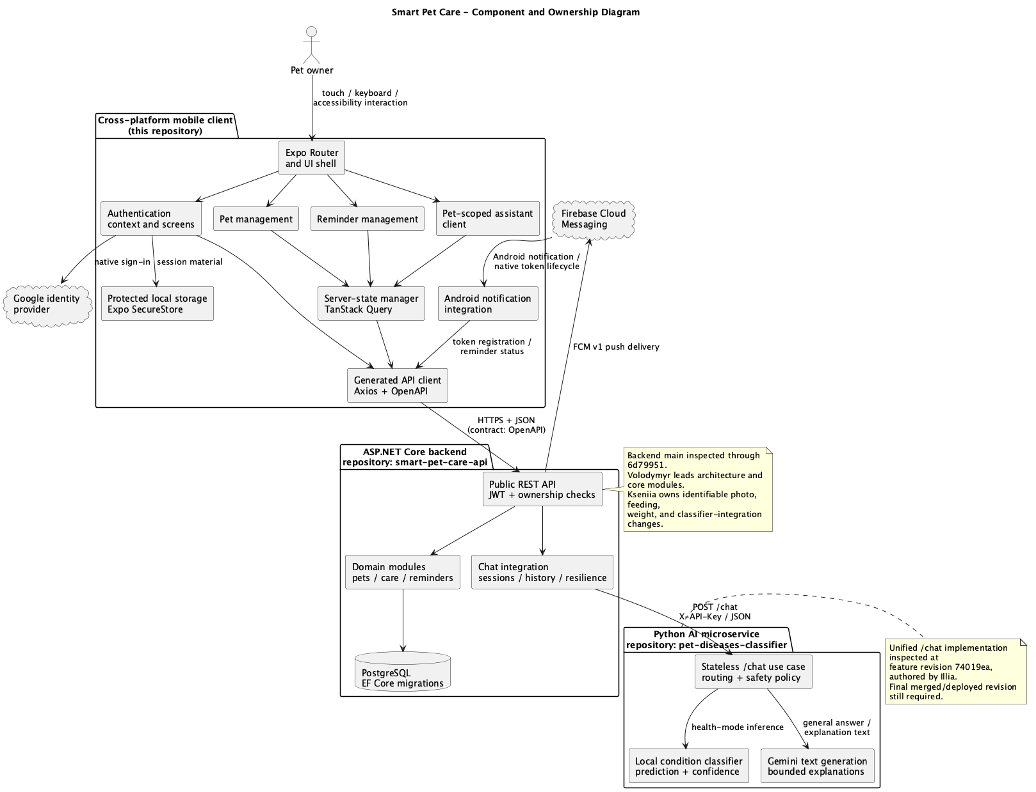
Figure 3.1. Component view of the mobile client, C# backend, and AI-service ownership boundaries (source: authors' own work; working draft requiring verification).
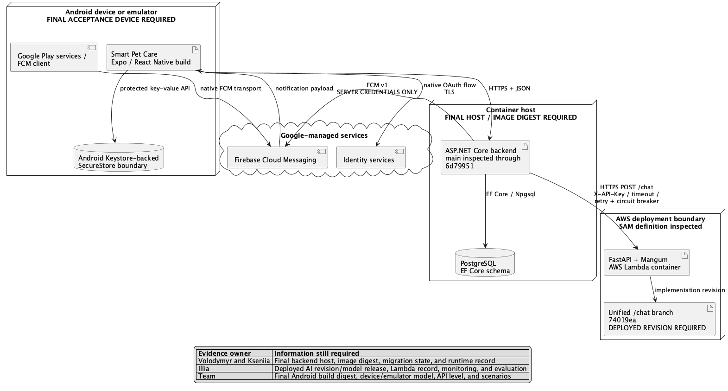
Figure 3.2. Deployment-definition view with final release identifiers still requiring confirmation (source: authors' own work; working draft requiring verification).
AUTHOR INPUT REQUIRED: Review Figures 3.1 and 3.2 with the backend and AI-service leads. Add the accepted image, migration, model, API, and deployment revision identifiers, and distinguish a deployment definition from evidence that the same artifact was deployed and exercised.

3.4 Domain and interaction models
WHO WRITES THIS: Volodymyr confirms backend/domain relations; Illia confirms contracts and sequences; Anastasia reviews user flows.
TIP: Explain the main entities and relationships, then describe authentication, notification, and assistant sequences using the final API contract.
The principal domain concepts visible in the client contract include a user profile, pets, pet photographs, weight and health records, feeding logs, reminders and reminder runs, notification tokens, and assistant sessions and messages. A domain model must distinguish these declared API entities from client-only view state and from unverified backend persistence entities.
Figure 3.3 covers account, pet, reminder, and notification interactions; Figure 3.4 covers assistant and connectivity behavior. Together they form the complete provisional use-case view, and their stable UC-01-UC-18 identifiers map to Table 2.3. Figure 3.5 is derived from the committed OpenAPI response models and uses foreign-key fields and embedded response structures to express only contract-level relationships. It therefore does not claim that the backend uses the same classes, multiplicities, or persistence design.
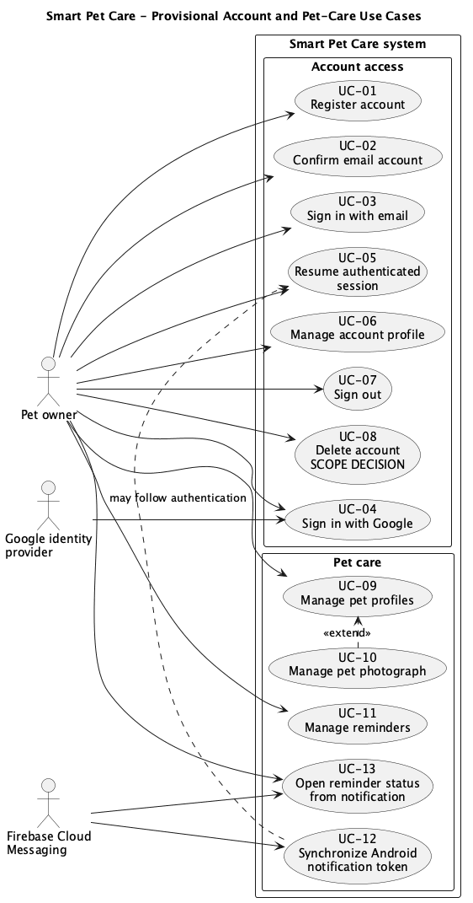
Figure 3.3. Provisional account and pet-care use-case view (source: authors' own work; working draft requiring verification).
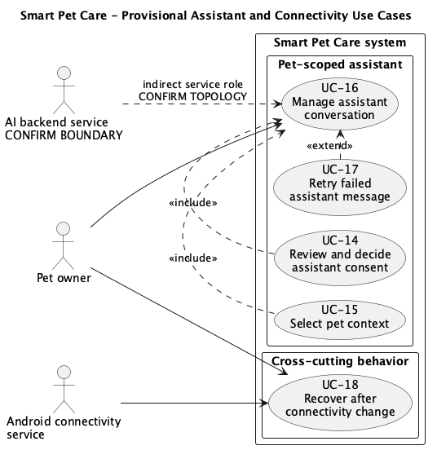
Figure 3.4. Provisional assistant and connectivity use-case view (source: authors' own work; working draft requiring verification).
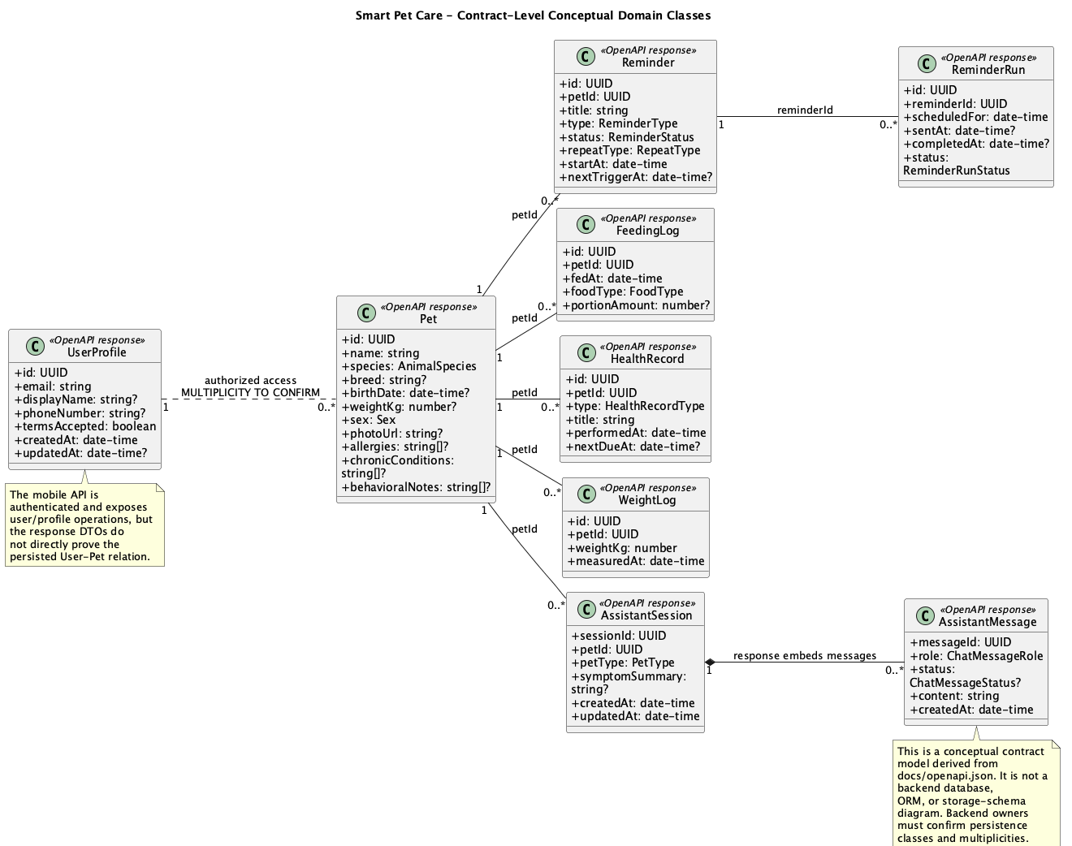
Figure 3.5. Contract-level conceptual domain classes derived from the committed OpenAPI snapshot (source: authors' own work; working draft requiring verification).
Figures 3.6-3.8 then describe three implementation-critical interaction paths: session restoration and refresh after authentication failure; Android notification-token synchronization followed by reminder-status handling; and assistant consent, session bootstrap, message submission, and retry. Each sequence ends with the evidence boundary that remains outside the current automated or repository-level proof.
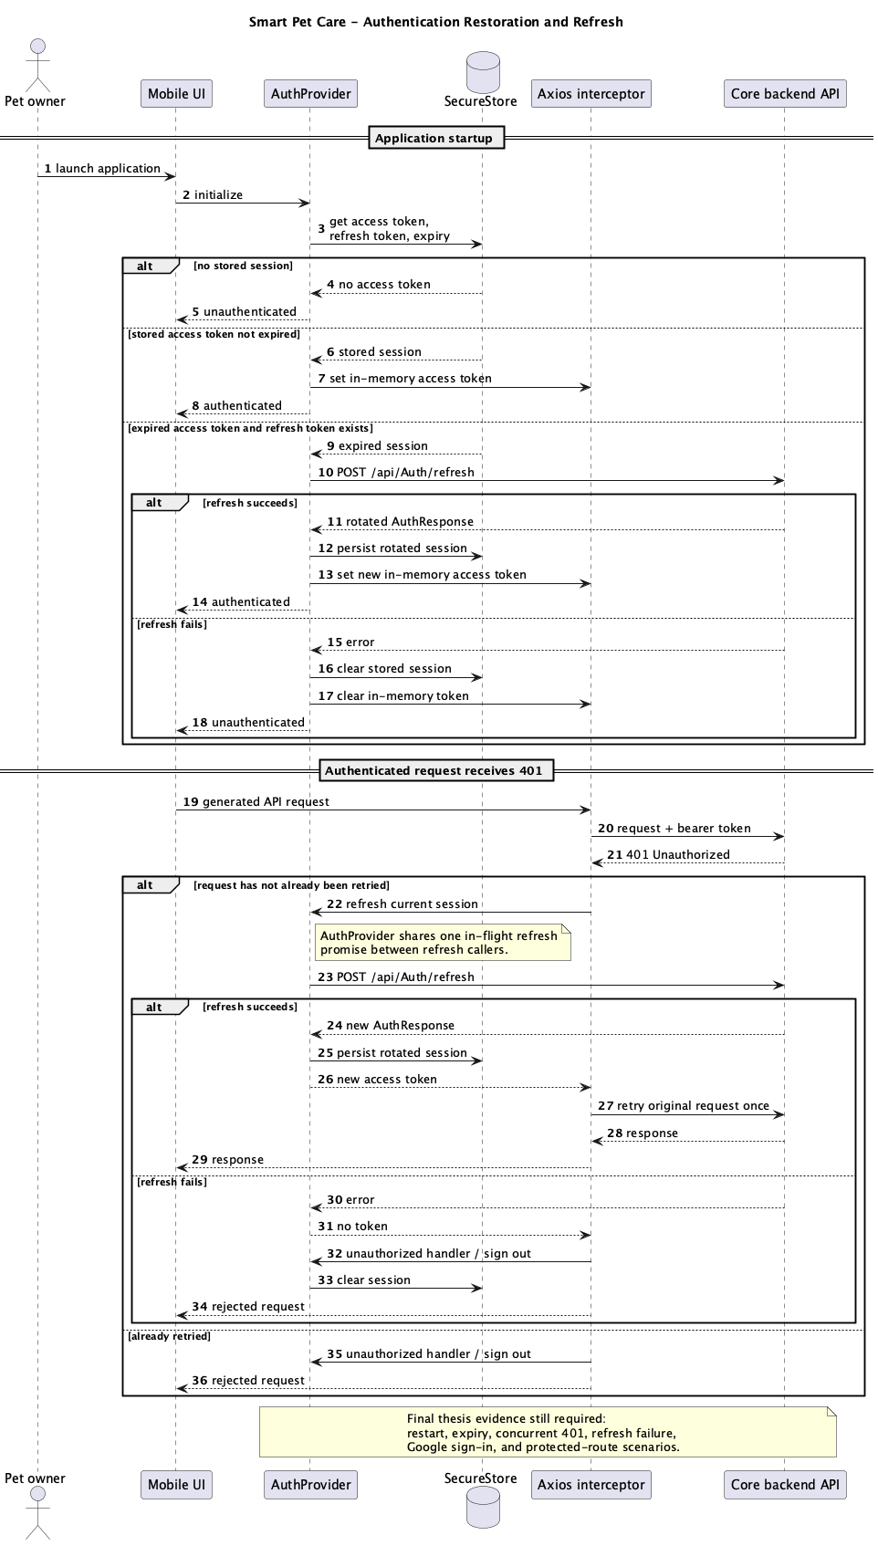
Figure 3.6. Authentication restoration and access-token refresh sequence (source: authors' own work; working draft requiring verification).
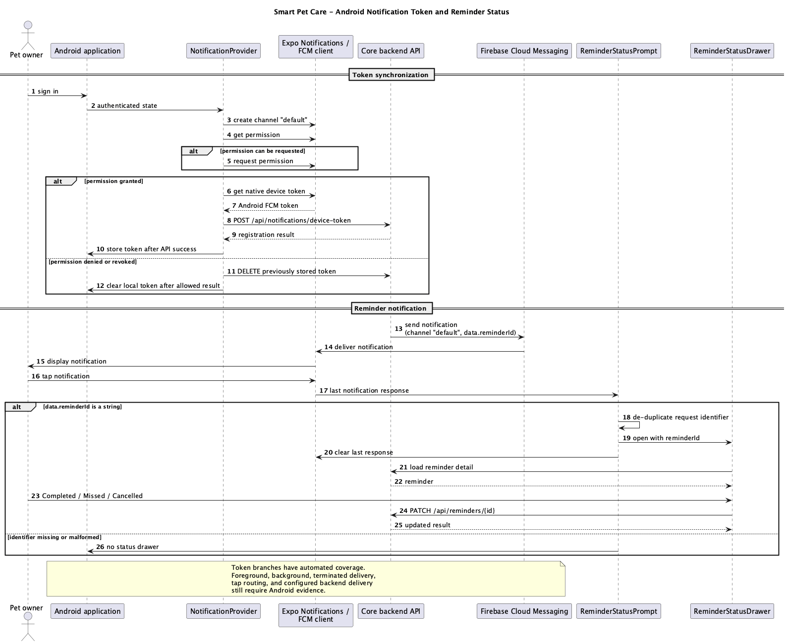
Figure 3.7. Android notification-token synchronization and reminder-status interaction (source: authors' own work; working draft requiring verification).
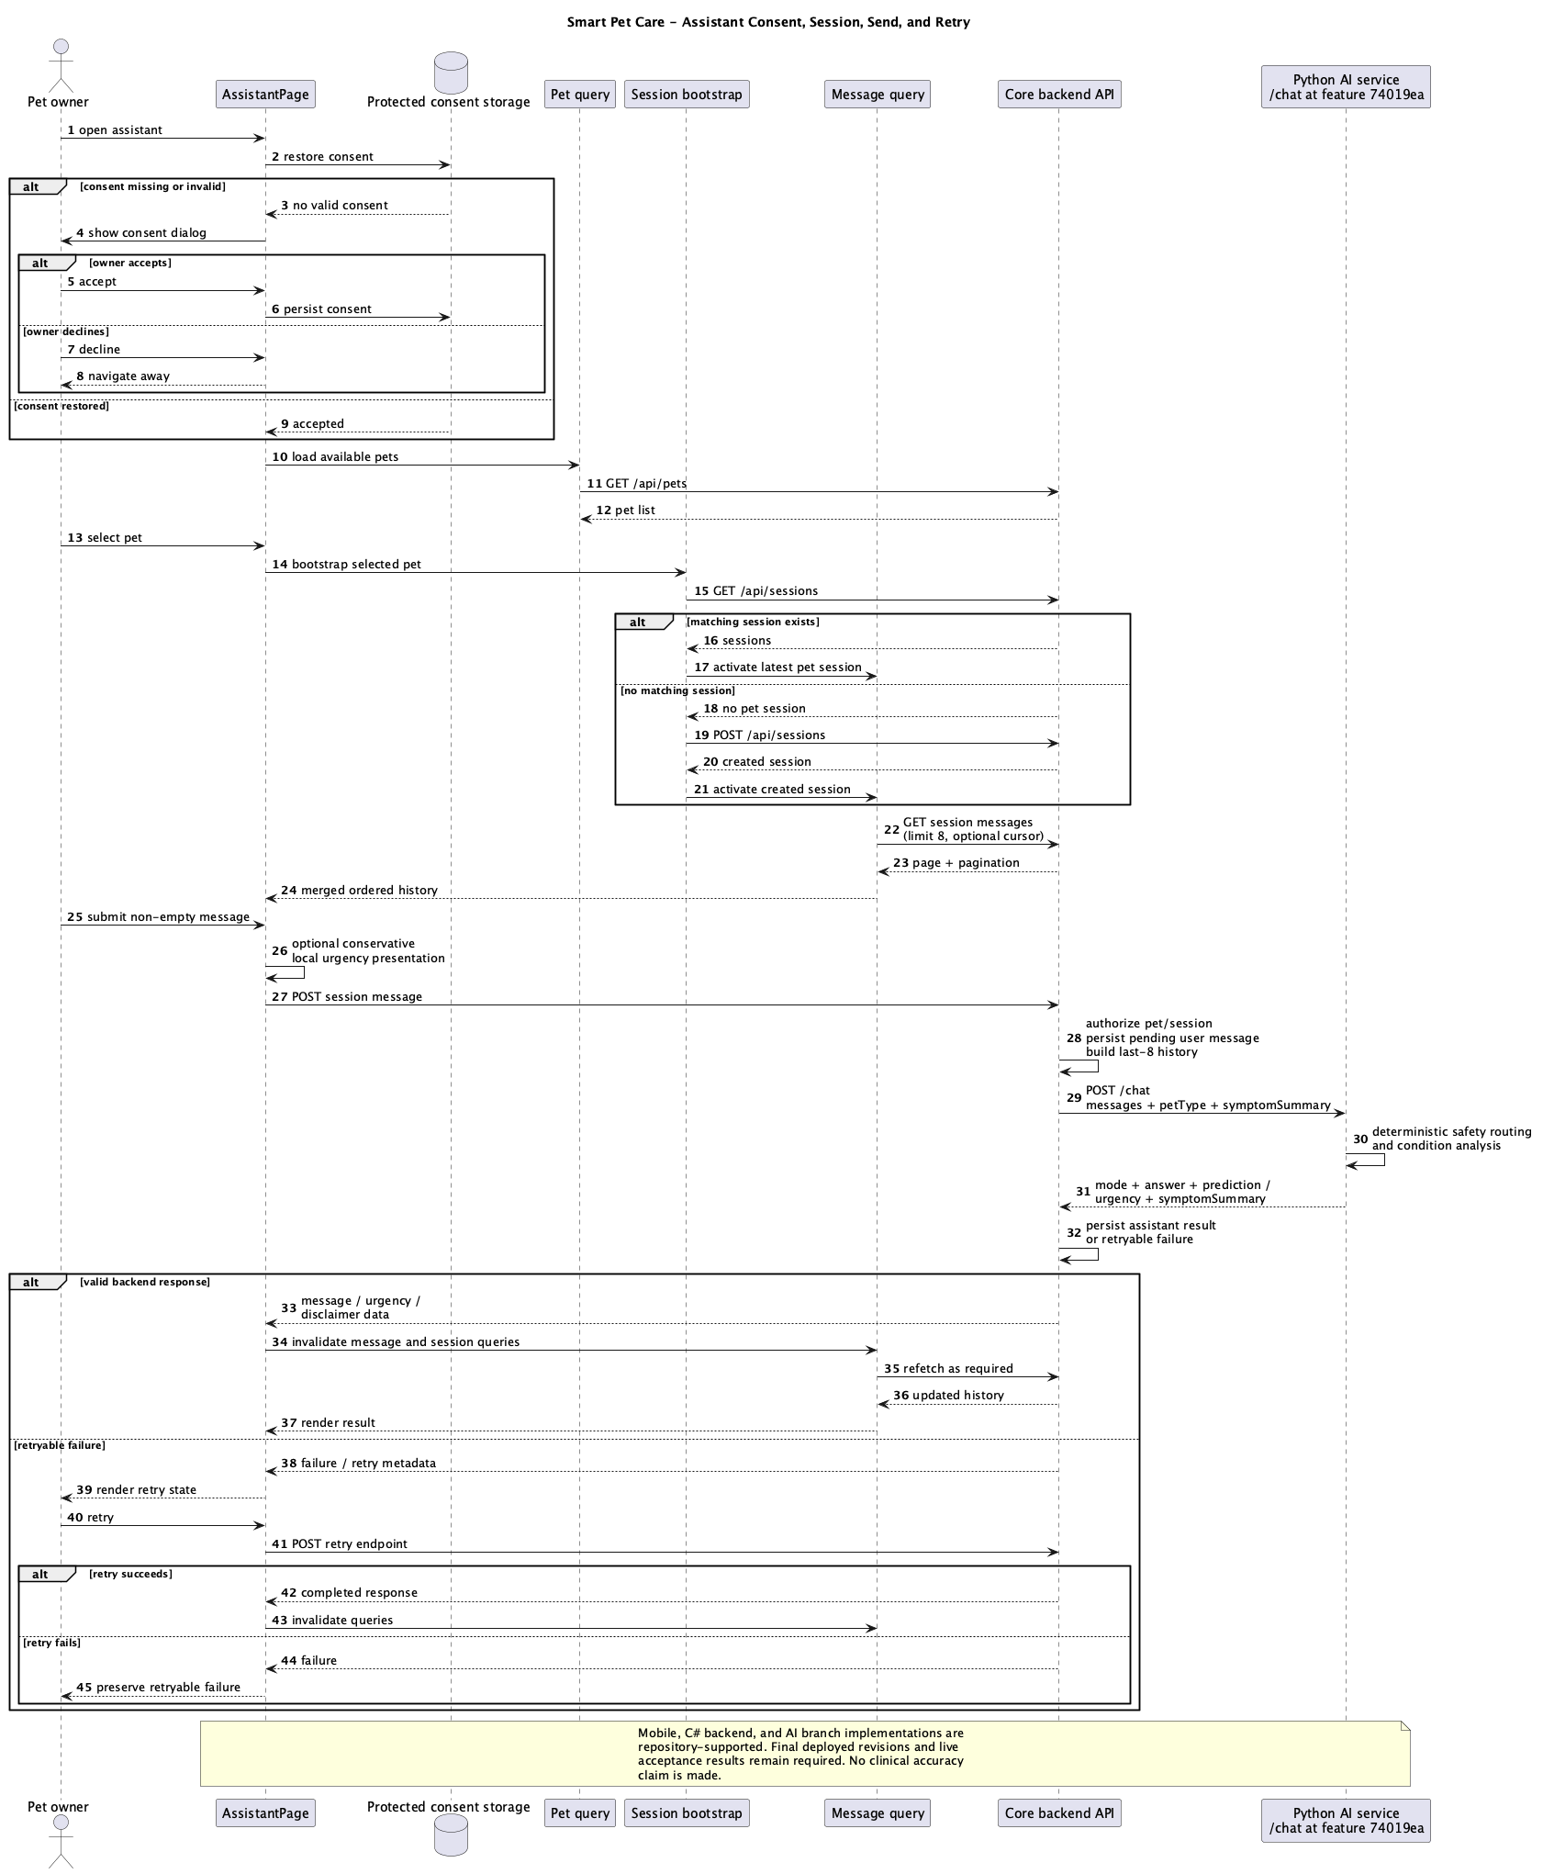
Figure 3.8. Assistant consent, pet-scoped session, message submission, and retry sequence (source: authors' own work; working draft requiring verification).
AUTHOR INPUT REQUIRED: Review Figures 3.3-3.8 against the final approved requirements, Android release, OpenAPI contract, backend implementation, and AI-service evidence. Resolve the provisional User-Pet multiplicity and external AI topology, then remove all draft labels before submission.

3.5 Technology-selection method
WHO WRITES THIS: Illia writes technical decisions; Kseniia checks sources and rejected alternatives.
TIP: For each important technology record the requirement, alternatives actually considered, decision criteria, trade-off, participants, and reconsideration trigger.
Technology decisions were assessed against project constraints rather than described as universally optimal. The working criteria are platform reach, team competence, native API access, typed integration, development and release workflow, testability, maintainability, performance risk, ecosystem maturity, and compatibility with the backend contract. Cross-platform performance remains context dependent [1], so current dependency presence or popularity cannot establish superiority.
To limit retrospective rationalization, the audit distinguishes versioned implementation evidence from ignored local OpenSpec decision records and from missing author confirmation. Table 3.1 therefore uses present-tense claims for the evaluated client. Expo Router, TanStack Query, Orval, and Zod documentation explains library behavior [15, 16, 20, 21, 23], but project selection history must come from the team's own dated evidence.
Table 3.1. Provisional technology-decision matrix for the evaluated mobile client (source: authors' own work based on revision 0d5e33b and local OpenSpec records inspected on 25 July 2026).
Technology boundary | Repository evidence | Recorded rationale / alternative | Thesis status
Expo, React Native, and Expo Router | `package.json`, `app.json`, routes, native plugins, typed routes, and runtime/update configuration | Local record selects route-level boundaries over one top-level boundary and rejects a separate assistant route group/fifth tab. | Implemented; original framework-selection date, participants, and alternatives unverified
TypeScript and Zod | Strict compiler configuration plus feature schemas for forms, routes, persistence, and runtime boundaries | Local records select route-entry parsing and discriminated models instead of unsafe coercion. | Implemented; original language and schema-library choice history unverified
TanStack Query and Axios | Shared clients/providers and feature query/mutation hooks implement transport, caching, and invalidation | Local records reject global focus refresh, central option maps, and direct page-to-Axios assistant coupling. | Implemented; initial library comparison and team approval unverified
OpenAPI and Orval | Committed contract, Orval configuration, generated Axios client/models, and reproducibility record | Local record keeps generated calls behind feature hooks and rejects coercing incomplete DTOs into obsolete richer types. | Implemented; original generator-versus-handwritten-client decision unverified
Unistyles and reusable UI primitives | Theme configuration, shared components, feature styles, and Figma-related repository history | No explicit comparison with React Native StyleSheet, styled-components, or another styling system was found. | Implemented; comparative rationale is retrospective until author-confirmed
Jest and React Native Testing Library | Configured commands, test files, and recorded unit/component results | Design records require deterministic boundary tests but contain no initial test-framework comparison. | Implemented; choice criteria, participants, and alternatives unverified
EAS Build and Expo Updates | Build profiles, channels, fingerprint runtime policy, and CI workflows | No release-platform comparison was found; configuration proves intended process, not a production deployment. | Configured; selection history and final deployment proof unverified

Table 3.1 supports the narrower conclusion that the technologies are implemented coherently and that several later architecture refinements have written trade-offs. It does not prove that all alternatives were prototyped, benchmarked, or approved by the four-person team. The ignored OpenSpec files are useful working records, but their filenames and filesystem dates are weaker provenance than versioned issues, commits, or signed meeting notes.
AUTHOR INPUT REQUIRED: Confirm Table 3.1 with the relevant owners. For every retained row, record the decision date or phase, participants, requirement or constraint, alternatives genuinely reviewed, accepted trade-off, and reconsideration trigger. Link versioned decision evidence where available and remove any retrospective rationale that the team cannot verify.

3.6 Verification method
WHO WRITES THIS: Illia writes the verification process; Kseniia checks methodology; every technical owner supplies test procedures.
TIP: Define PASS, FAIL, BLOCKED, and NOT RUN; record revision, environment, steps, expected/observed result, executor, date, and evidence for each test.
Verification is organized around requirements rather than around a single test command. ISO/IEC/IEEE 29119-2:2021 defines generic software test processes applicable across development life cycles [8]. For this project, each final requirement should identify a test level, preconditions, input data, device or runtime, steps, expected result, observed result, evidence location, executor, date, and defect reference where applicable.
The planned evidence layers are source and contract review; strict TypeScript and lint checks; automated unit, hook, context, component, and page tests; generated-client checks; Android user scenarios; notification lifecycle checks; offline and recovery scenarios; accessibility review; and measurements performed on named devices and datasets. Security checks are scoped to named OWASP MASVS categories [17]. Assistant checks cover software safety behavior and do not claim veterinary correctness.
Each executed protocol item receives one primary outcome. PASS means that the observed result matches the approved expectation and that the identified final system, executor, date, and sanitized evidence are complete. FAIL means that the observed result contradicts the expectation. BLOCKED means that a stated precondition or external dependency prevented execution, while NOT RUN means that the team did not execute the item. A thesis-level label such as partially verified may summarize several items, but it must not replace these primary outcomes in the underlying records.
Requirement-level synthesis uses the most restrictive mandatory outcome rather than a majority vote. A requirement is verified only when every mandatory mapped item passes on the identified final system; any failed, blocked, or not-run mandatory item keeps the requirement open and is discussed explicitly. Quantitative results must retain units, dataset size, device state, repetitions, aggregation method, and raw observations. Inferential claims are excluded unless the authors approve a study design that supports them.
AUTHOR INPUT REQUIRED: Create the final traceability/results table. Repeat all automated checks on a clean final revision, execute the Android scenarios, preserve sanitized logs and screenshots, and record all failures as well as passes.

4. Project implementation
WHO WRITES THIS: Each technical owner writes their subsections; Illia integrates the chapter.
TIP: Write what was actually built, why important decisions were made, problems encountered, solutions applied, and evidence for each subsystem.
AUTHOR INPUT REQUIRED: The paragraphs in this chapter are repository-grounded starting points. Each technical lead must verify and rewrite the sections describing their work, add diagrams/screenshots, and document important problems encountered during implementation.

4.1 Mobile application structure
WHO WRITES THIS: Illia writes; Anastasia reviews frontend/product structure.
TIP: Explain Expo Router, providers, feature modules, shared components, state/data flow, and which accepted revision contains the structure.
The executable entry point loads the shared style and API configuration before delegating to Expo Router. Routes are declared by the directory structure under `src/app`, with separate unauthenticated and tab-based route groups. The root layout loads fonts, controls the splash-screen transition, applies Android navigation-bar behavior, and wraps navigation with application and authentication providers.
The application provider composes the gesture, keyboard, bottom sheet, server-state, portal, and toast infrastructure. Domain features are separated into `auth`, `home`, `pets`, `reminders`, `profile`, `notifications`, and `assistant` modules. Each feature combines only the pages, components, queries, schemas, utilities, and local translation resources it needs, while shared API, UI, style, and error-recovery code remains under common modules.
Repository attribution was evaluated at two scopes. The ancestry reachable from revision `0d5e33b` contains 26 human commits, all attributed to Illia Dolbnia. The separate `feature/care-screen` branch has the evaluated revision as its merge base and is 30 commits ahead, all attributed to Anastasia Leonova. Commit identity supports a repository-visible contribution, not sole design authorship, complete effort, or a contribution percentage.
Table 4.1. Repository-grounded mobile implementation attribution and release-inclusion boundaries (source: authors' own work based on revision 0d5e33b and local Git references inspected on 25 July 2026).
Implementation scope | Paths / revisions | Visible attribution | Inclusion and claim boundary
Application shell and shared UI | `src/app`, `src/common`, `src/styles`, `src/shadecn`; 8ee6c2e-0d5e33b | Reachable commits attributed to Illia | Present in evaluated revision; design, review, and pair contributions unverified
Authentication and profile | `src/auth`, `src/profile`; 63a6b46, 47b8c7f, 1d25103 | Reachable commits attributed to Illia | Client implementation present; backend and final device behavior separate
Pets, reminders, and notifications | `src/pets`, `src/reminders`, `src/notifications`; 8f17f55-1d25103 | Reachable commits attributed to Illia | Client paths present; CRUD, scheduling, FCM, and lifecycle results unverified
Assistant client | `src/assistant`; 0d5e33b | Reachable commit attributed to Illia | Client present; AI-service implementation and clinical validity not proved
Care-screen branch | `feature/care-screen`; 9c54123-15da8ee; 30 branch-only commits | Branch-only commits attributed to Anastasia | Not in evaluated revision; mock-backed and without care-specific tests
C# core backend | `smart-pet-care-api`; main through 6d79951 | Volodymyr: 39 non-merge commits; Kseniia: four squash commits | Implementation evidence present; final release and runtime acceptance remain separate
Python AI service | `pet-diseases-classifier`; main 682dfb5; unified-chat branch 74019ea | Seven commits attributed to Illia | Implementation and branch evidence present; merged/deployed revision and model evaluation remain open

Table 4.1 establishes that the evaluated client and the care-screen branch are different evidence populations. The branch proves that Anastasia has a substantial visible frontend history, but its mock collections, absence from the evaluated revision, and lack of care-specific test files prevent a claim of accepted or backend-integrated release functionality. Final allocation must also include Figma, reviews, external repositories, testing, research, and coordination evidence.
AUTHOR INPUT REQUIRED: Add author attribution, source-code figure or diagram references, implementation decisions, encountered problems, and verified results.

4.2 Authentication and session lifecycle
WHO WRITES THIS: Illia writes the mobile flow; Volodymyr writes or reviews backend authentication behavior.
TIP: Describe registration/login, token storage, restoration, refresh, concurrent 401 handling, Google sign-in, logout, and related mobile/backend tests.
The authentication context models three client states: loading, authenticated, and unauthenticated. Email/password and Google flows pass a backend authentication response to one session transition. Access tokens, optional refresh tokens, and expiry timestamps are stored through the shared SecureStore policy and mirrored in memory so request interceptors do not read protected storage for every request.
On startup, the context loads the stored session. An unexpired access token is applied directly; an expired session with a refresh token attempts one refresh before local data is cleared. A shared promise serializes refresh calls inside the context. The Axios interceptor adds the current bearer token, retries a particular failed request at most once after a successful refresh, and invokes the registered unauthorized handler when recovery fails.
Sign-out attempts to unregister the stored Android notification token and clear a previous Google session, then deletes local authentication material and transitions the client to the unauthenticated state. Automated tests cover failure tolerance during this cleanup, but restoration, expiry, concurrent `401` handling, and configured Google sign-in still require final scenario evidence.
AUTHOR INPUT REQUIRED: Add author attribution, source-code figure or diagram references, implementation decisions, encountered problems, and verified results.

4.3 Pet-profile management
WHO WRITES THIS: Anastasia describes the UI; Illia describes mobile integration; Volodymyr confirms backend behavior.
TIP: Describe list/detail/create/edit/delete/photo and accepted weight/health/care flows, cache invalidation, validation, backend endpoints, and Android evidence.
The pet module separates list and profile pages from create, edit, delete, and photograph interactions. List and detail queries use distinct server-state keys. Successful creation invalidates the list, updating writes the returned pet into the detail cache before invalidation, and deletion invalidates both the list and the removed detail. This behavior is intended to keep screens consistent with the backend without treating cached data as an independent source of truth.
Before photograph upload, the selected image is rendered and saved as a compressed JPEG. The client converts the native file URI into a React Native multipart value and sends it to the contract endpoint. This implementation choice reduces upload size and handles the native networking boundary, but image dimensions, quality, permissions, failure recovery, and actual backend storage must be evaluated on the final Android build.
AUTHOR INPUT REQUIRED: Add author attribution, source-code figure or diagram references, implementation decisions, encountered problems, and verified results.

4.4 Reminders and native notifications
WHO WRITES THIS: Illia writes mobile and FCM-client behavior; Volodymyr writes backend reminder and notification behavior.
TIP: Describe reminder CRUD, schedules/time zones, FCM token registration/rotation, notification tap routing, backend delivery, and lifecycle tests.
Reminder pages and drawers implement list, description, creation, status, update, and deletion interactions. Read queries distinguish all reminders, pet-scoped reminders, and detail records. Create and schedule-changing update requests add the current UTC offset, and successful mutations invalidate the reminder query family. The use of a 60-second stale interval for reminder queries is a client caching decision, not a guarantee of real-time delivery.
When an authenticated Android client becomes active, the notification provider creates the default channel, checks or requests permission, obtains the native Android push token, and synchronizes it with the backend. Token rotation triggers another registration. A replaced token is deleted where possible, and sign-out attempts remote and local cleanup. Eight automated tests cover these token and permission branches.
A tapped notification is accepted only when its data contains a string `reminderId`. The response identifier prevents duplicate handling, and a reminder-status drawer is opened for the parsed identifier. This source path does not prove delivery or routing in foreground, background, and terminated application states. Those lifecycle cases, notification icons, channel behavior, and permission revocation require device-level evidence.
AUTHOR INPUT REQUIRED: Add author attribution, source-code figure or diagram references, implementation decisions, encountered problems, and verified results.

4.5 Pet-scoped assistant
WHO WRITES THIS: Illia writes mobile and Python AI analysis; Kseniia writes the C# persistence/integration part; Volodymyr reviews shared backend work.
TIP: Separate mobile presentation, C# session/history integration, and Python analysis; explain consent, last-eight context, safety rules, prediction, Gemini text, failures, and disclaimers.
Assistant entry is gated by stored consent and pet selection. For the active pet, the client loads existing backend sessions, selects the latest matching session, or creates the first session when none exists. A pet-reference guard prevents completion for a previous selection from replacing the current state. Message history is loaded in cursor pages of eight records and normalized before presentation.
Sending and retrying use dedicated backend endpoints and query keys. Successful sends mark the relevant history stale without immediately discarding displayed data and invalidate the session list. Runtime schemas restrict request length and validate response identifiers, mode, answer, optional prediction, urgency, confidence ranges, related topics, clarification state, and disclaimer before the client treats a response as valid.
A short local phrase list can trigger immediate conservative emergency presentation while a message is still submitted. This logic is not a classifier and must not be described as emergency detection. The server-provided urgency and prediction fields are also presentation data rather than clinical validation. Seven mobile test files cover consent, session bootstrap, pagination, send, retry, rate limiting, malformed states, urgency presentation, and selected accessibility behavior.
The C# service persists sessions and messages, supplies at most eight prior messages plus the latest symptom summary to the downstream service, and implements retry metadata, failure mapping, metrics, and a circuit breaker. The AI service's unified `/chat` branch applies deterministic emergency and abstention rules, invokes the local condition classifier for health mode, and uses Gemini for human-readable response generation. The C# layer therefore owns integration and history, while the AI service owns analysis. A versioned live-service evaluation is still required.
AUTHOR INPUT REQUIRED: Add author attribution, source-code figure or diagram references, implementation decisions, encountered problems, and verified results.

4.6 Offline behavior and error recovery
WHO WRITES THIS: Illia writes and supplies mobile recovery evidence.
TIP: Describe what remains visible offline, which operations fail or pause, reconnection behavior, retry limits, error UI, and tested transitions.
A shared connectivity adapter passes native connection and internet-reachability changes to the server-state manager. Queries are configured to refetch after reconnection, with automatic query retry disabled and a default one-hour stale interval unless a feature overrides it. The global offline banner and route error fallback distinguish offline recovery from a generic rendering failure.
This design pauses or recovers selected reads but does not implement an offline mutation queue, conflict resolution, or complete offline operation. The final evaluation must show what data remains visible, what actions are disabled or fail, and how authentication, pets, reminders, and assistant state behave across an offline-to-online transition.
AUTHOR INPUT REQUIRED: Add author attribution, source-code figure or diagram references, implementation decisions, encountered problems, and verified results.

4.7 User interface, localization, and accessibility
WHO WRITES THIS: Anastasia writes product, UX, and design decisions; Illia adds implementation and test evidence.
TIP: Explain design system and major UX choices; provide Figma/screenshots and evidence for English localization, labels, scaling, contrast, focus, and touch targets.
The interface uses shared style tokens and UI primitives together with feature-specific pages and components. Inter and Fraunces font families are loaded before the splash screen is hidden. Bottom sheets, portals, keyboard control, gestures, toasts, skeletons, and route-level recovery provide repeated interaction patterns across features.
Internationalization resources are divided by feature namespace, but the configured language inventory currently contains English only. This organization supports future translation; it does not make the current application multilingual. The final thesis must describe English localization accurately and should not list loaded date-library locales as available interface languages.
Selected components expose accessibility labels, hints, or target sizes, and assistant urgency is presented with text or icon cues rather than color alone. Current automated accessibility evidence is limited to the assistant page. Manual Android evaluation of focus order, TalkBack output, font scaling, contrast, touch targets, and error announcements is required across every critical flow.
AUTHOR INPUT REQUIRED: Add author attribution, source-code figure or diagram references, implementation decisions, encountered problems, and verified results.

4.8 External backend and AI-service boundaries
WHO WRITES THIS: Volodymyr writes core C# backend; Kseniia writes owned backend features and classifier integration; Illia writes Python AI service.
TIP: Document final repository revisions, owned modules, data flow, contracts, persistence, model/provider boundary, resilience, deployment, monitoring, and tests.
The core backend was inspected in the public `smart-pet-care-api` repository through main revision `6d79951`. It is an ASP.NET Core service with Entity Framework migrations, PostgreSQL persistence, JWT-based authentication, pet ownership checks, OpenAPI documentation, Firebase notification integration, and modules for users, pets, photographs, weight, health, feeding, reminders, journal, and chat. Docker and workflow artifacts describe build and deployment paths, but the final hosted release and its sanitized runtime configuration still require an acceptance record.
The chat module makes the service boundary explicit. The C# backend owns authorization, session replacement, message persistence and status, history ordering and truncation, symptom-summary persistence, request forwarding, timeout and cancellation handling, error translation, retry metadata, metrics, and circuit-breaker behavior. The downstream Python service is stateless and owns general-versus-health routing, symptom analysis, condition prediction, urgency assignment, clarification behavior, and the informational answer. This allocation prevents the C# integration work from being misdescribed as implementation of the analysis model.
The Python `pet-diseases-classifier` repository is attributed entirely to Illia Dolbnia in its visible history. Its main revision `682dfb5` contains FastAPI `/predict`, `/ask`, and `/wellness` routes plus AWS SAM and container definitions. The integrated stateless `/chat` contract, deterministic emergency and abstention rules, tests, CI, ONNX support, and model-release documentation are present on `origin/feature/unified-caht-endpoint-tests-and-docs` at `74019ea`. Because that revision is not the repository's main branch, the team must identify whether it was merged, tagged, or deployed before calling it the final production release.
An authenticated, read-only comparison on 25 July 2026 found additive contract drift between the committed mobile snapshot and the configured backend description. The committed description contains 34 paths, 50 operations, and 60 component schemas; the fetched description contains 38 paths, 57 operations, and 70 schemas, with no removals. The additions cover pet journal operations, a symptom catalogue, and symptom support in the existing health-record contract. The generated client inspected during the check contains no corresponding journal or symptom-catalogue symbols. This result proves that release reconciliation is required; it does not prove endpoint behavior, mobile implementation, backend revision attribution, or clinical validity.
A separate temporary generation check used the installed Orval 8.14.0 client generator against the committed snapshot without overwriting repository source. The temporary and committed generated `index.ts` files were byte-for-byte identical: both contained 1,252 lines, occupied 34,534 bytes, and had SHA-256 `6116b5bab5e86f7e7abbeb8c3fa1df66554127f8995113a7d520e2f398f43aa2`. A fresh strict TypeScript check also passed. This proves deterministic generation for the currently committed snapshot, not approval of that snapshot as the final contract, live endpoint behavior, or final Gate A-02; the worktree was not clean and the live additive drift remains unresolved.
Backend Git evidence separates the two backend roles. Volodymyr Biletskyi authored the dominant architectural and feature history, including persistence, authentication, pet CRUD, reminders, notifications, health, journal, OpenAPI, and deployment work. Kseniia Kushlak's identifiable squash commits cover Cloudinary pet photographs, feeding, weight history and tests, and classifier/chat integration; the last two commits record Volodymyr as co-author. Jira assignments provide planning context but do not override contradictory commit and comment evidence.
AUTHOR INPUT REQUIRED: Insert final immutable service tags or image digests, sanitized deployment records, successful live contract exchanges, database migration state, monitoring evidence, and test results. Redact all secrets and personal data.

4.9 Verification results
WHO WRITES THIS: Illia assembles; every owner supplies results for their modules and reviews the interpretation.
TIP: Report observed results in tables with exact revisions and environments; include failures and limitations and avoid converting repository presence into PASS.
A provisional repository validation was repeated on 25 July 2026 at Git revision `0d5e33b091e9582a7075786c0b9cf724510825f9` with Node.js `v24.18.0`. The configured `pnpm lint` command and a separate strict TypeScript check completed with exit code zero. A broader `eslint . --max-warnings=0` check failed with one Prettier error and zero warnings in the ignored generated declaration `expo-env.d.ts`. The same broad diagnostic passed with `--ignore-pattern expo-env.d.ts`. The configured static gate therefore passes, while the exact final generated-file exclusion still requires approval and a clean-revision rerun.
Nine of nine Jest suites and 79 of 79 tests passed in repeated standard and `--detectOpenHandles` executions. The latest standard run reported that Jest did not exit one second after completion, while the latest diagnostic run reported no concrete open handle. Earlier executions emitted React `act(...)` warnings from assistant-query/page or `VirtualizedList` update paths, with counts that varied by timing and grouping. The result is therefore passing but not teardown-clean. Seven of the nine test files target the assistant module; the other two target authentication sign-out and Android notification-token registration. No current test file directly targets the pet, reminder, home, profile, or general navigation modules.
An Android-only Expo export also completed, bundling 2,817 modules and 84 assets. The generated Hermes bundle occupied approximately 6.8 MiB on disk and had SHA-256 `b4785f3588da7eab6f7e45c36745804c7d3df889b1b72b4f4fae32fbff34fb7d`. This demonstrates JavaScript and asset bundling in the evaluated environment; it does not demonstrate an APK, native linking, installation, OAuth, FCM delivery, live backend behavior, or production deployment. The working tree was not clean, so the Git revision alone does not identify the evaluated file state.
A connected physical Samsung SM-G781B running Android 13 (API 33) was also inspected on 25 July 2026. Android reported the installed package `com.anonymous.smartpetcareapp`, version 1.0.0, version code 1, target SDK 36. The main activity resolved successfully and `am start -W` returned status `ok` with a 3,057 ms wait time. The device remained locked, so the UI hierarchy exposed Android System UI rather than application content. The installed artifact was not linked by digest to the evaluated source revision; consequently, this is device and launch-intent availability evidence, not a functional or performance result.
Table 4.2 classifies the evidence currently available for the working draft. Its rows are checkpoints, not a substitute for the final requirement-results matrix. In particular, a provisional pass is limited to the exact sub-check and evaluated file state described in the evidence column.
Table 4.2. Current verification checkpoints and claim boundaries (source: authors' own work based on the recorded 25 July 2026 evidence).
Checkpoint | Current observation | Bounded interpretation
A-02 | Orval 8.14.0 reproduced the committed generated client byte-for-byte. | Current-snapshot sub-check passes; final contract approval and clean-release rerun remain open.
A-03 | Configured lint completed with exit code zero. | Provisional static pass for the evaluated worktree; repeat on the final clean revision.
A-03b | Broad lint failed on the ignored generated declaration and passed when that file was excluded. | Final scope and exclusion are unapproved; the checkpoint remains open.
A-04 | Strict TypeScript checking completed with exit code zero. | Provisional pass for the evaluated file state; repeat on the final clean revision.
A-05 | Nine suites and 79 tests passed, but delayed exit and earlier asynchronous warnings remain unresolved. | Passing assertions do not satisfy the warning-free final gate; the checkpoint remains open.
A-06 | Android Expo export produced a JavaScript and asset bundle. | Bundling sub-check passes; no native build, installation, or functional behavior is established.
Device | Android exposed package metadata and accepted the launch intent while the device remained locked. | Availability only; no Gate B-F functional, accessibility, or performance item passes.
Contract | The configured live description contains additive journal and symptom surfaces. | Drift is verified; endpoint behavior and final release consistency remain unverified.

The current evidence therefore supports selected static, generation, and bundling observations only. It does not yet verify FR-01-FR-12, Android accessibility or performance, notification lifecycle behavior, or live backend and assistant-service behavior. The final version must replace this checkpoint view with requirement-level outcomes, preserve all failures and blocked or not-run items, and use those outcomes as the sole basis for the summary and conclusions.
AUTHOR INPUT REQUIRED: Repeat all checks on the final clean revision, approve and encode the exact generated-file lint exclusion, resolve every unaccepted test warning and delayed-exit condition, add Android and external-service scenario evidence, and replace this provisional text with the complete requirement-results table.

5. Deployment and operation
WHO WRITES THIS: Volodymyr writes backend deployment; Illia writes mobile and AI deployment and integrates the chapter.
TIP: Explain how each accepted component is configured, built, deployed, operated, monitored, and rolled back using sanitized evidence.

5.1 Prerequisites and configuration
WHO WRITES THIS: Illia documents mobile/AI prerequisites; Volodymyr documents backend/database prerequisites.
TIP: List exact supported tool/runtime versions, required environment variables by name only, external services, database setup, and secret-handling rules.
The repository declares Node.js 24.18.0 and pnpm 11.5.1. The mobile client uses Expo 56 and React Native 0.85.3. It requires a backend API URL and web, iOS, and Android Google OAuth client identifiers from the configured identity project. Android push-notification builds additionally require the Firebase Android client configuration. `EXPO_PUBLIC_*` values are compiled into the client and must never be treated as secrets; backend credentials, Firebase service-account material, signing data, and access tokens must not be included in the thesis or client bundle.
The committed application configuration declares portrait orientation, the Android package `com.anonymous.smartpetcareapp`, an iOS bundle identifier, the `smartpetcareapp` scheme, a fingerprint-based EAS runtime policy, and native plugins for protected storage, notifications, Google sign-in, image selection, and date/time input. These declarations require confirmation against the final release. The Android manifest request for `RECORD_AUDIO` must be justified by an evaluated feature or removed before release.

5.2 Installation and Android execution
WHO WRITES THIS: Illia writes and supplies the final Android build, installation, and execution evidence.
TIP: Give repeatable build/install/run steps and record device model, Android/API level, package/version, artifact digest, and observed launch result.
Table 5.1 summarizes the repository-grounded installation and Android execution sequence. It separates reproducible local steps from external configuration that must be supplied through approved channels.
Table 5.1. Installation and Android execution sequence (source: authors' own work based on repository configuration).
Step | Repository command or action | Purpose
1 | `pnpm install --frozen-lockfile` | Install the declared dependency graph reproducibly
2 | Generate and compare the API client | Confirm the approved OpenAPI snapshot is reproducible
3 | Copy `.env.example` to `.env` | Create local public configuration without committing values
4 | Set `EXPO_PUBLIC_API_URL` | Select the external backend host
5 | Configure OAuth client identifiers | Enable native Google sign-in
6 | Provide Android Firebase client file | Enable native FCM registration
7 | `pnpm android` or an identified EAS artifact | Build, install, and run the native Android application

Expo Go cannot validate the native Google sign-in and FCM paths used by this project. The repository defines internal Android APK profiles for development and preview, plus a production profile with automatic version incrementing. A successful Metro export is a useful bundling gate but does not replace native build and installation evidence.
AUTHOR INPUT REQUIRED: Re-run these steps from a clean checkout and record the exact successful environment. Never paste real tokens, passwords, or private configuration.

5.3 External system boundaries
WHO WRITES THIS: Volodymyr documents backend, database, and Firebase boundaries; Illia documents Google and AI-service boundaries.
TIP: Explain Google identity, Firebase, Cloudinary if retained, backend database, and AI service responsibilities, credentials, protocols, timeouts, and failure behavior.
The backend is external to the mobile repository. The client consumes a committed OpenAPI snapshot and regenerates a typed Axios and server-state client. Google identity and Firebase messaging are also external service boundaries. A final deployment diagram must show the actual hosted nodes, interfaces, and communication protocols supplied by the backend leads.
The pull-request workflow declares frozen dependency installation, API generation, lint, TypeScript, Jest, and Expo export gates. Separate preview workflows request an EAS Android build when native-affecting configuration changes and publish JavaScript/asset updates for other changes. The fingerprint runtime policy helps separate compatible updates from builds requiring new native binaries. Workflow definitions prove intended automation, not successful runs; final GitHub Actions and EAS identifiers are still required.

5.4 User operation
WHO WRITES THIS: Anastasia writes user instructions and selects screenshots; Illia confirms they match the final build.
TIP: Write short step-by-step instructions for the final core flows and insert sanitized screenshots taken from the identified accepted build.
The intended operating sequence begins with email or Google authentication, continues through the home overview and pet-profile creation, and then exposes pet-scoped reminders and the assistant. A notification carrying a valid reminder identifier opens the status workflow. Assistant use requires consent and pet selection, and its responses must be presented as informational rather than diagnostic. Profile maintenance and sign-out complete the owner-facing lifecycle.
AUTHOR INPUT REQUIRED: Insert final-artifact screenshots and concise numbered instructions for authentication, pet creation, reminder management, notification status, assistant use, profile update, and sign-out. Record the build, device, test-data identity, and observation date; redact all personal and secret data.

5.5 Maintenance and limitations
WHO WRITES THIS: Volodymyr writes backend operational limits; Illia writes mobile/AI limits; all authors review.
TIP: Describe migrations, logging, monitoring, backups, dependency/model updates, rollback, known defects, operational risks, and future improvements.
The API client is regenerated from the committed OpenAPI contract rather than edited directly. Contract changes require regeneration, type checking, review of the resulting diff, and coordinated backend versioning. Native dependencies, notification configuration, OAuth configuration, and incompatible runtime changes require a native rebuild; JavaScript and asset changes may be eligible for a compatible EAS update.
A thesis-evaluated release should identify the mobile revision, lockfile and artifact digests, OpenAPI snapshot, backend and AI-service releases, EAS build profile and identifier, environment, device, executor, and evidence location. Current limitations include uneven automated-test distribution, unresolved test warnings and direct-ESLint scope, unverified native permissions, missing Android scenario results, and unavailable external-service deployment evidence.

Summary and conclusions
WHO WRITES THIS: All authors provide conclusions from their area; Illia assembles the final two-page section.
TIP: Answer the objective and every acceptance criterion using final results; state achieved, partial, failed, and future work without adding new evidence.
AUTHOR INPUT REQUIRED: Write this section only after the final results are available. Address every objective and acceptance criterion, distinguish achieved and partially achieved outcomes, interpret evidence, discuss problems and trade-offs, and identify grounded future work. Maximum two pages.

Bibliography
WHO WRITES THIS: Kseniia maintains and verifies the bibliography; all authors confirm sources used in their sections.
TIP: Include only sources cited in the thesis, verify metadata against authoritative records, preserve the required format, and remove unsupported or duplicate entries.
DRAFT BIBLIOGRAPHY NOTE: The entries below use a continuous working numeric sequence and are cross-referenced from the current prose. Ksenia and the relevant technical lead must still review every original source. Before submission, approve the source set, preserve alphabetical ordering within both sections, renumber if any entry changes, add every source needed by later chapters, and remove every uncited entry.

Printed and scientific literature
WHO WRITES THIS: Kseniia verifies metadata, relevance, and source-to-claim mapping.
TIP: Check authors, title, journal/standard, year, volume/pages, DOI or identifier, full-text access, and the exact claim supported.
[1] Biørn-Hansen A., Rieger C., Grønli T.-M., Majchrzak T.A., Ghinea G., An empirical investigation of performance overhead in cross-platform mobile development frameworks, Empirical Software Engineering, 2020, 25, pp. 2997-3040, https://doi.org/10.1007/s10664-020-09827-6.
[2] Chu C.P., ChatGPT in veterinary medicine: a practical guidance of generative artificial intelligence in clinics, education, and research, Frontiers in Veterinary Science, 2024, 11:1395934, https://doi.org/10.3389/fvets.2024.1395934.
[3] Dorfer T., Demetz L., Huber S., Impact of mobile cross-platform development on CPU, memory and battery of mobile devices when using common mobile app features, Procedia Computer Science, 2020, 175, pp. 189-196, https://doi.org/10.1016/j.procs.2020.07.029.
[4] Haase L., Sedlmayr B., Sedlmayr M., Monett D., Winter J., Towards mHealth applications for pet animal owners: a comprehensive literature review of requirements, BMC Veterinary Research, 2025, 21:190, https://doi.org/10.1186/s12917-025-04658-3.
[5] International Organization for Standardization, ISO 9241-11:2018, Ergonomics of human-system interaction - Part 11: Usability: Definitions and concepts, Edition 2, 2018.
[6] International Organization for Standardization, ISO/IEC 25010:2023, Systems and software engineering - Systems and software Quality Requirements and Evaluation (SQuaRE) - Product quality model, Edition 2, 2023.
[7] International Organization for Standardization, ISO/IEC/IEEE 29119-1:2022, Software and systems engineering - Software testing - Part 1: General concepts, Edition 2, 2022.
[8] International Organization for Standardization, ISO/IEC/IEEE 29119-2:2021, Software and systems engineering - Software testing - Part 2: Test processes, Edition 2, 2021.
[9] International Organization for Standardization, ISO/IEC/IEEE 29148:2018, Systems and software engineering - Life cycle processes - Requirements engineering, Edition 2, 2018.
[10] International Organization for Standardization, ISO/IEC/IEEE 42010:2022, Software, systems and enterprise - Architecture description, Edition 2, 2022.
[11] Kogan L., Oxley J.A., Hellyer P., Schoenfeld R., Rishniw M., UK pet owners' use of the internet for online pet health information, Veterinary Record, 2018, 182(21):601, https://doi.org/10.1136/vr.104716.
[12] Springer S., Lund T.B., Corr S.A., Sandøe P., Does 'Dr. Google' improve discussion and decisions in small animal practice? Dog and cat owners use of internet resources to find medical information about their pets in three European countries, Frontiers in Veterinary Science, 2024, 11:1417927, https://doi.org/10.3389/fvets.2024.1417927.
AUTHOR INPUT REQUIRED: Confirm whether the complete ISO standards are available through the CDV library. If only the official abstracts were reviewed, limit the corresponding thesis claims and record the official ISO pages as online sources instead of implying full-text review.

Online sources
WHO WRITES THIS: Kseniia verifies links, access dates, metadata, and source-to-claim mapping.
TIP: Prefer official documentation; record title, publisher, stable URL, version where relevant, access date, and the thesis claim supported.
[13] 11 Pets Ltd, 11pets: Pet care, Google Play, https://play.google.com/store/apps/details?id=com.m11pets.elevenpets (accessed: 25.07.2026).
[14] Expo, Expo SecureStore, SDK 56, https://docs.expo.dev/versions/v56.0.0/sdk/securestore/ (accessed: 25.07.2026).
[15] Expo, Introduction to Expo Router, https://docs.expo.dev/router/introduction/ (accessed: 25.07.2026).
[16] Orval Labs, Overview - Generate type-safe TypeScript clients from OpenAPI specifications, https://orval.dev/docs/ (accessed: 25.07.2026).
[17] OWASP Foundation, OWASP Mobile Application Security Verification Standard (MASVS), version 2.1.0, https://mas.owasp.org/MASVS/ (accessed: 25.07.2026).
[18] PetDesk, LLC, PetDesk - Pet Health Reminders, Google Play, https://play.google.com/store/apps/details?id=com.locai.petpartner (accessed: 25.07.2026).
[19] Shibapp LLC, Dog and cat care - PetnotePlus, Google Play, https://play.google.com/store/apps/details?id=com.lancerdog.petnote_plus (accessed: 25.07.2026).
[20] TanStack, Query Invalidation - TanStack Query v5, https://tanstack.com/query/v5/docs/framework/react/guides/query-invalidation (accessed: 25.07.2026).
[21] TanStack, React Native - TanStack Query v5, https://tanstack.com/query/v5/docs/framework/react/react-native (accessed: 25.07.2026).
[22] Vitus Animal Health, Inc., VitusVet: Pet Health Care App, Google Play, https://play.google.com/store/apps/details?id=com.vitusvet.android (accessed: 25.07.2026).
[23] Zod, Basic usage, https://zod.dev/basics (accessed: 25.07.2026).

List of figures
WHO WRITES THIS: Illia updates the Word field after all figures are final.
TIP: After final captions are fixed, update the Word field and check that every figure number, title, body reference, and page number is correct.
Update after final captions are inserted.
AUTHOR INPUT REQUIRED: Use the final caption label required by the thesis language and update this field in Word.

List of tables
WHO WRITES THIS: Illia updates the Word field after all tables are final.
TIP: After final captions are fixed, update the Word field and check that every table number, title, body reference, and page number is correct.
Update after final captions are inserted.
AUTHOR INPUT REQUIRED: Use the final caption label required by the thesis language and update this field in Word.

Streszczenie
WHO WRITES THIS: Illia drafts from the final conclusions; Kseniia and the full team review the Polish text.
TIP: Write a concise Polish summary of problem, objective, method, implementation, main verified results, limitations, and five or six keywords.
AUTHOR INPUT REQUIRED: Add the final Polish abstract and five or six Polish keywords after the conclusions are approved.

Abstract
WHO WRITES THIS: Illia drafts from the final conclusions; Kseniia and the full team review the English text.
TIP: Write the English equivalent of the approved Polish summary with the same facts, result boundaries, and five or six keywords.
AUTHOR INPUT REQUIRED: Add the final English abstract and five or six English keywords after the conclusions are approved.

Team work-allocation sheet
WHO WRITES THIS: Illia collects the final entries; every author verifies and signs their allocation.
TIP: Copy the final evidence-reviewed responsibilities and percentages into the official CDV form and collect all required signatures.
Table A.1 is a working phase allocation derived from the confirmed roles. The official CDV sheet, completed consistently and signed by all authors, must replace or follow this table as the final pages of the submission.
Table A.1. Working phase allocation among the four authors (source: authors' own working allocation).
Project phase | Weight | Volodymyr | Ksenia | Anastasia Leonova | Illia
Domain research and requirements | 15% | 15% | 40% | 30% | 15%
System architecture and product design | 10% | 30% | 15% | 20% | 35%
Core backend and API | 20% | 50% | 35% | 5% | 10%
Mobile frontend | 25% | 5% | 5% | 45% | 45%
AI backend service | 10% | 20% | 15% | 5% | 60%
Testing and quality assurance | 10% | 25% | 25% | 25% | 25%
Deployment, thesis evidence, and documentation | 10% | 30% | 25% | 20% | 25%

AUTHOR INPUT REQUIRED: Add full legal names and album numbers, reconcile the percentages with verifiable artifacts, obtain all authors' and supervisor's approval, and append the signed official CDV sheet.

