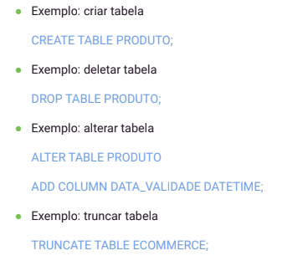

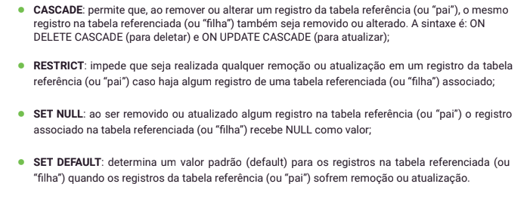

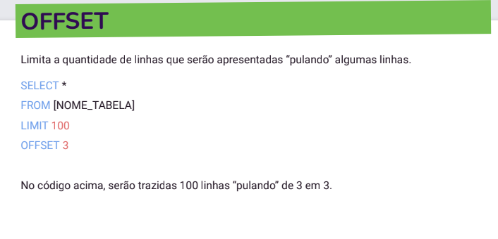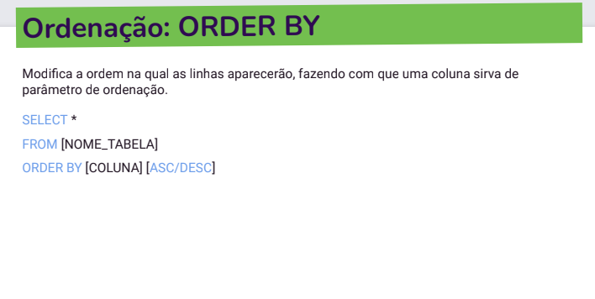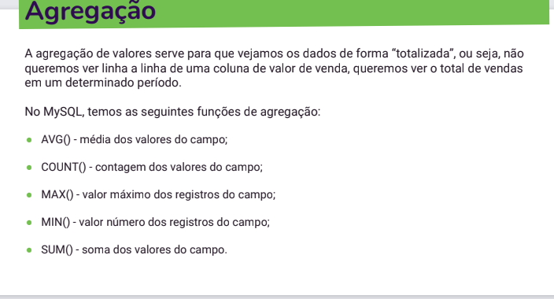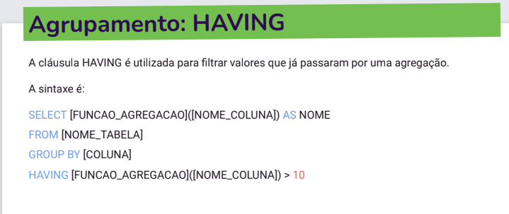

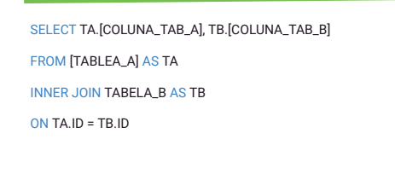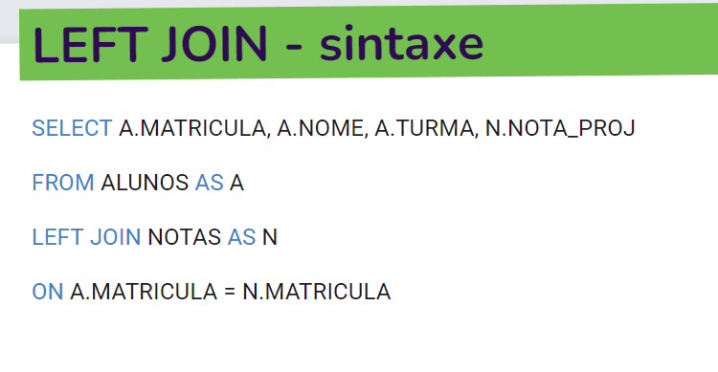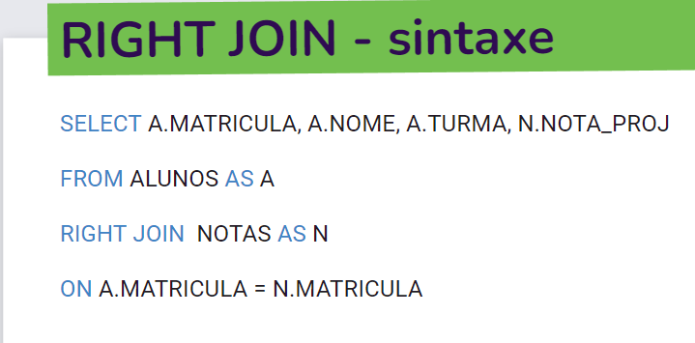

create database revisaopraprova;

use revisaopraprova;

-- Criar tabela

create table projeto (

id int not null auto_increment primary key,

nome varchar (60) not null,

descricao varchar (120) not null,

data_criacao date not null,

data_alteracao date not null

);

-- Inserir Valores

insert INTO projeto VALUES

(default,'Nome1','Em andamento', '2019-10-17', '2019-10-17'),

(default,'Nome2','Em andamento', '2019-10-18', '2019-10-18'),

(default,'Nome3','Em andamento', '2019-10-19', '2019-10-19'),

(default,'Nome4','Em andamento', '2019-10-20', '2019-10-20'),

(default,'Nome5','Em andamento', '2019-10-21', '2019-10-21');

-- Atulizar Valores

UPDATE projeto SET nome = 'Nome6' WHERE id=2;

delete from projeto nome WHERE id=3;

-- Pesquisa com Apelidos

select id as Identidade, nome as Nomes, descricao as Resumo, data_criacao as Data1, data_alteracao as Data2 from projeto;

-- Selecionar somente com limite, distintos e concatenar

select * from city limit 10;

select distinct Name from city;

select concat('Name', 'Countrycode') as Countrydescription from city;

-- Selecionar conforme condições

select * from city where Countrycode like 'NLD';

select * from city where Countrycode like 'NLD' AND Population > 10;

select * from countrylanguage where percentage > 50;

select Language from countrylanguage where IsOfficial like 'T%';

select Language as 'TotalOficial' from countrylanguage where IsOfficial like 'F%';

-- Ainda na tabela “countrylanguage”, faça uma consulta que retorne o total de línguas (com o alias “TotalOfficial”) e o código dos países (“CountryCode”) agrupando pelo código e ordenando pelo total de línguas de forma crescente.

select count(*) as 'TotalOficial', Countrycode from countrylanguage group by CountryCode order by Totaloficial ASC;

-- agrupar

select count(*) as 'Total', Name from country group by Continent;

-- media

select AVG(Surfacearea) as Average from country;

select AVG(LifeExpectancy) as Average, Region from country group by Region;

select AVG(LifeExpectancy) as Average, Region from country group by Region having AVG(LifeExpectancy) > 70;

-- INNER JOIN

-- SELECT TA.[COLUNA_TAB_A], TB.[COLUNA_TAB_B]

-- FROM [TABLEA_A] AS TA

-- INNER JOIN TABELA_B AS TB

-- ON TA.ID = TB.ID;

select A.Matricula, A.nome, A.turma, N.nota_proj

from alunos as A

inner join notas as N

on A.matricula = N.Matricula;

-- entre tres tabelas

select A.nome, A.turma, D.NOME_DISCIPLINA

from alunos as A

inner join notas as N

on A.matricula = N.Matricula

inner join disciplinas as D

on d.COD_DISCIPLINA = N.COD_DISCIPLINA order by nome;